



Digital Europe

Chips JU
DIGITAL Simple Grant (DIGITAL-Chips-2024-SG-CPL-5)
Call for proposals for operational activities of the pilot lines under the Digital Europe programme

Application form (DEP)

Project proposal – Technical description (Part B)

Version 1.1 19/07/2024

Version | Date | Change | Page
V 1.0  ED 2024.153 | 03/07/2024 | Initial version
V 1.0  ED 2024.159 | 19/07/2024 | Version for Call opening: Correct ED decision code | Header

HISTORY OF CHANGES
Date | Part A/B | Explanation
26/05/2025 | Part B | Update staff effort  Update of UVIGO Purchase costs  Update of CSIC Internally invoiced goods and services
10/02/2025 | Part A | Risks & Mitigation measures added: Significant cost deviations in equipment
10/02/2025 | Part A | Comment on cooperation in the context of “design-as-a-service” added to T2.2
10/02/2025 | Part A | D3.2-D3.6 were extended to include also reporting on Training activities together with Operations and Interoperability.
10/02/2025 | Part A | D2.2 moved from M12 to M24, as the engagement phase that starts in the second year
10/02/2025 | Part A | D3.18 and D3.19 have been moved to M48. Corresponding MS7 and MS8 have been moved to M48.
10/02/2025 | Part A | WP1 and WP3 references to Deliverables and Milestones corrected
18/02/2025 | Part A/B | The WPs of the parallel Horizon Europe proposal have been indicated as WP#-HE, for example WP4-HE.
18/02/2025 | Part A/B | Terminology corrected: Coordinator is the RTO (ICFO) and while Pilot Line Director the individual.
13/02/2025 | Part B | ESR comments. (i) Engagement KPIs and related deliverable included.  (ii) A specific text was added to Task 3.1. (iii) Task 2.1 of HE, Task 2.1 and 2.2 of DEP revised and deliverable including “product passporting” added. (iv) Additional text in Task 3.1. (v) Risk register deliverables have been added. (vi) Deliverables on PIXEurope Gateway & Operational Procedures will be continuously updated. (vii) Text added to Task 3.3, p. 144 for support to design-as-a-service. (viii) Text added to Task 3.2. (ix) Procedures for standardised material and equipment supply chains will be part of WP3. (x) Four types of end-user and more than 60 letter of support documented in the Impact section. (xi) Text was added o WP3 and related deliverables to cover the operation  procedures. (xii) Covered by Annex 1 of HA. (xiii) HA and CA are reference documents.
19/02/2025 | Part B | ICFO’s purchase cost table updated. The total purchase cost amount updated.
14/03/2025 | Part B | TNO’s purchase cost table updated. The total purchase cost amount updated.
 |  | WPs renumbered and all related references to WPs and Tasks updated:
 |  |  | CfEoI - original | HE DoA | DEP DoA
 |  |  | WP1 | WP1 | WP1
 |  |  | WP2 | WP3 | WP3-HE
 |  |  | WP3 | WP3 | WP3-HE
 |  |  | WP4 | WP4 | WP4-HE
 |  |  | WP5 | WP5 | WP5-HE
 |  |  | WP6 | WP6 | WP6-HE
 |  |  | WP7 | WP7 | WP7-HE
 |  |  | WP8 | WP8 | WP8-HE
 |  |  | WP9 | WP9 | WP9-HE
 |  |  | WP10 | WP3-DEP | WP3
 |  |  | WP11 | WP2 | WP2
20/03/2025 | Part B | Link to V. Pruneri ICREA added, in-kind contribution specified
20/03/2025 | Part B | Description of Pilot Line Administrative Executive updated
07/08/2025 | Part A & B | UC3M replacement by IMDEA
30/09/2025 | Part A & B | Add IMDEA as partner Nº 17
10/04/2026 | Part A | - Milestone 11 Staff Training Completed added  - Milestones 9 & 10 deleted  - Risk 2 deleted  - Risk 3 updated
10/04/2026 | Part B | Table 16 & 17 updated
10/04/2026 | Part B | Text updated p. 37

PIXEurope
Advanced Photonic Integrated Circuits Pilot Line for Europe


Name | Prof. Dr. Valerio Pruneri | 
Position | Group Leader, ICREA Professor, Corning Inc. Chair
Organisation | Institut de Ciències Fotòniques
Email | valerio.pruneri@icfo.eu
Phone | +34 663 787182

List of participants:

 | Participant organisation name | Short name | Country | Nature
1 | Institut de Ciències Fotòniques | ICFO | ES | RTO
2 | University College Cork – National University of Ireland, Cork  – Tyndall National Institute | TNI | IE | RTO
3 | Technische Universiteit Eindhoven | TU/e | NL | UNI
4 | Universitat Politècnica de Valencia | UPV | ES | UNI
5 | Teknologian tutkimuskeskus VTT | VTT | FI | RTO
6 | Interuniversity Microelectronics Centre | IMEC | BE | RTO
7 | Consejo Superior de Investigaciones Científicas | CSIC | ES | RTO
8 | Nederlandse Organisatie voor Toegepast Natuurwetenschappelijk Onderzoek | TNO | NL | RTO
9 | Universiteit Twente | UTWENTE | NL | UNI
10 | UC3M | UC3M | ES | RTO
11 | Universiteit Gent | UGENT | BE | UNI
12 | Universidad de Vigo | UVIGO | ES | UNI
13 | Instituto de Telecomunicaçoes Aveiro | IT | PT | RTO
14 | Warsaw University of Technology | WUT | PL | UNI
15 | Silicon Austria Labs | SAL | AT | RTO
16 | Commissariat à l’Energie Atomique et aux Energies Alternatives - Laboratoire d'électronique des technologies de l'information | CEA-LETI | FR | RTO
17 | Fundación IMDEA Networks | IMDEA | ES | RTO

TABLE OF CONTENTS

TECHNICAL DESCRIPTION (PART B) ERROR! BOOKMARK NOT DEFINED.
COVER PAGE Error! Bookmark not defined.
PROJECT SUMMARY 5
- RELEVANCE 5
  - Objectives and activities 5
    - Objectives and ambition 5
    - Relation to the Call 9
    - Key Performance Indicators KPIs 12
  - Contribution to long-term policy objectives, policies and strategies — Synergies 14
  - Digital technology supply chain 17
    - Demonstrator Work Flows and Operation 17
    - Artificial Intelligence (AI) in PIXEurope 20
    - Pilot Line Operations (Methodology) 23
    - PIXEurope Services (MPWs, dedicated services, process and transfer to industry for scale-up to production)
......................................................................................................................................................................... 27
    - Open Access and Conditions 30
    - Training & Skill Development 37
  - Financial obstacles 39
- IMPLEMENTATION 40
  - Maturity 40
  - Implementation plan and efficient use of resources 42
  - Capacity to carry out the proposed work 51
  - Expected outcomes and deliverables — Dissemination and communication 77
  - Competitiveness and benefits for society 92
  - Environmental sustainability and contribution to European Green Deal goals 96
- WORK PLAN, WORK PACKAGES, ACTIVITIES, RESOURCES AND TIMING 97
  - Work plan 97
  - Work packages, activities, resources and timing 99
Staff effort (n/a for Lump Sum Grants) 99
In-kind contributions provided by third parties 100
Subcontracting (n/a for prefixed Lump Sum Grants) 100
Purchases and equipment 101
Other cost categories 104
Timetable 107
- OTHER 108
  - Ethics 108
  - Security 108
- DECLARATIONS 108
ANNEXES 109
#@APP-FORM-DEP@#
#@PRJ-SUM-PS@# [This document is tagged. Do not delete the tags; they are needed for the processing.]


PROJECT SUMMARY

Project summary
See Abstract (Application Form Part A).
#§PRJ-SUM-PS§# #@REL-EVA-RE@# #@PRJ-OBJ-PO@#

RELEVANCE

Objectives and activities

Objectives and activities
Describe how the project is aligned with the objectives and activities as described in the Call document.
How does the project address the general objectives and themes and priorities of the call? What is the project’s contribution to the overall Digital Europe Programme objectives?
1.1.1. Objectives and ambition

Photonic Integrated Circuits (PICs) combine the benefits of miniaturised photonics onto microchip- scale dimensions with their development on a trajectory similar to the remarkable progress of Electronic
Integrated Circuits (EICs). PIC technologies can address and transform massive emerging markets in communications, artificial intelligence, sensing, healthcare, security, augmented and virtual reality displays, and a wide range of consumer-driven applications. These market demands will require significant growth in PIC development and up-scaling production capacity [Market value 14bn Euros in 2024 and CAGR of 20.47% to reach 35bn Euros by 2029, Photonic Integrated Circuit (PIC) Market Insights, Verified Market Reports, November 2023].
Europe has made significant investments in PIC technologies. Much of this has been focused in separate areas such as chips,
packaging, and test. Furthermore, PIC chips are becoming highly integrated and extremely complex, often requiring 100s of optical and 1000s of electrical connections, and presenting significant thermal management and packaging challenges. Although there has been considerable progress in each area, it is now recognised that fragmentation of the PIC ecosystem exists and is a major roadblock impeding the standardisation and commercialisation of related technologies. The European Chips Act and, more specifically, the Chips JU CPL-5 Pilot Line initiative presents a unique opportunity to address this overarching and global challenge and unleash the power of PICs across multiple emerging markets.
PIXEurope will create the world’s first fully integrated Open Access PIC Pilot Line, grouping Europe’s top research organisations across all areas of advanced PIC technologies. Combined, they will establish a uniquely unified and standardised PIC ecosystem, placing Europe in a global leadership position and giving Europe sovereignty and a competitive advantage in this critically important future technology. Investments in state-of-the-art equipment will establish critical European infrastructure to develop breakthrough PIC technologies. This goes beyond what is currently available at other state-of-the-art facilities globally, such as the flagship American Institute for Manufacturing (AIM) Integrated Photonics initiative in the US. PIXEurope will offer a wider range of advanced monotlithic PIC platforms (Si, SiN, SiC, InP, AlO, and Ge-Si), novel materials integration processes, advanced wafer-level packaging processes, high-throughput test and reliability analysis procedures, all available through standardised and accessible Design Kits (Figure 1). The proposed technical breakthroughs will also enable the integration of PICs with EICs to produce advanced semiconductor systems.
PIXEurope will work closely with European manufacturing companies, transferring breakthrough PIC processes and technologies to industry for upscaling to volume production to meet growing market demands. PIXEurope will greatly benefit European SMEs and startups, providing a dedicated and easily accessible one-stop-shop resource. It builds much-needed production capacity and will enhance the innovation potential of companies, allowing them to develop and manufacture their PIC-based products in Europe. The proposed Pilot Line will also support research organisations to bridge the gap from lab to fab, exploiting their latest scientific results and accelerating research commercialisation, particularly by supporting the creation of new startup companies.
PIXEurope will establish a centralised operations structure managed by a single point of contact, the
Pilot Line Gateway. The Gateway will coordinate all Pilot Line services, ensuring unified and

synchronised operations between the distributed Pilot Line partners. PIXEurope will also create and deliver unique and in-depth training courses on advanced PIC manufacturing, educating and up- skilling the future European workforce, ensuring companies can access the skilled people they need to grow their businesses.
PIXEurope will become a key part of Europe’s Chips Act Strategy and bolster Europe’s competitiveness, sovereignty and resilience in semiconductor technologies and applications.
Direct actions related to the European Chips Act include:
- Strengthen Europe’s research and technology leadership towards faster and more densely integrated PIC chips.
- Establish a framework and ecosystem to increase PIC production capacity.
- Build and reinforce unified European capacity to innovate in the design, manufacturing and packaging of advanced PIC chips.
- Develop technologies to integrate PIC and EIC chips to produce advanced semiconductor systems.
- Develop an in-depth understanding of global semiconductor supply chains.
- Address the skills shortage, attract new talent and support the emergence of a skilled workforce.
PIXEurope addresses critical challenges to European Competitiveness and is timely following recent reports by Digital Europe (June 2024) and Mario Draghi’s report on boosting European competitiveness (September 2024). The Digital Europe report states that 'The EU struggles to scale and consolidate companies due to the fragmentation of the single market and a lack of a unified strategy, limiting EU companies' ability to scale and compete globally' and 'We must ensure that technology companies, across the whole supply chain, can be born, scale and stay in Europe, supported by partnerships with likeminded countries'. Mr Draghi's report recommends 'larger and pan-European investment in critical technologies, better commercialization of research, breaking down barriers to scale' A key objective for PIXEurope is to unify the PIC supply chain through a partnership of likeminded research organisations, defragmenting and creating a unique research and commercialisation platform. This will give European companies a competitive advantage in developing and scaling the production of new products in the face of tough global competition.

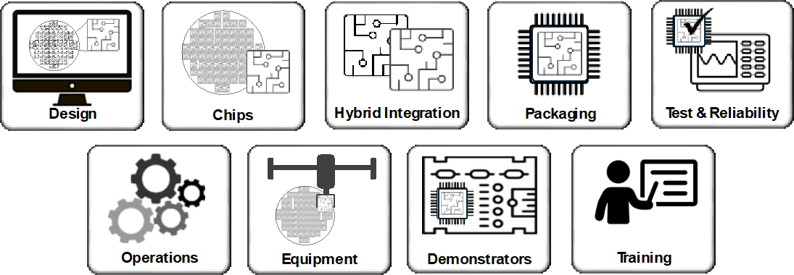
Figure 1: PIXEurope will establish foundational technology nodes working on design, chip fabrication (monolithic PICs), hybrid PIC integration and functionalisation, packaging, test and reliability. Building upon these technologies, we will establish a centralised Pilot Line operation and use state-of-the-art equipment to create highly innovative demonstrators to validate and showcase Pilot Line technologies. PIXEurope will also establish in-depth training courses in advanced PIC manufacturing to educate and up-skill the future European workforce.

PIXEurope’s objectives are:
Objective 1: Unify Europe’s top research organisations to establish the world’s first Open Access PIC ecosystem, using state-of-the-art equipment to develop breakthrough PIC technologies and
processes. Thus greatly increasing Europe’s industrial competitiveness, sovereignty and global leadership in this critical technology.
- Establish a centralised Gateway to coordinate, synchronise and manage the distributed Pilot Line operations, and to provide European companies with a unique one-stop-shop to develop and scale their innovative PIC-based products.
- Install state-of-the-art equipment across the distributed Pilot Line to develop breakthrough processes that enables new applications and increase PIC production capacity.
- Establish a robust PIC development and production supply chain in collaboration with European manufacturing companies and material suppliers.
- Develop a business model and sustainability plan that ensures the continuous growth and successful delivery of PIXEurope Pilot Line services.

Objective 2: Develop, mature and standardise breakthrough PIC processes and technologies, including PIC design, chip fabrication and hybrid integration, through to packaging, test and
reliability technologies. Moving them from TRL 2 to 6, enabling the development of advanced prototypes and transfer to volume production.
- Develop breakthrough PIC manufacturing processes and technologies, including highly efficient design procedures based on standardised PIC Design Kits, increased capacity chip fabrication and new materials integration processes, innovative wafer-level packaging techniques that improve performance and can be scaled to significantly higher production volumes, standardised test and reliability protocols that monitor production processes, yields and efficiencies. Combined, these breakthrough PIC technologies will deliver a unified technology supply chain with a well-defined route to scaled volume production.
- Enlarge the operational wavelength range of PICs by developing novel platforms from Ultraviolet (UV)/Visible (VIS), 0.3 to 0.75 µm, to near-infrared (NIR), 0.75 to 2 µm, and mid-infrared (MIR), 2-10 µm.
- Develop breakthrough chiplet integration platforms for co-packaging of PICs and EICs, enabling the production of advanced semiconductor systems.
- Develop state-of-the-art demonstrators to validate PIXEurope’s advanced PIC technologies and to showcase PIXEurope’s technological capabilities and services.
- Collaborate with European research organisations, using the Pilot Line to accelerate the commercialisation of their research and support the technological sustainability of the Pilot Line.
- Evaluate the use of Artificial Intelligence algorithms to improve the design, fabrication, packaging and testing of PICs.
Objective 3: Offer advanced services based on PIXEurope’s breakthrough technologies, including standardised MPW runs, advanced packaging and test services, as well as specialised and
dedicated services.
- Develop a full range of Open Access services based on PIXEurope’s breakthrough PIC processes and technologies and prepare them for user access through the Pilot Line Gateway.
- Develop MPW Open Access services, including 23 PIC chip and 10 Hybrid Integration MPW runs, 6 Multi-Project Packaging runs, 40 Test and 20 Reliability services runs per year.
- Prepare Open Access services to be compatible with PIXEurope’s standardised Design Kits enabling users to easily design their PIC-based systems from chip to package and test.
- Offer dedicated and specialised services beyond PIXEurope’s standardised MPW services.
- Maximise and effectively manage IP generation in the Pilot Line, especially to enable an industry- friendly approach and access.
- Roll-out PIXEurope’s advanced services during the third year of the project.
Objective 4: Increase the European capacity in PIC production.
- Develop large-scale processes and technologies that increased production capacity. This includes the development of increased wafer diameter production processes, wafer-level packaging processes and faster test procedures.
- Develop processes using state-of-the-art automated equipment to reduce process cycle times and improve yields.
- Develop significantly more efficient PIC design procedures using standardised Design Kits, ensuring complete coherence in the PIC design process from chip to package and test.
- Collaborate with European manufacturing industries to transfer PIXEurope’s breakthrough processes from the Pilot Line to industry, ensuring companies can quickly transition their innovative pilot line processes to full-scale production.
- Lead initiatives to promote the industrial production of PICs in Europe, including the promotion and use of a robust European supply chain for related materials.
Objective 5: Use PIXEurope’s unique research, training and open access platform to foster a vibrant European PIC community that supports the formation and growth of companies to address the emerging mass demands for innovative PIC-based products.
- Establish a vibrant community and ecosystem of researchers, manufacturers and technology users that increases collaboration and offers support measures to encourage the further development and use of PIC technologies
- Strengthen the PIC supply chains to increase the competitiveness of European companies.
- Build strong links with the European electronics community to maximise the potential for the development of advanced semiconductor systems.
- Promote PIC-based businesses, including the launch of new start-ups, and support new investments through engagement with private and public European organisations, such as venture capital companies.
Objective 6: Establish highly visible and well-coordinated training and dissemination programmes. These activities will be managed by partners who have led-the-way in providing pioneering PIC training and dissemination programmes.

- Prepare comprehensive training courses on advanced PIC manufacturing, including online and hands- on courses. PIXEurope will prepare and deliver 28 online, 18 hands-on and specialised one-to-one training courses targeting 1000 attendees per year.
- Collaborate with the European Competence Centres to roll-out PIXEurope’s training courses.
- Roll-out PIXEurope’s training courses during the third year of the project.
- Organise Open House events, giving users an opportunity to view and evaluate Pilot Line facilities. Dedicated one-to-one visits for more detailed on-site training and consultation will also be provided.
- Prepare internal training courses so all Pilot Line partners are fully competent in all aspects and technical capabilities of the Pilot Line, especially for new Pilot Line hires.
Objective 7: Collaborate with other European and national semiconductor initiatives, particularly other Chips JU Pilot Lines (CPL1-4), European Design Platform and Competence Centres.
- Collaborate with other Chips JU Pilot Lines (CPL1-4) on technology standardisation and roadmaps initiatives, business model and sustainability planning, and joint training opportunities. This includes holding regular Pilot Line open days to educate a wide European stakeholder group on the many benefits and services of the Chips JU Pilot Lines.
- Collaborate with the new European Design Platform to develop PIXEurope’s standardised Design Kits.
- Collaborate with the European Competence Centres to promote and support the roll-out of PIXEurope’s training courses.
- Collaborate with European and regional funding agencies to support companies and research organisations access PIXEurope’s advanced Pilot Line services.

The Pilot Line will have three main phases. The first phase (Years 1-5) will involve Pilot Line Development to set it up, the second phase (Years 2-10) will involve Engagement with European End- users, especially industry partners, to support the transfer of the developed Pilot Line processes to industrial-scale production, while the third Operation phase (Years 4-10) will offer the full range of Open Access services, see Figure 2.
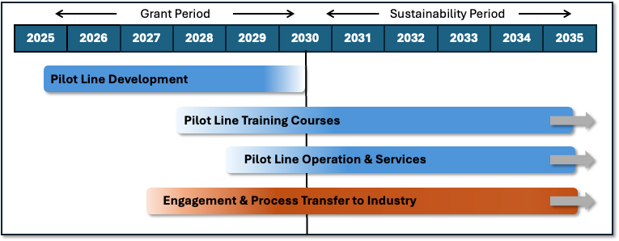

Figure 2: Timeline of PIXEurope Pilot Line from the project grant period to operations and sustainability.

The work plan is divided into 12 distinct work packages (WPs). These WPs are structured to ensure that all the above objectives are achieved, including infrastructure installation and commissioning (3), technical objectives (WP4-8-HE), technology validation and demonstrators (WP9-HE), operations (WP3), collaboration and training (WP2-HE), and overall project management (WP1). Each WP has clearly defined milestones and deliverables, which provide continuous and detailed technical and management reports. Many important KPIs have also been selected to measure progress and ensure the ambitious objectives are achieved.
The PIXEurope team consists of Europe’s top research organisations, see Figure 3, consisting of researchers who have pioneered breakthrough innovations in PIC technologies, including PIC design, fabrication, integration, packaging and testing. They have led flagship research programmes, provided advanced technology services to the industry, and demonstrated success in supporting and spinning out many PIC-based companies (supporting CVs provided in Annex 1, Section 3.3.2). They are supported by research organisations with specialised staff with the necessary expertise to operate and maintain complex semiconductor fabrication, packaging and test equipment in advanced facilities. They are also backed by their national governments, who all see PIXEurope as a vital technological resource in their future economic and industrialisation plans.

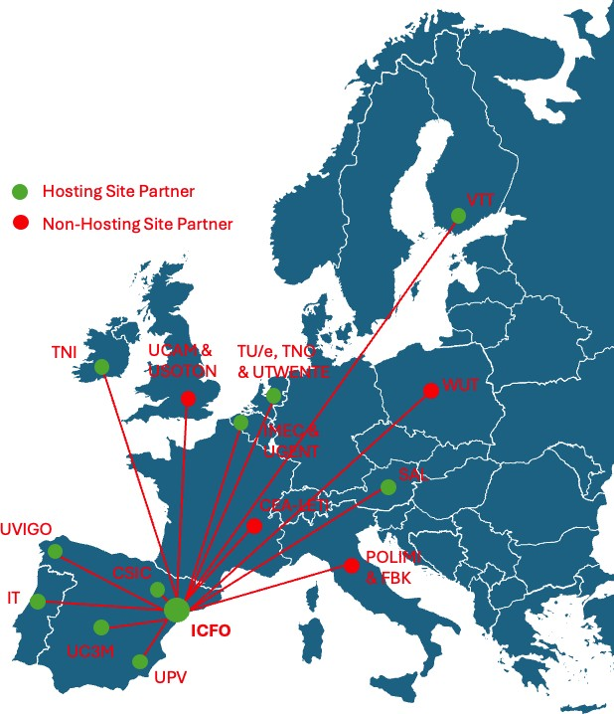

Figure 3: Map of PIXEurope’s partners, including hosting and non-hosting sites, showing the centralised structure with a Gateway at ICFO, the coordinator.

1.1.2. Relation to the Call

The call DIGITAL-Chips-2024-SG-CPL-5: Pilot Line on Advanced Photonic Integrated Circuits highlights the need for critical infrastructure to bridge the gap between research and industrial production, facilitating the development of reliable, scalable, and cost-effective PIC solutions. The call requires that the Pilot Line enhance Europe’s competitive edge in a key technological domain and contribute significantly to Europe’s economic resilience, strategic autonomy and sovereignty in critical technologies. Table 1 below are details of how the PIXEurope proposal addresses the specific challenges and scope of the call (Additional details referring more to Impact are provided in Annex 1, Section 2.1.2).

Table 1: How the PIXEurope proposal addresses the specific challenges and scope of the call DIGITAL- Chips-2024-SG-CPL-5: Pilot Line on Advanced Photonic Integrated Circuits.
 | DIGITAL-Chips-2024-SG-CPL-5: Pilot Line  on Advanced Photonic Integrated Circuits Objectives | PIXEurope’s relation to the work programme
 | “Serve as a critical infrastructure for bridging the gap between laboratory research and industrial- scale production”  and  “foster collaboration among research institutions, SMEs, and large corporations across Europe” | PIXEurope unifies Europe's PIC ecosystem, from chip design (WP4-HE) and fabrication (WP5-HE) to hybrid integration (WP6-HE) and packaging (WP7-HE), test and reliability (WP8-HE). Through this unified technology supply chain, the PIXEurope Pilot Line will create new and essential processes and technologies to address the challenges driven by the continuous increase in PIC complexity and the demand for more scalable production processes. PIXEurope will bridge the gap between research and industrial production by operating at TRL 2-6, supporting European research organisations and companies to overcome the highly dispersed and fragmented nature of PIC  research and commercialisation.

 | “Sustainable pilot line open to all European stakeholders, especially focusing on enabling SMEs and start-ups to leverage advanced PIC technologies” | PIXEurope will operate on an Open Access basis, giving European companies and research organisations unfettered access to the results of the Pilot Line. This includes access to PIXEurope’s standardised: (i) Design Kits for chips, package and test, (ii) Fabrication Processes, (iii) Equipment for process, test and metrology equipment and (iv) Models for technology, process and test data analytics, and cost analytics. PIXEurope’s Open Access approach, including standardised MPW runs and specialised services, will encourage European stakeholders, especially SMEs and start-ups, to incorporate advanced PIC technologies in their products. The setup, management and operation  of Open Access services is fully covered in WP3.
 | “Not only enhance Europe’s competitive edge in a key technological domain but also contribute significantly to the continent’s economic resilience and strategic autonomy in critical technologies” | PIXEurope recognises the critical importance and unique opportunity of creating a Pilot Line that unifies advanced PIC chip design and fabrication along with the development of breakthrough PIC packaging technologies. This unified ecosystem, the first-of-its-kind in the world, also ensures that photonic and electronic chips and packages are co-designed with common standards and can be scaled for mass production. PIXEurope’s concept is to create a uniquely unified research, training and commercialisation platform, providing well- coordinated services to develop and de-risk advanced PIC technologies, giving Europe greater control, sovereignty and a competitive  advantage in this critically important technology.
 | “Develop and enhance PIC technologies by extending the operational wavelengths into the visible and mid-infrared spectrum” | PIXEurope will develop monolithic PIC technology platforms, covering wavelength ranges from UV and VIS to NIR and MIR (WP5&6-HE). This extension of the wavelength range beyond NIR is crucial for tapping into new application areas such as biomedical imaging, augmented reality, and environmental sensing. Functional demonstrators will be developed to showcase PIC operation at  these wavelengths (WP9-HE).
 | “Develop scalable and cost-effective manufacturing processes for PICs, ensuring compatibility with current industrial standards” | PIXEurope will develop internally standardised technologies, from chip design and fabrication to hybrid integration and advanced packaging, through to testing and reliability. This standardised approach will be developed and demonstrated on state-of-the-art equipment compatible with scaling for industrial production. The technical Work Packages (WP4-8-HE) will all contribute to this objective. PIXEurope will work to promote these internally developed standardised technologies to become more formally recognised international standards through collaborations with leading industry groups and international  standards organisations (e.g., IEEE and IEC).
 | “Foster the integration of PICs with electronic integrated circuits, enhancing the functionality and efficiency of combined systems for applications in computing, telecommunications, and beyond” | PIXEurope recognises the technological importance of integrating PICs with EICs to enable the development of advanced semiconductor systems. The work programme includes significant activities on co-packaging PIC and EICs using advanced interposers to enable high-density DC and RF electrical interconnects (WP7-HE). The work programme includes the development of functional demonstrators to showcase PIC-EIC device integration for  communications, AR/VR, signal processing and computing (WP9-HE).

 | “Innovate in the fields of photonic testing and packaging to improve reliability, scalability, and performance of PICs” | Packaging and testing are recognised as major cost contributors to PIC-based production and has become a significant bottleneck. PIXEurope includes dedicated packaging and test work packages, WP7-HE and WP8-HE, respectively. PIXEurope will deliver breakthrough wafer-level chiplet-based packaging technologies that address existing production bottleneck and cost challenges. This will be supported by standardised testing and reliability technologies. The combination of these advanced backend technologies with PIXEurope’s frontend chip design and fabrication technologies across a wide range of photonic material platforms gives PIXEurope a truly unique offering globally. These  will be validated and demonstrated in WP9-HE for a wide range of applications.
 | “Enable rapid prototyping through Multi-Project Wafer runs, allowing for timely validation and iteration of PIC designs” | Standardised Open Access technologies will be made available through regularly offered Multi- Project Wafer (MPW) runs, including chip fabrication, integration and packaging. Users will prepare their designs using standardised Design Kits (chips, package, and test Design Kits), and access services through a single point of contact, Pilot Line Gateway, managed by the project coordinator, ICFO (WP3). PIXEurope offers an unparalleled range of MPW runs, from chip to  package and test.
 | “Develop demonstrators to validate the achievement of the advanced PICs technology and to quantify its performance” | Functional demonstrators will be developed during the project to validate the processes and technologies, targeting areas that address major applications, such as communications, artificial intelligence, augmented reality, LIDAR and sensing. The demonstrators will be developed using PIXEurope's chip and package Design Kits to highlight the benefits of the standardization approach. Besides being highly effective vehicles to validate the established process, the demonstrators will also be used to measure the operational efficiency of the Pilot Line, such as process cycle times and partner interoperability  (WP9-HE).
 | “Process Design Kits and Assembly Design Kits, crucial for the design and development of next- generation PICs” | PIXEurope will focus on developing standardised PIC Design Kits across the entire technology supply chain (chip, package and test), ensuring compatibility between PDKs, ADKs, and TDKs. This approach will enable users to more easily develop highly complex PIC-based systems for a wide range of applications. These Design Kits will be developed in collaboration with the new  European Design Platform (WP4-HE).
 | “Comprehensive training programs and skill development initiatives to ensure that European technologists and engineers are equipped with the knowledge and tools necessary to excel in the field of photonic integration” | PIXEurope will develop unique and in-depth training courses in advanced PIC manufacturing. This which will include online and hands-on courses. These courses will address key Pilot Line technologies, from PIC design, to fabrication, packaging, testing and reliability. They will be developed in collaboration with the European Competence Centres. The courses will target European technologists, entrepreneurs and companies, including non-photonics companies interested in evaluating PIC technologies for the first time. Dedicated one-to-one training will also  be made available for specialised use cases (WP3).

 | “Fostered collaborative development through synergies with other Chips JU pilot lines, ensuring complementarity especially with the pilot lines dedicated to quantum technologies, heterogeneous integration, and wide bandgap materials” | PIXEurope will form synergistic collaborations with other key European initiatives, particularly other ChipsJU Pilot Lines (CPL1-4). This includes collaboration on training, technical workshops and open days. Additional collaboration opportunities include the development of common photonic- electronic fabrication, packaging and integration standards and formalising design rules (e.g. CPL3). PIXEurope will also collaborate with the new European Design Platform and European Competence Centres on the development of Design Kits and standards, and the roll-out of training courses, respectively. PIXEurope will also collaborate with the future Quantum Pilot Line,  which will have a photonics pillar.
1.1.3. Key Performance Indicators KPIs

We have identified a comprehensive set of specific KPIs to measure progress for all work packages and to ensure PIXEurope’s key objectives are achieved. The following section summarises the high-level KPIs specifically related to the setup and operation of the Pilot Line, including project demonstrators to validate Pilot Line operations and interoperability between partners (WP9-HE), organising and scheduling of Open Access services, including standardised MPW runs and specialised user services (WP3), to the setup and delivery of in-depth training courses on advanced PIC manufacturing and collaboration with other European programmes and initiatives (WP2-HE). As a result of these KPIs, we have added impactful follow-on or resultant KPIs related to capacity building of PIC production in Europe, building a unified European PIC ecosystem between research organisations, industrial manufacturers, end-users and product developers and the investment community, and establishing a more robust European supply chain
to support the growth of PIC production in Europe.
Demonstrators (WP9-HE – KPIs interconnected with DEP activity)
PIXEurope will develop eight state-of-the-art demonstrators to validate all processes and technologies. These demonstrators address important applications such as AI, VR displays, communications, computing and sensing. Critically, they are developed using only technologies available within the Pilot Line from across all technology nodes (chips, integration, packaging, and test).
High-Level KPIs
- 8 fully functioning demonstrators involving all PIXEurope consortium partners and validating most of the PIXEurope processes and technologies.
- Demonstrators used to measure critical KPIs such as cycle time to develop a complete PIC-based system and interoperability between distributed Pilot Line partners.
- Demonstrators used in training to showcase technologies and as exemplars of how to use PIXEurope processes.
- All demonstrators developed using PIXEurope’s standardised design kits (PDKs, ADKs and TDKs).
Open Access and Services (WP3)
Develop a full range of Open Access MPW services addressing all aspects of advanced PIC based on mature and standardised PIC processes and technologies and made available to users through a single point of contact Pilot Line Gateway office.
High-Level KPIs
- MPW Open Access services include 23 PIC chip and 10 Hybrid Integration MPW runs, 6 Multi-project Packaging runs, 40 Test and 20 Reliability services runs per year.
- All MPW Open Access services will be compatible with PIXEurope’s standardised Design Kits, enabling users to easily design their PICs from chip to package and test.
Training (WP2-HE)
PIXEurope will establish training courses addressing all aspects of advanced PIC manufacturing, including design, fabrication, packaging and integration, test and reliability. This will be done as soon as they become available during the development phase and will continue during operation of the Pilot Line, in direct collaboration with the new European Competence Centres to ensure
PIXEurope courses are promoted and supported across all of Europe.
High-Level KPIs
- Prepare comprehensive training courses on advanced PIC manufacturing, including online and hands- on courses.
- Training courses include 28 online, 18 hands-on and specialised one-to-one training courses.
- Targeting 1000 trainees per year.
Collaboration

PIXEurope will collaborate with the four existing Chips JU Pilot Lines (CPL1-4). This includes direct technical collaborations and high-level cooperation to promote the Chips JU Pilot Line initiative, such as through an annual Pilot Line Open Day in Brussels. We will also collaborate with Design Platform, Competence Centres and national funding programmes.
High-Level KPIs
- Direct technical collaboration in areas such as packaging standards with CPL-3 (Heterogeneous Integration Pilot Line).
- Collaboration on the setup of common training programmes.
- Collaboration on the development of international technology roadmaps and standards.
- Annual Pilot Line Open Day in Brussels.
- Collaborate with European Competence Centres on training
- Collaborate with the Design Platform on the development and use of PIXEurope’s design kits.
- Collaboration with other European Photonics initiatives such as photonixFAB and PhotonHub Europe.
Capacity Building
To increase capacity for designing, fabricating, packaging, and testing Photonic Integrated Circuit (PIC) chips, PIXEurope will install state-of-the-art manufacturing equipment. The process development will focus on increasing throughput by incorporating new advancements, such as the use of larger wafer diameters for chip fabrication and implementing wafer-level packaging processes. Ultimately the developed, validated and stabilised processes will be transferred to
manufacturing industry.
High-Level KPIs
- Standardised and unified design kits for the rapid design, development and validation of the complete PIC-based systems, from chip through to package and test.
- Increased wafer size in several PIC technologies, reaching up to 150 mm in InP and 300 mm in SOI and SiN PICs.
- Automated wafer-Level chiplet-based packaging processes on electro-optical interposers to reduce the PIC packaging bottleneck.
- Compatibility with EIC integration and packaging using similar automated equipment to enable the production of advanced semiconductor systems.
- Transfer of PIXEurope’s PIC technologies and processes to industry for scale-up to volume production.
Unified PIC Ecosystem
PIXEurope will establish a complete technology supply chain, from PIC design and chip fabrication through to packaging and integration, test and reliability. All technology steps will be linked through a common design kit chain (PDK->ADK->TDK). Users can access these technology
services through a single Pilot Line Gateway office.
High-Level KPIs
- Complete technology supply chain under a unified distributed Pilot Line.
- Single point of contact front office, Pilot Line Gateway.
- Unified Open Access design kits for all technologies, from chip to package and test.
- Support the growth of investment in PIC technologies through engagement with public and private investment groups, such as venture capital companies. PIXEurope can be seen as a platform to de-risk technology development and will encourage more investors to support new and growing companies in Europe.
Stable European Manufacturing Platform
All processes developed will be made available for transfer to European manufacturing industry for upscaling to volume production. This unified European ecosystem will cover PIC development
and pilot-scale services within PIXEurope through to industrial-scale production with commercial partners.
High-Level KPIs
- State-of-the-art process equipment installed and processes validated with standard operating procedures.
- Processes ready for transfer to industry partners for scale-up.
- Every PIXEurope process has an industry ‘process scale-up’ partner option by the end of the grant period, ready for user scale-up requests, with additional industry ‘process scale-up’ partners engaged.
Resilient European Supply Chain
PIXEurope will primarily source all components and materials from European suppliers. This includes materials for chip fabrication, packaging and test. European equipment suppliers will also be engaged, ensuring EU tender rules are followed. Where European component and materials suppliers are unavailable, initial sourcing will be done elsewhere. However, PIXEurope will strive to establish new European-based suppliers during the project. This approach will encourage growth in and boost Europe’s PIC supply chain, strengthening the ability to fully
manufacture PICs and associated materials in Europe.
High-Level KPIs
- First choice of European-based materials and component suppliers.
- Support the emergence of European suppliers where they currently do not exist.


- Monitor the percentage of European suppliers during the project and foster the percentage increase towards the end of the project.
- Prepare a European component and materials supplier list database and promote their services.
#@COM-PLE-CP@#

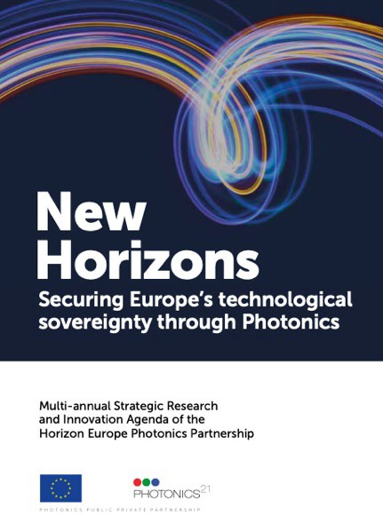
Contribution to long-term policy objectives, policies and strategies — Synergies

Contribution to long-term policy objectives, policies and strategies — Synergies
Describe how the project contributes to long-term policy objectives of the call’s domain/area and to the relevant policies and strategies, and how it is based on a sound needs analysis in line with the activities at European and national level.
What challenge does the project aim to address?
The objectives should be specific, measurable, achievable, relevant and time-bound within the duration of the project.
The PIXEurope Pilot Line addresses key EU socio-economic policies, ranging from technology sovereignty to competitiveness in advanced manufacturing, supply chain resilience, environmental sustainability, and emerging technologies such as quantum. Below, we have outlined how PIXEurope addresses some of these important EU policies and long-term objectives.
European Chips Act & Chips JU: Semiconductor chips are central to our modern economies and daily lives. Chips underpin digital transformation and are essential to all industries. The European Chips Act and the Chips JU Pilot Line initiative will boost Europe’s sovereignty in semiconductor chip technologies, increasing Europe’s competitiveness and resilience and contributing to the digital and green transitions. PIXEurope will become a key part of Europe’s Chips Act Strategy by increasing Europe’s competitiveness in advanced PIC chip technologies and their
applications. PIXEurope has direct actions related to the European Chips Act which include,
- Establish the EU’s scientific excellence and innovation leadership in emerging components and systems technologies and promote the active involvement of SMEs. PIXEurope will strengthen Europe’s research and technology leadership towards smaller and faster PIC chips.
- Establish a framework and ecosystem to increase PIC production capacity by 2030.
- Build and reinforce the capacity to innovate in designing, manufacturing and packaging advanced PIC chips and ensure that the developed components and systems technologies address Europe’s societal and environmental challenges.
- Enable the development and deployment of cutting-edge semiconductor technologies, cutting-edge quantum technologies and the innovation of established technologies that will reinforce advanced design, systems integration and chip production capabilities in the EU
- Develop technologies to integrate PIC and EIC chips to produce advanced semiconductor systems.
- Develop an in-depth understanding of the global semiconductor supply chain.
- Address the skills shortage, attract new talent and support the emergence of a skilled workforce. PIXEurope also plans to collaborate with new EU initiatives, including direct collaboration with the existing Pilot Lines (CPL1-4), the new Design Platform and European Competence Centres to support the development and roll-out of training courses in advanced PIC manufacturing.

Photonics21: The Photonics Partnership represents a commitment between the European Commission and Photonics Stakeholders (industry and research organisations) to invest in Europe to secure Europe's industrial leadership and economic growth in photonics and its enabled industries. Photonics21 has long promoted the development of PIC technologies. The organisation has pointed to Europe's strength in PIC technologies, with a high level of competence in research and manufacturing and a diverse industrial base, with many SMEs and larger companies covering a wide range of application domains. Photonics21 has made significant efforts to promote greater resilience in Europe’s supply chains, a critical area in which PIXEurope will invest significant effort (investing in Strategic Value Chains). Another opportunity identified by Photonics21 is the need for complete photonic-electronic solutions and the limited level of standardisation in process flows. These weaknesses are areas addressed by PIXEurope. Photonics21 also recommends increased collaboration between companies in the supply chain and Pilot Line projects, with a strong focus on standardisation by using Design Kits and the development of co-packaged optics and electronics using
chiplet approaches [Research and innovation priorities, Photonics21 website]. These key objectives for




PIXEurope align well with the Photonics21 roadmap [Europe's Age of Light – How photonics will power growth and innovation, Strategic Roadmap, Photonics21 website].

Digital Europe: The Digital Europe Programme (DIGITAL) supports the transformation to digital technology of European businesses, public administrations and its citizens. The programme is designed to bridge the gap between digital technology research and market deployment. The programme’s main objective is to address challenges and support projects in key capacity areas such as supercomputing, artificial intelligence, cybersecurity, and advanced digital skills and ensure a wide use of digital technologies across the European economy and society. It supports industry, small and
medium-sized enterprises (SMEs), and public administration in their digital transformation with a reinforced network of European Digital Innovation Hubs. PIXEurope contributes significantly to Digital Europe as the many PIC technologies developed in the Pilot Line are essential to the digital infrastructure, especially for advanced communication systems.

Environmental Sustainability: The European Green Deal is a set of policy initiatives by the European Commission with the aim of making the European Union climate-neutral in 2050. In particular, the EU's Green Deal Industrial Plan will enhance the competitiveness of Europe's net-zero industry and support the fast transition to climate neutrality. The EU Green Deal recognises the essential role of digital transformation in achieving a resource- efficient, carbon-neutral, and sustainable world. Photonics has
been defined as a vital technology in Europe's future digital transformation. It is an inherently green technology and a driver of global sustainability. For example, the world is entering a new age of hyper- scale data use. According to the IEEE, the number of devices that connect to the internet is expected to grow 30% to 38bn by 2025. Average internet traffic per user is expected to double every three years. And the advent of artificial intelligence and machine learning will add massive pressure on bandwidth capabilities. Data centres need a revamp, and photonics is key to the transition. PIXEurope contributes to Europe's Green Deal policy as it will develop and support the deployment of energy- efficient PIC-based products and devices, supporting the growth of mass markets that face critical challenges in terms of their future energy use. PIXEurope will also support the development of internal material supply chains in Europe, leading to improved supply chain resilience, lower product air miles and more sustainable production processes.

Quantum Technologies: Quantum Technologies derive from applications of quantum theory and will revolutionise the way we live in the future, significantly improving the efficiency of everything from communication to computing and sensing by harnessing the principles of quantum physics. Europe has a long tradition of excellence in quantum research. Developing a solid
industrial base that builds on this tradition is crucial. With coordinated research and funding efforts at the European level, Europe will avoid falling behind its global competitors. The Quantum Technologies Flagship was launched in 2018 [www.qt.eu] to meet this challenge. It is a large-scale, long-term research initiative with a budget of €1 billion funded by the EU. It brings together research institutions, industry and public funders, consolidating and expanding European scientific leadership and excellence in this field. All EU Member States also signed the EuroQCI Declaration, agreeing to work together, with the Commission and with the support of the European Space Agency, towards the development of a quantum communication infrastructure covering the whole EU [www.qt.eu/ecosystem/quantum-communication-infrastructure]. Integrated quantum photonics uses PICs to control photonic quantum states for applications in quantum technologies. PICs, therefore, provide a unique approach to the miniaturisation and scaling up of optical quantum circuits. Quantum Photonic PICs are already part of several FPA/SGAs of the quantum Flagship and will likely constitute a pillar of the future Chips JU call on Quantum Pilot Line (please see Annex 1, section 1.3.2). PIXEurope will play a vital role in building Europe’s quantum technology future as it develops the PIC technology building blocks and the routes to manufacture used to produce highly integrated quantum circuits, upon which the future Quantum Pilot Line can build.

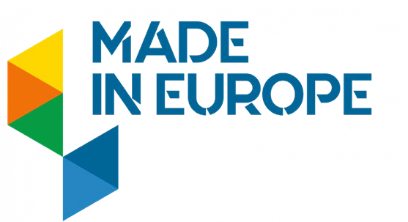
Made in Europe: When it comes to quality, European products consistently come out top. Not only are European products of excellent quality, but many are also more sustainable and eco-friendly than their competitors. This is partly due to design standards guided by EU laws that are often well ahead of global competition. These strict regulations set high benchmarks for production processes, leading to better production systems with fewer pollutants and higher safety standards in the workplace. The Made in Europe policy is a
manufacturing partnership with the European Commission under the Framework Programme Horizon 2021-2027 [Made in Europe - the manufacturing partnership in Horizon Europe, European Commission website]. The Made in Europe partnership drives sustainable manufacturing based on joined expertise and resources, boosting European manufacturing ecosystems towards global leadership in technology, circular industries and flexibility. The partnership contributes to a competitive, green, digital, resilient and human-centric manufacturing industry in Europe. PIXEurope contributes to this important European policy through its focus on building a strong European manufacturing supply chain. It ensures that European manufacturing will continue to operate at the highest technological level by accelerating the transfer of the latest technical developments from research to production in direct collaboration with European industry.

European Skills Agenda: The European Skills Agenda is the European Union's high-level plan to equip individuals and businesses with the digital skills needed for life and work [https://digital-skills- jobs.europa.eu/en/actions/european-initiatives/european-skills-agenda]. The European Skills Agenda complements the European Digital Strategy, the Strategy for SMEs, and exists within the framework of
the Recovery Plan for Europe. The plan has several main objectives: to strengthen sustainable competitiveness and contribute to the targets and ambitions of the European Green Deal, to enhance social fairness and equality by implementing the first principle of the European Pillar of Social Rights, i.e. access to education, training and lifelong learning for all, and to improve overall resilience and the ability of citizens and businesses to react to crises. The European Skills Agenda sets targets based on pre-defined indicators, such as raising the participation of younger adults, job seekers, and those with little experience and a
lower qualification skillset. PIXEurope supports the European Skills Agenda by building new capacity in advanced semiconductor chip manufacturing, enabling new jobs in emerging markets. This includes jobs for highly skilled and mid-level skilled people. The technologies being developed, such as AI and faster communication systems, will enable improved digital learning capabilities. PIXEurope will also develop
online and hands-on training courses on advanced semiconductor manufacturing, supporting the upskilling of European citizens in essential technologies for the future.

#§COM-PLE-CP§#

Digital technology supply chain

Digital technology supply chain
Explain to what extent the project would reinforce and secure the digital technology supply chain in the EU. This criterion might not be applicable to all topics — for details refer to the Call document.
1.3.1 Demonstrator Work Flows and Operation

Modern global semiconductor manufacturing supply chains are complex, typically involving many stages of production distributed across many countries. The distributed nature of semiconductor manufacturing has evolved over many years, and the logistics are highly efficient and well-coordinated. However, these supply chains are vulnerable to stresses such as those caused by the recent pandemic, inflicting serious delays and product shortages on customers. Localisation of supply chains can alleviate these problems. The Chips JU Pilot Line initiative presents a unique opportunity for Europe to build strong internal supply chains for its advanced semiconductor technologies. The PIXEurope consortium recognises this opportunity and has structured the Pilot Line in a distributed way to maximise its technical capabilities while ensuring it is operated efficiently and with efficient coordination and synchronisation between its consortium partners.

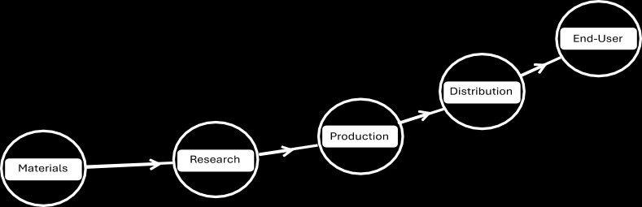
Figure 4: Modern global semiconductor supply chains are complex and highly distributed but operated in a highly efficient way. PIXEurope and other EU Pilot Lines present Europe with a unique opportunity to build robust internal supply chains for advanced semiconductor manufacturing. Project demonstrators can be used to develop, test, and validate the distributed supply chains in the Pilot Line. They are an essential part of the project.

PIXEurope also addresses the global challenge of fragmentation of the PIC ecosystem, which is a major roadblock impeding the standardisation and commercialisation of related technologies. The development and manufacturing of PIC products requires access to a broad range of advanced technologies and manufacturing capabilities, including chip design, fabrication, packaging, testing and reliability-failure analysis. Furthermore, companies ideally require an accessible development and early-stage production facility where the technologies and expertise necessary to support their needs are available in a unified and well-coordinated work flow. This is especially important for SMEs and startups that often do not have the expertise or resources to manage widely distributed supply chains. The capital investment and level of expertise required to house all of these capabilities under one roof is extremely high. Europe's leading research organisations have state-of-the-art technologies and facilities specialising in particular technologies but often do not have the full range of technologies or the ability to scale beyond producing a few prototypes. However, when unified, these research organisations can become a powerful capability that can address the future needs of Europe's companies. To achieve this, these research organisations must combine and standardise their technical disciplines and facilities, coordinating their operations towards the singular objective of an easy access distributed Pilot Line.
A defining feature of PIXEurope is the highly interdisciplinary nature of the consortium. PIXEurope is comprised of experts from across the complete PIC technology supply chain, ensuring an effective and highly capable project team able to meet the challenges of operating a state-of-the-art Pilot Line which engages with users from diverse application areas. The PIXEurope consortium comprises leading experts from PIC design, fabrication, hybrid integration, packaging, test and the delivery of foundry services. Additional skills in project management and business development, outreach, dissemination and training further strengthen these technological capabilities. This broad range of technical and non-technical skills enables the creation of a uniquely unified research, training and commercialisation platform, providing well-coordinated services to develop and de-risk advanced PIC technology and production processes using well-established unified work flows.

Regarding the development and strengthening of the supply chain, PIXEurope will primarily source all components and materials from European suppliers. This includes materials for chip fabrication, packaging and test. European equipment suppliers will also be engaged, ensuring EU tender rules are followed. PIXEurope will also strive to support establishing new European-based suppliers. This approach will encourage growth in and boost Europe’s PIC supply chain, strengthening the ability to manufacture PICs and associated materials in Europe. To achieve these important objectives, we will continuously monitor the percentage of European suppliers during the project and encourage the increased use of European suppliers. This includes preparing a European component and materials supplier list database and actively promoting their capabilities and services.
PIXEurope’s project demonstrators show users how its many breakthrough technologies can be configured to meet their unique application needs, defragmenting the design cycle and technology supply chain between chips, packaging and test. Essentially, the demonstrator work flows are representative of those of future services. As explained in the previous section, eight demonstrators have been selected, representing a variety of application domains. In Figure 5, we have highlighted three demonstrators to illustrate the process (work) flow between technology partners, each contributing to the development of the demonstrator. It shows a partner map and their roles in developing and building these three demonstrators. As can be seen, a wide distribution of partners contributes to all technologies required to develop the demonstrators. Critically, the project coordinator, ICFO, will manage the process flows and operations between the various partners to ensure efficient timing between each process step and to foresee and manage risks. This includes preparing detailed project Gantt charts for each demonstrator, agreeing, and setting key milestones for each partner.

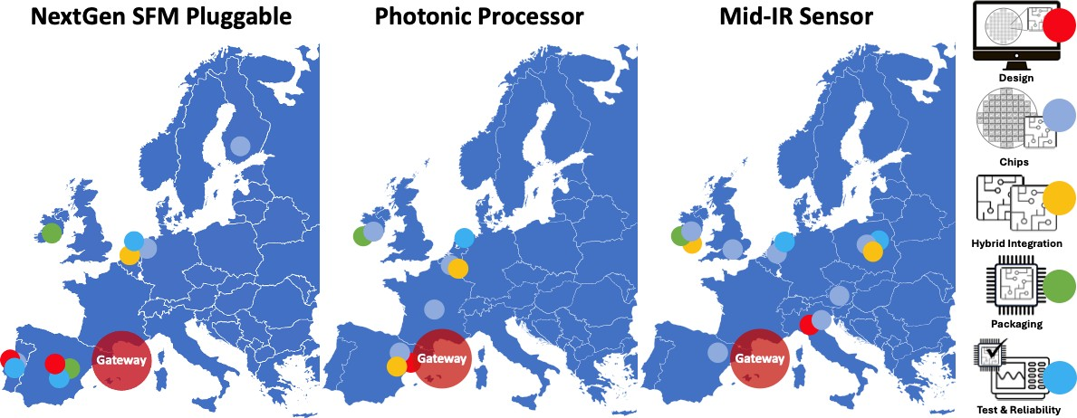
Figure 5: Map showing the distribution of partners involved in three of the eight project demonstrator activities. As can be seen, a wide range of partners contribute to all technologies required to develop the demonstrators. Process flow operations will be managed by the Pilot Line Gateway, located at the project coordinator, ICFO.

Figure 6 shows more details, including a table, of partner contributions for the 'Next-Generation Small Form-Factor Pluggable for PON Optical Transceivers' demonstrator.

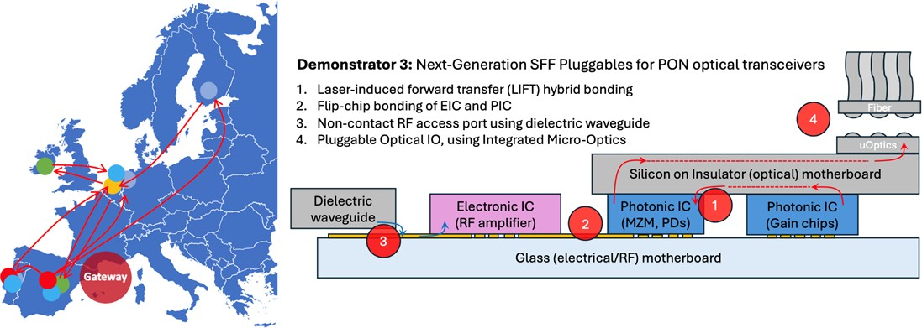

Figure 6: Details showing partner names and their contributions to develop Demonstrator 3, Next- Generation Small Form-Factor Pluggable for PON Optical Transceivers.

Demo | Name | Coordinator | Design | Chips | Hybrid Integration | Packaging | Test
3 | NextGen SFM Pluggable | IMDEA | IMDEA | TNO | TNO | TNI | IMDEA
3 | NextGen SFM Pluggable | IMDEA | IT | VTT | TNO | ICFO | TU/e
 |  |  |  | IT | TNO |  | IT

PIXEurope leverages the unique expertise of multiple partners with experience managing cross-border technology development. Several consortium partners have previously collaborated in the PIXAPP packaging Pilot Line to demonstrate the development of a silicon-photonic-based transceiver module, see Figure 7 [Bundalo, IEEE J Select Topics on Quant Elect, Vol 28, No 3, 2022]. This expertise in scheduling and project management, as well as collaborative technology development, will be invaluable when implementing the demonstrator tasks.

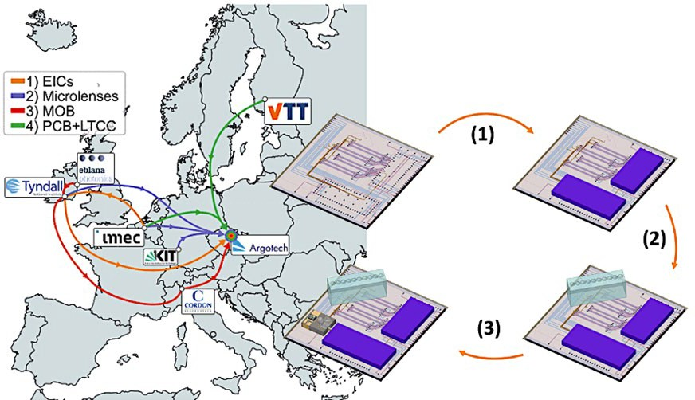
Figure 7: Consortium partners have significant experience managing distributed technology development, leveraging their unique capabilities to create complex integrated photonic modules. This figure shows how TNI, IMEC, and VTT previously collaborated with industry partners in the PIXAPP Pilot Line project to develop a silicon-photonic PIC-based transceiver. This experience will be invaluable in ensuring the distributed process flows between partners are efficient and well-synchronised [Bundalo, IEEE J Select Topics on Quant Elect, Vol 28, No 3, 2022].

Although the consortium has significant experience managing distributed development activities, it recognises the challenges and risks of operating distributed technology development and manufacturing. These include technology, planning, people, and logistical risks. Based on our experience, we have identified risks and proposed risk mitigation procedures. These details are provided in Table 2.
Table 2: List of risks and risk mitigation procedures associated with the process flows and operations to develop the project demonstrators.
 | Risk | Mitigation
 | Planning: Insufficient planning, coordination and synchronisation of activities between partners involved in the demonstrator development. | PIXEurope Gateway, managed by ICFO, will prepare detailed project plans, including Gantt charts, which will be agreed upon in advance by all participating partners. The Gateway will continuously monitor progress and intervene if delays arise to support partners and resolve issues.
 | People: Lack of shared experience between partners and their staff in running joint | Internal training courses are provided to ensure that all partners, especially new hires, gain a detailed understanding of all Pilot Line

 | development activities, resulting in inefficiencies and poor results outcome. | technologies and how these are distributed among the partners.
 | Design: Incompatibility with the design between the different stages of demonstrator development (e.g. chip fabrication and packaging). | PIXEurope will operate on the principle of standardised design rules and Design Kits that are compatible across all technology platforms. This will significantly support internal development activities, particularly demonstrator development, ensuing design compatibility across development phases.
 | Equipment: Delays installing equipment. | Demonstrator activities will start when equipment has been installed, and any delays will be seen well in advance and planned accordingly (e.g., redirecting activity to another partner capable of completing the task).
 | Logistics: Issues with shipping of materials and components between partners, causing delays in processes and completion of the demonstrators. | All consortium partners have significant experience in managing reliable logistics processes, such as procedures for shipping and tracking of goods. In the case where issues arise, partners will be supported by the PIXEurope Gateway to identify and resolve issues.
 | Technology readiness: Issues with novel, immature technologies that may cause delays or challenges. | Mitigating this risk involves rigorous testing and validation to ensure technological maturity. Early detection of issues and proactive management will help maintain progress and minimize delays.
1.3.2 Artificial Intelligence (AI) in PIXEurope

PIXEurope Pilot Line and related advanced PIC technologies and platforms will benefit from AI (AI for PIXEurope), while AI will benefit from hardware that can be developed using PIXEurope’s outcomes (PIXEurope for AI).
AI for PIXEurope
One of the long-term ambitions of PIXEurope is to serve as a cutting-edge field lab for digital production built around a data-driven architecture. Tool specifications and interfacing are defined from the outset with a data-centric approach, enabling advanced process diagnostics and optimizations through AI and, more specifically machine learning (ML). This forms a robust foundation for digital twin technology and sophisticated factory automation.
Historically, photonics fabrication has relied on available toolsets or evolved organically, resulting in fragmented data collection and incomplete metrology. In contrast, PIXEurope’s Pilot Line is architected from a data-plane perspective, integrating state-of-the-art manufacturing tools and systems designed to handle massive data flows from both process and metrology tools. This approach enables deep insights into process dependencies and variations, significantly reducing ramp-up time and enhancing predictability. Leveraging expertise from Pilot Line designs in other sectors, PIXEurope aims to create advanced, data-driven PIC design, fabrication and testing lines.
Digitization and standardized data exchange are the cornerstones of this initiative, providing the groundwork for implementing emerging technologies like AI, ML, and digital twins. The Pilot Line’s data infrastructure will facilitate research and development projects aimed at factory-level optimizations, positioning Europe as a leader in next-generation semiconductor production.
Unlike conventional photonics fabs, which have often been assembled from repurposed or adapted production lines, PIXEurope is building a state-of-the-art 150 mm line from the ground up for the InP PIC foundry processes. This allows for comprehensive, real-time production metrology, yielding shorter ramp- up times and more predictable outcomes for new processes. Data will be seamlessly shared across a complex production environment, extending to the supply chain and encompassing machine, production, and process data. Standardized protocols, such as SECS/GEM and OPC-UA, will be implemented to ensure seamless communication between various systems, a critical requirement during the procurement of equipment.

Factory capability will be enhanced with the Manufacturing Execution System (MES), ensuring accurate recipe execution and data labelling. The AI/ML-ready environment will be underpinned by a secure, efficient, and protected infrastructure, adhering to established SEMI and ISO standards. This data architecture will allow data mining across massive databases to identify correlations between equipment performance, process outcomes, and device functionality, ensuring high-quality data for machine learning models. Furthermore, the production system architecture will support multi-agent systems, enabling decentralized problem-solving and aligning the Pilot Line with broader European initiatives focused on data sovereignty, machine learning, and system modelling based on digital twin technology. This will result in faster, more innovative product development while safeguarding customer IP through stringent data security measures.
Design capability will be similarly upgraded by mining data across different design abstraction levels AI plays an increasingly crucial role in the fabrication of Photonic Integrated Circuits (PICs) by optimizing complex processes, improving design precision, and enhancing overall manufacturing efficiency, and these can be correlated with functional performance data from the designers. PICs, which integrate multiple photonic functions on a single chip, are used in various applications such as telecommunications, sensing, and data processing. These intricate processes stand to gain significantly from AI-driven methodologies. In this context, PIXEurope will utilize the vast amounts of data generated across design, chip fabrication, packaging, and testing stages to train models relevant to each of these domains. This data will serve as an unparalleled resource, enhancing the understanding and optimization of technology nodes and opening of new scientific fields.
AI for PIC design
One key area where AI is transforming PIC fabrication is design optimization. AI algorithms, particularly ML techniques, can analyse vast datasets from previous designs and fabrication runs to predict and optimize the performance of photonic components. This includes refining the layout of waveguides, optimizing coupling efficiency between photonic elements, and minimizing losses caused by fabrication imperfections. AI can be used in root cause analysis, where the origins of deviations and failure modes are counterintuitive. By leveraging AI, PIXEurope’s end users will be able to aim at identifying the most efficient designs that meet specific performance criteria, significantly reducing the need for costly and time-consuming trial-and-error processes.
However, while AI's potential in Design optimization is transformative, it presents challenges, particularly regarding the availability of training data for automated design. AI-driven layout design requires extensive training with known layout performance data, but this must be done without exposing customer designs to avoid intellectual property (IP) concerns. To address this, PIXEurope will focus on data security measures from the architectural perspective. This method enables continuous design refinement while ensuring consent to the use of any sensitive data.
The implementation of AI-driven layout design demands careful consideration of IP and confidentiality, as these factors limit the use of customer-specific data for training models. PIXEurope will pay attention to these limitations by allowing AI to generate and assess layouts while maintaining the security of proprietary information, supporting both white-box and black-box methodologies within Design Kits.
AI for PIC fabrication
Another crucial application of AI in PIC fabrication is process control and monitoring. AI can enhance the precision of various fabrication steps, such as lithography, etching, and deposition. ML models can predict potential defects or variations in real time, allowing for adjustments during the fabrication process to improve yield and consistency. For instance, PIXEurope will develop architectures to support the use of AI to analyse data and identify preventative measures for process-out-of-control events using in-line metrology tools to pre-emptively detect deviations from expected parameters, enabling corrective actions in the line. While such activities will require partnerships outside of PIX Europe, the project proactively consults with the AI community to ensure that the data quality, quantity and completeness is aligned to the needs of factory scale models. This predictive capability will not only enhance the quality of the final product but also reduce waste and lower production costs.
AI integration in PIC fabrication is expected to drive advancements across both the design and manufacturing stages, enabling the production of more efficient, reliable, and cost-effective photonic chips. The large volume of labelled component performance data from high-frequency foundry processes helps train AI models to optimize components produced in small and medium series production runs, because the unit cells are the same across many different designs. AI is expected to support PIC component design and optimization, with new initiatives building on the capabilities during the operational phase.
AI for testing
ML and AI will play a crucial role in developing and optimizing testing, reliability, and inspection systems within the PIXEurope Pilot Line. These technologies will be employed to automate the analysis and

reporting of raw test and measurement data, enabling more efficient and accurate processes. Telemetry data from the automated handling and probing subsystems will be comprehensively logged and analysed using ML, allowing for clear classification and analysis. This approach will support systematic performance monitoring, preventive maintenance, and overall process optimization. Additionally, trained AI models will be deployed at the edge, ensuring sensitive data is protected while enabling rapid and autonomous decision-making for optimal resource utilization.
ML models will also be used to analyse large test datasets, identifying reliability issues related to material properties, fabrication processes, and the functional performance of photonic devices. Furthermore, ML will help correlate data across the entire production flow, pinpointing bottlenecks and facilitating optimization to improve overall yield.
ML and AI is expected to become integral to advanced wafer-scale inspection, helping to identify, classify, and assess the criticality of defects, as well as quantify quality and validate fabrication process steps. These methods will also enable circuit integrity analysis and monitoring. The use of design or "golden" samples as references will further enhance accuracy and accelerate the training process.
Ultimately, ML and AI will drive significant improvements in the optimization, efficiency, and utilization of testing, reliability, and inspection tools and processes in the PIXEurope Pilot Line.
PIXEurope as AI development platform
A Process-Design Kit (PDK) is a library of components that designers use to build circuits. PDKs and their associated test data are typically owned and managed by foundries or design houses to align with specific manufacturing processes. These PDKs and test data are often protected by extensive licensing agreements, and even when accessed, they are frequently hidden within IP black boxes. While this approach safeguards the foundry's IP, it can hinder innovation and is a significant limitation for AI design tools, which depend on accessible data to generate reliable design solutions. The lack of available data leads to less effective AI-driven designs. Furthermore, organizations exploring AI-based photonic device design currently lack the necessary datasets, along with their associated device designs, for AI tools to leverage. Making component test data and associated devices from the PDK openly available would be transformative for AI in PICs.
PIXEurope will become an ideal experimentation platform to support AI models. Within the project, a way of working will be developed to ensure that such models can be fed with high quality data, while ensuring proprietary IP is fully protected. Methods to ensure consent for data release from fabrication process recipes, process-relevant test data, open PDKs across multiple technologies, optical measurements, characterization data, and even carbon footprint information will be created and validated. All data will be organized, categorized, and traceable. Open data will be shared on open-access platforms like GitHub. The PIXEurope Gateway will provide the entry point to AI developers across the supply chain. Terms and conditions will be developed which do not compromise end-users or European technological sovereignty and at, the same time, safeguard know-how (e.g. trade-secrets) of Pilot Line partners.
PIXEurope will expand on previous Pilot Lines’ existing open-access PDKs by integrating them with measured test data, drastically reducing barriers to innovation. Additionally, this approach will enable AI tools to harness actual device performance data, making cutting-edge design tools accessible to non- expert users. By providing PDKs and test data, PIXEurope will position Europe at the forefront of AI-driven PICs, supplying the data that ML tools require to create AI-supported designs. This will unlock new possibilities in design, testing, and manufacturing, enabling truly intelligent and data-driven innovation in the field.
PIXEurope for AI
Photonics presents several advantages over traditional electronics in AI applications, offering large bandwidths, parallelism, lower power consumption, and reduced latency. These benefits are particularly relevant for scaling AI workloads, where processing speed and energy efficiency are critical. For instance, advanced programmable PICs can facilitate powerful matrix-vector multiplication (MVM) circuits, a core operation in AI, by leveraging the inherent parallelism of photonics. These MVM circuits are scalable and can dramatically improve the performance of AI computations.
A notable demonstration of this potential is in the programmable photonic processors being developed within the PIXEurope Pilot Line, within demonstrator 8. To further unlock the power of these MVM processors and ensure their scalability, several technological advancements are necessary:
- Minimizing Losses in the Chip: By employing silicon nitride (SiN), a material known for its low optical losses, the efficiency of MVM circuits can be significantly improved. This loss reduction is crucial for ensuring that the photonic processors maintain high performance as they scale.
- Enabling Lossless Cascading of Multiple Processing Chips: To create large-scale photonic
computing systems, multiple processing chips need to be cascaded. This can be achieved by integrating amplification technologies into the photonic processors, such as transfer-printing

amplifiers onto the SiN chips. This amplification ensures that signal strength remains robust across multiple processing stages.
3. Driving Complex High-Radix Configurations: As the number of matrix coefficients (weights) and input/output ports increases, packaging solutions must evolve to handle the complexity. High-performance packaging will be developed to support dense PICs with large I/O counts, providing the necessary electronic driving for matrix operations and ensuring robust fiber-optic connections for high-bandwidth data transfer.
In addition to programmable photonic processors, PIXEurope will develop another demonstrator focused on AI interconnects. This will involve using advanced co-packaged optics (CPO) to provide high-port- count multiplexing, significantly increasing the bandwidth between digital processors and memory units. This development directly addresses one of the bottlenecks in current AI hardware architectures: the limited bandwidth and high latency of electrical interconnects. By employing photonics, the interconnect between processors and memory can be accelerated, reducing power consumption while increasing performance.
AI model training in datacenters is currently extremely power-intensive, with much of the energy demand coming from the data networks that support AI hardware. The technologies developed within PIXEurope aim to mitigate these challenges. By integrating photonic solutions into the datacenter infrastructure, the power consumption of network operations can be drastically reduced. In parallel, the PIC hardware developed will enable all-optical vector-matrix calculations, offering enhanced performance and scalability for AI tasks. The inherent parallelism of photonic processors, combined with reduced energy demands, makes them ideal for the large-scale computations required in AI training and inference.
In the broader context of the PIXEurope Pilot Line, these advancements will showcase how photonic integration can revolutionize AI hardware. The technologies and services developed in PIXEurope will help European research groups and companies to develop PIC-based AI solutions. By merging AI-driven PIC fabrication with open-access data in PIXEurope, Europe can position itself as a leader in AI hardware innovation. The ability to leverage high-performance, low-power photonic components for AI, backed by the extensive research and development conducted within PIXEurope, represents a major step forward in both the scalability and sustainability of AI technologies.
Ultimately, the integration of programmable PICs, advanced packaging, and photonic interconnects will provide a blueprint for how AI hardware can evolve beyond the limitations of traditional electronics, driving the next generation of AI computing systems with unmatched efficiency and scale.

1.3.3 Pilot Line Operations (Methodology)

Pilot Line operation can be divided into five main activities. These cover all aspects of operations, access to Open Access services and interoperability between partners, external training and collaboration with other large-scale European initiatives:
- Pilot Line Operations and Interoperability
- Training
- Cost Models, Sustainability and Life Cycle Analysis
- Open Access
- Collaborations

Standardised Design
To operate efficiently, we have formed a Distributed Pilot Line, with consortium partners carefully positioned along critical elements of the technology supply chain. All parts of this supply chain are synchronised to ensure a smooth and fast transition between its various stages. Implementing consistent PIC design standards across the entire supply chain is critical in ensuring efficient operation. Specifically, this requires the development of PIC design rules that are compatible with chip fabrication, packaging and testing. These design rules are formalised in easily accessible in Process Design Kits (PDKs), Assembly Design Kits (ADKs), and Test Design Kits (TDKs) for chip fabrication, packaging, and testing, respectively (Design Kits will be developed in WP4-HE). This standardised approach ensures internal coherence between all consortium partners distributed across the Pilot Line. It also ensures end-users of the Pilot Line have access to PIXEurope's Design Kits, providing them with the standardised design rules covering the full suite of technical capabilities, from chip to package and test, see Figure 8.

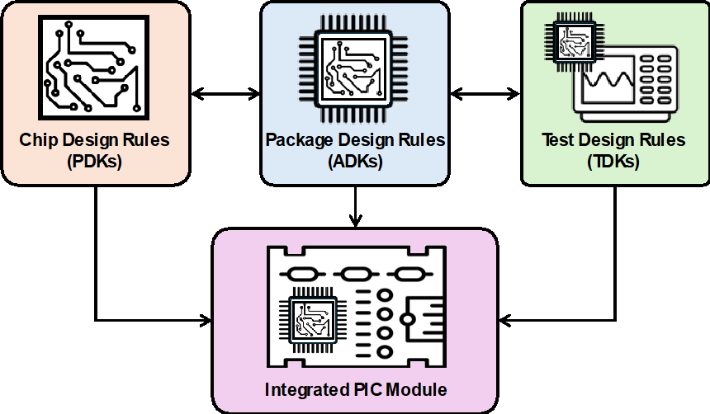

Figure 8: The development of consistent PIC design standards across the entire supply chain is critical in ensuring efficient Pilot Line operation. PIXEurope will develop integrated PDKs, ADKs and TDKs, enabling the development of highly complex PIC-based modules for a wide range of applications.

Furthermore, we plan to disseminate details about standardised Design Kits to industry, ensuring their PIC manufacturing processes and technologies are compatible with those of PIXEurope. We will achieve this by giving regular training courses, workshops, and open-day events. This approach will enable the efficient transfer of new and established Pilot Line processes to industry partners for scale-up to volume manufacturing. Fortunately, the PIXEurope consortium can draw on best practices from PIXAPP and JePPIX Pilot Lines, which previously developed similar design rule standards. PIXEurope will extend this capability to merge the ecosystem, addressing the complete PIC development and supply chain. Work packages 5-8 will focus on technology development across the full supply chain and the generation of design rules for these technologies. Work package 4 will gather the design rules from each technology work package and prepare formalised Design Kits. This will be achieved through close collaboration with the Design Platform to be established under the Chips JU initiative, creating new software tools containing PIXEurope's essential design rules. The Pilot Line will operate on the principle of Open Access, where European companies and research organisations will have unfettered access to critical project results. The design rules and Design Kits are critical project results and will be made available digitally through online documentation and software tools. This includes software design tools used for PIC chip layout and Graphic Data Structure (GDS) file creation.
Pilot Line Gateway
PIXEurope’s model for coordinating and managing the distributed Pilot Line is based on a centralised Gateway, see Figure 9. The Pilot Line Gateway will be managed by PIXEurope’s coordinator, ICFO, and staffed by experienced personnel with skills in PIC technologies, project management, and business administration. ICFO is well positioned for this role; it has an excellent track record of managing large- scale projects with many partners distributed across Europe. ICFO also has a track record of collaborating with industry and spinning out many successful photonics companies. The Gateway staff at ICFO will include a Technology and Operation Manager and an Administrative Executive, reporting directly to the project coordinator and supported by a team of skilled personnel, including 1) Technical experts to review incoming user requests, 2) Project Management experts to organise efficient scheduling between partners in the Pilot Line supply chain, ensuring timely delivery of PIC chips, packages etc. and 3) Administrative personnel to manage user enquires, quotes, invoices, etc. Additionally, partners leading activities in the core technologies (WP4-8-HE leaders) will appoint a manager at their facility who will collaborate directly with the ICFO Gateway. In particular, TNI will appoint an Interoperability and Training Manager while TU/e an Open Access Manager. The Pilot Line Coordination and Management, described in detail in Annex 1, Section 3, will ensure efficient information sharing between the partners during and after the Grant period (e.g. reviewing, preparing and monitoring new end-user projects during the operational and sustainability
phases).

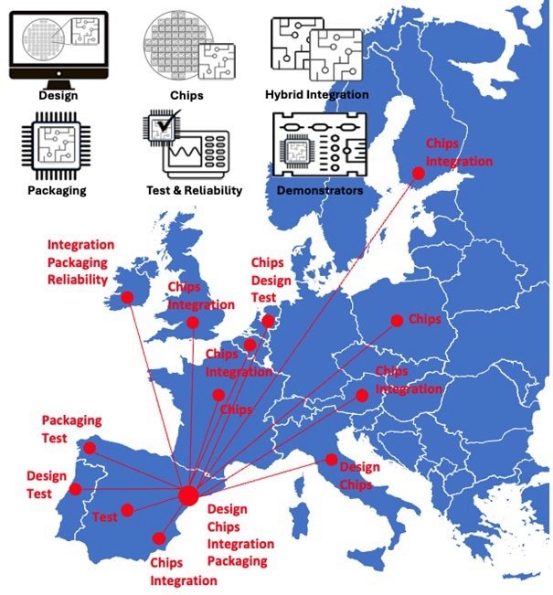
Figure 9: PIXEurope will operate as a distributed Pilot Line with a centralised Gateway managed by Pilot Line coordinator, ICFO. Partners leading activities in the core technologies (WP4-8-HE leaders) will appoint a manager at their facility who will collaborate directly with the Gateway. The map highlights the distribution of key technologies across the Pilot Line.

WP3 will focus on establishing and optimising the operation and interoperability of the distributed Pilot Line and will be strongly linked with WP9-HE, using the demonstrators to be developed between the partners in WP9-HE to evaluate and optimise overall operational efficiency. WP2-HE will focus on creating a business model for the Pilot Line, addressing economic sustainability after the Grant period concludes. Figure 10 shows a schematic of a potential operational model post-project, where the Pilot Line collaborates directly with European industrial partners to support the transition to volume production. This model is based on the invaluable experience of operating the JePPIX and PIXAPP Pilot Lines, which have worked well. Training courses developed within the Pilot Line will also enable future users to understand what services are available and how to access them.

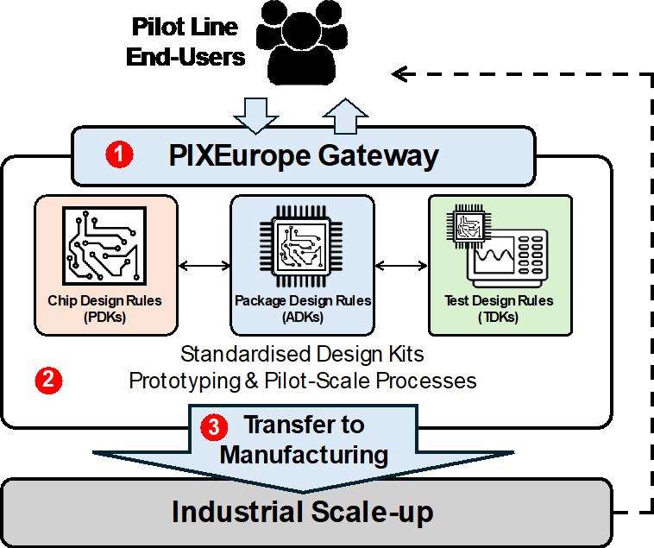
Figure 10: Model of Pilot Line operations post-project. Users will have access to validated and standardised PDKs, ADKs, and TDKs covering all processes and technologies available within the Pilot Line. The Gateway will be the single point of contact for users and will be managed by the project coordinator, ICFO. The Pilot Line takes responsibility for initial process development and prototyping, and process scaling will be achieved through technology transfer to our European industry partners.

Design Kits are an essential tool to manage the development of complex semiconductor devices. They support the development of standardised designs using mature and well-documented fabrication processes. When used correctly, Design Kits give users confidence that their designs will work according to plan. Design Kits are commonplace in electronics but to a lesser degree in photonics. However, over the past decade, photonic foundries have developed sophisticated fabrication processes and offered a wide range of component technologies that can be integrated into a single chip. To avoid costly mistakes when using these complex processes and simplify the design process, foundries have started to develop Process Design Kits (PDKs) accessible using software design or layout tools from vendors including Synopsys, Luceda Photonics and Cadence. Using PDKs for PIC chip design is essential if users want to use the mature processes offered by these foundries. However, the design environment is still fragmented, as a standardised design approach in packaging and test is still not well-aligned with chip design. Packaging or Assembly and Test Design Kits, ADKs and TDKs, respectively, must be developed to be fully compatible with PDKs. This unified approach enables users to design their complete modules, from chip to package and test, within a single standardised design environment.
PIXEurope will establish the first fully Open-Access Pilot Line PIC service, from chip to packaging and test, across a wide variety of photonic materials and operating wavelengths. Crucially, PIXEurope will develop compatible Design Kits for all stages of the design process. This important design innovation can only be achieved in an environment encompassing all stages of PIC development, from chip to packaging and test. The first stage in developing Design Kits is to generate design rules for each process step. These design rules ensure essential features such as the optimum layout of waveguides or electrical bondpads so they can be packaged later in the manufacturing process. The next step involves formulating these design rules into a design file, which can be implemented in software layout tools. The design tool can also perform Design Rule Checking (DRC) to ensure all design rules are respected.

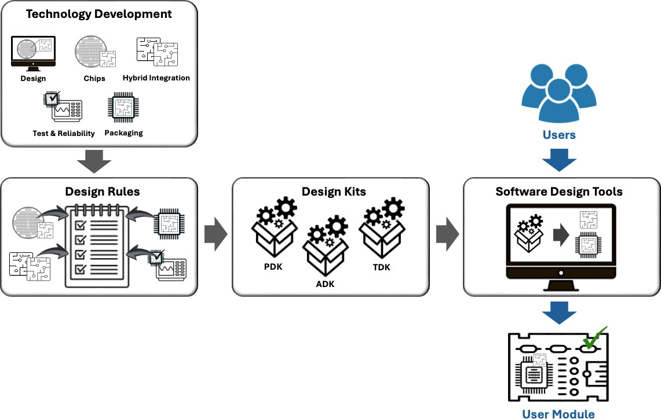
Figure 11: Schematic showing the development cycle of creating Design Kits (PDKs, ADKs, TDKs) and how users will access PIXEurope’s services, including MPW services, using standardised Design Kits available using the latest software design tools.

PIXEurope will collaborate with the new European Design Platform to formulate these Design Kits (PDKs, ADKs, and TDKs) and transfer them to the software tools in collaboration with the software providers. The Design Kits will be a key project result. They will be how users access and use the MPW services. The Design Kits will be updated as new processes and technologies are developed or existing processes are refined.

1.3.4 PIXEurope Services (MPWs, dedicated services, process and transfer to industry for scale-up to production)

PIXEurope offers a unique service covering the complete technology supply chain, from design and chip fabrication to hybrid integration, packaging, test and reliability. All these technologies will be available through PIXEurope’s centralised Gateway, managed by the project coordinator, ICFO. Two principal user engagement approaches for these services are foreseen: 1) PIXEurope’s standardised MPW services run on scheduled dates during the year, and 2) Dedicated one-to-one engagements addressing unique or custom user needs, see Figure 12.
The standardised MPW services follow PIXEurope’s standardised designs and processes, and users can access them via standardised Design Kits (PDKs, ADKs, and TDKs). A unique feature of PIXEurope’s MPW services is the ability of users to develop full solutions, from chip to package, test and reliability analysis. Alternatively, users can engage directly with the Pilot Line to address unique needs, such as specialised chip designs or packaging requirements, beyond the standard MPW services. This can also include equipment access. For example, to evaluate the viability of a new PIC manufacturing process they wish to implement. Following successful outcomes from these initial engagements, users can proceed to work with the Pilot Line to investigate early-stage process scaling projects. This service will evaluate important factors such as product manufacturability and equipment suitability for production, analyse process yield, and cost modelling analysis. Following these process scaling projects, users will proceed to full-scale manufacturing with PIXEurope’s industry partners, freeing PIXEurope to continue working with new users and to fill the innovation pipeline. Critically, PIXEurope will endeavour to transition user engagements to industry partners as soon as these partners are ready to support them. PIXEurope will support users where the technical risk is too high or the technical capabilities do not exist with industry partners. Additionally, PIXEurope will collaborate with its industry partners to support them in developing new capabilities demanded by users, and which will present new business opportunities to these partners.

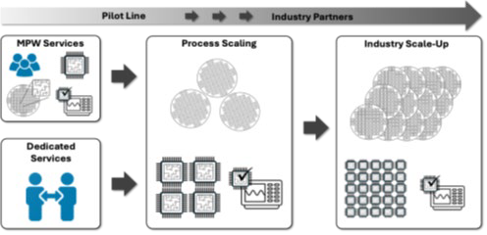
Figure 12: Users can initially engage with PIXEurope by accessing its standard MPW services, including chips, integration, packaging and test prototyping services. Alternatively, they can engage in dedicated one-to-one projects. Following these initial engagements and successful outcomes, users can proceed to process scaling projects focusing on early-stage scale-up to evaluate critical process parameters such as process manufacturability, yield and cost. Users can then proceed to industrial scale-up by engaging with PIXEurope’s industry partners, freeing the Pilot Line to continue to fill the innovation pipeline.

PIXEurope will offer a wide range of MPW services, as outlined in Table 3. This includes 23 monolithic PIC MPW, 10 Hybrid Integration, 6 Packaging, 40 Test and 20 Reliability services runs. All these services will be compatible with PIXEurope’s standardised Design Kits (PDKs, ADKs, TDKs), and users will access these services via the Design Kits. During the project Development Phase, the demonstrators developed in WP9-HE will validate the full range of PIC technologies and operation of the Pilot Line (e.g. inter-operation between partners). These demonstrators will be designed using the Design Kits. Hence, the demonstrators will be invaluable in validating the usability of the design kit. Once validated, MPW services will be made available, and users will follow the same approach used to design and produce the demonstrators, see Figure 13. These services will be centralised at PIXEurope’s Gateway office at ICFO for fast and easy access.

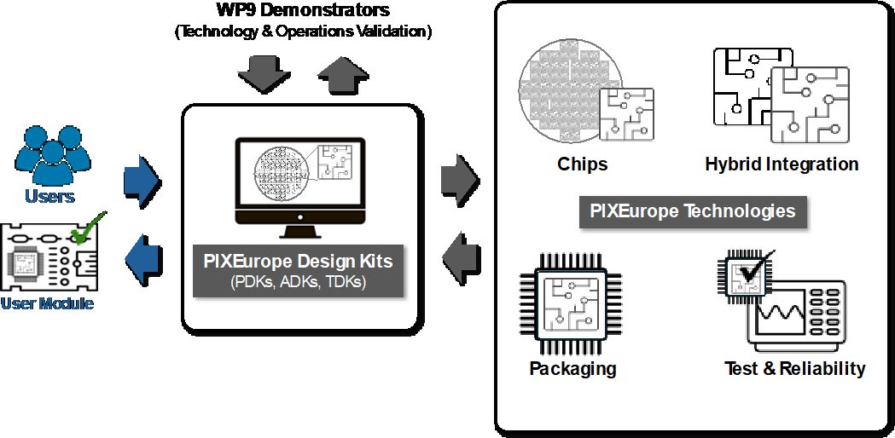

Figure 13: PIXEurope is unique as it offers the full technology supply chain, from chips and hybrid integration to packaging, test, and reliability. This provides users with a one-stop-shop for advanced PIC development and prototyping of complete module/product solutions. Users access the Open Access MPW services via PIXEurope’s standardised Design Kits (PDKs, ADKs, TDKs).

Technology | MPW Service Details | Release Date
InP | InP PICs: Lasers, Amplifiers, Modulators, Passives Full standardised PDK linked to MPW runs  (4 MPW runs per year) | Month 48
SOI | Thick SOI PICs: Passive and active 3 µm SOI PICs for NIR with Ge photodetectors on 200 mm wafers Full standardised PDK linked to MPW runs  (4 MPW run per year)  Thin SOI: 220 nm SOI process iSiPP300 for NIR with scaled micro-bumps on 300 mm wafers  Full standardised PDK linked to MPW runs (1 MPW run per year) | Month 30  Month 39
SiC | SiC on insulator PICs for VIS-NIR and SiC membrane for NIR-MIR  Full standardised PDK linked to MPW runs  (2 MPW run per year for VIS-NIR/1 and NIR-MIR/1) | Month 30
SiN | SiN PICs on 150, 200 and 300 mm wafers for VIS and NIR with modulators and other new functionalities  Full standardised PDK linked to MPW runs (6 MPW run per year for NIR/4 and visible/2) | Month 30
AlO | AlO PICs on 200 mm wafers  Full standardised PDK linked to MPW runs (2 MPW run per year) | Month 33
Ge-on-Si | Ge-on-Si PICs for MIR on 150 mm wafers Full standardised PDK linked to MPW runs (2 MPW run per year) | Month 24
Hybrid Integration | InP on Thin SOI (2 MPW runs per year) InP on Thick SOI (2 MPW runs per year) InP on SiN (3 MPW runs per year)  New Materials Integration:  TFLN on Si/SiN (1 MPW run per year) Graphene on Si/SiN (1 MPW run per year) CQD on Si/SiN (1 MPW run per year) | Month 48
Packaging | Standardised photonic packages with fibre and electrical interconnect (3 packaging runs per year)  Standardised PIC and EIC on interposer with  pluggable micro-optics connector (3 packaging runs per year) | Month 36  Month 56
Test | Electro-optical, Optical, DC, RF (+50GHz) tests Chip-Level, Sub-Assembly, Package-Level Synchronised with the PIXEurope’s chip MPW runs Design flows for test (DfT)  Standardised TDKs compatible with PIXEurope PDK & ADK  40 test services per year | Month 36
Reliability | Package and sub-system reliability analysis  Burn-in/accelerated aging, vibration, thermal shock, humidity  20 reliability analysis services per year | Month 36

Table 3: Summary of MPW services provided by PIXEurope across all PIC technologies. These services include 23 PIC and 10 Hybrid Integration MPW runs, 6 Packaging, 40 Test, and 20 Reliability service runs. All these services will be compatible with PIXEurope’s standardised Design Kits (PDKs, ADKs, TDKs), enabling users to easily design their PICs from chip to package and test.

Cost Modelling
It is highly beneficial for companies to estimate the cost implications of adopting new technologies, especially while these technologies are still in the early stages of development. If available, companies
can use product cost information to assess potential future costs and revenues for new products. This

information can support critical decision-making regarding which products are worth pursuing and which manufacturing processes are the most profitable. However, estimating costs at an early stage of product development is challenging, and process choices can often be determined on a trial-and-error basis. Process-Based Cost Modelling was developed especially for process production technologies, serving as a method for estimating the economics of emerging manufacturing processes without the prohibitive economic burdens of trial-and-error innovation [Fuchs, JLT, Vol 24, No 8, 2006]. Developing accurate Process-Based Cost Models requires generating significant amounts of process information or data. This data is used to refine the model's ability to predict different process production scenarios. Unfortunately, many companies cannot access this information, especially smaller companies (e.g. SMEs or startups) that may have limited production volumes or low-volume early-stage prototypes. However, the process and technology choices they make in the early stages of product development may be critical to their long- term business success. A Pilot Line provides a unique opportunity to collect large amounts of process data and develop accurate Process-Based Cost Models. Additionally, these models can be adopted to address a complete manufacturing ecosystem if the Pilot Line operates across a broad technology supply chain. These models would be of great benefit to companies that use the Pilot Line services, especially smaller companies. They would also benefit the Pilot Line by providing vital information to adopt and optimise processes for greater efficiency and cost savings.

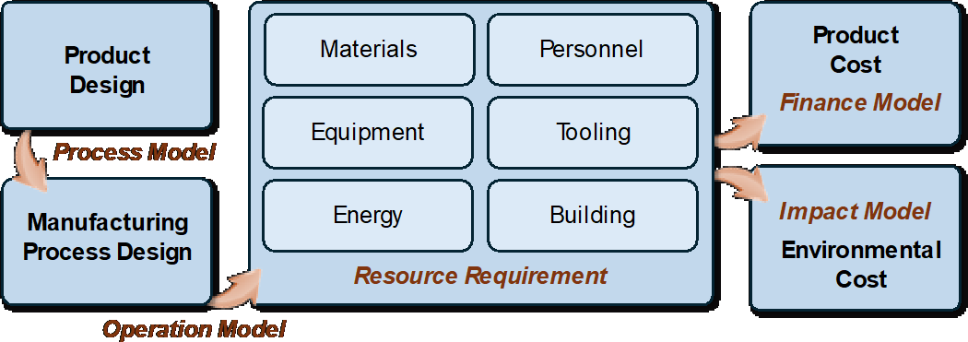

Figure 14: A Pilot Line provides a unique opportunity to collect large amounts of process data and develop accurate Process-Based Cost Models. Cost model information can support critical decision-making regarding which products are worth pursuing and which manufacturing processes are the most profitable.
In PIXEurope, we plan to use process information generated across the entire technology chain (chip fabrication, integration and packaging, test and reliability) to develop Process-Based Cost Models. To begin with, we will gather data from the processes used to develop the project demonstrators (WP9-HE) to build the first iteration of a cost model. Critical process input parameters, including materials, process yield, personnel costs, energy usage, equipment, and building costs, will be accounted for in the model. The models can also be developed to provide environmental impact information, leading to better decisions regarding sustainability and product life cycle analysis (from materials generation to final product disposal, recycling and reuse). Developing a better understanding of the impact of product and manufacturing processes on the environment is becoming an essential part of product development. A Pilot Line can support companies in addressing this challenge, helping to ensure their products are designed for future regulatory compliance and standards. The initial objective is to prepare a project demonstrator exemplar cost model that will be delivered as part of PIXEurope’s training courses on PIC manufacturing (WP3). Following the successful development and evaluation of a cost model using the demonstrator test cases, a second objective is to make the model available to companies who wish to evaluate the Pilot Line processes regarding its technological and economic offering. This cost modelling capability is expected to develop over time, improving in accuracy as more data is generated through additional Pilot Line test runs. We have reached out to other Pilot Lines, including the Heterogeneous Integration Pilot Line (CPL-3 coordinated by Fraunhofer-IZM), and we have agreed to collaborate on this important topic, sharing experiences and collaborating to develop these invaluable decision-making tools.

1.3.5 Open Access and Conditions

Europe has led in Open Access photonics, pioneering the foundry model with the ePIXnet program in the early 2000s, resulting in platforms like JePPIX and ePIXfab for indium phosphide and silicon photonic circuits. However, Europe risks falling behind as North America and Asia strengthen their photonic innovation capacity, despite Europe’s technological edge. Europe's Open Access remains fragmented and lacks critical mass. To address this, a workplan is in place to:
- Build a technology pipeline linking R&D to industry
- Develop IP strategies for smoother European innovation
- Enhance workforce skills for broader industry engagement

Region | Initiative | Scope of activities
Europe | Manufacturing Pilot Lines for Photonics [Photonics21] | Individual platforms established and consolidated
Europe | PhotonHUB Phactory | Open access and guided orientation to established photonic technologies
North America | American Institute of Manufacturing: Photonics | Silicon photonics R&D and scale-up
North America | Canadian Photonics Fabrication Centre | InP R&D, new product introduction and volume manufacturing
Asia | Singapore Institute for Microelectronics | Innovation accelerator for Semicon; Talent development and R&D on industry-grade tools

- Foster cross-technology innovation
- Improve technology transfer with clear models for European innovators

Global Positioning
North America and Asia have consolidated around key initiatives in Canada, the US, and Singapore, supported by commercial suppliers like Global Foundries and TSMC. Europe’s diverse platforms, showcased by ten pilot lines listed by Photonics21, highlight both its strength in variety and its weakness in fragmentation, leading to reduced visibility and impact. The prominent Open Access initiatives are summarised in Table 4.
Table 4: Globally prominent Open Access research, development and innovation facilities. Europe has built inspiring individual Pilot Line capabilities. Asia and North America are creating industry-facing multi- platforms.

European initiatives have created a comprehensive range of services for new businesses and academic researchers, allowing innovators from various fields to utilize PIC technologies. Key focus areas include designer training, technology access, business coaching, regional support, ecosystem development and access to finance.

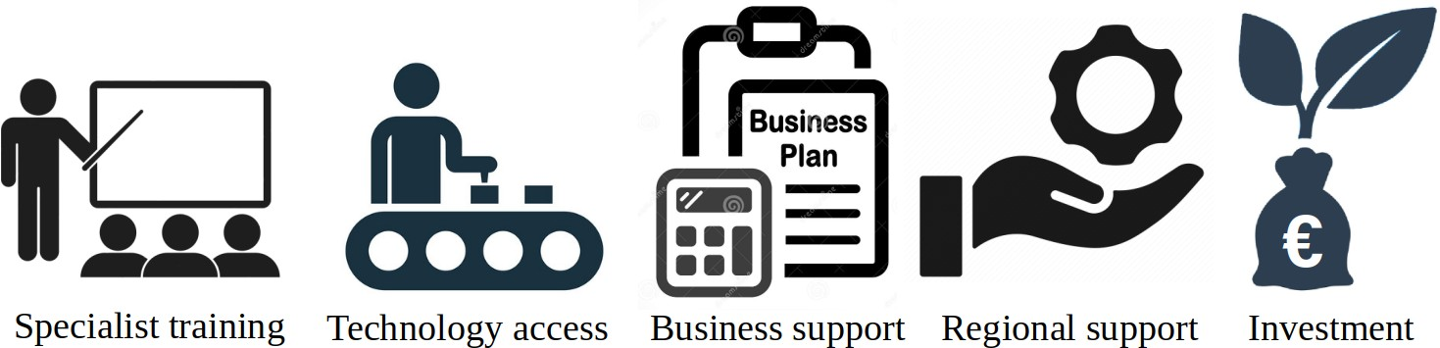
Figure 15: State of the art instruments used for Open Access
- Training focuses on deep-tech design, with over 100 participants annually in ePIXfab and JePPIX courses for photonic circuits, and PIXAPP offering hands-on equipment training.
- Technology access is provided by JePPIX and Europractice, with hundreds of designs annually in InP, SiN, and SiPho technologies, involving both industry and academic collaboration.
- Business support from PhotonHub Europe helps companies navigate market entry.
- Regional support is driven by programs like PhotonHub Europe and PhotonDelta.
- Investment is facilitated by InvestNL, PhotonVentures, and TechTour, targeting photonics SMEs.
These initiatives have fostered a dynamic ecosystem of businesses, but challenges remain in bridging the gap between research and industrialization, requiring further deep-tech support as shown schematically in the following Figure 16:

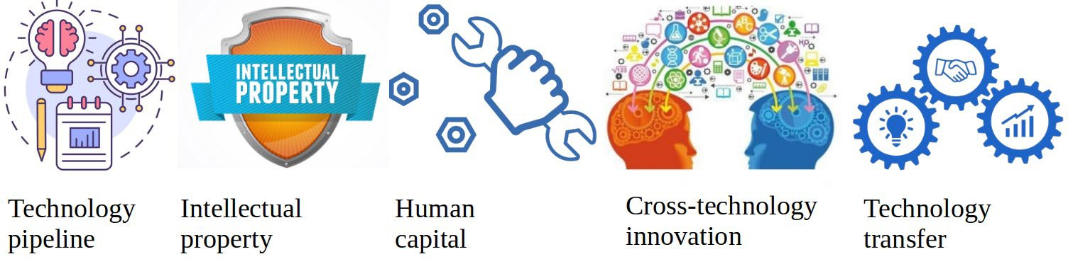
Figure 16: Open access innovations in PIXEurope to accelerate end user driven innovation
Technology pipeline of distributed Pilot Line
Managing the distributed elements of the Pilot Line for European PICs requires proactive coordination, enabling it to function as a single virtual RTO. Standardized Design Kits and design flows simplify technology access, supported by common operational methods for low-barrier services. A digital platform will manage technical workflows and provide real-time updates for non-technical communications. Suppliers and designers will co-develop platform extensions to improve the customer journey, with clear partner roles and responsibilities defined at the workflow level.
Table 5 outlines key non-technical support, with timelines for actions within workflows and operational protocols to ensure timely execution. These methods, trialled for Monolithic InP Design Kits in JePPIX MPW services, will now be streamlined for all Design Kits. The growing number of stakeholders—sales teams, legal services, procurement, quality managers, designers, and service providers—highlights the need for timely, accurate data. Communication delays were a major challenge before the digital platform's introduction in the JePPIX Pilot Line.
Table 5: Milestones to be introduced to the operational workflow in the digital platform
 | Timeline | Milestone | Implementation
 | Service available | Legal workflow defined | Service providers have an agreed workflow for tax, export and IP management
 | Service available | Service definition | Pricing plan, and Design Kit available with publicly available terms and conditions
 | Service available | Terms and conditions | A legal service agreement that is defined by the service provider with a project-aligned format
 | Work-order acceptance | End user statement | Assessment against dual-use criteria, recognising that Horizon Europe does not support military technology development
 | Work-order acceptance | Export checks | Export control checks for all classes of released IP and services.
 | Work-order acceptance | Terms sheet agreed | Pre-defined terms and conditions, inclusive any non- disclosure terms.
 | Work-order acceptance | Critical-to-quality parameters | Applicable for Design Kits at TRL5 and above: Agreement on critical parameter targets (not yield)
 | Work-order acceptance | Publication permissions | Acknowledgement terms, and agreements for end-user interviews and public advocacy
 | Tape-out | Account manager assigned | One Account Manager assigned as first point of contact for technical and operational workflow
 | Tape-out | Service team assigned | Service manager from each partner providing a service is named and known to end-user
 | Tape-out | Analysis support | Partner composition of root cause analysis team known in the event that a deep dive is required

 | After completion of design cycle | End user satisfaction interview | Formal questionnaire on operational and technical satisfaction with open-ended tops and tips request
 | After completion of design cycle | Showcasing | Support with publicizing high impact developments in appropriate forums
The Gateway serves as the first point of access for new users, managing customer relationships and assigning mentors and Account Managers to guide workflow setup. It will actively engage new users through technology transfer strategies. Workflows are overseen by the Open Access Manager, who monitors key performance metrics and tracks operational milestones. The digital platform will include performance monitoring and feedback mechanisms to enhance workflow efficiency and designer satisfaction. Operational milestones as per the Table 5 will be recorded to monitor efficiencies and areas for improvement with regards to end user support.
Account Managers ensure smooth workflow progress, supported by real-time updates via the digital platform. Service Managers at each partner are responsible for design updates and reports. Regular internal training will foster a unified approach and upskill teams for multi-technology projects. The platform also provides detailed descriptions of available services and contact points.
Intellectual property
The management of Open Access intellectual property (IP) focuses on creating exploitable IP packages that benefit Europe's SMEs and researchers. This involves five key approaches:
- Grouping background IP: Bringing together IP from multiple partners using Design Kits.
- Creating common foreground IP: Developing shared IP through open innovation programs.
- Transferring IP or rights: Facilitating the transfer of IP to a single organization.
- Building on Design Kits: Developing new IP like compact models and hybrid platforms based on existing Design Kits.
- Optimizing IP for SMEs: Ensuring IP formats are tailored to the needs of European SMEs.
These approaches will be coordinated with business developers and innovation officers from different RTOs, coordinated by the Pilot Line Exploitation and Innovation Manager, to ensure consistency and support exploitation objectives.
Grouping background IP from multiple partners helps simplify IP management and is central to the Design Kit approach. In addition to technical alignment, legal agreements will standardize non-disclosure and rights-of-use, aiming to create a unified multi-party agreement. This will ensure clear terms for accessing and using the IP, including pathways for its commercial use.
Common foreground IP allows RTOs to pool their expertise and create valuable shared IP that can be used by a broad range of European businesses. This model, successfully implemented by partners like IMEC and TNO, encourages collaboration without granting exclusivity. For example, the Photonic Integration Technology Centre brings together expertise from various institutions, showing how pooled IP can accelerate technology development across platforms.
The transfer of IP or rights will follow a clear framework to align with the Pilot Line’s goal of strengthening Europe’s photonics ecosystem. While the decision to exploit IP rests with the RTOs, any transfers to third parties must benefit European interests, such as by encouraging investment. Non-exclusive rights will be the default approach, with exceptions justified and reported.
For infrastructure procurements made during the setup of the Pilot Line, co-ownership will be maintained for a defined period, with regular reporting on their usage. These tools will be accessible under Open Access terms for the duration of the Pilot Line, ensuring that they remain available for use by qualified end users.
Built-upon IP refers to new IP, such as compact models and hybrid Design Kits, developed from existing Design Kits. This IP needs to be closely integrated with continually evolving platforms to retain value. Agreements will be established to ensure streamlined maintenance and updates to built-upon IP, including notifications of Design Kit updates and revalidation procedures. This will support cross-platform IP development, accelerating design, scaling, and integration with complementary technologies like semiconductors.
The consortium will stay informed on European Commission IP regulations and protect valuable foreground IP, offering licenses to third parties that comply with the project’s requirements under the Chips JU framework.
Human capital
Building human capital for the Open Access innovation model requires a cohesive approach to workforce upskilling, community engagement, and advocacy within the photonics and Semicon sectors. Currently,

PIC training is disconnected from mainstream Semicon, and there are too few skilled professionals to meet industry demand.
Combining training efforts will broaden skill sets and allow courses to scale, but this requires collaboration between training sites. Currently, different photonics platforms, such as JePPIX (InP) and ePIXfab (silicon photonics), operate separately, leading to fragmented training and conferences that often pit technologies against each other. PIXEurope aims to shift this narrative by fostering collaboration and complementarity across platforms, sharing training materials to ensure consistency across the community.
- Promote synergies between technologies.
- Hold workshops and forums to unite innovators.
- Share training materials with other European programs.

As mentioned earlier, semicon and photonics are often seen as separate fields due to differences in scale and materials, but roadmaps like the Heterogeneous Integration Roadmap (coordinated by IEEE, backed by SEMI consortium, https://eps.ieee.org/technology/heterogeneous-integration-roadmap.html) and Integrated Photonic Systems Roadmap show convergence is necessary. Some standardization efforts, such as JePPIX's biannual roadmap, IEEE standards for electronic-photonic design automation, help build trust and visibility within the broader Semicon community.
- Engage proactively in roadmapping for visibility and trust.
- Participate in standards development for Semicon design automation.
- Outreach to Semicon designers through Chips JU programs.
The photonics community's limited scale has hindered engagement with the larger, skilled Semicon industry, mainly due to higher costs and smaller manufacturing scale. Figure 17 below identifies the cost- throughput relations for advanced PIC processes at common PIC wafer sizes. Increasing PIC wafer sizes in the technical workplan will reduce costs by processing more area per batch and improving yield with advanced tools. The challenge is to ensure operational workflows support cost reductions and yield improvements for any production volume.
Stable Design Kits will lower costs for small production runs, ensuring consistent quality and reliability across scales. Clear road-mapping will build confidence in future capabilities, while automated Known- Good-Die selection will reduce costs after singulation for testing and packaging.

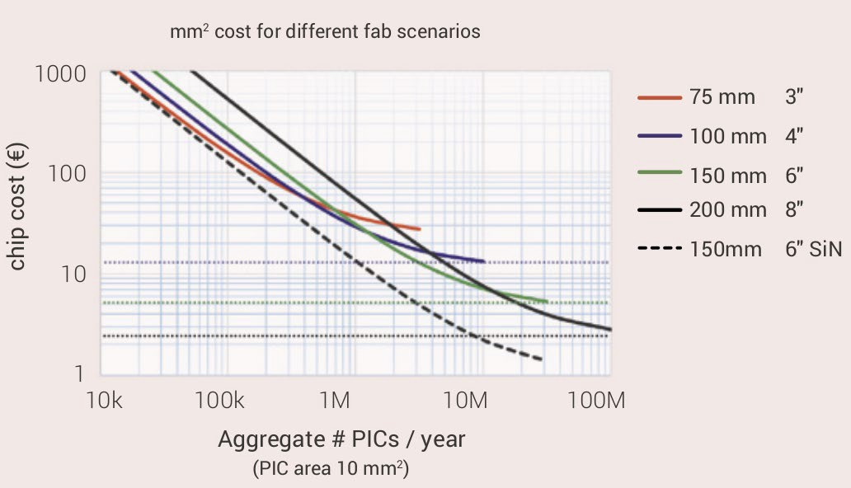
Figure 17: Cost downs achievable with generic foundry processes and wafer size scaling [JePPIX roadmap]
Volume production and also peaks in demand for small series production will require extended capacity. End-users will also need to be confident that production can scale when needed. The consortium will partner with external RTOs and industry to facilitate interoperable workflows, allowing designs to be ported across platforms when required. Open standards for the project Design Kits will streamline this process. This is particularly important for the process steps after singulation such as packaging and functional testing. Noting that high-volume fabs are not able to support low-volume requests, the consortium will develop programs to hothouse promising developments for onward transfer to European-based production facilities at e.g. Lumentum (UK), Xfab (FR), Coherent (DE) and ST (FR) when needed.
- Roadmap to enable the wider Semicon community to invest in skills
- White papers on route to market for small and large series production
- Strategic partnerships with European-based production for visibility on scale-up.

Cross-technology innovation

Technology to be transferred | Process for transfer
Scientific breakthroughs | Consortium approves for release as per Consortium Agreement; All data in public domain
Open standards contributions
Design Kits | Request on behalf of a specific entity is evaluated and registered by the Gateway following the Eligibility Protocol
Open services
Open infrastructure
Open innovation programs
Transfer and licensing of intellectual property | Intellectual property protocols elaborated for spin-offs and also to established European businesses
Economic activity reporting | Detailed revenue reporting per partner

Measures are being taken to standardize formats for open infrastructure, services, and innovation to promote cross-platform and interdisciplinary research, enabling efficient co-design. Open infrastructure models, both at local and regional levels exist but are fragmented across photonics platforms. Training requirements vary, and access to tools is inconsistent. To address this, a unified language around infrastructure capabilities, terms, and conditions will be created, with common documentation and accessibility guidelines for all Chips JU-funded infrastructure available via a digital platform. Tariffs, training, and certifications will be standardized, and PIXEurope will provide necessary skills training for researchers.
Open services will focus on multi-project services, widely adopted by developers for small-scale production. These services will use the same Design Kits for both multi-project and dedicated wafers, helping platforms mature faster. Services will also be developed for wafer batches, assembly, and testing. Test services will include deep-dive characterization and fast testing for large datasets, all detailed in the digital platform.
Open innovation models for advanced PIC technology, based on successful microelectronics models, will combine infrastructure with expert services. Partners like TNO and IMEC have established program lines with external and RTO teams to solve interdisciplinary challenges and de-risk photonics manufacturing. The Photonic Integration Technology Centre in the Netherlands is an example of fostering cross-platform innovation, focusing on scaling and industrialization. Open innovation is expected to lead to breakthroughs that smaller groups couldn't achieve alone.
The three models to be developed are expected to satisfy the full range of technologies and use cases. The key role for the Open Access activity is to elaborate the possibilities in a coherent way and to operationalise the way of working. Ambitions include.
- Documenting the scope of Open Access tools that support cross-technology innovation.
- Elaboration of showcases to accelerate this collaborative way of working.
- Articulating of the benefits of IP sharing for accelerated innovation.

Technology transfer and services
PIXEurope acknowledges that sharing information and materials with external parties is a form of technology transfer. Such exchanges may require policy checks, export controls, and economic activity assessments. To ensure the project's goal of benefiting Europe, clear guidelines and protocols will be established to facilitate fair, open, and strategic transfers to industry. The guiding principles are elaborated in Table 6 below.
Table 6: Procedures for end users to access project outputs

An eligibility protocol for end-users will be operationalised to ensure careful checks on the interest and exploitation of project output. Particular attention will be placed on current policy objectives and an alignment across the consortium on how these objectives are to be interpreted. Figure 18 captures the key steps in a sequential manner.

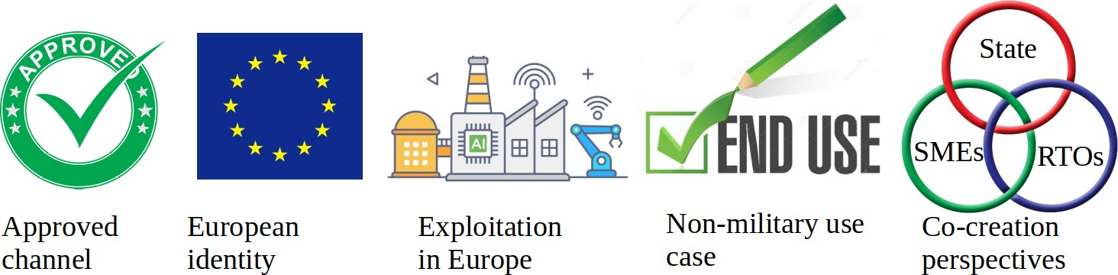
Figure 18: Steps taken to ensure a prospective end-user is eligible to benefit from the Pilot Line
European advantage will be ensured by aligning with the objectives of the Chips Joint Undertaking and relevant funding streams. A protocol will assess supported businesses and researchers against key criteria.
- Pilot Line access will include Chips JU initiatives (Competence Centres, Design Platform, Pilot Lines) and services from Horizon Europe, IPSEI, and national programs. The Pilot Line Gateway will coordinate outreach and ensure synergy between initiatives.
- The project will prioritize European stakeholders, especially SMEs and start-ups, based on Horizon eligibility principles.
- Exploitation will focus on value-added work within Europe, with IP export outside the EU minimized.
- End-user statements will be required early for eligibility and export control checks.
- The triple helix model (state, industry, research) will foster collaboration and maximize SME resources for innovation.
- Eligibility criteria will ensure the pilot line operates on the principles of Open Access, offering fair access to all European stakeholders, with a focus on SMEs and start-ups. The key principles are:
- Inclusivity: Access to facilities, resources, and expertise will be available to a broad range of users across the EU, including academia, industry, and research institutions.
- Transparency: Clear documentation of access criteria, processes, and terms will be provided to ensure users fully understand the access framework.
- Non-Discrimination: Access will be granted fairly, without preference based on location or affiliation.
The project will closely work with the Chips JU Design Platform, according to task 4.7, to integrate advanced PIC Design Kits into major photonic and Semicon software tools. The platform will handle the distribution of both open and non-disclosure-agreement Design Kits, ensuring smooth operations through standardized protocols. Accredited and versioned Design Kits will be available to approved users, who can access both baseline and enhanced versions with additional functionalities. Formalised methods are already in place for selected platforms, integrating Design Kits within software tools from Synopsis, PhotonDesign, Lumerical, VPI Systems, Luceda, Nazca Design, GDSfactory and more. Collaboration will extend across all Chips JU pilot lines to offer and use shared services and capabilities.
Revenue from project output will be recorded, tracking infrastructure usage and funding for public and private research.

- Partners separate their accounts for non-economic and economic activities and follow their national legislation and international accounting standards.

- Profits from economic (commercial) activities are reinvested in the primary activities of the research organizations.
- Open innovation will support SMEs and the research community, retaining IPR within RTOs.

- Access will be provided on market terms, granting favourable access to start-ups and SMEs.
- Multi-Project Wafer runs will offer a cost-effective prototyping route, focusing on SMEs, academics, and start-ups. Partners like CEA-LETI, IMEC, CSIC and TU/e will extend their service experiences across technology nodes of the Pilot Line. Pricing policies will favour these groups, promoting collaboration and data sharing for improved design strategies. Demonstrations will validate PIC technologies in various fields, including communication, health, and space.
Regarding the transition to manufacturing, PIXEurope will unify the technology supply chain, from design to mass production, as a virtual RTO. Strategic partnerships and collaborations will ensure scalability, forming a pan-European PIC ecosystem that connects RTOs with both small and large companies for a seamless transition from research to production.

1.3.6 Training & Skill Development

PIXEurope will develop unique and in-depth training courses specifically on PIC Manufacturing using the specialised knowledge gained in setting up and operating the Pilot Line. The courses developed will cover the key technical activities undertaken in the Pilot Line, including PIC design, fabrication, packaging, testing and reliability. This will include courses on equipment operation, especially for the transition to production. We plan to develop internal and external training courses managed in WP2 (Task 2.1) and WP3 (Task 3.1), respectively. Internal courses will be established for PIXEurope’s partners so they are fully competent in all aspects and capabilities of Pilot Line technologies besides their areas of expertise, especially for new hires of the consortium. This will ensure maximum coherence between all partners, giving a greater and unified impact. External training courses will be for industrial users, particularly European SMEs and start-ups. These courses will address the key Pilot Line technologies, including PIC design, fabrication, packaging, testing and reliability. Critically, the courses will be developed and delivered in close collaboration with the new European Competence Centres. External training courses will target engineers and company managers, providing them with unique experiences in selecting and developing advanced PIC manufacturing processes for their businesses. They will also promote the use of PIXEurope's standardised PIC technologies. The primary objective is to build Europe's future PIC manufacturing workforce. We plan to develop online and hands-on courses, see Figure 19. This includes introductory courses on PIC manufacturing, targeting new PIC users such as entrepreneurs, and encouraging them to consider the many benefits of PIC technologies and how they can achieve sustainable routes to manufacture in Europe. The consortium’s partners bring considerable training and education experience to the PIXEurope Pilot Line, with expertise in developing and delivering training courses across all areas of PIC technologies. They are leading partners in flagship European PIC training initiatives such as PhotonHub Europe and ePIXfab. They also have significant experience organising workshops at leading international conferences and exhibits such as ECOC, ECIO, PIC International, OFC, and Photonics West.

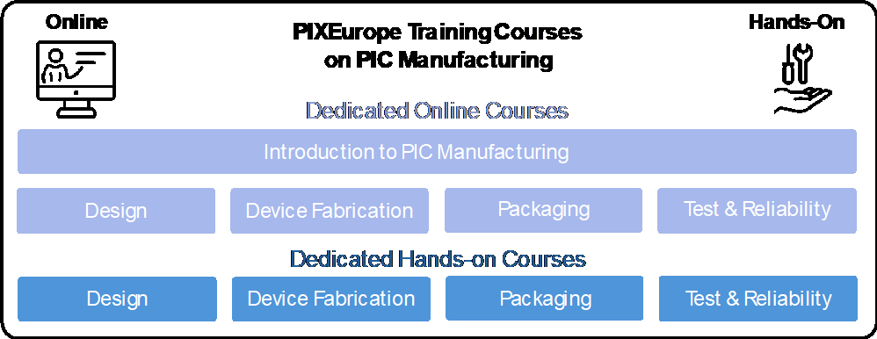
Figure 19: PIXEurope will develop specific training courses on PIC Manufacturing using the specialised knowledge gained in setting up and operating the Pilot Line. Both online and hands-on course will be developed and delivered in collaboration with the European Competence Centres to internal (within the consortium) and external end-users.
We also plan to give practical hands-on training located at partner sites. This includes training on key Pilot Line equipment, ensuring participants are given the essential experiences to make informed decisions on their options for future manufacturing processes and large-scale equipment investments. The consortium has unique experience developing both online and hands-on courses. For example, hands-on courses taking 3-4 days, where attendees gain practical experience on advanced PIC manufacturing equipment, see Figure 20. The structure of these courses will enable attendees to first engage online and then transition, making a greater commitment to hands-on training at a PIXEurope partner site. A key metric for the Pilot Line will be to measure the successful transition of attendees from online to hands-on training, as this provides a strong indication of user commitment. This approach to training complements other leading European training initiatives such as PhotonHub Europe, JePPIX and PIXAPP, which provide training courses on photonics technologies and innovation but are not dedicated providers of training in advanced PIC manufacturing and capacity building across a unified and fully standardised European PIC supply chain (i.e. PIC design, fabrication, testing and reliability). We also plan to link to third-party training courses, especially those provided by European industry, such as equipment training using digital twins. We have already engaged with several equipment companies interested in this collaborative approach as it brings considerable benefits to both parties and deepens the training experiences of Pilot Line users. We also plan to link with European academic programmes, starting with consortium partner academic programmes. This includes Master's and PhD students to support the upskilling of the next generation of PIC technologists and entrepreneurs.

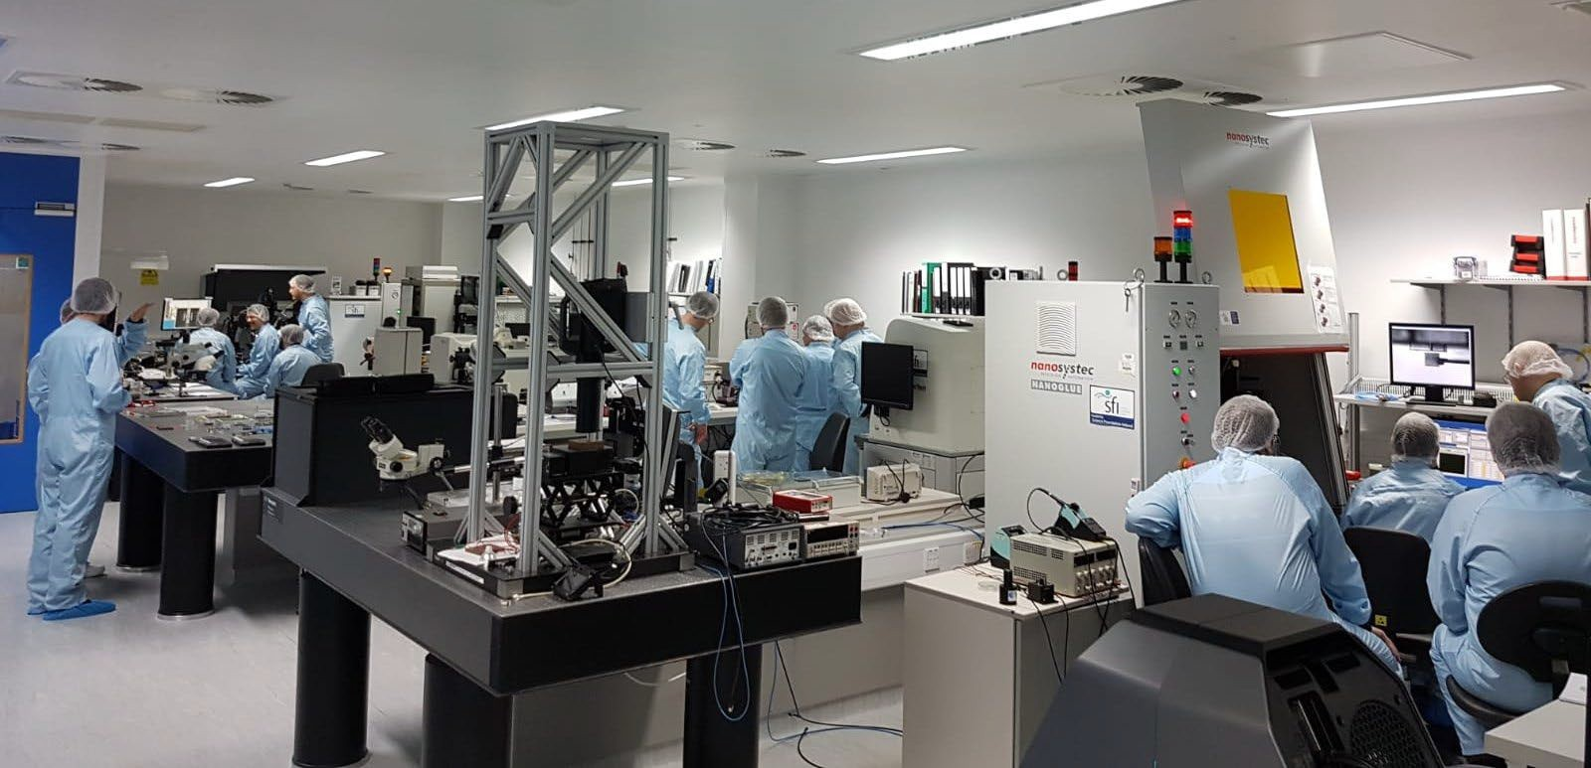
Figure 20: We will develop practical hands-on training courses, consisting of 3-4 days visits to PIXEurope partner sites. Course attendees will gain valuable experience in advanced PIC manufacturing processes and equipment usage. The PIXEurope consortium has unique expertise in developing these immersive, hands-on courses (image shows TNI packaging training course).
We first plan to develop internal training courses for PIXEurope partners during the project's second year and are ready to start during the third year. The external training courses, in collaboration with the European Competence Centres, will be organised during the project's third year when substantial Pilot Line course material becomes available and ready to deliver these courses at the end of the same year. Exact scheduling details will be defined during the project's first year when the Competence Centres will be established, and to this end, there is a dedicated task in WP2-HE (Task 2.5).
Table 7: The table below summarises the training courses in advanced PIC manufacturing to be offered by PIXEurope when the Pilot Line is fully established and operational (Month 54).
 | PIXEurope Training Course | Training Course Details | Training Course Schedule & Number of Attendees
 | Online Training | 3-Hour Online Course  - Introduction to PIC & PIC Manufacturing  - PIC Design & Design Kits  - PIC Fabrication  - PIC Integration  - PIC Packaging  - PIC Test & Reliability  - PIC Applications & Demonstrators | 7 technology areas  (4 courses per technology area per year)  28 online courses per year  20 attendees per online session  560 attendees per year
 | Hands-On Training | 3-Day On-Site Pilot Line Course  - PIC Design & Design Kits  - PIC Fabrication  - PIC Integration  - PIC Packaging  - PIC Test & Reliability  - PIC Applications & Demonstrators | 6 technology areas  (3 courses per technology area) 18 hands-on courses per year 10 attendees per course  180 attendees per year
 | Specialised Training | Dedicated On-Site Pilot Line Course  Addressing the specific needs to individual companies with live demonstration of PIC manufacturing processes, equipment and demonstrator technologies | 5 key technology sites (fabrication, integration, packaging, test & reliability, applications & demonstrators)  2 visits per month per technology  24 visits per year per technology site  Average of 2 attendees per site visit  120 total site visits per year  240 attendees per year
 | PIXEurope Training Course Summary | 46 training courses per year (online, hands-on) 120 dedicated site visits per year  560 attendees for online courses

180 attendees for hands-on courses 240 attendees for dedicated visits
Total of 980 attendees on training courses per year

  - Financial obstacles

Financial obstacles
Describe to what extent the project can overcome financial obstacles such as the lack of market finance. This criterion might not be applicable to all topics — for details refer to the Call document.
PIXEurope’s related technology market is widening and the underlying platforms are becoming increasingly strategic. On the one hand, there is the need to meet new market demands, for example, an ever-increasing transfer data rate in data centres and worldwide internet, while, on the other hand, the pressure of energy saving and low cost.
Table 8 Potential financial obstacles
 | Potential barrier | PIXEurope’s contribution to mitigation and countermeasures
 | Starting TRL too low to achieve the Pilot Line goal (TRL 6). | Demonstration in the field of PICs technologies has been taking place and is steadily growing. PIXEurope is proposing a wide variety of PIC technologies at different starting TRL. With a proper market pull, the Pilot Line will promote engineering work to increase their maturity level and scalability toward mass- production. The effort on demonstrators will be essential in assessing technology readiness levels.  The project is defining the workflow for bringing any technology from TRL2-3 to TRL6. While the speed at which the stage gates are achieved will depend to some extent on market engagement, the methods will streamline the process. The key point is to formalise and accelerate the process of maturing the technology  platforms.
 | The market for PIC does not grow as expected. | PIXEurope establishes advisory boards and close links with Competence Centres and the Design Platform to ensure the Open Access capabilities land well in the market. Furthermore, the consortium leverages the developer communities that work on the fragmented technologies from prior pilot lines. PIXEurope will perform detailed business analysis related to the technologies and platforms of the Pilot Line in WP2-HE, to connect effectively  with the most promising market segments.
 | Competition from other Pilots or service providers, especially outside Europe. | PIXEurope will be a unique Pilot Line, offering the widest possible technology platforms with an intuitive design flow and single entry-point. In addition, the quality, and Open Access conditions will be compelling for research and development purposes. PIXEurope will actively support European service providers, while focussing on ensuring a competitive technology edge with  regards to non-European suppliers.
 | The number of end-users of the Pilot Line or of their requests is limited. | PIXEurope has already a large number (>60) end-users that have expressed interest in the future services. In addition, the majority of partners has experience in previous PIC related Pilots, this offering a community of end-users for our new and larger infrastructure. The Open Access team will configure, develop and also proactively promote services with strategically important European projects. We note that the services of PIXEurope are for achieving up to TRL6. For high TRL innovation, end-users will transition seamlessly to industrial suppliers, for example when there is a need for large scale manufacturers to increase their  product volume capacity.

 | The scalability of PIC production, its yield and assembly cost are widely seen as challenges in photonic technology sector. | PIXEurope will work closely with manufacturers from the early stage of the grant period, to make sure the processes will be scalable and available in the future. There will be a constant effort to refine processes and design methods to facilitate volume production, which will happen outside the Pilot Line. Besides technology manufacturers, we will also constantly work with suppliers, other end-users of the Pilot, which will provide to us the latest advances of equipment to demonstrate precision  manufacturability at scale.
#§PRJ-OBJ-PO§# #§REL-EVA-RE§# #@QUA-LIT-QL@# #@MAT-URI-MU@#

IMPLEMENTATION

Maturity

Maturity
Explain the maturity of the project, i.e. the state of preparation and the readiness to start the implementation of the proposed activities.
The consortium comprises top institutes and RTOs across Europe for photonic integration, attracting top talent, investing in state-of-the-art technology, and being operationally prepared. The PIXEurope consortium is confident that the project is in a high state of readiness to start implementation of the proposed activities.

Talent is a global challenge, and the partners are attracting and training at an international competitive level. All consortium partners staff senior researchers and their teams with expertise in developing advanced PIC processes and technologies. The majority of partners have extensive experience in the participation and coordination of pilot lines. The current doctoral and scientific research capacity of the participating integrated photonic research groups is above 1000 people. The Pilot line expects that proactive expansion of photonics teaching will provide a talent pipeline. For example, TU/e introduces a compulsory photonics course for hundreds of second-year bachelor students in 2024. PIXEurope partners' strong links between research and industry prove highly attractive to early-career researchers. PIXEurope will provide internal training to support new hires, expediting the induction process and making new hires aware of best European practices at start of project.

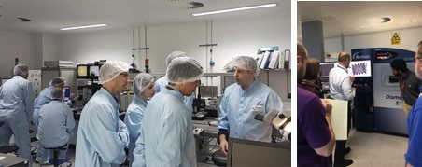

Figure 21: The consortium will provide internal training to all new hires, ensuring they are ready and well- skilled to start working on the project. Internal training will be given on a regular basis and will include online and hands-on training on essential PIC processes and technologies.

Infrastructure and technology are leading edge for academic research. The investments for industry- ready platforms will attract top talent to the host institutes and complement the more experimental tools with high maturity capabilities. From a technical perspective, many of the novel and innovative approaches proposed to increase production capacity, such as improved packaging using wafer-level processes, and precision growth, lithography, etching and deposition, are backed by detailed metrology, simulations and validation runs. The proposed concepts have also been validated in terms of industry demand, especially in terms of boosting production capacity. This includes approaches such as increased wafer sizes,
reproducible monolithic processes with lasers and amplifiers, integration of lasers with 200 mm processes, new materials on PICs, and the move to wafer-level packaging. The project is also mature in terms of

critical technical areas that will accelerate developments, including experience in developing process design rules and design kits and the development of PIC multi-project wafer runs (for InP, SOI, and SiN platforms). Partners have played a leading role in open standards for design kits and design flow. Advanced integration processes include fabrication-tolerant micro transfer printing, the design and fabrication of reference PICs to accelerate packaging process development, fibre and micro-optical packaging, interposer and chiplet packaging, standard testing of PICs and the design of complex PIC systems and demonstrators. All these pre-established capabilities will ensure the project starts quickly and continues to progress as set out in the project plan.

Consortium partners have invested considerable time reviewing what new equipment must be purchased and have close relations with important potential equipment suppliers across Europe. Suppliers recognise the importance and impact of having their equipment located in a leading European Pilot Line and will endeavour to prioritise these purchases. Fast equipment delivery time will be an important factor when tendering for new equipment. Opportunities to experiment with the latest tool capabilities are also compelling. Collaborations with ASML, Aixtron, Ficontec, SPTS have already proved invaluable in previous joint efforts. Most of the requested equipment has a typical lead time of 12-18 months, and some are shorter than this. When possible, while waiting for the new equipment, the consortium will organise the work to leverage existing similar equipment for developing the processes. The consortium partners also plan to work with equipment suppliers to support the development of new processes and to keep them engaged during the project to provide ongoing technical support (the Pilot Line will be an invaluable reference site for these companies). PIXEurope will continuously engage material and component suppliers as it establishes the material supply chain during the project. In addition, all partners bring considerable existing infrastructure to the project to support new equipment purchases. We will make available this existing equipment (not retroactive equipment) as soon as the project starts. Facilities are also ready for new equipment installs, with advanced plans for allocating suitable space to locate new equipment. All hosting partners have expert facility maintenance staff who will support equipment installation and commissioning. Partner organisations have relevant recent experience and are aware of the planning.

Operational capacity is already at a high level. Much of the work at the start of the project involves the design and preparation of materials before new equipment installation. We will run concurrently these design activities w with the purchase and installation of equipment. The setup of the Pilot Line Gateway is another important task planned at the start of the project. The Gateway is essential to the project, as it manages and coordinates many centralised tasks. Based on previous experience with PIXAPP and JePPIX, the consortium is uniquely experienced in setting up a Gateway for a distributed Pilot Line operation. In WP3, all partners, especially ICFO, TU/e and TNI, will work closely for setting up operation, services and Gateway. As a result, the consortium is confident the project's initial phase will run as scheduled, with key milestones achieved as described in the work plan. The consortium also recognises risk areas, that it must factor-in them, and establish mitigation processes. A detailed risk analysis review is presented later in this document. The nature of the Chips JU Pilot Line call requires that each partner receives their national government's full support and that the project is recognised as a national priority. As a result, all partners have been provided with the commitment and support they need in terms of infrastructure to ensure they deliver on their commitments to the project.

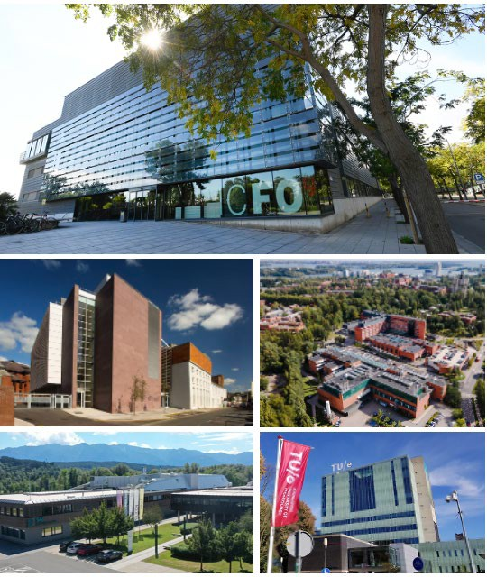

Figure 22: The consortium consists of national centres of excellence. They have received the full support of their national governments who all see the PIXEurope Pilot Line as a national research and industrialisation priority (the image shows some partner facilities, including ICFO, TNI, VTT, SAL and TU/e).
#§MAT-URI-MU§# #@CON-MET-CM@# #@PRJ-MGT-PM@# #@FIN-MGT-FM@# #@RSK-MGT-RM@#

Implementation plan and efficient use of resources

Implementation plan
Show that the implementation work plan is sound by explaining the rationale behind the proposed work packages and how they contribute to achieve the objectives of the project.
Explain the coherence between the objectives, activities, planned resources and project management processes.
Show how the project integrates, builds on and follows up on any pre-existing work or EU funded projects. Provide details (including architecture and deliverables) about pre-existing technical solutions.
Workplan with respect to objectives
The consortium has organized the work-plan and work-package structure to ensure that all key objectives are achieved. These objectives include:
- Creating a fully integrated Open Access PIC ecosystem, unifying Europe’s top research organisations that will give European industry easy access to a wide range of advanced PIC technologies.
- Installing and operating state-of-the-art equipment to develop advanced PIC manufacturing processes and create breakthrough PIC technologies.
- Developing mature and standardised best-in-class PIC technologies, including PIC design, chip fabrication and hybrid integration, through to packaging, test and reliability technologies. Moving these breakthrough technologies from TRL 2 to 6, enabling Pilot manufacturing and transfer to industry for upscaling to volume production.
- Validating the established PIC technologies using state-of-the-art demonstrators, with demonstrators selected from areas addressing emerging socio-economic challenges, including communications, healthcare and security.
- Establishing highly visible and well-coordinated training and dissemination programmes.

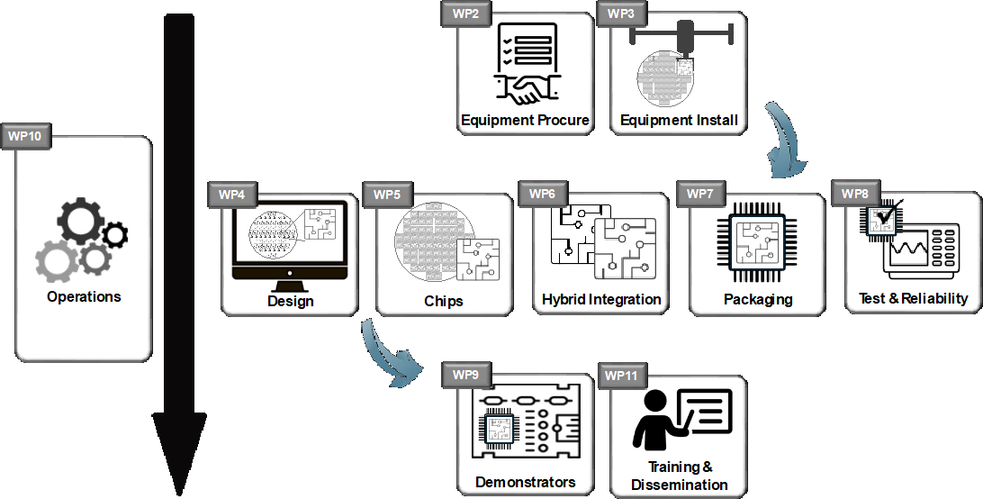
6. Collaborating with other large-scale European and national semiconductor initiatives, particularly other Chips JU Pilot Lines (CPL1-4), Design Platform, and European Competence Centres.

The work plan comprises 12 distinct work packages (WPs). It includes equipment procurement, commissioning and installation (WP3), technical objectives (WP4-8-HE), demonstrator development (WP9-HE), operations, training, collaboration, dissemination and exploitation (WP3, WP2 and WP2-HE-
), and overall project management (WP1). The rationale behind the structure of these WPs is clear, as they are sequenced to fit with the critical phases of the project. This includes the setup or development phase of the Pilot Line and the subsequent operational phase where Pilot Line offers services to users. PIXEurope groups its WPs are grouped around common activities which start at similar times, see Figure
- These groupings include:
  - Operations (WP3).
  - Equipment procurement and installation (WP3).
  - Technology development across all technology nodes, including design, chip fabrication, hybrid integration, packaging, test and reliability (WP4-8-HE).
  - Demonstrator development, training and dissemination (WP9-HE&WP2 and WP2-HE).

Figure 23: Schematic showing the work package structure and how they are grouped and contribute to achieving the key objectives outlined above.

WP groupings support the work plan in achieving the objectives, especially in terms of timelines and delivery of results. Equipment must be first procured, commissioned and installed before technology development can occur, especially for developing advanced processes (e.g. chip fabrication, integration, packaging and testing). Essential workflow alignments, design activities and planning for process development will occur before equipment installation to ensure all new processes are available as early as possible. We will then use the demonstrators to validate these established processes. Their design will use the standardised design kits generated in technology WPs (WP4-8-HE). PIXEurope will establish training courses using knowledge developed in the equipment operation and process implementation and the consortium will prepare additional training material using the information and knowledge gained from developing the demonstrators. Operations will play a central role in harmonizing all these activities. WP3 will oversee and coordinate them, including the organisation of services for the Pilot Line operation phase. The work plan is based on sound planning but will be sufficiently flexible to adapt to any issues that may arise.

Planned resources and project management
The PIXEurope Pilot Line will create a European ecosystem incorporating the complete technology value chain, from PIC design, chip fabrication and hybrid integration, through to packaging, test and reliability. This requires investment in state-of-the-art equipment staffed by highly experienced personnel using a wide range of materials and consumables to develop processes and demonstrate advanced PIC technologies. The Pilot Line is configured to be distributed, with partners located in leading research institutes across Europe to perform specific tasks related to their areas of expertise. The distributed nature of the Pilot Line reflects the diverse range of advanced technologies required to build a comprehensive and robust PIC ecosystem. In addition, critical areas such as chip fabrication require a comprehensive range of photonic material systems, including SOI, SiN, SiC, AlO, Ge and InP in an interoperable, industry-ready form. This calls for investment in similar types of equipment at different partner sites, as it is highly undesirable to move sensitive photonic materials between fabrication partners. Moreover, optimizing one unique piece of equipment for all the material processes will compromise

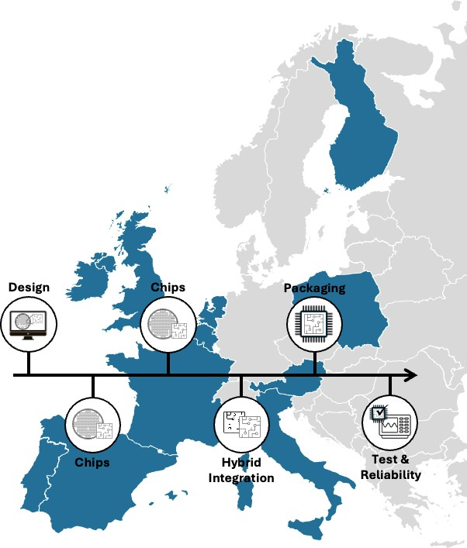
reproducibility, accuracy, and yield. The consortium has been careful to minimise equipment duplication to avoid unnecessary costs. Any duplication is a necessity, especially for chip fabrication activities. Other important areas that require investments include hybrid integration and packaging. Packaging, especially, is a critical technology and currently a production bottleneck. Moving to wafer-level processes that will enable significant upscaling requires investments in high-precision automated flipchip bonding equipment. Test and reliability are also essential for a functioning supply chain, and these require similar levels of investment. All equipment requests are well justified and part of a single manufacturing supply chain. They are all required to deliver on the key objectives as each plays an essential role in developing the advanced processes and technologies required to build a wide range of PIC-based products.
The efficient implementation of the work-plan requires highly experienced personnel to oversee the building of the Pilot Line, including the setup of technical and operation activities. Besides these experienced personnel, engineers and technicians will run the processes. Partners with complex processing equipment will require facility engineers to support equipment operation and minimise downtime. In addition, PIXEurope will need project management and administrative personnel to support the technical staff and engage with users as the Pilot Line rolls out activities such as training and the provision of technology. Details on the consortium, partners, personnel involved, and management structure can be found in Annex 1, Sections 3.3.1 and 3.3.2.
The implementation of the pilot line will need additional resources that include materials and components, to develop processes and build demonstrators. All technical activities (chip fabrication, integration and packaging, test) require investment in these consumables. PIXEurope will focus on sourcing materials and components from European suppliers when developing its processes and technologies. It is an important objective of the Pilot Line to grow the European supplier database. This approach will support the development and growth of a resilient material and component supply chain, contributing to a more robust European ecosystem.

Figure 24: PIXEurope will establish a comprehensive PIC ecosystem across the complete technology supply chain. This requires investments in advanced equipment, skilled personnel and a wide range of materials and components. (Insert in image ‘Complete European PIC Ecosystem’) The end-user engagement strategy will ensure engagement beyond the consortium partners and across Europe

PIXEurope builds on previous projects
PIXEurope builds on an impressive portfolio of European, national and industry-funded projects in PIC technologies. Two of the most relevant projects are PIXAPP (packaging) and JePPIX (InP chip

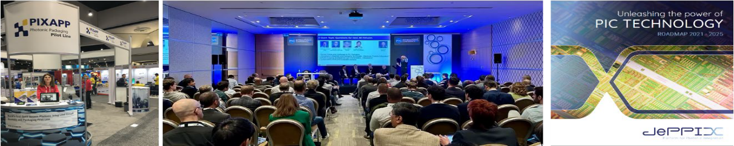
fabrication) Pilot Lines. These were funded under the Horizon 2020 programme, have operated at higher TRLs, not focusing on new technology development. Both projects pioneered the development of Pilot Lines and set an international benchmark for how a pilot line should operate. For example, PIXAPP pioneered the concept of a centralised Gateway as a single point of contact for users of Pilot Line services. JePPIX developed leading edge software infrastructure for automated Design Kit management and work-in-progress monitoring for complex supply chains. It also pioneered much of the development of Multi-Project Wafer (MPW) PIC runs. PIXAPP developed training courses in advanced packaging and JePPIX has provided PIC designer training for almost two decades. Key differences between PIXAPP, JePPIX, and PIXEurope are: a) PIXEurope's larger scale, b) the focus on developing new technology (lower TRLs), and c) the key objective to increase research and development capacity. PIXEurope operates across a wider TRL range (2-6) and will develop much-needed interoperability between high- capacity PIC production processes using advanced automated manufacturing equipment. Most significantly, PIXEurope unifies the complete PIC ecosystem, from design and chip fabrication to integration, packaging, testing, and reliability. PIXEurope has a much more comprehensive and intuitive scope than the previous Pilot Lines and will serve European companies and research organisations well into the next decade.
PIXAPP and JePPIX identified the pressing need to increase production capacity through investment in new equipment, especially for automated high-throughput processing, and investment in new technologies, such as precision wafer processing and wafer-level packaging processes. Much of this awareness has been gained through the data mining of functional test data and production metrology, but also through direct user feedback. The transition from prototyping to industrialization remains a persistent challenge. This awareness gained from direct user experimentation with pilot processes has informed the technical work plan and structured the tasks. PIXAPP and JePPIX are distributed Pilot Lines. The experience gained in establishing and operating both Pilot Lines is highly complementary and will prove invaluable when setting up PIXEurope's centralised operating procedures at ICFO.

Figure 25: The PIXAPP and JePPIX bring valuable technical know-how and market intelligence to the PIXEurope Pilot Line. This includes know-how on which PIC technologies are in critical demand, including future demands (technology roadmaps), managing a distributed Pilot Line, and establishing MPW runs for shared user services.

All consortium partners are involved in many European and national projects on PIC technologies, especially at lower TRLs. PIXEurope provides a unique opportunity to progress these technologies toward production and to merge them intoa single well-coordinated activity. PIXEurope also benefits from other projects, such as PhotonHub Europe and Europractice, where consortium partners are leading participants. PhotonHub is a one-stop-shop for the industry to investigate and evaluate the development of new photonic products, including PIC-based products (PhotonHub will be succeeded by a new Horizon Europe project called Phactory that will have a similar focus and the same consortium partners). The PhotonHub project also supports the transition to upscaling from research concepts towards production but does not offer production solutions. Therefore, there is an excellent opportunity to collaborate with PhotonHub to provide industrial users with a full portfolio of solutions from design to production. In addition, PhotonHub provides training to industry which is more focused on an introduction to technology areas with some specialisation in particular topics. PIXEurope will develop training courses in advanced PIC manufacturing to complement those offered by PhotonHub. TNI manages training in the PhotonHub project and is perfectly positioned to coordinate between projects. Europractice is another project in which consortium members are involved. Itis a large-scale European project that has been running for many years and provides a range of services to design and fabricate electronic circuits and smart integrated systems. The project offers affordable access to a wide range of CAD tools, training courses and fabrication technologies, including ASICs, MEMS and Photonics. PIXEurope can collaborate directly with Europractice to offer PIC development and pilot-scale-up services beyond what is currently available to their users. PIXEurope can also provide its design kits (PDKs, ADKs and TDKs), which Europractice can promote among its users, ensuring a well-coordinated transition from lab to fab. Consortium partners are also involved in other leading European projects such as Medphab (photonic medical devices) and QSNP (quantum PIC devices), which the PIXEurope coordinator, ICFO, leads. These projects bring valuable application know-how to the PIXEurope consortium, especially in emerging areas with strategic importance such as quantum technologies.

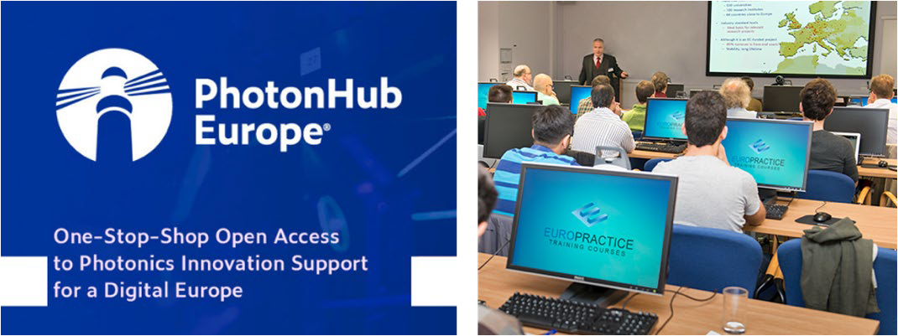
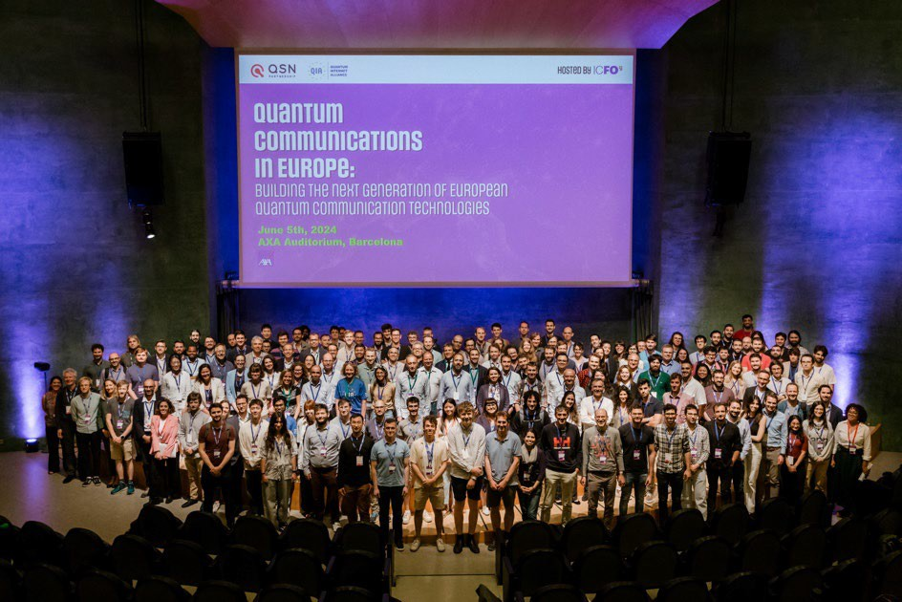
Figure 26: PIXEurope benefits from direct collaboration with PhotonHub Europe and Europractice projects. Many PIXEurope consortium partners are involved in both projects, bringing expertise in training, business support, product design, and opportunities to offer Pilot Line services.

Figure 27: PIXEurope benefits from existing projects in emerging areas, such as projects involving medical devices and quantum technologies. For example, ICFO is a recognised leader in photonic-based quantum technologies, leading, for example, the large-scale QSNP FPA/SGA project funded under the European Quantum Flagship Programme with an entire pillar dedicated to Integration, of which one work- package is dedicated to quantum PICs.

PIXEurope benefits from existing infrastructure and technical solutions
The PIXEurope consortium plans to install state-of-the-art equipment to achieve its ambitious objectives for industry-ready platforms. However, this equipment alone is not the only infrastructure that will be used to realise these objectives. All partners in the consortium already have extensive facilities and equipment which will be used to benefit the Pilot Line. Figure 28 highlights some of these partner facilities. This includes a wide range of wafer fabrication capabilities and state-of-the-art processing equipment housed in modern cleanroom facilities. Additionally, partners bring extensive device integration, packaging and test capabilities. National governments have typically funded this modern infrastructure over the past decade. All facilities are up and running, and many partners are opening and expanding their facilities, which will be used to house PIXEurope equipment. Other partners plan to swap-out old equipment with new equipment purchased for the project, using the facilities already available. Annex 1, Section 3.3.1 provides a detailed overview of partners' key facilities. All partners also have experienced facilities staff who will support the installation of new equipment and provide support with commissioning so it can be efficiently made available for process development.

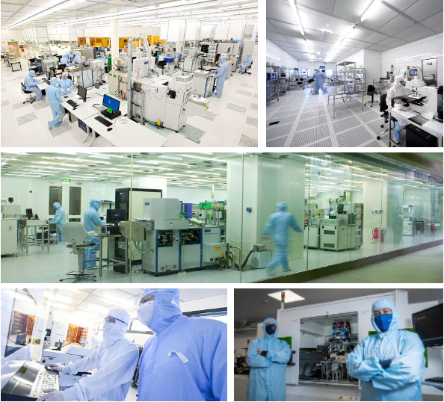
Figure 28: PIXEurope greatly benefits from pre-existing infrastructure and advanced semiconductor device fabrication, packaging, and testing expertise. This infrastructure will support the Pilot Line in achieving its ambitious objectives and accelerate the start-up phase of the operation.

PIXEurope also builds on and follows up on pre-existing work on PIC technologies across all parts of the supply chain. Table 9 provides details of important pre-existing work the partners bring to the project.
Table 9: Overview of important pre-existing work which consortium partners bring to PIXEurope
 | Pre-Existing Work | Technical Details
 | PIC Design | Preparing design rules for chip layout, hybridization, testing and packaging, and formalising these design rules into Design Kits which are available through widely available software design-layout tools (e.g. through CAD tool developers via the CHIPS JU Design  Platform)
 | PIC Chip Fabrication | The development of PIC chips via foundry processes and multi-project wafer runs, including MPW runs for SOI, SiN and InP chips.
 | PIC Integration | Micro Transfer Print (MTP) and Laser Induced Forward Transfer (LIFT) integration of PIC chips, such as the integration of InP laser chips on SOI  and SiN passives.
 | PIC Packaging | The development of standardised packaging design rules for photonic and electronic chips and offering of packaging multi-project runs.
 | PIC Testing | Automated electro-optical testing of PIC chips at die and wafer-level.
 | Reliability | Burn-in testing and failure analysis of packaged PIC chips for high-reliability application such as space.
 | PIC Modules/Demonstrators | The development of complex photonic-electronic modules using PIC chips along with integrated  electronic chips and thermo-mechanical components (for a variety of applications).

Project management, quality assurance and monitoring and evaluation strategy
Describe the measures planned to ensure that the project implementation is of high quality and completed in time. Describe the methods to ensure good quality of monitoring, planning and control activities.
Describe the evaluation methods and indicators (quantitative and qualitative) to monitor and verify the outreach and coverage of the activities and results. The indicators proposed to measure progress should be specific, measurable, achievable, relevant and time-bound.
There are four areas of activities related to management in PIXEurope:
- Technical & development activities (WP4-9-HE), under the supervision of Steering Committee (SC)
- Operational (including procurement and installation of equipment, WP3-HE & Open Access (WP3), by Management and Coordination Team (MCT)
- Strategic, including dissemination, communication and exploitation (WP1, WP2, WP2-HE), overseen by the MCT, assisted by General Assembly (GA)
- Overall Project Management (WP1) by MCT
The full management structure together with the roles of MCT, GA and SC is described in Annex 1, Section 3.3.4, which should ensure an effective and timely implementation of the project following the methods described below.
Evaluation methods and Indicators
The progress of the Pilot Line will be assessed at two levels:
1/ Quality Control Assurance: with the help of general indicators, which include objectives, milestones, deliverables and appropriate use of budget;
2/ KPIs monitoring during: the MCT will ensure efficient translation of generated know-how to services. To this end, a set of Key performance indicators (KPIs) will be reviewed and analysed at six-monthly intervals to ensure the project remains on track to connect technology to an optimum exploitation trajectory. Performance evaluation summaries collected from Partners and summarised in task 10.1 will provide the main inputs.
These methods will enable the recommendation for remedial actions.

Quality Control Assurance during Project Implementation
Key element of this structure responsible for quality assurance throughout the Grant Period are the Work Packages and their Leaders. The Progress of WPs will be regularly assessed. WPLs will be responsible for:
- Monitoring progress in their own WP in terms of technical achievement, planned deliverables and milestones and identifying risks (e.g. non-performing partners) and rapidly informing the SC and the Pilot Line Coordinator,
- Ensuring that deliverables are produced to the agreed quality and milestones achieved,
- Collection of technical and programmatic information needed to prepare periodic progress reports,
- Managing regular WP-level meetings and topic-oriented meetings, and report to the SC and Pilot Line Coordinator on all matters related to the topic (planning, costs, etc.).
- Continuous interaction with the 5 Managers of WP3 and WP2 and WP2-HE listed previously and as shown in the Figure 23, especially to build and operate the services to external end-users.
- All technical deliverables generated by the leading Partner (see list of deliverables) will be checked and controlled in this sequence: WP4-9-HE leading Partner > Pilot Line Manager > Exploitation and Innovation Manager > Pilot Line Coordinator and SC > submission to Chips JU/EC > Chips JU/EC Pilot Line Officer or reviewer. Moreover, the SC will conduct the internal quality assessment of milestones and deliverables that are based on the quantified objectives detailed in Annex 1, Section 1.1 and within the WPs’ descriptions. The 6-month periodicity for the SC meeting is foreseen to perform an internal assessment of the Pilot Line and ensure the conformity and the quality of all Pilot Line deliverables with the requirements. Management and coordination efficiency will be quantified by the timeliness of partner reporting and the punctuality in the quality control process.
- All operational and Open Access-related deliverables generated by the leading Partner (see list of deliverables) will be checked and controlled in this sequence: WP3 leading Partner > Pilot Line Manager > Exploitation and Innovation Manager > Pilot Line Coordinator and Management and Coordination team > submission to Chips JU/EC > Chips JU/EC Pilot Line Officer or reviewer.
- All strategic dissemination, communication and exploitation deliverables generated by the leading Partner (see list of deliverables) will be checked and controlled in this sequence: WP2- HE and WP2 leading Partner > Pilot Line Manager > Exploitation and Innovation Manager > Pilot
Line Coordinator and Management and Coordination team > submission to Chips JU/EC > Chips JU/EC Pilot Line Officer or reviewer.

D3.1 | Web for PL equipment | Online data base with all PL equipment | WP3- HE | CSIC | DAT A | SEN | M12
D3.2 | On-site equipment acceptance | Acceptance and payment of equipment | WP3- HE | CSIC | R | SEN | M40

MS | >50% of procured equipment installed and accepted | WP3- HE | M24 | Report with acceptance documents
MS | 100% of procured equipment installed and accepted | WP3- HE | M40 | Report with acceptance documents

KPIs to be monitored are presented across this document. Specifically, KPIs can be divided into 4 categories:
- Technical KPIs are detailed in Annex 1, Section 1.1.2 for WP4-WP9-HE, focusing on performance, scalability and demonstration
- Interoperability and Open Access KPIs are detailed in Annex 1, Section 1.1.2 for WP3), focusing on services readiness and Pilot Line performance
- The KPIs for the availability and the overall use of the Pilot Line, including the potential access by SMEs and Start Ups, are also detailed in the Annex 1, Section 1.1.2, under the titles “Collaboration”, “Capacity Building”, “Unified PIC Ecosystem”, “Stable European Manufacturing Platform”, “Resilient European Supply Chain”.
- Training KPIs (defined in Annex 1, Section 1.1.2 for WP2-HE “Training”), focusing on contribution to skills

As for the non-availability of the pilot line due to maintenance, repairs, installations, etc., we defined the following Deliverables and Milestones:

The KPI on the total amount co-invested by the private sector in the Pilot Line does not apply to PIXEurope within the Grant Period and will be defined and monitored for the Sustainability.

Cost effectiveness and financial management (n/a for prefixed Lump Sum Grants)
Describe the measures adopted to ensure that the proposed results and objectives will be achieved in the most cost- effective way.
Indicate the arrangements adopted for the financial management of the project and, in particular, how the financial resources will be allocated and managed within the consortium.
Do NOT compare and justify the costs of each work package, but summarize briefly why your budget is cost effective.
PIXEurope’s consortium, supported by a central coordination and management structure, will optimise resources to obtain the best outcomes at minimum expenditure. Each partner can rely on consolidated experience in managing and optimising finances of large collaborative projects, while the coordinator with the assistance of the administrative executive will lead the effort to analyse costs for developing and operating the Pilot Line.
Measures for achieving objectives in a cost-effective way
The Work Breakdown Structure is organized into dedicated technical work packages (WPs), providing a clear and efficient framework for the project’s execution. This structured approach allows for the most cost-effective achievement of the objectives by carefully aligning tasks with each partner's specific expertise, preventing overlap and duplication of efforts. Each task and WP have already been assigned to the partners with the most appropriate competencies and technical capabilities, ensuring that resources are deployed efficiently.
During the pilot line's development and operational phase, we will also optimize partner collaboration through the regular GA and WP meetings outlined above and other exceptional, minuted meetings more specific to solving unexpected issues. This will ensure a smooth execution that minimizes delays and additional costs.
Personnel and budget management
The personnel costs included in the budget are based on actual expected costs incurred by each partner involved in the Pilot Line. The consortium has taken care to ensure that personnel resources are fully

optimized, so that their involvement directly contributes to achieving the defined objectives. During the proposal phase, we have designed the budget to be as lean as possible while ensuring that the required personnel are available for each task.
In addition, to further enhance the cost-effectiveness of the project we have planned the expenses related to Pilot Line meetings, technical gatherings, Open Access publications, and conference participation to reduce overall costs while maximizing the impact of these activities related to PIXEurope’s outcomes.
Financial management and transparency within the consortium
Each partner will manage its allocated funds in strict accordance with national accounting regulations and the European Commission’s guidelines. To ensure complete transparency and accountability the respective accounting departments within each partner will monitor all financial transactions, through separate cost centres dedicated to the Pilot Line constituent projects. These departments have extensive experience in managing European projects and are fully compliant with financial best practices.
The consortium will facilitate regular audits to certify that all costs are justified and in line with PIXEurope’s objectives. The consortium is committed to maintaining a high standard of financial management, ensuring that every euro spent contributes directly to the success of the project.
Decision-making process for cost optimization
The consortium’s bases the decision-making process for Pilot Line development, operation and resource allocation on three key criteria: site capability, site cost analysis, and collaborative access between partners. This ensures the allocation of resources in the most efficient way possible, both in terms of cost and time. By regularly reviewing site-specific capabilities and costs through their related administrative units in collaboration with the Pilot Line administrative executive, the consortium can make informed decisions that maximize the impact of available resources within each partner and between partners of the same Member States.
This collaborative approach not only guarantees cost-effectiveness for the Grant period (first 5 years of the Pilot Line) but also fosters long-term partnerships within the consortium for the sustainability phase (up to 10 years).
Financial oversight and reporting mechanisms
The Pilot Line coordinator will be responsible for overseeing the distribution of financial resources among the consortium partners in strict accordance with the Grant Agreement. The coordinator will ensure that funds are allocated equitably and that any discrepancies or unauthorized changes in resource allocation are swiftly resolved. The resource management activities will focus on the careful monitoring of operational costs, compliance with quality standards, and adherence to the project timeline.
To ensure that the project remains on track, we will internally report key financial figures—including planned versus actual results, efforts, and costs per WP and per partner—on a regular basis, at least annually. This internal reporting will serve as the foundation for the preparation of the periodic financial reports required by Chips JU/EC. These reports will provide a detailed overview of the Pilot Line’s financial performance, ensuring full transparency and compliance with all regulations.

Critical risks and risk management strategy
Describe critical risks, uncertainties or difficulties related to the implementation of your project, and your measures/strategy for addressing them.
Indicate for each risk (in the description) the impact and the likelihood that the risk will materialise (high, medium, low), even after taking into account the mitigating measures.
Note: Uncertainties and unexpected events occur in all organisations, even if very well-run. The risk analysis will help you to predict issues that could delay or hinder project activities. A good risk management strategy is essential for good project management.
Risk No | Description | Work package No | Proposed risk-mitigation measures
1 | Delay with setup of Gateway and organisation of Pilot Line operational procedures (Low/Medium) | WP3 | TNI has significant experience and established procedures for setting up a Gateway. TNI will organise regular (bi-monthly) on-site visits to meet with the ICFO Gateway team to review  progress and immediately address any issues if they arise.

2 | Delay with preparation and delivery of PIXEurope training courses  (Low/Low) | WP3 | Significant course material will be produced between all project partners, and priority will be given to course topics where materials are available soonest, ensuring courses start as scheduled if delays are experienced with other  course material.
3 | Delay with preparation and availability of PIXEurope Open Access service promotional material  (Low/Medium) | WP3 | Internal training and workshops will identify the need for clarity in communicating key service information, including terms and conditions, and legal and financial aspects.
4 | Significant deviations in the  implementation of the services | WP3
5 | Transfer of  equipment/hosting to another organization (Low/Medium) | WP3-HE | A full evaluation of any potential transfer will be performed, in collaboration with the Chips JU, to make sure that the Pilot Line development and services are not weakened.
6 | Limited interest from users and industry  (Medium/Medium) | WP2 | PIXEurope has already received expression of interest from more than 100 companies, majority of them being SMEs, start-ups and spin-offs. The consortium will leverage experience and networks from previous Pilot Lines to offer adequate services of industrial interest. Additionally, dissemination and  communication activities will be tailored to target the end-users.
7 | Issues with the collaboration with the Design Platform and Competence Centers | WP2 | PIXEurope has a Gateway which will route both direct and indirect service requests. We expect a significant number of indirect requests coming from the Design Platform and Competence Centers. Conversely, PIXEurope Gateway will constantly provide updated PDKs, ADKs and TDKs to the Design Platform and Competence Centers. Most of the PIXEurope Partners are  also participating in Design Platform and Competence Centers, creating a direct link.
8 | Issues with the sustainability of the PL | WP3 | Given the low percentage of allowed economic activities, the Hosting Entities will intensify the publicly supported projects and interaction with local and national authorities to receive the OPEX required to operate the Pilot Line beyond the Grant Period. In some cases, when suitable and in agreement with the Chips JU, transfer to third parties will also be considered as a way  towards an effective exploitation and more sustainable operation.
#§CON-MET-CM§# #§PRJ-MGT-PM§# #§FIN-MGT-FM§# #§RSK-MGT-RM§# #@CON-SOR-CS@#

Capacity to carry out the proposed work

Consortium cooperation and division of roles (if applicable)
Describe the participants (Beneficiaries, Affiliated Entities and Associated Partners, if any) and explain how they will work together to implement the project. How will they bring together the necessary expertise? How will they complement each other?
In what way does each of the participants contribute to the project? Show that each has a valid role and adequate resources to fulfil that role.
Note: When building your consortium you should think of organisations that can help you reach objectives and solve problems.
Consortium description, cooperation and division of roles
PIXEurope’s RTOs are all global leaders in the fields of PIC design, fabrication, packaging, testing, materials, and application development. They also have unique capabilities in providing PIC services, including PIC device foundry and packaging services, having also had leading roles in previous Pilot Lines (e.g., JePPIX, PIXAPP, OIP4NWE,

photonixFAB, and PIX4life). All partners also have a strong track record of spinning out new PIC companies and supporting industries, especially European SMEs.

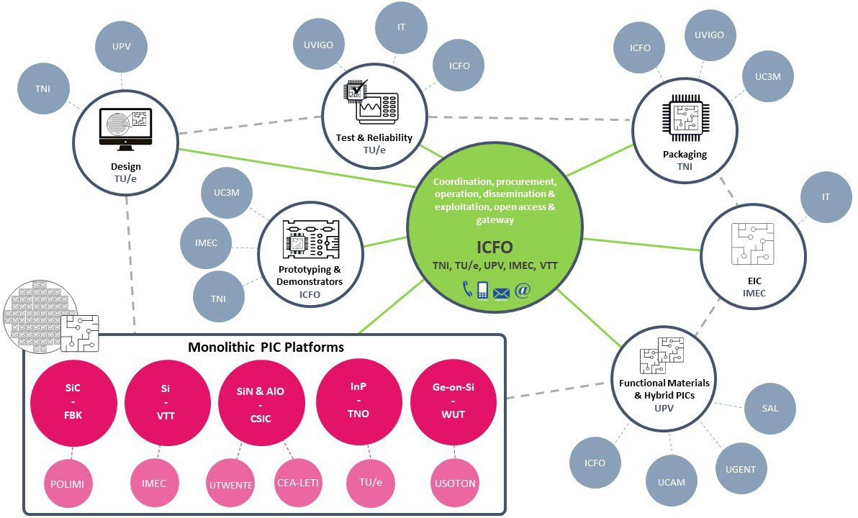
Figure 29: PIXEurope’s distributed Pilot Line with main technology nodes and partner’s main responsibilities, showing complementarity and full coverage of PIC platforms.

PIXEurope’s partners are complementary, each with a clearly identified role. Figure 29 gives an overview of the distributed Pilot Line where key technologies and the primary responsibilities of the partners are identified. Below, we will provide details on each partner that clearly support the capacity for carrying out the work and the need of all of them and their competencies to make PIXEurope successful in offering unprecedented PIC services to the European industry.
Partner: ICFO
Profile
ICFO-The Institute of Photonic Sciences currently hosts 450 people, organized in 26 research teams that use 80 state- of-the-art research laboratories and central infrastructures, including 2 clean-rooms, post-processing laboratory, electronic and mechanical workshops. Research lines encompass diverse areas in which photonics plays a decisive role, such as Information and Communication Technologies, Energy, Health and Quantum Technologies. In addition to three consecutive accreditations of the Severo Ochoa national program for top research excellence, ICFOnians have been awarded 16 elite ICREA Professorships as well as 50 ERC grants. ICFO also leads or has a critical role in several large European projects, such as 3 FPA/SGA of the Quantum Flagship, where PIC technologies are central. ICFO is very proactive in fostering entrepreneurial activities, spin-off creation, and creating collaborations and links between industry and researchers. To date, ICFO has helped create 11 start-up companies, with three of them using
PIC and photonic integration as core technologies for their products (Quside, Luxquanta and Qurv).
Key Competences related to PICs
Design and functionalization of InP, Si, LiNbO3, SiN PICs for applications in communication, sensing and quantum. Novel photonic and optoelectronic materials, such as colloidal quantum dots (CQDs), and ultrathin metal films (UTMFs). Experience in ion-exchange waveguide fabrication, scalable micro-nano-structuring processes, optical/electrical interconnection, testing of PICs. Use and integration of PICs in devices for fast electro-optic modulation, sensing, computation, quantum random number generation, quantum key distribution and entanglement.
Key infrastructure and equipment
- Nanofabrication Laboratory. ICFO-NFL is located in the recently constructed 4,360 m2 Mir-Puig-Buildin. The dedicated 450 m2 ISO6&7 clean room includes 5 main fabrication areas covering: Electron beam lithography, Optical lithography, Dry etching, Wet etching and Process control. Each area has a fully controllable and independent temperature, humidity and pressure control.
- Nanofabrication Laboratory East. ICFO-PKL is an additional cleanroom of 250 m2 (ISO6&7), which has just started a process of refurbishment for hosting packaging and fabrication equipment in 2026.
- Nano-Characterization Laboratory. ICFO-NCL facility offers state-of-the-art services for the
characterization of nanomaterials and nanostructures developed at ICFO in a 150 m2 area, within the various groups as well as in the nanofabrication facility (NFL).

- Advanced Engineering Laboratory. ICFO-AEL occupies some 200 m2, that provides state-of-the-art tools for electronic design, assembly and characterization as well as for micromechanical engineering.
- Optoelectronics Laboratory. ICFO-OPTO Labs over 150 m2 are include state-of the art equipment for testing and prototype buildings, from fundamental experiments to technology transfer demonstrators.
- Post-processing Laboratory. ICFO-PPL facility of 50 m2 supports the processing, fabrication, and characterization of optical materials and components (state-of-the-art dicing and polishing machines, 150 mm sputtering machine, electroplating benches, wire bonders, among other equipment).
- Chemistry Laboratory. ICFO-CL facility of 50 m2 features three fume hoods as well as glassware, equipment
and services to prepare solutions and perform chemical reactions.
 | Role in PIXEurope
Technical: (i) in WP4-HE, ICFO will be responsible for the Design Kit implementation and evaluation (lead of T4.6), (ii) in WP6-HE, new functional materials (CQD and UTMF) for PIC hybrid platform (leader of T6.5) over 8” substrates; (iii) in WP7-HE, ICFO has a key role in developing optical and electro-optical interposer interposers, also for demonstrators; (iv) in WP8-HE, ICFO is responsible for characterization of materials and PIC morphology with related services (leader of T8.1); (v) ICFO leads WP9-HE and is responsible for specifications of demonstrators (lead of T9.1) and the Optical Space Switch demonstrator.
Management: ICFO coordinates the Pilot Line and is responsible for overall project management (WP1), dissemination and exploitation (WP2 and WP2HE), and leads the technical operation (T3.1) and gateway (T3.3) of the Pilot Line (WP3).
 | Partner: TNI | 
 | Profile
 | The Tyndall Institute is Ireland’s largest research centre and is part of University College Cork. The institute has a multidisciplinary community of over 600 researchers, engineers, and support staff, of 52 different nationalities. This includes more than 150 full-time postgraduate students, 60% of whom move directly into industry upon completing their postgraduate research. Key areas of research excellence include semiconductor device simulation and design, fabrication, packaging and integration, and applications in advanced communications, healthcare, quantum, energy and the environment. The institute’s annual budget is competitively won from national research funders, EU Programmes, the European Space Agency, and direct industry collaborative projects. Tyndall has established a global reputation in photonic-electronic packaging and integration. In addition, Tyndall has state-of-the-art semiconductor fabrication facilities, both Silicon and IIIV, and hosts a European Space Agency certified reliability test centre. Tyndall also hosts several leading global semiconductor and medical device companies, many SMEs and start-up companies.
 | Key Competences related to PICs
 | Recognised leader in advanced PIC and EIC packaging and integration technologies, and systems development. Leader of PIXAPP Pilot Line with significant expertise in transitioning research to commercialisation and providing technical services to companies. Also, a pioneer in developing training courses in PIC technologies, online and hands- on courses. Expertise in optical fibre and micro-optical packaging, electrical packaging and co-packaging of PIC and EIC chips, including RF design and packaging. Thermal management of PIC packages and reliability analysis of packages for high-rel applications such as aerospace and medical devices. Design and simulation of PIC devices and packages (optical, electrical, thermal and mechanical).
 | Key infrastructure and equipment
- Semiconductor wafer fabrication. Facilities include the only full silicon CMOS, MEMS (micro-electro- mechanical systems) and III-V semiconductor wafer fabrication research facilities and services in Ireland
- Photonics packaging. A fully equipped state-of-the-art facility dedicated to photonic system prototyping and manufacturing across the board spectrum of photonics from Free-Space Optics to MOEMs to PICs. TNI supports multiple end-user industries, particularly in communications, biomedical and sensing.
- Electronics Packaging. Wide array of advanced electronic packaging technologies including flipchip and wirebonding (ribbon and ball bond). DC and RF packaging capabilities, including capabilities to design full electronic systems on board.
- Test and Reliability. Ultrasonic microscope, environmental test chambers, and wide range of optical and electron microscope systems for package analysis (ESA certifiied facility).
- Simulation & Design. Optical design, including optical (Lumerical and Zemax), electrical (HFSS and ADS), thermal (ANSYS and Comsol) and mechanical design (Solidworks).
 | Role in PIXEurope
TNI is responsible for overall packaging tasks (WP7-HE). In WP8-HE, TNI will be responsible for setting up reliability test equipment and performing reliability investigations and failure analysis on packaged PIC modules and demonstrators. In WP9-HE, TNI will take responsibility for packaging all demonstrators. In WP3, TNI will support ICFO to set and operate the Pilot Line Gateway, and in WP2-HE, TNI will take responsibility for establishing the PIXEurope
training courses. TNI is also involved in WP3, focusing on equipment procurement and installation.

 | Partner: TU/e
 | Profile
 | TU/e belong to the international top-tier in the field of semiconductor research with extensive research across tens of research group in chip design for electronics, quantum and photonics technologies at the Eindhoven Hendrik Casimir Institute. Expertise in photonic integration focusses on process technologies for InP PICs, and their wafer-scale heterogeneous integration with silicon and InP microelectronics. The Photonic Integration research group comprises 70 researchers and was pioneering in the application of Design Kit enabled foundry platforms for photonic integration technologies, enabling one common process technology to be used for many circuit designs and applications. Relevant spinoff companies include Effect Photonics, Smart Photonics, Microalign and PhotonIP. Smart Photonics licenses key technologies to provide pureplay PIC foundry services, becoming the first company to provide PDKs for InP PICs. TU/e recently launched the first nanophotonic MPW service in 2023 to include native lasers and amplifies using its indium phosphide membrane on silicon (IMOS) technology. TU/e chairs the JePPIX platform of approximately twenty companies which aligns commercial design tools and foundry processes through interoperability homologation and training and manages the services developed in the JePPIX Pilot Line. TU/e also co-founded the Photonic Integration Technology Centre with partners UTWENTE and TNO to support open innovation program lines with industry.
 | Key Competences related to PICs
- Design methodologies for advanced PIC technologies and automation methods for data integrity management.
- Fabrication methods for InP PICs and InP based coupons
- Design of active components using InP technology
- Testbeds for LiDAR chip sets
- Test automation methods
- Operational management for Open Access technology platforms
 | Key infrastructure and equipment
- Metrology lab. Laboratory configured to bring-up and validate the latest test automation methods. Particular focus is on generic methods where the measurement limitations are statistically studied and understood.
- Nanolab@TU/e clean room. Epitaxy through to singulation for a 100 mm pilot line with deep UV scanner lithography, and extensive metrology capabilities. The academic research line is routinely used for the production of first-of-a-kind III-V PIC process development and creating wafer-bonded heterogeneous circuits.
- Optical laboratory. Twelve independent optical setups configured for broadband optical, broadband electrical and functional testing of photonics integrated circuits in bare die form. Assessment from blue to mid
infra red.
 | Role in PIXEurope
 | TU/e is responsible for design (WP4-HE) and test and reliability (WP8-HE). TU/e will lead tasks on InP PIC technology T6.1 and Open access 10.5. In WP9-HE, TU/e will lead the LiDAR demonstrator. TU/e will develop the digital platform to support design and design kit workflows, and support ICFO in the efficient operation of the Gateway.
 | Partner: UPV |  | 
 | Profile
The Technical University of Valencia (UPV) is a Spanish public university located in Valencia, specializing in science, technology, and the arts. Established in 1968, the university now includes 11 engineering schools, 2 faculties, and 45 research centers and institutes. The primary research and innovation activities in integrated photonics are conducted by the Institute of Telecommunications and Multimedia (ITEAM, www.iteam.upv.es) through its affiliated Photonics Research Labs (PRL, www.prl.es) and UPVfab (www.upvfab.upv.es). PRL is home to approximately 40 researchers across five key areas: photonic integrated circuits, microwave photonics, optical fiber sensors, programmable photonics, and optical wireless communications. PRL researchers have secured 6 ERC grants and have played a leading role in over 20 EU-funded projects. PRL's infrastructure includes test and measurement setups for advanced photonic integrated circuits (PIC) and world-class photonic and RF instrumentation. PRL has also contributed to the creation of four start-up companies, three of which base their business on PICs: VLC Photonics, iPronics, and Calsens. VLC Photonics represents UPV's first successful exit, having been acquired by Hitachi High-Tech in 2020. UPVfab
serves as UPV’s microfabrication R&D and pilot line facility, featuring 500 m² of ISO-7 (class 10,000) cleanrooms and automated tools for backend processing of semiconductor wafers.
 | Key Competences related to PICs
 | Design, process development, technology development and characterization of PICs. Focus on hybrid integration of

III-V on silicon and wafer-level advanced test methods.
Use of PICs in several verticals: ultra-narrow line width lasers, programmable photonics.
 | Key infrastructure and equipment
- UPVfab cleanrooms. 500 m2 ISO-7/Class 10.000 cleanrooms.
- Oxidation and syntering furnace. Tempress TS83001 system with 3 tubes with loading capacity of 200 wafers per tube, up to 8 inch wafers, configured for oxidation and syntering, as well as LPCVD of silicon nitride (stochiometric and low stress.
- Micro-fabrication cluster tool. Nordiko 5000 tool with load-lock and transfer chamber, equipped with 4 process modules, 2x PECVD, 1x RIE, 1x Sputtering of semicon wafers up to 6 inch.
- Lab grade transfer printing tool. X-Display MTP-1003 lab grade transfer printing tool for substrates up to 6 inch.
- Mask less lithography tools. Quantum Design GmbH, MicroWriter 3 Pro (x2 units) for mask less writing (fast prototyping) with resolution down to 0.4 µm.
 | Role in PIXEurope
UPV is responsible for hybrid PIC integration (WP6-HE, leading 3 out of 10 tasks).
Design kit review and release (T4.2) and Test and reliability methods for integrated photonics (T8.2). In WP9-HE, UPV will lead the Photonic Processor demonstrator.
 | Partner: VTT | 
 | Profile
VTT Technical Research Centre of Finland Ltd (VTT), is a state owned and controlled non-profit limited liability company established by law. As an impartial RTO and with the national mandate and mission to support economic competitiveness, societal development and innovation, VTT carries out research and innovation activities for the needs of industry and knowledge-based society. In 2023, VTT had 2355 employees, 450 patent families, 1135 customers and 45% net turnover from abroad, while producing 488 scientific articles. VTT's multidisciplinary activities cover almost all fields of technology and include photonic integrated circuits, as well as many other photonics technologies from chips to systems. VTT's work in PIXEurope will mainly take place in the Micronova facility in Espoo. Micronova has a 2611 m2 cleanroom, as well as extensive laboratory facilities, to support research in PIC, MEMS, RF, sensor and quantum technologies. Primary (silicon) wafer size will be upgraded from 150 to 200 mm in 2025 and an extension to Micronova, called Kvanttinova, will be built in 2025–2027 to partly extend the fabrication capabilities to 300 mm
wafers.
 | Key Competences related to PICs
Design, fabrication and characterization of waveguides, waveguide components and PICs especially on Thick SOI, but also on SiN and other material platforms.
Hybrid integration of control electronics and III-V optoelectronics with PICs. PIC packaging, including fiber pigtailing.
PIC development for various communication and sensing applications and demonstrators (transceivers, switches,
tunable lasers, spectrometers, LiDARs etc.).
 | Key infrastructure and equipment
- Micronova facility for micro and nanoelectronics R&D. Clean room 2611 m2 reaching up to ISO-4. Acting as a national pilot line for silicon photonics, microelectronics, MEMS and quantum technology R&D.
- DUV Stepper. Deep-UV lithography tool with minimum resolution 150 nm or less for improving patterning resolution in Thick SOI PICs.
- PIC hybrid integration tool. Tool for the hybrid integration of other PICs and photonic components on Thick SOI PICs with submicron accuracy.
- Ge+Si epitaxial reactor. Tool for the epitaxial growth of Si, Ge and SiGe on 200 Si/SOI wafers.The same tool could be used for hydrogen annealing.
- CD-SEM/EDX. Scanning electron microscope for the measurement of critical dimensions and material compositions on Thick SOI PICs.
 | Role in PIXEurope
VTT leads WP5-HE, where it also develops its own Thick SOI PIC fabrication technology and services. Contributions in other WPs are mainly related to this particular PIC technology. In WP4-HE, VTT contributes to the making of PDKs and in WP6-HE VTT leads task T6.7, where it develops hybrid integration technology on Thick SOI. VTT contributes to packaging and testing development in WP7-HE and WP8-HE, respectively. In WP9-HE, VTT will contribute to the
demonstration of an optical pluggable transceiver.
 | Partner: IMEC | 

 | Profile
IMEC is the world’s leading independent nanoelectronics and digital technology innovation R&D hub. Gathering more than 5,500 expert scientists including industrial residents, guest researchers and Ph.D. students, IMEC focuses on those domains where it sees a growth potential and where it can differentiate itself from other research institutes. A cornerstone of IMEC’s strategy is to create innovative leverage between its research domains using its extensive infrastructure (including 12,000m2 cleanrooms hosting e.g. a 300 mm semiconductor pilot line and state-of-the-art labs) and expertise. The competences of IMEC's research groups are gathered and steered by a number of strategic programs, covering lithography, logic devices, memory devices, connectivity including optical I/O and high-speed transceivers, and 3D system integration. At its campus in Leuven (Belgium), IMEC has world-class research facilities. Its 200 mm and 300 mm cleanrooms run a in semi-industrial operation mode, 24 hours a day, 7 days a week, all year round. IMEC has developed a first Silicon Photonics platform in its 200 mm pilot line, which has been adopted by a wide range of end users focusing on applications such as datacom, telecom and sensing. More recently, a 300 mm Silicon Photonic platform has been established featuring more advanced lithography and process modules such as Through-Silicon Vias (TSVs) allowing 3D integration options. Under the scope of IMEC’s Advanced RF program, technologies such as broadband-capable Silicon interposers including microbumps have been developed, which are to be combined with the Silicon Photonic platform for further extending the platform’s capabilities. In addition to the technology platforms, the IMEC-IDLab group located at Ghent University brings extensive experience in the design and test of high-speed integrated electronics and transceiver applications. Next to that, IMEC has a close collaboration
with Ghent University (Photonics Research Group) on establishing a 200 mm micro-transfer printing pilot line to augment the 200 mm IMEC silicon photonics platform with non-native devices.
 | Key Competences related to PICs
300 mm Si (SOI) Photonics platform under the technology name iSiPP300.
Design, processing and characterization of heterogeneous silicon photonic integrated circuits & integrated photonic devices.
 | Key infrastructure and equipment
- 300 mm pilot line for silicon photonic ICs
- 200 mm pilot line for silicon photonic ICs
- Micro-transfer printing pilot line jointly operated with UGENT
- High-speed characterization lab jointly operated with UGENT
 | Role in PIXEurope
IMEC is responsible in WP5-HE for one of the key technologies (thin SOI) as part of T5.2.
IMEC is responsible in WP6-HE for T6.3. Micro-transfer printing of functional materials over silicon photonics platform. IMEC is Work package leader WP9-HE and task leader T9.2.
IMEC is responsible for demo 2 and demo 8 in WP9-HE
IMEC also contributes to WP4-HE in extending the maturity of the 300 mm iSiPP PDK and new test facility in WP8- HE.
 | Partner: CSIC | 
 | Profile
CSIC (Consejo Superior de Investigaciones Científicas) is the largest public multidisciplinary scientific organization in Spain. Within this proposal, CSIC is represented by its research institute, the Instituto de Microelectrónica de Barcelona-Centro Nacional de Microelectrónica (IMB-CNM), which comprises 190 people organized into 8 research groups. IMB-CNM has extensive knowledge and experience in silicon technology since 1990, and in developing miniaturized device-based technologies, such as Micro- and Nanoelectronics and Photonics. The institute’s technological advancements are supported by its state-of-the-art Clean Room for Integrated Micro and Nanofabrication, recognized as a Singular Scientific-Technical Facility (ICTS) by the Spanish Government since 2004. This ICTS is also a partner of NFFA-Europe (Nanoscience Foundries & Fine Analysis – EUROPE), a multi-site research infrastructure that enables researchers to tackle complex nanoscience challenges beyond the capacity of any single facility.
Research activities are developed in the frame of 10+ EU, and 35+ national projects. This year, IMB-CNM was awarded the María de Maeztu Excellence Award by the Spanish Government for the next five years. In terms of technology
transfer, IMB-CNM has applied for an average of 8 patents per year over the last 15 years and has contributed to the creation of 11 technology-based companies, 9 of which are currently operational.
 | Key Competences related to PICs
Mature SiN PIC technology in NIR with an already developed mature PDK, offered as MPW since 2015 (currently MPW8).
Long term experience (more than 25 years) in photonic integrated sensors working in the visible range and based on Silicon technology with different confinement structures (ARROW, TIR, HOLE).

BBs development for RGB applications using the same SiN single mode WG structure covering the complete visible spectrum.
Tuning the stoichiometry of SiN layers adjusting their optical properties for wide application, specially for monolithic integrated Transceivers in Silicon.
Reconfigurable SiN photonics, using modulators and other active devices, using functional materials as PCMs, silicon layers, graphene and more.
 | Key infrastructure and equipment
- ICTS (Singular Research Infrastructure) Integrated Clean Room for Silicon Micro- and Nano- Technologies. 100/150 mm wafer diameter, 1500 m² ISO 5-6 Clean Room for Silicon micro- and nanofabrication. ISO 9001 certified allowing for standarization of processes with industrial grade. Minimum pattern size is 500 nm, using an i-line stepper.
- Silicon Nitride Photonic Integration Platform. The Silicon Nitride photonic integrated platform covers the wavelength range from the visible to the long NIR for photonic integrated circuits and systems applications. The photonic platform runs by the IMB-CNM (CSIC) in their Clean Room. A PDK for C-Band is available for automated design.
- CMOS Line. Complete CMOS line, extended component and circuit library for two metals processes, working within the Clean Room of Integrated Micro- and Nanotechnologies (mask aligners, i-line stepper and EBL), hosted at the IMB-CNM.
- Photonics Lab. The IMB-CNM photonic integrated lab offers the possibility of characterizing photonic integrated components in the visible range of the spectrum cantered at 633 nm wavelength. In the characterization, active components using electrical probes can also be measured.
- Modelling and simulation tool. IMB-CNM (CSIC) uses COMSOL Multiphysics, Synopsis and/or Ansys Lumerical for modelling and simulating photonic structures and doping profiles. For design, they use GDSfactory and Nazca Design, with KLayout for mask drawing and verification, supporting comprehensive
photonic circuit development.
 | Role in PIXEurope
CSIC is responsible for WP3-HE, overseeing the equipment acceptance activities, and leading tasks in WP5-HE aimed at enhancing integration and functionality of SiN PICs in the NIR range (T5.4) as well as the development of RGB technology for UV-Visible PICs (T5.7).
CSIC is also involved in WP4-HE, contributing to the development of SiN process Design Kits, design manuals, and building blocks. Furthermore, CSIC plays a key role in developing a hybrid III-V/SiNx photonic chip platform and the plasma dicing of hybrid PICs (WP6-HE). Additionally, CSIC contributes to material and structural characterization, wafer and package-level testing, reliability assessments, and the development of test methods and protocols (WP8- HE), as well as working on two demonstrators (4 and 7) in WP9-HE.
CSIC will also participate in WP3 and WP2 and WP2-HE, focusing on Open Access to developed technologies and contributing to training, dissemination, and exploitation plans.
 | Partner: TNO | 
 | Profile
TNO, the Dutch Organization for Applied Scientific Research is an independent statutory research organization in the Netherlands that focuses on applied science by conducting independent research, contract research and offering specialist consulting software. TNO currently employs some 3.300 FTE in various R&D fields, ranging from Health to Chemistry, Defense and High Tech. TNO industry, situated in both Eindhoven and Delft is dedicated to the High Tech industry, having a long track record in optics, display, electronics, mechatronics, metrology and much more. TNO Holst center, which will take the lead in setting up the 150 mm InP wafer fab, has extensive experience in setting up pilot lines for and with industry. TNO Holst center is also in a deep collaboration with the TU/e and UT in the field of integrated Photonics, cemented by the Photonic Integration Technology Center (PITC) agreement, where TNO is specifically tasked to help with the industrialization part, and has thus been put forward to help set up the 150 mm InP
wafer fab part of the PIXEurope Pilot Line.
 | Key Competences related to PICs
 | Extensive experience in setting up and running industrial scale pilot lines in collaboration with and for industry. Partner in the Photonic Integration Technology Center, tasked with the industrialization of Integrated Photonics in the Netherlands.
 | Key infrastructure and equipment
- Elletrorave PECVD. Deposition tool for SiN waveguides.
- Barrel Etch. Etching for Lithography steps on 150 mm.
- Thermal Evaporator. 150 mm metallisation layers.
- E-Beam evaporator. 150 mm metallisation layers.
- Spin coaters. 150 mm gen 1 for positive and negative resist.

- Heidelberg. Maskless lithography tool 150 mm and gen 1.
- RIE Etcher. Etching for Lithography steps on 150 mm and gen 1.
- Suss Microtek MAB scil tool. Nanoimprint lithography on 150 mm.
- Sputter tool. 150 mm and gen 1 sputter tool.
- Sheet 2 Sheet ALD. Spatial Atomic Layer Deposition on 150 mm.
 | Role in PIXEurope
 | TNO will be responsible for Task 6.4 and will also be involved in WP1, WP2, WP3, WP3-HE, WP4-HE, WP5-HE, WP9- HE
 | Partner: UTWENTE | 
 | Profile
UTWENTE-MESA+ Institute for Nanotechnology currently hosts over 550 people, organized in 45 research groups that use state-of-the-art research laboratories and central infrastructures, including a clean-room (1000 m2), and an analysis laboratory. Embracing a cross-disciplinary approach and benefiting from the MESA+ NanoLab, our researchers deliver high quality, frequently ground-breaking research. MESA+ actively seeks collaboration with external partners providing an excellent setting for consortium formation. Next to our excellent scientists and facilities, we offer a strong regional ecosystem that creates the breeding ground to let ideas blossom and grow to relevant, successful solutions and businesses. MESA+ researchers were awarded frequently, amongst others, 4 Spinoza and Simon Stevin prizes (highest achievements in the Netherlands), 25 ERC grants, and over 30 vernieuwingimpuls prizes (NWO). UTWENTE leads and plays a significant role in several national and international (EU) programs and is consortium chair of NanolabNL (consortium of all Dutch Nanolabs). UTWENTE plays a significant role in Photon Delta national growth fund (Dutch consortium on integrated photonics). UTWENTE is the entrepreneurial university in the Netherlands and MESA+ has spin-out over 20 companies (6 photonics related, i.e. Lionix, Phix, Quixquantum, Aluvia
Photonics, Brilliance, Superlight Photonics).
 | Key Competences related to PICs
Design and fabrication of SiN and Al2O3 PICs for applications in communication, sensing and quantum and photo- acoustics. Novel photonic and optoelectronic materials, as well as epitaxial integration of modulator materials. Micro- nano-structuring processes, testing of PICs. Use and integration of PICs in devices for fast EO modulation, sensing,
and Quantum-photonics.
 | Key infrastructure and equipment
- Nanolab@University of Twente. This state-of-the-art NanoLab comprises a 1250 m2 cleanroom (ISO 5 / ISO 7) and an area of 1000 m2 containing specialized analysis equipment as well as dedicated research group labs.
- Cleanroom@University of Twente. Fully equipped cleanroom for 5 process platforms – Electronics, 3D nanoshaping, Photonics, MEMS/NEMS and Fluidics – for research and pilot production.
- MESA+ SEM. ZEISS MERLIN HR-SEM.
- MESA+ TEM. THERMO SCIENTIFIC SPECTRA 300 SCANNING TEM WITH PROBE CORRECTOR.
- MESA+ FIB. THERMO SCIENTIFIC HELIOS 5 UX DUALBEAM.
- MESA+ XPS. PHI QUANTES DUAL SCANNING X-RAY PHOTOELECTRON MICROPROBE.
- MESA+ XRD. BRUKER D8 DISCOVER X-RAY DIFFRACTOMETER.
 | Role in PIXEurope
 | UTWENTE will set-up 200 mm pilot line for fabrication of SiN and Al2O3 PICs. New processes will be developed for lowest loss waveguides, as well as low power modulation using stress-optical and electro-optical modulation by monolithic integration of piezo-electric and electrooptical materials, such as PZT, ScAlN, and BaTiO3.

 | Partner: UGENT |  | 
 | Profile
Ghent University has a close collaboration with IMEC on establishing a 200 mm micro-transfer printing pilot line to augment the 200 mm IMEC silicon photonics platform with non-native devices. The Photonics Research Group (about 85 people) is part of the Department of Information Technology of Ghent University. The group is headed by Prof. Dries Van Thourhout and has been active in photonics device research for many years. The other professors in the group are Roel Baets, Peter Bienstman, Wim Bogaerts, Stephane Clemmen, Alberto Curto, Bart Kuyken, Nicolas Le Thomas, Yanlu Li, Geert Morthier, Gunther Roelkens and Kasper Van Gasse. The main research directions are silicon nanophotonics, heterogeneous integration, optical communication, neuromorphic computing, photonic (bio)sensors and photonic integrated circuits for biomedical applications in the near-infrared and mid-infrared wavelength range. The Photonics Research Group has been coordinating the network of excellence ePIXnet and is involved in a number of EU-projects, including the H2020 projects ActPhast4R, AQUARIUS, CALADAN, FUN-Comp, Hydroptics, InSiDe, INSPIRE, MedPhab Pilot Line, MIRPHAB Pilot Line, PIX4Life Pilot Line, MORPHIC, NEBULA, Neoteric, TopHit and PhotonHub. The group also hosts two EOS Research projects, INTERREG projects and several ITNs (MICROCOMB, OMT, WON, Phonsi). Furthermore, the group is partner of the Center for Nano- and Biophotonics of Ghent University and leads ePIXfab, the European Silicon Photonics Alliance.
The group has been awarded six ERC Independent Researcher Starting Grants, one ERC Consolidator Grant and two ERC Advanced Investigator Grants.
 | Key Competences related to PICs
 | Design, processing and characterization of heterogeneous silicon photonic integrated circuits & integrated photonic devices.
 | Key infrastructure and equipment
- Micro-transfer printing pilot line, installed in the UGent cleanroom (ISO 4 - ISO 7), and jointly operated with IMEC
- High-speed characterization lab jointly operated with IMEC
- VIS/NIR characterization lab
 | Role in PIXEurope
 | UGENT has a strong contribution in Task 6.3 on the micro-transfer printing process development.
 | Partner: UVIGO | 
 | Profile
The University of Vigo, UVIGO, located at Vigo, Galicia, was founded in 1990 as a result of the separation of the University of Santiago de Compostela, which was the only university in Galicia until then. This young and dynamic university occupies a prominent position in science and technology research. It has three university campuses - in Vigo, Ourense and Pontevedra - with 22.000 students, 1.600 faculty staff and 700 administration and service staff.
The Dept. of Signal Theory and Communications – STC (specifically the Optical Communications Group) will oversee
the project. The STC department has 7 research groups devoted mainly to ICT and wide experience in public/private projects. Since 2001, it has participated in > 200 projects between contracted activities, licenses, and reports, valued at >€7M. The STC Dept. has 50 Prof full-time employed and 20 postdocs. The Optical Comm Group is formed by 12 full-time prof., 4 postdocs researchers and 4 PhDs. This group has published more than 500 papers in international journals since 1990. Nearly 25% of the University technology transfer R&D comes from the Comm Group.
The STC Department is a member of AtlantTIC (Atlantic Research Center for ICT). Formed by 215 professionals with more than 40 R&D active projects. The Optical Communications Group inside the STC has a strong background in high-performance computing (HPC) applied to computational electromagnetic fields. It is also involved in the Galician Network for High Performance Computing, which brings together and interlinks research centres and groups from the Galician university system in the field of HPC (High Performance Computing) technologies. It has more than thirty laboratories at its disposal (owned by AtlantTIC) located in the premises of the School of Telecommunications
Engineering at the University of Vigo. The Group has two labs dedicated to photonics with optical communication testbeds and commercial software like Optodesigner, Lumerical, RSOFT, Optiwave.
 | Key Competences related to PICs
 | Design and functionalization of InP, SiNx, and Si, communication, sensing and quantum. Micro-nano-structuring processes, optical/electrical interconnection, testing of PICs. Use and integration of PICs in devices for fast EO modulation, sensing, computation, quantum random number generation, and quantum key distribution.
 | Key infrastructure and equipment
- QOPHI LAB. Fiber optic characterization. Characterization of passive and active optical devices (optical modulators, optical amplifiers, LEDs, lasers, filters…). Verification of optical networks and fibre links. Performing of fusion splicing for different types of optical fibres. Testing of optical fibre links.
- QOPHI LAB. Testing of optical fibre links and electrical systems in terms of Bit Error Ratio. Testing of QKD setups with ultra low noise measurement systems. Characterisation of optical sensors. Design and simulation
of photonic components and integrated photonic circuits. Layout generation.
 | Role in PIXEurope
UVIGO is leading Task 4.5 involving the creation of BB models based on measurement data, which will apply to BBs in all the photonic technologies. In WP7-HE, UVIGO will have a key role in developing next-generation packaging strategies using novel materials. In WP8-HE, UVIGO will be responsible for developing test methods and protocols
that can be used in high-volume manufacturing to quickly and reliably extract yields of the wafers.
 | Partner: IT |  | 
 | Profile
Instituto de Telecomunicações (IT) is a private, non-profit, association of six Portuguese universities, one polytechnic, one telecom operator and one telecom equipment manufacturer, established in 1992 with a mission to create and share scientific knowledge in telecommunications at world level and to host and tutor graduate and post-graduate students. IT hosts more than 300 PhD researchers, 7 of which are Fellows of IEEE, and 3 Fellows of the IET, 200 PhD Students and 200 MSc students. Ever since its inception, IT has invested in advanced laboratorial facilities to support applied R&D in Photonics and RF, which has been carried out in the framework of national and international projects in cooperation with industrial and academic research institutions across the globe. IT has contributed to the advancement of PICs for the last 25 years. To date, IT has help creating 11 start-up companies, one of which is
centred on PICs (PICadvanced).
 | Key Competences related to PICs
Design, numerical modelling and characterization of Si, SiN and InP PICs for optical communications (namely for passive optical networks), and for microwave photonics.
Design, numerical modelling and characterization of EICs for PICs and EPICs, leveraging BiCMOS technology.
Such key competences provide guarantees that IT can deliver in design, numerical modelling and characterization of PIC-related activities in PIXEurope.
 | Key infrastructure and equipment
- Design and Simulation Software. IT has a set of tools for designing and simulating the behavior of PICs, namely Lumerical and in-house software.
- RF and Photonics laboratories. IT has state of the art RF and photonics labs, with test and measurement (T&M) capabilities up to 110 GHz of bandwidth and 120 Gbps.
- Fabrication facilities. IT also has fabrication facilities, which include a fiber Bragg grating recording system,
a 200 nm resolution 3D printer, a scanning electron microscope, and a thermal chamber.
 | Role in PIXEurope
The main contributions of IT shall be in:
1. Test and reliability (WP8-HE): leadership of T8.7 (Design for Test and Reliability). Besides aggregating all
contributions of the participants of this task following PIXEurope’s guidelines into developing PIXEurope’s unified approach to Design Kit creation (see fig. 7), IT will develop novel test and measurement procedures starting from the development of a test design kit (TDK) with test-suitable packaging procedures, and culminating on OFDR characterization methods to allow characterizing multiple devices from a single access point.
2. Technology validation and demonstration (WP9-HE): participating in developing a demonstrator 3, which involves designing and characterizing a pluggable coherent transponder prototype, including system architecture, PIC and EIC. The contributions in WP8-HE are important to develop the test and reliability competences of PIXEurope’s Pilot Line, whereas the activities to be done in the demonstrators (WP9-HE) are important to improve the cooperation between
participants, and to provide a first validation of PIXEurope’s Pilot Line.

 | Partner: WUT | 
 | Profile
Warsaw University of Technology (WUT) is the largest and one of the leading technical universities in Poland, with a strong commitment to scientific and research activities across nearly all fields of applied science. The Institute of Microelectronics and Optoelectronics (IMO WUT) specializes in cutting-edge technologies in modern electronics and photonics. The IMO team's key competencies brought into the PIXEurope project include expertise in the modelling, design, and characterization of photonic integrated circuits (PICs) and the development of PIC-based device demonstrators.
The Centre for Advanced Materials and Technologies (CEZAMAT WUT) represents the largest high-tech infrastructure in Poland. As a unique research center, CEZAMAT supports interdisciplinary research on advanced materials and future-oriented technologies, providing access to state-of-the-art clean-room laboratories and a semiconductor
technology line. CEZAMAT fosters innovation in nanotechnology, micro- and nanoelectronics, micro- and nanophotonics, microsystems, nanomaterials, functional materials, and bio-med-chem engineering.
 | Key Competences related to PICs
Expertise in modelling and designing of photonic integrated components and circuits. Experience in PDK development. Expertise in characterization of PICs (MIR, NIR, VIS).
Expertise in the development of technology demonstrators and prototypes of the devices based on ASPICs realized in generic foundries for telecom, sensing and quantum applications.
Expertise in the processing technology of Ge-on-Si, SOI and SiN PICs for the MIR and VIS spectral range. Knowledge and expertise in fabrication of phase-change/transition and optimization of deposition processes.
 | Key infrastructure and equipment
- Electrical characterization. Semiconductor Characterization System Keithley 4200 and Keysight B1500A equipped with unique probe-shield stations with shield enclosure. The apparatus will permit very accurate, low-noise measurements and thus comprehensive characterization of electrical properties of investigated materials.
- Semiconductor devices experimental line. The technology line includes equipment for various processes: surface cleaning and wet etching, plasma etching, thermal processes, photo- and nanolithography (e-beam), layer deposition, characterization tools: spectroscopic ellipsometry, optical microscopy, scanning electron microscopy.
- Laser Spectroscopy Laboratory. Offers a long lineup of spectroscopy apparatus enabling preparation of practically any measurement set-up for spectroscopic characterization of optical materials: bulk, fiber, planar, liquid and nanopowder samples.
- Laboratory of Integrated Photonics. Allows accurate alignment of optical fibers with photonic devices realized in planar technologies by means of dedicated positioners. Equipment enables performing measurements of physical parameters and quantities (optical spectrum, power, time-domain characteristics of electrical/optical signal).
- Fiber Optic Photonics Laboratory. Enables the implementation of R&D works in the field of design and comprehensive characterization of active and passive elements of the physical layer of optical fiber networks.
The laboratory is also prepared for the comprehensive characterization of active elements of optical fiber lines.
 | Role in PIXEurope
WUT is responsible for leading Task 5.6 in WP5-HE, which focuses on the development of mid-infrared integration technologies based on various material platforms (Ge-on-Si, SOI, SiN, Al2O3).
In WP9-HE, WUT will lead the development of the “MIR Photonic Sensing Blocks” demonstrator. In WP4-HE, WUT will develop a new PDK for the mid-IR platform.
In WP6-HE, WUT will work on hybrid integration for the mid-IR platform using phase-change/transition materials.

 | Partner: SAL | 
 | Profile
Silicon Austria Labs (SAL) is Austria's top research center for electronic based systems, which are the technological backbone of digitization. At three locations (Graz, Villach, Linz), SAL is conducting research in the areas of Microsystems, Sensor Systems, Power Electronics, Intelligent Wireless Systems and Embedded Systems to develop future-oriented solutions for industrial production, health, energy, mobility and safety. SAL counts more than 300 people divided in the various divisions. In addition to numerous highly equipped laboratories, including multiple dedicated Photonics Lab, SAL has established two R&D cleanroom facilities covering a total area of 1400 m2. SAL also cooperates with industry and scientific partners on a regional, national and international level with the aim to build
an excellent research network (e.g. TU Graz, TU Wien, EVG, Infineon Technologies).
 | Key Competences related to PICs
PIC development on AlN and LiNbO3. Design of passive and active components and complex photonic integrated circuit on multiple passive platforms. Co-integration of photonic components with MEMS.
Fabrication of PIC on wafer-level: from layer deposition, to high resolution lithography, etching and metal deposition. From sample to wafer electro-optic testing of fabricated components/circuits.
Multiple applications investigated: LiDAR, QKD, communication.
 | - Key infrastructure and equipment
- SAL CR1. 300m2 cleanroom ISO5 with up to 200 mm process capabilities.
- SAL CR2. 1100m2 ISO4/5 cleanroom, 200 mm compatible. Semi-automated lab ready for small series production.
- Lithography tool park. Raith EBPG5200 EBL, EVG Lithoscale, Süss MA200 mask aligner, EVG150 resist track, EVG nanoimprint lithography.
- Dry Plasma etch tool park. AMAT ETCH Centura II, Oxford ICP RIE (F and Cl based), Veeco IBE.
- Deposition. Evatec Clusterline BPM 200-E (optical films), Evatec Clusterline (crystals), Evatec metal evaporation, Oxford PECVD.
- Wet and related. Rena revolution solvent, EBARA frex200M2 CMP, wet benches, SPTS HF vapour.
- Process characterization. Helios G4 SEM / FIB, Panalitycal XRD, Park System NX20 AFM, Semilab Ellipsometer, Bruker Dektak profiler, Filmetrics Thickness Mapping, Filmetrics Resistivity Mapping, Onto Rudolph F30 AOI.
- PIC characterization. FormFactor CM300xi-SiPh 300 mm probe station, electro-optical testing tools.
 | Role in PIXEurope
SAL participates in the project aiming to develop a reliable process for transferring material with strong electro-optic properties onto monolithic platforms i.e. SOI, SiN. The techniques adopted are die/wafer to wafer bonding, or direct sputtering deposition on wafer.
SAL collaborates with other partners in the definition of components design employing proposed functional layers, additionally it is involved in the demonstration of developed technologies.
 | Partner: CEA-LETI | 
 | Profile
CEA (Commissariat à l’Energie Atomique et aux Energies Alternatives) is a French Governmental Research Organisation (15,000 employees) devoted to both fundamental and industrial Research & Development. Within CEA, CEA-LETI is one of the major European research centers for applied electronics (2000 employees), pioneers micro and nanotechnologies, tailoring differentiating applicative solutions that ensure competitiveness in a wide range of markets. The institute tackles critical challenges such as healthcare, energy, transport and ICTs. Its multidisciplinary teams deliver solid expertise for applications ranging from sensors to data processing and computing solutions, leveraging world-class pre-industrialization facilities. CEA-LETI is located in Grenoble (France) where it operates 11000 m²-State-of-the-Art CMOS clean rooms, 200 and 300 mm wafer size.
CEA-LETI’s silicon photonics Laboratory has been actively working in integrated photonics for more than 20 years and has developed numerous technological platforms based on different materials (Silicon, Silicon Nitride and Germanium). These technologies are enriched thanks to a long experience in heterogeneous integration of various
materials on silicon photonics wafers. The main approach pursued now for more than 15 years is direct bonding, whether it is wafer to wafer bonding or die to wafer bonding.
 | Key Competences related to PICs
Design, fabrication and test of PIC in 200 mm and 300 mm wafer format.
In particular: ultra-low loss SiN waveguide (<5dB/m) for nonlinear applications, heterogeneous integration of various materials by direct bonding, silicon and germanium processing, greyscale lithography, nano-imprint lithography, copper pillar for flip-chip assembly of EIC, wafer scale optical/electrical test from DC to 110GHz.
 | Key infrastructure and equipment
- CEA-LETI platform. 12,000m2 state-of-the-art cleanroom for in-house fabrication (CMOS, Silicon and Silicon Nitride Photonics…) based on 100 mm to 300 mm wafers.
- CEA-LETI process. Processing capabilities supported by over 80 advanced characterization tools of which a number are on line in the clean room, including equipment for LPCVD, annealing, surface preparation, bonding, Germanium epitaxy, LNOI & Ge lithography and etching.
- CEA-LETI design and characterisation. A dedicated lab of more than 30 people working on silicon photonics design, simulation, process and characterization of SiN based components.
 | Role in PIXEurope
CEA-LETI technological development are part of WP5-HE and WP6-HE: the ultra-low loss SiN platform will be augmented with novel high speed device integration based on silicon, and with turning mirrors based on nano-imprint or greyscale approaches. The platform will combine nonlinear optical effect and RF features for high data rate communications (WP5-HE). In the field of hybridisation, CEA-LETI will propose an innovative die level process enabling flip-chip stacking of EIC dies over PIC with pitch below 40 µm (WP6-HE). PDK development supporting the future MPW offer is done in WP4-HE.
In WP8-HE, CEA-LETI will enhanced its wafer-level PIC characterization capabilities with the will to act as a characterization service provider in the future Pilot line.
In WP9-HE, CEA-LETI will use its SiN platform to contribute to the Programmable Photonic Processor demonstrator: low-loss, passive waveguide mesh with thermo-optic phase shifter and transceiver based on optical comb generated by nonlinear effect.
 | Partner: IMDEA |  | 
 | Profile
IMDEA – IMDEA Networks – is an independent public research center, located in the town of Leganés, where UC3M is also located. The research in the center is focused on the development of future networks, with activity in the physical and transport layers, with relevant developments in wireless communications research involving emerging wireless technologies such as extremely high frequency communications for 5G and wireless LANs and visible light communication. IMDEA Networks has extensive experience in European projects (61 EU projects in total), relevant communications demonstrator testbeds (5TONIC, ESFRI SLICES, HELIX, MIMORPH) and strong collaborations with relevant industrial partners in communications sector (Telefonica, Ericsson, NEC, …) relevant to “Small Form-factor Pluggables (SPF) for PON optical transceivers” PIXEurope demonstrator the strong synergies with ESFRI SLICES to multiply the impact in advanced communications networks. IMDEA has a Wireless Research Group led by Dr. Joerg
Widmer who has an extensive publication record in wireless communications and sensing. The group also has strong expertise in designing ultra-high bandwidth mmWave experimentation platforms as well as building fully custom modular RF frontends for massive and distributed 6G MIMO, which have been key enablers to develop and validate algorithms. The research group led by Dr. Domenico Giustiniano has strong expertise in visible light communication. The institute also has substantial machine learning know how and several high-performance AI compute clusters to support the work. This expertise is completed with the incorporation of members from Grupo de Optoelectronica y Tecnologia Láser, bringing know-how on photonic integrated circuits application on mobile front-haul of future
communication networks.
 | Key Competences related to PICs
Design and characterization of photonic integrated circuits for high-frequency applications (Wireless Communications) Ultra-high frequency (millimeter-waves) instrumentation, measurement and probing
Artificial intelligence algorithms for process automation.
Use and integration of PICs in devices for millimeter-waves generation, photonic-based RF phase arrays, on-chip antennas, on-chip modulated signal processing.

 | Role in PIXEurope
 | IMDEA is responsible for the package simulation and design (T7.1), to combined material characteristics and radiofrequency in the package design, the non-contact probing and inspection (T8.5), developing the techniques to probe components in wafer and dies in packages. In WP9-HE, leads the functional demonstrator testing, where the selected demonstrators will be evaluated in laboratory and relevant environments. IMDEA will also have a key role leading the communications demonstrator aiming at new hybrid assembly processes enabling PIC small form factor pluggable in collaboration with VTT, TNO, ICFO, IT and TNI.

Project teams and staff
Describe the project teams and how they will work together to implement the project.
List the staff included in the project budget (budget category A) by function/profile (e.g. project manager, senior expert/advisor/researcher, junior expert/advisor/researcher, trainers/teachers, technical personnel, administrative personnel etc. — use the same profiles as in the detailed budget table, if any (n/a for prefixed Lump Sum Grants)) and describe briefly their tasks.
Name and function | Organisation | Role/tasks/professional profile and expertise
Valerio Pruneri  Coordinator | ICFO | Valerio Pruneri (MEng Politecnico di Milano, PhD University of Southampton) - ICREA Prof. and Group leader at ICFO, previously Avanex and Corning OTI (h-index: 64, invited talks: 100+, patent families: 65+, spin-offs: Quside, Luxquanta and Sixsenso). | PIC experience: Integrated electro-optic LiNbO3-PIC modulators and sensors, Tunable laser with InP-PIC, Phase change materials and entangled photon sources in SOI-PIC, QRNG and QKD in SOI- and InP-PIC, and photonic processors in TFLN on Si and SOI. | Leadership: Lead R&D teams in industry and academia, coordination of 7 EU projects, including a 25M€ Q-Flagship FPA/SGA, and a 60+M€ National Q-Communication program. Founder and Board Member of Quside, Luxquanta and Sixsenso. Chair of the Corning Inc. Lab at ICFO and board member of Nano- fabrication and Post-processing facilities at ICFO. In industry, he led the development of packaging of a tunable laser for C and L Telecom bands and the development of low voltage and large bandwidth integrated electro-optic modulators using domain-inverted LiNbO3 PIC. He was the Technical/General chair of the European Conference on Integrated Optics (ECIO) and the Conference on Lasers and Electro-optics in Europe (CLEO Europe) in 2012 and 2017, respectively. | Awards: Pirelli Fellowship, Philip Morris Prize, IBM Faculty Award, Duran Farell Prize, Ignite award (SLAS Europe), Paul Ehrenfest Best Paper Award, National Innovation Award for new companies (Luxquanta), RSEF-BBVA Prize for Physics, Innovation  and Technology, and Corning Inc. Chair.
Stefano Signorini  Senior expert/advisor/ researcher/post  doc | ICFO | M Physics University of Trento, PhD Physics University of Trento) – Senior Postdoctoral Researcher at ICFO (MSCA fellowship, PROBIST fellowship). | PIC experience: Integrated classical and quantum photonics, experience with Si/SiN/SiON/TFLN platforms, integrated photon pair sources for entangled states in novel active materials, PIC-based heralded ultra-pure single photons for quantum  information, gas sensing/spectroscopy on chip, quantum

sensing/spectroscopy on chip, classical and quantum PIC design/simulation/characterization, nonlinear and multimode photonics in integrated devices, PIC photonic processor, PIC transmitters for QKD, novel fiber- and chip- based quantum sources, MIR light generation and detection, QD waveguides, active PIC devices for GHz optical computation/communication, ultra-low loss
phase shifter for quantum information
Luis Trigo Vidarte  Senior expert/advisor/ researcher/post doc | ICFO | MEng University of Vigo, MSc Université Paris Cité, PhD Université Paris-Saclay) – Senior Postdoctoral Researcher at ICFO. | PIC experience: Design, conditioning and testing of integrated devices for quantum communications, in particular transmitters (InP) and receivers (InP, Si) for continuous-variable quantum key distribution (CV-QKD). Design, conditioning and testing of devices for photonic  processors (SiPh, TFLN)
Peter O’Brien Principal Investigator | TNI | BAMod [Physics] Trinity College Dublin, MEngSc & PhD University College Cork) - Prof. and Group Leader at Tyndall Institute, University College Cork (Packaging & Systems Integration Group), previously CEO and founder of Biophotonics company, successfully sold in 2009, Silicon Fab Manager (General Semiconductor), Research Scientist (NASA-JPL), Postdoc (Caltech). Responsible for bringing ficonTEC GmbH (packaging equipment company) to Ireland and setting-up packaging equipment R&D facility at TNI. | PIC experience: Photonics packaging, heterogeneous integration and device fabrication. | Leadership: Director of PIXAPP Pilot Line and European Photonics Academy at PhotonHub Europe. Over 50M € in research funding awarded over past ten years. Guest Professor - Keio University, Japan and College of Optical Sciences, University of Arizona, Regular conference keynote and invited speaker. | Awards: University College Cork - Research Group of the Year 2016, Science Foundation Ireland - Best International Collaborator 2018, Enterprise Ireland - European Research Champion 2018, University College Cork - Research Award for Most Cited (Field-Weighted) Publication  2020
Kevin Williams Principal Investigator | TU/e | BEng University of Sheffield, PhD University of Bath) – Professor and chairman of the Photonic Integration research group at Eindhoven University of Technology (TU/e) comprising seventy researchers, technical staff and scientific staff. | PIC experience: photonic integrated circuits, active component integration, and the relationship between process tolerances and functional performance. | Leadership: Coordinator of the InPulse (JePPIX) Pilot Line as well as multiple EC and national projects. | Awards: Royal Society university research fellowship, fellow of Churchill College at the University of Cambridge, EC Marie Curie Chair, and a Dutch Vici  Laureate
Katia Panina Senior expert/advisor/ researcher/post doc | TU/e | PhD Università degli Studi di Trento, MBA TIAS Business School) – JePPIX Coordinator and Operations Manager of JePPIX Pilot Line (InPulse) | Supply chain coordination: Enabled efficient streamlined supply chain operation with complex data exchange, data validation and project execution across 16 industrial partners in integrated photonics (JePPIX Consortium) | Open access: Account management for more than 140 businesses worldwide leading to over 1200 designs manufactured in Open Access foundry model. Significantly improved customer experience, transparency of communications and trustworthiness evidenced by customer retention. | Digitalisation: Co-created a concept digital platform which streamlines multi-directional communications in the complex, highly fragmented network of customers and suppliers. This  infrastructure enables seamless order execution stepping up the quality removing human error
Sylwester Latkowski Senior expert/advisor/  researcher/post doc | TU/e | M.Sc. and Eng. degrees in optoelectronics and technical physics from the West Pomeranian University of Technology in Szczecin, Poland, and a PhD in photonics at the Centre for High-Speed Devices and Systems at Dublin City University, Ireland. His early research  concerned mode-locked semiconductor lasers, millimeter and terahertz photonics, and all-optical signal processing for data

transmission. He followed up his interests with the Photonic Integration group at Eindhoven University of Technology (TU/e), the Netherlands, focusing on test assembly and packaging of integrated photonics, photonic integration technologies, and on-chip laser systems for sensing applications. Along with his research activities, he supervises and co-supervises bachelor, master, and Ph.D. students. He delivers annually a series of lectures on integrated photonics at the Warsaw University of Technology. He shares his university duties with the position of scientific director at the Photonic Integration Technology Center, an applied research center for photonic technologies, where he is responsible for shaping the strategic R&D agenda of shared research program lines, and engagement with industry. In the works of PITC Sylwester is also managing a Metrology Program for integrated photonics. The metrology program currently involves a team of nine researchers and engages more than 15 industry partners, who work closely on next- generation test solutions. Sylwester and his team took the leading role in the development of test methods and processes in several national and European projects including PIXAPP, InPulse, PIC-Test, MEKOPP, PhotonicLEAP, PhotonDelta NGF Metrology, High-Tech Next Gen NGF. | PIC experience: active role in road-mapping initiatives for integrated photonics. He is a chair and co-chair of the electronic-photonic test Technical Working Group of the Integrated Photonic Systems Roadmap International supported by AIM Photonics Academy and Photon Delta ecosystems. Sylwester has a sitting in the steering committee of the joint European platform for photonic integrated components and circuits, JePPIX. Sylwester is a senior member of the IEEE and IEEE Photonics Society and a voting member of the IEEE Standards Association, and Photonic Standards Committee. He is chair of the working group for the standardization of electronic-photonic design automation, IEEE SA P3112. He has authored and co-authored more than 135 publications in international
scientific journals and conference proceedings
Pascual Muñoz Principal Investigator | UPV | MSc, PhD Universitat Politècnica de València -UPV-) Full Prof. of Photonic Integration at UPV, Director at UPVfab (h-index: 25, patent families: 6, spin-offs: VLC Photonics) | PIC experience: design and test (SiNx, SOI, InP) manufacturing (SiNx) and hybrid integration (µTP). | Leadership: UPV PIC Group Leader (since 2005), Lead entrepreneur (2010) for VLC Photonics (Hitachi Group since 2020), CEO (2011-2013) and Board Director (2011-2023), UPVfab Director (since 2018), PIXSpain Coordinator (since 2021). | Awards: UPV  Technology Transfer 1st edition Award (2023)
José Capmany Senior expert/advisor/ researcher/ postdoc | UPV | MEng Electrical Engineering, Universitat Politècnica de Madrid, MSc Physics UNED, PhD in Electrical Engineering Universidad Politecnica de Madrid, PhD in Physics Universidad de Vigo). Full Prof of Photonics at UPV and PRL Leader (> 650 papers + 8 textbooks, h- index: 63, invited talks: 100+, patent families: 20+, spin-offs: VLC Photonics (acquired), Ephoox and iPronics | PIC experience: Integrated RF-Photonics Filters and OEOs (InP, Silicon and Silicon Nitride), programmable integrated photonics pioneer | Leadership: Lead PRL since 1991, coordination of 3 EU projects, and 4 ERC grant awardee (2 Advanced and 2 Proof of Concept) | Awards: National Research Award on Engineering, King James I award in new technologies, IEEE Photonics Society Engineering Achievement Award, RSEF-BBVA Prize for Physics, Innovation and Technology,  Chinese Academy of Science Presidential Award
Timo Aalto Principal Investigator | VTT | M.Sc. & D.Sc. Helsinki University of Technology) – Research Team Leader in Silicon Photonics (h-index: 20, journal papers: 35, conference talks: 100+, patent families: 12 granted + 5 pending)  | PIC experience: Pioneering silicon photonics since 1997 with main focus on Thick SOI PICs and hybrid integration of III-V optoelectronics on SOI, and applications ranging from optical communication and microwave photonics to optical coherence tomography, industrial gas sensing, wearable sensors and LiDARs |  Leadership: Lead R&D teams since 2006, coordination of 2 and principal investigator of 3 EU projects, coordination of 5 other project

consortia (ESA, national), leading of multiple large contract R&D projects (total >20 M€) | Awards: VTT Award 2014 for the demonstration of considerable business thinking, for boosting business and sales, and for developing and uniting VTT's technology offering. Multiple Recognition Awards at VTT for various results and
contributions
Fei Sun Senior expert/advisor/  researcher/post doc | VTT | PhD Institute of Semiconductors, Chinese Academy of Sciences) – Senior Scientist in Silicon Photonics (h-index: 4, journal papers: 20+, conference talks: 20+, patent families: 1+) | PIC experience: 20+ years of continuous experience in PIC development, including device simulation, design, fabrication and testing on different platforms (ranging from GeSi, SiON and Thin SOI to Thick SOI). Nowadays leading the wafer fabrication, process developments and monolithic/hybrid process integration on VTT's Thick SOI platform for various photonic applications | Leadership: Experiences in leading both academic and commercial R&D projects | Awards: Multiple times of Recognition Awards at VTT for the achievements on  fabrication developments and project managements
Mikko Harjanne Senior expert/advisor/ researcher/post doc | VTT | M.Sc. Helsinki University of Technology) – Research Scientist in Silicon Photonics (h-index: 20, journal papers: 25+, patent families: 5+) | PIC experience: Over 20 years of PIC simulation and design expertise, focused on component and layout design on the thick-SOI platform; application in the data- and telecom and optical sensing domains. Extensive experience in developing custom control electronics for device characterization. | Leadership: Lead R&D for  process design kit on SOI platform and head of VTT’s PIC MPW offering
Joris Van Campenhout Principal Investigator | IMEC | MEng Ghent University, PhD Ghent University) – Senior R&D Director and Fellow at IMEC, Belgium (h-index: 56, paper citations: 12000+, patents: 15+ | PIC experience: silicon photonics, 3-D integration, III-V semiconductor devices, datacom/telecom transceivers, Optical I/O | Leadership: leading IMEC’s industry affiliation R&D Program “Optical I/O” | Awards: Alcatel-Lucent Bell  Scientific Award Belgium, 2008
Gunther Roelkens Principal Investigator | IMEC | MEng Ghent University, PhD Ghent University) - Micro-transfer printing group leader @ IMEC-Ghent University (h-index: 77, invited papers: 150+, patents: 10+, spin-offs: Caliopa, Indigo)| PIC experience: silicon photonics, heterogeneous integration, III-V semiconductor devices, datacom/telecom transceivers, sensing | Leadership: lead R&D team at Ghent University - IMEC & Ghent University Photonics cleanroom team (25 people) | Awards: Andreas  De Leenheer award, Laureate of Academy of Sciences/Art 2019
Peter Ossieur Principal Investigator | IMEC | MEng Ghent University, PhD Ghent University) – Program manager high-speed transceivers at IMEC, prof. at Ghent University, previously at Tyndall National Institute (h-index: 23, papers: 200+, patents: 7) | PIC experience: silicon photonics, optical transceivers, high-speed electronic integrated circuits for transceiver applications | Leadership: lead IMEC-IDLab team at IMEC and Ghent University  (40 people) | Member technical program committee International Solid-State Circuits Conference (ISSCC, wireline subcom)
Carlos Domínguez Principal Investigator | CSIC | MSc Chemistry, and PhD Universidad Complutense de Madrid) – Research Professor and Manager of the Photonics Integrated Platform at IMB-CNM (h-index: 39, invited talks: 20+, patents: 19, spin-offs: Silicon Sensors and Sensia) | PIC experience: Development of various photonic platforms (TIR, ARROW, Si-HOLE structures), Bio-chemical sensing devices based on SiN technology in the visible (MZI, Bimodal Interferometer, Absorbance Sensor, Optical Cantilevers), Si-based full monolithic integrated Transceiver (Source based on Si rich materials, WG + Photodetector in the visible range), SiN PIC moderate losses technology in the NIR(PDK owned by VLC Photonics SL) | Leadership: IMB-CNM Technical Deputy Director (from 2002 to 2005) and Deputy Director (from 2008 to 2012). Project leader of 30+ national projects, 6 international (EU)  projects and 30+ industrial contracts

David Quirion Senior expert/advisor/ researcher/post doc | CSIC | ENSPG-INPG, Grenoble, Ph.D. University Joseph Fourier). Deputy Director of the clean-room facility at the IMB-CNM (h-index: 22, published papers: 106). In 2001, post-doc at the Max-Planck- Institute-for-Solid-State-Research, in the group of Prof. von Klitzing, where he studied the Kondo effect in quantum dots based on GaAs/AlGaAs heterostructures. Canberra France (Lingolsheim, France) as project leader on coaxial germanium gamma-ray detectors (2004-2008). 2009, Radiation Detector Group at the Institute of Microelectronics in Barcelona (IMB-CNM, Spain) where he was in charge of the technology development and process supervision in the clean room for all types of silicon detectors: micro- track detectors, 3D detectors, thin detectors. Leadership: Manager of the national infrastructure programme (ICTS-2017-17- CSIC-2) (ICTS-2019-01- CSIC-2) to enhance and actualize the processes within the CMOS and Nanofabrication lines running within the IMB- CNM research infrastructure (budget > 25 M€), and responsible of the Nanoscience Foundries and Fine Analysis - Europe PILOT. DOI:  10.3030/101007417.
Joaquín Faneca Senior expert/advisor/  researcher/post doc | CSIC | MSc in photonics, and PhD at University of Exeter) – Senior Researcher and part of the Photonics Integrated Platform at IMB- CNM (h-index: 12, invited talks: 7) | PIC experience: Passive and reconfigurable photonic integrated circuits, based on the integration of various reconfigurable materials with silicon and silicon nitride photonic components. Application to tunable individual building blocks, including photonic memories, modulators, filters, interferometers and others. | Awards: In 2019, he was one of just 85 individuals worldwide to be awarded a SPIE scholarship, recognizing his potential for long-term contributions to optics and photonics. He was awarded with the research fellowship from EPSRC (U.K.) to pursue the Ph.D. research project in photonic integrated circuits at University of Exeter, co-funded by the Company Lumentum Operations LLC. Juan de la Cierva (Excellence from Spanish Government) postdoctoral fellowship in 2022 for silicon nitride photonic properties in the visible range of the spectrum. 1st conference prizes technical winner award in silicon photonics in 2018 and 2019. | Leadership: President of the SPIE and OSA Optical Society in the Exeter student chapter from 2017 to 2018. Since 2022, member of the technical committee for the IEEE Photonics Conference in the communications and devices section. Responsible for the photonics lab at Exeter Univ (2017 to 2020), and now oversees the Photonic Integrated Lab at IMB-CNM. Organizing committee for the Master of Microelectronics at IMB-CNM, managing the Integrated Photonics course. Supervisor of five master’s theses, five bachelor’s theses, and is currently supervising two PhD students. J. Faneca has led two national projects, participated in five international (EU) projects, five national projects, leading work packages (WPs), and  contributed to four industrial contracts
Ton van Mol Principal Investigator | TNO | graduated with honours from Eindhoven University of Technology in Chemical Technology in 1997, and received his PhD in the area of Thin-Film Technology in 2001. His thesis was on the study of atmospheric-pressure chemical-vapour deposition (APCVD) of tin- oxide coatings used in energy-saving windows and solar cells. He worked at Sandia National Laboratories (Livermore) as a visiting scientist on the development of improved APCVD reactor systems and joined TNO in 2003 as a senior scientist in the area of flexible solar cells. In 2005, Ton helped set up the open-innovation initiative between IMEC and TNO called Holst Centre. He started as program manager at Holst Centre for the development of flexible OLED lighting and thin-film barrier technology, respectively. Since 2015, Ton is managing director of Holst Centre for TNO (120 FTE) and since 2019 also responsible for the 3D-printing activities of TNO. Ton is also  Managing Director for the PITC institute, tasked with industrialization of Integrated Photonics in the Netherlands
Gerwin Gelinck Senior expert/advisor/ | TNO | received his Ph. D. degree in Physical Chemistry from the Delft University of Technology, The Netherlands, in 1998. In that same year he joined Philips Research as a Senior Scientist, where he

researcher/post doc |  | pioneered flexible electronics. In 2002 he was co-founder of Polymer Vision, an internal start-up company in the Philips Technology Incubator. From 2002 to 2006 he was Chief Scientist of Polymer Vision leading a team that established a pilot line for production of flexible displays in the Netherlands. Since 2007 he has been working at TNO, first as Program Manager/Director of Holst Centre and later as CTO. He became part-time professor at Eindhoven University of Technology in 2014. Gerwin has been involved in a large number of national and international funded projects. FP7 and H2020 examples including FlexiDIS, NAIMO, ONE-P, FLAME, ORICLA, MOMA,  COSMIC, ORAMA, PING, Hi-Response and DICOMO. The Interreg project ‘Flexlines’ successfully launched a pilot line on flexible electronics in Eindhoven, based on proprietary technology of TNO-  Holst Centre and IMEC. Since 2022 he is program manager of PITC and managing an R&D team on heterogeneous integration
Guus Rijnders Principal Investigator | UTWENTE | Saxion University of Applied Science, PhD University of UTWENTE)  – Prof. and group leader at MESA+, Chair NanolabNL, Captain of Science Dutch topsector High Tech Systems and Materials, (h-index 52, invited talks 60+, spin-offs TSST, Solmates). | PIC experience: Integration of piezoelectric materials (PZT, ScAlN) with PICs, Complex oxides (such as BaTiO3) epitaxial integration with Si, SiN, and SiOx, Epitaxial growth of complex oxides. | Leadership: Lead R&D teams in UTWENTE, chair NanolabNL, scientific director MESA+ Institute (2016-2024), Captain of Science Dutch topsector High Tech Systems and Materials (with ministry of economic affairs).  | Awards: VIDI-NWO (vernieuwingsimpuls), FOM valorization prize, NWO TOP-PUNT (for established top research groups with a proven excellent track record), and the Julius Springer Prize (Prize to a scientist who has made an outstanding and innovative contribution to the field of applied physics). | Outreach: public lectures (festivals, societies, schools) and participate in public debates on nanoscience and technology. Since 2011, I organize the “Universitent” at the “Zwarte Cross” and “Mañana-Mañana” festivals. At these festivals, more than 5000 visitors attend scientific presentations from enthusiastic researchers as well as experiments from Science on  Tour students
Pepijn Pinkse | UTWENTE | MSc Univ. Leiden, PhD University of Amsterdam, Habilitation TU
Senior |  | Munich) – Prof. and group leader MESA+ (ISI h-index 33, invited talks
expert/advisor/ |  | 75+, spin-off QuiX Quantum, 3 patents, 1 pending). | PIC
researcher/post |  | experience: Development and Application of Integrated SiN
doc |  | Photonic Processors (with Renema and QuiX Quantum), design and
 |  | application of Integrated Photonic Fingerprint chips for security,
 |  | development of thick SiN. | Leadership: Set up and (for 15 years) led
 |  | the Applied NanoPhotonics cluster, now a Department of the Faculty
 |  | Science & Technology. Director of the center for QUAntum Nano
 |  | Technology UTWENTE (QUANT), leading European QuantERA
 |  | consortium. | Awards: Fellow of the Optical Society (Optica, formerly
 |  | OSA), NWO-VICI (vernieuwingsimpuls), Physics Prize of the
 |  | Academy of Sciences in Göttingen. | Outreach: Public lecture at
 |  | Spinoza te Paard, two public lectures at Studium Generale, organised
 |  | Quantum for Dummies Symposium on the day of my inaugural lecture
 |  | (2023)
Sonia Garcia | UTWENTE | BSc-MSc, Universidad Politécnica de Madrid (ETSIT, 1999), PhD
Blanco |  | University of Glasgow (2003)) – Professor and group leader of the
Senior |  | Integrated Optical Systems group at MESA+, co-founder of spin-off
expert/advisor/ |  | ALUVIA Photonics. | PIC experience: Development of novel
researcher/post |  | materials, devices and integration technologies for integrated
doc |  | photonics, including previous work on PLDs deposited with FHD,
 |  | sputtered TiO2, Al2O3, and AlN and thick Si3N4 on sapphire; hybrid
 |  | integration of active and passive components; on-chip amplifiers and
 |  | lasers based on rare-earth ion doping of Al2O3; applications in
 |  | sensing, LiDAR, quantum, spectroscopy and telecom. | Leadership:
 |  | Chair of the Integrated Optical Systems group. Currently coordinator
 |  | of several European projects (RIA Ophellia, EIC Transition ALUVia,
 |  | RIA QU-PIC). Chair of the OPTO Symposium at Photonics West
 |  | (2020-2024). | Awards: ERC Consolidator, ERC Proof-of-concept

Bart Kuyken Principal Investigator | UGENT | MSc EE Stanford University, MSc Eng Ghent University, PhD Ghent University) – Full Prof. at Ghent University, Group Leader IMEC (h- index: 52, invited talks: 20+, patent: 5) | PIC experience: Heterogeneous integrated electro-optic LiNbO3-PIC modulators, InP lasers and Mode-locked lasers, GaAs integrated lasers, MIR Ge platforms | Leadership: Lead R&D teams at Ghent University and IMEC, coordination of 5 EU projects, including EIC Pathfinder, EIC Transition, Horizon Europe and ERC grants. Lead bilateral R&D  projects with industry (total Man months > 50) Awards: IEEE Fellowship, BAEF grant, Vocatio Award
Maximilien Billet Senior  expert/advisor/ researcher/post doc | UGENT | MSc EE Lille University, PhD Lille University) – Group Leader IMEC/Ghent University (h-index: 11, invited talks: 3, patent: 2) |  PIC experience: Heterogeneous Integrated electro-optic LiNbO3-PIC modulators, Heterogeneous InP lasers and Mode-locked lasers, GaP heterogeneous integration | Leadership: Lead R&D team on the integration of in LiNbO3
Dennis Maes Junior expert/advisor/ researcher/PhD  student | UGENT | Currently PhD student graduating in November (h-index: 5) |  PIC experience: Heterogeneous Integrated of UTC diodes on Silicon nitrtride
Francisco Diaz Principal Investigator | UVIGO | Associated professor at UVigo within photonics and optical communications. He is Vice Director of the Telecommunication Engineering School, technological advisor for the Regional Government. With more than 15 years of experience in private companies like Vodafone and Movistar and trainer/advisor for major companies in photonics, Francisco collaborates in several European R&D projects| PIC experience: Integrated photonics in InP, and SOI technology, QRNG and QKD in SOI- and InP-PIC | Leadership: Coordination of 3 MSCA-EID in photonics (EDIFY, DRIVE-IN, and MWP4SPACE). Director of the R&D Chair for Underwater Optical Communications with Navantia. Director of the NEXTCHIP R&D  Chair in the Spanish Chips Act- PERTE Chip
Francisco J. Fraile  Trainers/ teachers | UVIGO | Full Professor. Francisco has more than 25 years of experience in research areas like optoelectronic devices, optical communications, nonlinear optics, and quantum optics. He has supervised more than 10 PhD students and 3 postdocs. He is national evaluator from the Spanish Ministry of Education and auditor for ANEP, National Agency for Quality Evaluation. He has more than 50 articles and has written two internationally recognized books on optical communications.  | PIC experience: Non-linear photonic integrated circuits | Leadership: Coordination of 3 MSCA-EID in photonics (EDIFY,  DRIVE-IN, and MWP4SPACE
Miguel Drummond Principal Investigator | IT | PhD University of Aveiro, Portugal) – Senior researcher and group leader of the Optical Sensors and Integrated Photonics Group at IT, previously senior R&D engineer in Coriant (now Nokia), 75+  publications, 9 patent families | PIC experience: 10+ years of experience, integrated microwave photonics circuits for RF  beamforming both in Si and in InP, including design, characterization and system architecture | Leadership: Coordination of R&D teams in industry and academia, namely in EU FP7 project BEACON (photonic beamforming using Silicon PICs) and ESA project PHOAM (photonic  beamforming using InP PICs
Pedro Rito Principal Investigator | IT | MSc University of Aveiro, PhD Technical University of Berlin) – Professor at University of Aveiro and Researcher at Instituto de Telecomunicações, previously at IHP Microelectronics and Cisco Optical GmbH (75+ publications, 1 US/EU patent) | PIC experience: High-speed electro-optical transmitters and receivers integrating electronics and photonics in a single IC (SiGe EPIC) and FinFET transceivers for III-V PICs | Leadership: Led 30+ students and researchers in various EU and national projects including Aveiro STEAM City and 6G-PATH, and in the development of the Aveiro  Tech City Living Lab initiative
António Teixeira Principal Investigator | IT | PhD University of Aveiro, Portugal) – Full professor at University of Aveiro, senior Researcher at Instituto de Telecomunicações, Founder and CSTO of PICadvanced, previously at Nokia Siemens Networks, Siemens and Coriant (400+ publications, 10+ WO/US/EU patent) | PIC experience: Design, testing and concepts of high-speed photonics integrated circuits with applications to switching and access networks. Founder of a startup in PIC; Leadership: leader of the PICs group for 20+yrs, founder of startup, Head of the doctoral school for 10yrs, member of the direction of the electronics department for  15yrs, leader, 40+ participations in national and international projects
Ryszard | WUT | MSc, PhD, DSc Warsaw University of Technology, MBA). Associate
Piramidowicz |  | professor and Head of the Optoelectronics Division at the Institute of
Principal |  | Microelectronics and Optoelectronics WUT, Head of Product in VIGO
Investigator |  | Photonics company, president of the Polish Committee of
 |  | Optoelectronics of Association of Polish Electrical Engineers,
 |  | member of OSA, IEEE and SPIE. Member of the Photonics21 board
 |  | of stakeholders, CEO of Eastern Europe Design Hub (EEDH) - a
 |  | center for design and characterization of photonic integrated circuits
 |  | at WUT (h-index: 19, invited talks: 50+, spin-off: LightHouse,
 |  | President of the Board) | PIC experience: Design and development
 |  | of numerous application-specific photonic integrated circuits
 |  | (ASPICs) in generic integration technologies (InP and SiN) for
 |  | telecom, sensing, and quantum applications, development of the PIC
 |  | platforms for VIS (SiN-based) and MIR (based on Ge-on-Si and
 |  | suspended SOI) | Leadership: Lead R&D teams in academia and
 |  | industry, leader and coordinator in 30+ R&D and investment projects
 |  | | Awards: Silver Cross of Merit 2016, several individual and team
 |  | awards from the Rector of WUT for scientific, educational and
 |  | organizational achievements. First runner-up in the Multilateral
 |  | Project Category at the Photonics Innovation Village 2018 exhibition
 |  | at SPIE Photonics Europe 2018 (Strasbourg, France)
Stanisław | WUT | MSc Warsaw University of Technology, PhD Eindhoven University of
Stopiński |  | Technology), assistant professor at the Institute of Microelectronics
Senior |  | and Optoelectronics WUT (h-index: 6, spin-off: LightHouse, Member
expert/advisor/ |  | of the Board), Expert Optoelectronics Engineer in VIGO Photonics
researcher/post |  | company, CTO of Eastern Europe Design Hub (EEDH) - a center for
doc |  | design and characterization of photonic integrated circuits at WUT. |
 |  | PIC experience: Design and development of numerous application-
 |  | specific photonic integrated circuits (ASPICs) in generic integration
 |  | technologies (InP and SiN) for telecom, sensing and quantum
 |  | applications, development of the PIC platforms for VIS (SiN-based)
 |  | and MIR (based on Ge-on-Si and suspended SOI), design and
 |  | modelling of photonic integrated components and circuits |
 |  | Leadership: Leader and co-leader of numerous R&D PIC-oriented
 |  | projects | Awards: Individual and team awards from the Rector of
 |  | WUT for scientific, educational and organizational achievements,
 |  | Best Innovator of Mazovia in 2015, first runner-up in Multilateral
 |  | Project Category at the Photonics Innovation Village 2018 exhibition
 |  | at SPIE Photonics Europe 2018 (Strasbourg, France)
Piotr Wiśniewski Senior expert/advisor/ researcher/post doc | WUT | MSc and PhD Warsaw University of Technology), assistant professor and Head of the Intelligent Semiconductor Systems Department at the Centre for Advanced Materials and Technologies CEZAMAT WUT. Responsible for managing the semiconductor pilot line and R&D of the department. IEEE member and representative of the WUT in European industrial associations: Association for European Nanoelectronics Activities (AENEAS), and European Technology Platform on Smart Systems Integration (EPoSS). (h-index: 5) | PIC experience: Technology development of the PIC platforms for VIS (SiN-based) and MIR (based on Ge-on-Si and suspended SOI) | Leadership: Involved in national and international R&D and investments projects related to semiconductor technology, as a principal investigator or researcher, supported by various research agencies | Awards: Individual and team awards from the Rector of WUT for scientific achievements. First runner-up in Multilateral Project Category at the Photonics Innovation Village 2018 exhibition  at SPIE Photonics Europe 2018 (Strasbourg, France)
Mohssen Moridi Principal Investigator | SAL | Master’s and Ph.D. degrees in microtechnology from École Poly- technique Fédérale de Lausanne in Switzerland) – Senior Director and Head of department at Silicon Austria Labs GmbH, previously CTR AG (h-index:9, invited talks: 20+). | Micro and nano fabrication expertise: more than 20 years’ experience on all the related manufacturing technologies for micro and nanosystems, extensive knowledge on architecture and design of different kind of M(O)EMS, NEMS technologies, planning for integration of novel materials compatible for high volume manufacturing for next generation of MTM devices. | Leadership: Leading R&D department with more than 50 FTE, + 8M€ annual turnover, Establishing 1500m2 Cleanroom  infrastructure with more than 60M€ invest in the last 8 years, be part of +10 Steering committees
Tommaso Cassese Senior expert/advisor/ researcher/post doc | SAL | MEng Politecnico di Torino, PhD School of Advanced Studies Sant’Anna) – Senior Scientist at SAL, previously Senior R&D Engineer at Huawei Technologies Belgium. | PIC Experience: IIIV integration on passive platform, Tunable Laser design and fabrication on IIIV-on-SOI, passive PIC design. | Project Management: Coordination of 1 EU Project, management of multiple collaborative  RTO-industrial projects
Bertrand Szelag Principal Investigator | CEA-LETI | PhD degree in Microelectronics from the University of Grenoble in 1999. He has been a visiting researcher in Tohoku University in 1997 working in the field of sub-100 nm CMOS transistor properties. In 1999 he joint STMicroelectronics in Crolles, France to work on BiCMOS platfrom development for Analog/RF applications. He spent 3 years in Physical Design Kit development team and 2 years working as a project manager for process transfer to external foundries. Since 2013, he has been with the LETI, MINATEC Institute, Grenoble, France as a Project Manager and senior process integration researcher in the field of silicon photonic devices. His current research activities included high speed modulator, photodetectors and hybrid III-V laser integration in silicon. He is the author or co- author of more than 100 papers in scientific journals and international conference proceedings in the field of CMOS, Bipolar and DMOS  transistors and silicon photonic devices
Quentin Wilmart Senior expert/advisor/  researcher/post doc | CEA-LETI | Ph.D. degree in physics from Ecole Normale Supérieure, Paris, France in 2015. He joined CEA-LETI in 2016, working on design, fabrication and process integration of photonic circuits and devices for high speed communications. His current research focuses on ultra-low loss silicon nitride waveguides and their applications in quantum photonics and nonlinear photonics. He is an author or co-  author of nearly 50 journal and conference papers and holds several patents
Olivier Castany Senior expert/advisor/ researcher/post  doc | CEA-LETI | PhD, Research Engineer at CEA-LETI, has more than 15 years of experience in micro-technology, optics and packaging. He authored 20 articles and 3 patents
Guillermo Carpintero Principal Investigator | IMDEA | MEng Universidad Politécnica de Madrid, PhD Universidad Carlos III de Madrid) – Full professor in Photonics and Optoelectronics and Laser Technology Group leader, invited professor at University College London and University of Osaka (h-index: 20, journal papers:  > 70, conference talks: 100+, patent families: 5+, spin-offs: Leapwave Technologies). | PIC experience: Ultrawide tunable hybrid integrated lasers with InP/SiN and InP/Polymer, Monolithically integrated RF transceivers, Ultra-broadband instrumentation, Integrated Microwave/Millimeter-wave/Terahertz Photonics, Terahertz spectroscopy, Photonic-based room-temperature millimeter- wave/Terahertz radiometers. | Leadership: Lead R&D teams, coordination of 3 and principal investigator of 6 EU projects, including coordination of an EIC Pathfinder project | Awards: Extraordinary doctoral award 2000, 2000 PennWell’s Heather W. Messenger Young Investigator Award, Excellence award 2009, Best cooperation  European R&D project award 2011

Outside resources (subcontracting, seconded staff, etc)
If you do not have all skills/resources in-house, describe how you intend to get them (contributions of members, partner organisations, subcontracting, etc.) and for which role/tasks/professional profile/expertise
If there is subcontracting, please also complete the table in section 4.
PIXEurope consortium has been constructed around partners with complementary expertise to cover the full range of tasks necessary to deploy best-in-class Pilot Line. As a result, majority of skills and resources are available in-house, with a few exceptions which will require subcontracts, as explained in the following table.

The total amount of foreseen subcontracts represents about 1% of the Total cost of ownership.
 | ICFO | Cost (€) | Task | Description of tasks and justification
 | DEP  Subcontracting | 100,000 | T12.3 Open Access | ICFO has experience in managing operations and services to external users related to nano- fabrication, characterization and testing. However, the Open Access and Gateway of the Pliot Line requires management of a much larger operation involving also other RTOs. ICFO will thus seek for a subcontractor with such experience to assist their  staff in T10.3, especially in the management flows of the single-entry point.
Consortium management and decision-making (if applicable)
Explain the management structures and decision-making mechanisms within the consortium. Describe how decisions will be taken and how regular and effective communication will be ensured. Describe methods to ensure planning and control.
Note: The concept (including organisational structure and decision-making mechanisms) must be adapted to the complexity and scale of the project.
The consortium has carefully designed an effective management structure for the proposed Pilot Line, where all partners assume full technical and financial responsibility for their contributions and activities. The following figure represents PIXEurope’s management structure for the development and operational phases (grant period) and the subsequent sustainability period.

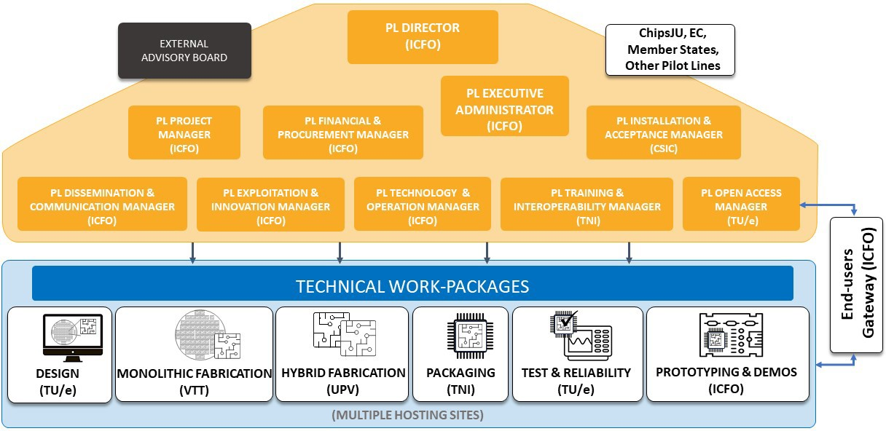

Figure 30: PIXEurope Pilot Line management structure for development, engagement and operation phases.

Decision making bodies
A challenging, large-sized and multidisciplinary Pilot Line like PIXEurope requires an effective, efficient and well-defined management structure. The proposed management scheme ensures a flawless exchange of know-how between various management levels. The main tasks will be to provide mechanisms to make decisions that will affect the Pilot Line’s outcome as well as administrative, technical and scientific coordination, and interaction with Chips JU, EC, Members States, other Pilot Lines, Design Platform and Competence Centres. In the case of PIXEurope, the management has to be effective for the operation and Open Access activities, closely connected to the technical WPs. Moreover, the defined structure will ensure the effective dissemination of the outcomes achieved during the Pilot Line and will help select the most appropriate exploitation routes for the generated know-how. The organizational structure, rights and duties of the operational bodies responsible for the decision-making are described in detail in the Consortium Agreement.
General Assembly (GA): GA is a high-level decision-making body at a strategic level. A GA will be established at the beginning of the Pilot Line, composed of key senior representatives from each partner organization; the Pilot Line Director will chair the GA and will be assisted by the Project Manager. The GA will be organized, will act and make decisions in line with the Consortium Agreement. All GA members have numerous years of experience in the relevant technological domains, with the majority of them participating in previous EC-funded programmes.
GA is responsible for:
- Keeping track of medium- and long-term objectives;
- Monitoring progress, achievements and costs, supervision of technical developments;
- Pilot Line exploitation strategies in order to guarantee their mutual consistency;
- Approval of contract amendments (if required) (budgets, resources, plans, etc.);
- Solving problems with potential effect on Pilot Line strategies and defining the necessary contingency plans;
- Solving conflicts on strategic issues.
Pilot Line Steering Committee (SC): The Pilot Line Steering Committee (SC), comprising all Work Package Leaders (WPLs) and the Pilot Line Director, will act as an executive decision-making body for the Pilot Line. The SC will be responsible for making decisions in those cases where it is unnecessary to refer to the GA. The SC will aim to reach a consensus wherever possible. If no consensus can be reached, decisions will be taken after a simple majority vote. The SC will meet at least twice a year on an ordinary basis and at least monthly through teleconferences.
SC is responsible for:
- Overseeing the progress of WPs;
- Controlling whether decisions needed for further progress are taken;
- Controlling that results are disseminated on time and the exploitation plans are effective;
- Supporting and motivating partners to perform their work at expected quality,
- Controlling that regular Pilot Line meetings are held,
- Amendments to the contract and Consortium Agreement are initiated
- Intellectual Property Rights issues are regularly reviewed
Conflict resolution procedures
Most of the decisions will be made by consensus among all the partners. As a first step, it is the role of the Pilot Line Coordinator to identify and resolve potential conflicts proactively in collaboration with WPLs. All cases will be discussed among the conflicting parties in good faith. However, in case of a serious conflict, when the Pilot Line Director cannot mediate between conflicting parties, either partner can ask the GA in writing to organise a conflict resolution meeting. The GA will arrange such a meeting within 30 days after receipt of the written request and attempts for arbitration will be made to increase the order of authority from the WPLs to the GA level. Within the meeting, agreements are searched for by dialogue and mutual concession. In case of a failure to find an agreement, the GA will make the final decision according to the voting rules described above (i.e., majority vote). Conflict resolution procedures will be agreed upon during the preparation of the Consortium Agreement.
Pilot Line Management and Coordination: key roles in management structure
The Pilot Line management structure is designed to ensure high-quality and timely implementation of the related activities, with a system of checks to ensure both technical, operational and strategic monitoring of the progress and agile decision-making mechanisms are in place. Note that for each role, we identify the partner assuming the responsibility, e.g. (ICFO).
Pilot Line Director (ICFO) will be responsible for the overall coordination of activities. The Pilot Line Director will be supported in this management task by the Pilot Line Administrative Executive, Project Manager, Work-Package Leaders, and the GA, who will be empowered to make high-level decisions on every aspect of the Pilot Line. The Pilot Line Director will be the sole interface between the Commission and the consortium and the contact point for communication with other Pilot Lines in the programme. Should any major problem arise, the Pilot Line Coordinator has the possibility to call for the Pilot Line SC
or for an extraordinary meeting of the GA. The Pilot Line Director, assisted by the Technology and

Operation Manager, is responsible for technical and operational monitoring of the Pilot Line. He will follow the Pilot Line throughout its whole lifecycle, on a day-to-day basis.
Pilot Line Administrative Executive (ICFO) will support the Pilot Line Director in the implementation and operation of the Pilot Line. In particular, she/he will be responsible for the overall distribution and optimization of resources and economic accounting of the Pilot Line. She/He will also be assisted by the Pilot Line Financial and Procurement and Pilot Line Installation and Acceptance Managers to ensure proper facility running and, with the Pilot Line Director, will be assisted by the Project Manager on the distribution of resources.
Pilot Line Project Manager (ICFO) supports the Pilot Line Director and WP leaders in their administrative, reporting, dissemination and communication organisation role. She/He will ensure prompt negotiation, and seamless Pilot Line project execution, consortium, amendments, monitoring and timing of technical deliverables and milestones, timely and quality reporting, and budget follow-up (e.g. checking cost statements and monitoring use of resources, etc.). The Project Manager will be responsible for proper information flow between GA and Pilot Line Director, and between WPLs and partners (minutes of meetings, decisions taken, to do lists, deadlines etc.). Moreover, the Project Manager will be responsible for organization of Pilot Line meetings.
Pilot Line Financial and Procurement Manager (ICFO) will support the monitoring of all phases of the calls for tenders, orders and deliveries of crucial equipment. She/he will assist the Pilot Line Administrative Executive and work closely with the Pilot Line Installation and Acceptance Manager. They will constantly interact with responsible managers of procurement at other sites of the distributed Pilot Line to promote common procedures and optimise the selection and operation of equipment.
Pilot Line Installation and Acceptance Manager (CSIC) will support the monitoring of all phases of the installation of crucial equipment, from delivery to acceptance. She/he will assist the Pilot Line Administrative Executive and work closely with the Pilot Line Financial and Procurement Manager. They will constantly interact with responsible managers of procurement at other sites of the distributed Pilot Line to promote common procedures and optimise the selection and operation of equipment.
Pilot Line Dissemination and Communication Manager (ICFO) will assist the Pilot Line Director, Administrative Executive and Project Manager in the dissemination and communication activities. She/he will be constantly monitoring and interacting with the entire Pilot Line consortium. The aim will be to inform the specialized research community and the society at large, as well as maintain informed the Pilot Line’s end-users about the latest achievements in research, technology and services.
Pilot Line Exploitation and Innovation Manager (ICFO) will assist the Pilot Line Director in the continuous assessment of the market potential of the developed know-how. By analysing evolving market characteristics and determining potential users and applications outside the Pilot Line, she/he will serve as the contact point for business-related issues (in cooperation with SC and GA). She/He will also manage the IP for the Pilot Line, according to the Open Access conditions outlined in the Relevance Section of the proposal.
Pilot Line Technology and Operation Manager (ICFO) will assist the Pilot Line Director in monitoring the technological and operational activities of the distributed Pilot Line. She/He will assist in the interaction with the Work Package Leaders and Hosting Sites for fostering technology innovation, assess the developments at different sites of the Pilot Line and promote synergies at both technology and operation levels. More specifically, she/he will be responsible for defining and preparing the distributed Pilot Lines operational system, including setup of the Gateway, details of the operational tools such as Customer Relationship Management (CRM). Interfacing with the digital platform provides real-time work-in-progress monitoring data for the operation-performance monitoring software, and defining key metrics to monitor and report on important operational metrics and KPIs.
Pilot Line Training and Interoperability Manager (TNI) will assist the Pilot Line Director in setting up and monitoring the training and interoperability activities. She/He will assist in the interaction with the Work Package Leaders to foster interoperability and will also be responsible for managing the setup and delivery of the PIXEurope’s training courses, which will be done in collaboration with the new European Competence Centres. She/he will lead the development of cost and sustainability model development, which will be included in the training programme. The training to form highly skilled personnel will be essential to increase the capacity of the Pilot Line and the offering to its external end-users. Training activities will be defined in collaboration with Competence Centres and other existing Pilot Lines (e.g EixFAb and JeppiX).
Pilot Line Open Access Manager (TU/e) will assist the Pilot Line Director in setting up, managing and monitoring the Open Access activities and procedures. She/He will co-define the Open Access services with partners in a consistent and intuitive format, ensuring full operational support and operational procedures are in place at partner organisations. Extensive homologation activities will ensure that service offered by partners are interoperable. The Open Access services will be made available to external end- users through Gateway using competence centres and eligible channels. The non-technical, operational aspects of workflow will be defined with partners. The Pilot Line Open Access Manager will also help create processes for the centralised Gateway which is planned to become available for the operational phase at the site of the Pilot Line Coordinator (ICFO). She/He will also provide analysis and
recommendations for operational improvements for the end user customer experience.

Management level | GA | EAB | SC | WPLs
Periodicity/Chair | Coordinator | Coordinator | Coordinator | WP Leader
Annually | x | x | x | x
Monthly |  |  | Teleconference | Teleconference

External Advisory Board (EAB): The External Advisory Board (EAB) support will guide the SC during the technical specification phase at the start of the Pilot Line. It will also advise on validating results, confirm the continuity of high-quality objectives before the mid-term review, and support result exploitation and the shift towards potentially new innovative products. During the project's first year, the SC will select high-level representatives from end-users. Industry and RTO representatives will be considered to create an optimal mix of different types of end users, including designers, suppliers, manufacturers, and vertical integrators. PIXEurope has already received significant interest from several high-level executives and researcher leaders in being part of the EAB.
Relation between Management and Coordination team, GA and SC
The Management and coordination team is responsible for supervising the operation and services of the Pilot Line. Instead, the GA and SC teams for the strategy, technical and operation aspects. Thus, the Director and other members who are part of all three teams must translate the strategic, technical and operation decisions of the GA and SC to the Management team for their implementation at operational level.
Quality Control Assurance
Progress of WPs will be regularly assessed. WPLs will have a key role in quality control, as they will be responsible for:
Monitoring progress in their own WP in terms of technical achievement, planned deliverables and milestones and identifying risks (e.g. non-performing partners) and rapidly informing the SC and the Pilot Line Director.
Ensuring that deliverables are produced to the agreed quality and milestones achieved,
Collection of technical and programmatic information needed to prepare periodic progress reports, Managing regular WP-level meetings and topic-oriented meetings, and report to the SC and Pilot Line Coordination on all matters related to the topic (planning, costs, etc.).
Continuous interaction with the 5 Managers of WP9-HE and WP3 listed previously and as shown in the
Figure 23, especially to build and operate the services to external end-users.
The progress of the Pilot Line will be assessed at two levels with the help of general indicators, which represent objectives, milestones and deliverables and appropriate use of budget. On top of that quality check, the Exploitation and Innovation Manager will ensure efficient translation of generated know-how to the commercialized products and services.
All deliverables generated by the persons in charge (see list of deliverables) will be checked and controlled in this sequence: WP leader > Pilot Line Manager > Exploitation and Innovation Manager > Pilot Line Coordinator and SC > submission to Chips JU/EC > Chips JU/EC Pilot Line Officer or reviewer. Moreover, the SC will conduct the internal quality assessment of milestones and deliverables that are based on the quantified objectives detailed in Annex 1, section 1.1 and within the WPs’ descriptions. The 6-month periodicity for the SC meeting is foreseen to perform an internal assessment of the Pilot Line and ensure the conformity and the quality of all Pilot Line deliverables with the requirements. Management and coordination efficiency will be quantified by the timeliness of partner reporting and the punctuality in the quality control process.
Meeting plans
Ordinary meetings will be organised according to the best practices developed during previous cooperative research Pilot Lines and to fully comply with Chips JU rules. Responsible personnel will inform at least 6 months prior to the meeting about the agenda and location of the physical meeting. To save time and resources, operational meetings could be performed via teleconferencing (e.g. MS Teams) or arranged according to the nearest possible availability. It is expected that all paperwork needed for the meeting to be productive will be submitted 5 days prior to the date.

Table 10: Pilot Line management meetings and communication

Innovation management
KPIs will be reviewed and analysed at 6-months intervals to ensure the Pilot Line remains on track to connect Pilot Line process and technology innovations to an optimum exploitation trajectory. Inputs from use cases will be collected and evaluated to assess the market readiness of Pilot Line solutions and technologies. The Exploitation and Innovation Manager will make sure that an IP strategy will always be in place to support and maximise exploitation.
Reporting to Chips JU and European Commission
It is foreseen that the Pilot Line will establish a cooperative relationship with the appointed Chips JU/EC Pilot Line Officer/s and nominated external reviewers. They will receive full access to the member’s
restricted area of the web archive to monitor progress and control the latest version of documents (meeting

minutes, deliverables, reports, etc.) in preparation. Deviations from the work plan will be proactively reported and contingency measures proposed.
#§CON-SOR-CS§# #§QUA-LIT-QL§# #@IMP-ACT-IA@# #@COM-DIS-VIS-CDV@#

IMPACT

  - Expected outcomes and deliverables — Dissemination and communication

Expected outcomes and deliverables
Define and explain the extent to which the project will achieve the expected impacts listed in Call document.
PIXEurope will have a profound impact on the science and technology of Europe, as well as on European industry, the economy and society at large. PIXEurope will build the PIC ecosystem to become an essential element of the European digital economy and society with a large variety of applications from communication to sensing, automotive, health and security. More specifically, PIXEurope will empower Europe’s innovators and safeguard European sovereignty by structurally connecting the latest semiconductor equipment and scientific research to up-scaled, industry-accessible research and development platforms. The project output includes a portfolio of complementary Open Access services to provide infrastructure access, MPW services and access to expertise. It empowers European industry to experiment, test and develop next-generation technologies to get ahead of the competition for next- generation products for high-impact applications from universal healthcare, safer and smarter buildings and transportation and the greening of communications and computing infrastructure.

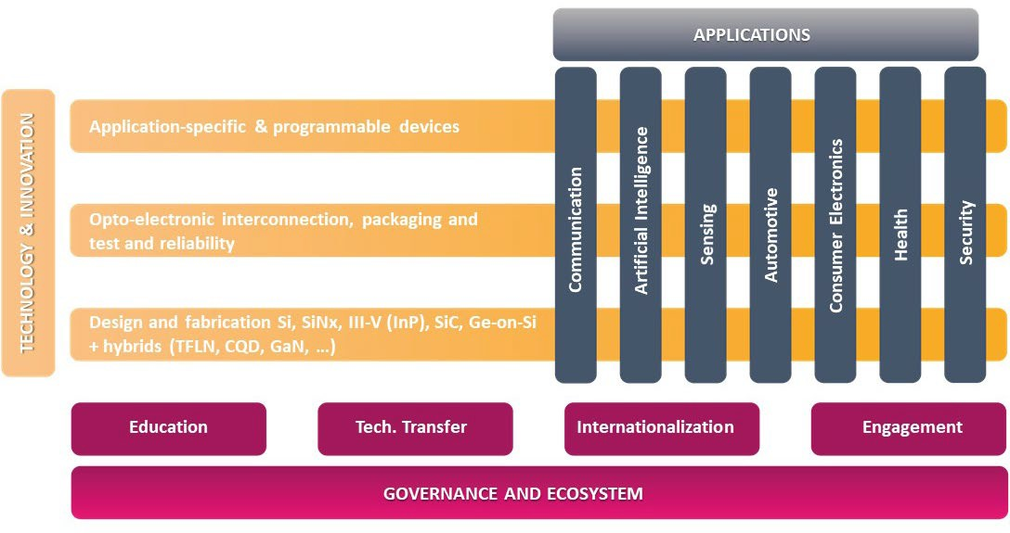
Figure 31: PIXEurope will enable the making of unprecedented innovations in PIC technologies both within the consortium and by the numerous external users of the pilot line. By leveraging the latest advances in semiconductor equipment, it will create a European infrastructure with all required activities (from design to fabrication, packaging, testing and prototyping) for addressing a wide range of applications.

A. The short to midterm in particular regarding availability of advanced capacities for testing and experimentation of advanced technologies.

In May 2024, a leading global OSAT company stated to PIXEurope partners that “Approximately 80% of companies, mostly SMEs and start-ups, approaching us for manufacturing support do not meet our selection criteria. We cannot support them as they are too early stage, too high risk and do not have immediate high-volume demands. A Pilot Line would clearly address this gap”. The same is true for wafer production, with a chasm in know-how and financial capacity between the capability of Europe’s disparate SMEs and the workflows required for sustainable foundry production. The proposed Pilot Line bridges the manufacturing gap by creating cost-shared, industry-ready workflows, standardised methods to maximise the capabilities available to any given designer, services that meet the needs of Europe’s SMEs and by upskilling Europe’s workforce to build innovation capacity.
The Development Phase: In the short term, we foresee the roll-out of the first Pilot Line Services using the already existing facilities (meeting immediate industry needs), with open standards for supply chain interoperability and seamless PIC module design, chip fabrication, packaging, and test offering (a world’s first). The same workflows will be used to build quality-controlled, intervention-free Design Kits for process Design Kits, assembly Design Kits and test Design Kits. This vision lays the foundations for first-time-right design for the full PIC-to-module build, reducing risk and accelerating design cycles.
The Industry Engagement Phase, starting by the end of year 2, enabled via complementary European programs according to the eligibility criteria, will ensure that the methods are validated as enabling and

complementary to industry capabilities, as shown schematically in Figure 30. This ensures that the capabilities, terms and conditions for the planned services meet the needs of the wider industry developer community. The consortium will build on the capabilities and partnerships developed in earlier European Pilot Lines, connecting existing developer communities to a pipeline of new platform capabilities.
The Operation Phase in the mid- and long-term ensures that critical emerging technologies will be rolled out by the partners in a roadmapped, structured way to enable product developers to align their own development programs to the latest emerging technologies. The improved visibility on use cases will enable feedback into new equipment and infrastructure needs, thus building resilience and a competitive supply chain with leading-edge services offered to industry. The operation phase will commence at the end of year 4 when a comprehensive range of technologies and services are ready for third-party research and development. Initially open access is offered on a restricted basis, to ensure that the way of working is of high quality, robust and scalable, and then after year five, with a focus on scaling to wider European engagement to ensure that the services can support the envisaged diversity in needs, application domains, and skills available within companies and the wider research community. Already in the Industry Engagement phase, particular attention will be paid to ensuring a symbiotic relationship with the industry.
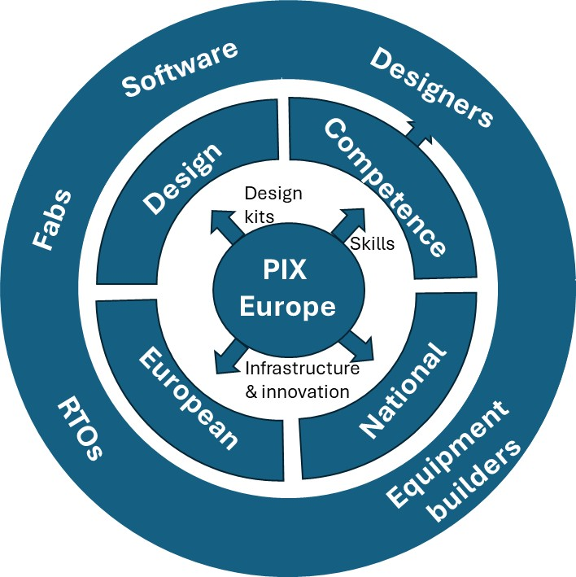
Figure 32: PIX Europe at the heart of European photonic innovation: Industry engagement phase involves updating Design Kits, upskilling industry and enabling state-of-the-art European research and development through Open Access services. The Pilot Line Operational phase consolidates industry engagement by synergistically connecting the wider community of RTOs, equipment builders, software developers and fabs through standards and road-mapping.

The roll-out of services will be accompanied by a communication campaign and networking activities organised within major events and conferences to ensure that European programs can optimally benefit from the capabilities developed in the industry engagement phase. In the Pilot Line operations phase, synergistic cooperations will be developed with the wider European industry by implementing the exploitation plan. Recognising that photonics has grown from many diverse scientific traditions and may appear fragmented to many new entrants, particular attention will focus on the common methods which are developed for the creation of PIC-enabled modules. In particular, communications will use the Semicon language to emphasise similarities and synergies with mainstream Semicon workflows. This both de-mystifies the technologies, enables some important myth-busting, and enables businesses to identify the resources needed to start PIC product developments. The end-users include SMEs, start-ups, large industries and RTOs, whose activities range from design to supply, manufacturing and vertical integration of products for a wide range of applications. Open access through the world’s first PIC Pilot Line provides unique capabilities for accelerating product development, design for manufacture, and will be crucial in bridging from low TRL to manufacturing in Europe, as depicted in Figure 33.

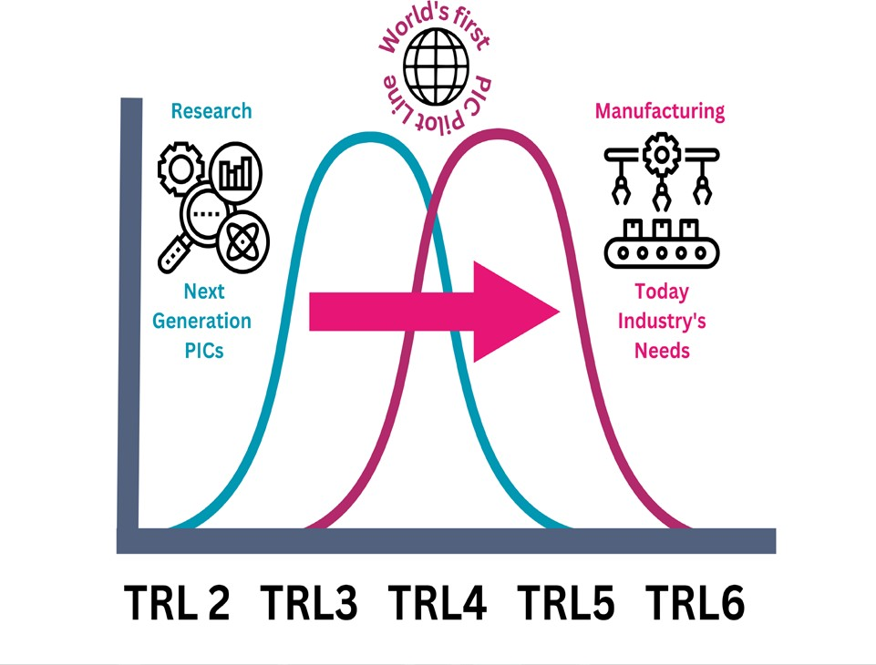

Figure 33: PIXEurope will address today’s industry needs while accelerating emerging PIC technologies. This will be done by increasing the Technology Readiness Level (TRL) and promoting services for the European industry and RTOs.

PIXEurope will impact several areas, from science to technology development, services for industry, and, ultimately, economy and society (Table 11).

Table 11: Impacts of PIXEurope in different areas

Science Open services: Industry-ready MPW services providing accelerated access to breakthroughs and advances, from new materials for PICs (e.g. SiC, phase-change materials and colloidal quantum dots) to extended functionalities and operation regimes (wavelengths from UV/VIS to MIR), will allow new integrated devices and systems for a wide range of applications. Stabler platforms enable innovations at the more sophisticated circuit function level. This enables the growth in capex-light fabless and labless innovators and spin-offs.

Technology Open infrastructure: Access to state-of-the-art equipment for training and test-before- invest experimentation. Reduced barriers for deep-tech companies working with the latest materials and processes, enabling shared training, and de-risking for new infrastructure investments.

Open access Open expertise, combining services, infrastructure access and expertise to tackle the and services big common challenges that face the wider industry, allowing shared costs and joint innovation with program lines. This will allow industry to accelerate TRL and MRL of their
products, leading to scaling of innovation and manufacturing capability in Europe and a focus for technology eco-systems.

Big data Data-driven design for next generation Pilot Line – specifically the InP PIC Pilot Line - delivers a field lab for digital production. Tool specification and interfacing are driven from the data architecture perspective to enable process diagnostics and optimisations through machine learning. This provides a solid basis for digital twinning and advanced factory automation.

In the following section, we will address the specific expected outcomes of the Chips JU CPL-5 call.

Contribution to Expected Outcomes
Develop and enhance PIC technologies by extending the operational wavelengths into the visible and mid-infrared spectrum, which is crucial for applications such as LiDAR and advanced sensing.
While most silicon-based and III-V photonic components have so far been realised in the near-infrared (near-IR) telecommunication bands, the visible (VIS) and mid-infrared (MIR) ranges also have a wide range of applications that impact our industry and society. These include short-reach fiber data transfer, free-space communication, light detection and ranging (LiDAR), augmented reality (AR) and head-up display (HUD), highly sensitive biological and chemical sensors, spectroscopy, and the quest for life beyond our planet. The rapid pace of advancements in VIS and MIR photonics has positioned it as one
of the most dynamic and promising areas of R&D.

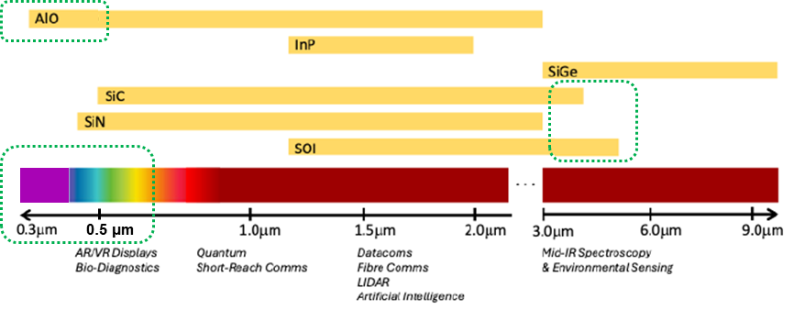

Figure 34: PIXEurope will develop PIC technologies covering a wide wavelength range, from UV-blue to mid-IR. This will enable users of PIXEurope’s services to address a diverse range of markets and applications.

PIXEurope creates integrated photonic technology platforms for UV/VIS (0.3-0.75 mm) and MIR (2- 10 mm) applications. In particular:
- In WP5-HE, we will develop: (i) SiN, AlO and SiC-based PIC platforms which have highly transmissive properties both in the VIS and MIR; (ii) monolithic Ge-on-Si which can extend the operational wavelength in the MIR.
- In WP6-HE, we will develop: (i) micro-transfer printing techniques to provide sources and/or detectors to the VIS monolithic PIC platforms, an example being red-blue-green (RGB) light emitting diodes on SiN; (ii) 2-D functional materials, especially graphene, which can be used for electro-optic modulation and plasmonic sensing on MIR platforms.

- In WP9-HE, by combining the technologies from WP5-HE and 6-HE together with design (WP4- HE) and packaging (WP7-HE), we have planned three demonstrators: (i) an RGB engine on a SiN platform for AR and HUD displays, (ii) a photonic processor operating in the VIS on SiN platform and (iii) a MIR Photonic Sensing Blocks on a Ge-on-Si platform for environmental monitoring.

By providing future services to companies that have already expressed interest in the Pilot Line for VIS and MIR PIC technologies, PIXEurope will generate an impact in several growing markets. Two specifically addressed by the CPL-5 call are LiDAR and advanced sensing.

For example, with respect to VIS-PIC related technology, EssilorLuxottica, a worldwide leader in the design and manufacturing of glasses, states in their letter of support to PIXEurope: “For developing augmented reality technologies for smart glasses, EssilorLuxottica recognises the importance of the PIXEurope Photonic Pilot Line. The complexity and variety of components are such that different developers and makers need to collaborate to address consumer applications. The PIXEurope facilities would represent an important opportunity for EssilorLuxottica to accelerate the development of AR technologies”.

Another example of a letter of support to PIXEurope related to LiDAR is from OMMATIDIA, which states, “Your initiative aligns perfectly with our goals of advancing Integrated Photonics for LiDAR and 3D optical metrology, and we are excited about the potential breakthroughs that our combined efforts can achieve. Together, we can drive innovation and create cutting-edge solutions for the industry”.

Robust LiDAR and environmental sensing applications benefit from longer wavelengths less susceptible to scattering. Looking further ahead, sensing in a wide wavelength range and with polarization diversity enables unique capabilities in materials identification as well as ranging and velocity measurement. VIS wavelengths provide high resolution and compatibility with existing silicon photonics technology. These properties make the MIR and VIS range critical to achieving the full potential of environmental sensing and, in the future, may be applied to LIDAR in automotive and industrial applications. New mass-deployment market opportunities also emerge in smart infrastructure, with applications in crowd monitoring in airports, autonomous checkouts, and traffic monitoring on highways and at intersections. These new applications and investments are expected to drive the LiDAR market to $6.3B in 2027 from
$2.1B in 2021.

VIS is used in several application areas of high importance. A traditional application benefiting from VIS is spectroscopy, a versatile analytical technique widely used across industries for its rapid and reliable measurements. Pharmaceutical research and quality assurance/control are ensured by accurately

quantifying molecules and monitoring structural changes. In environmental and industrial settings, UV- VIS enables efficient analysis of water samples both in the lab and field. Its versatility extends to materials testing, including thin films, solar cells, and optical coatings, particularly in advanced photonics research. Chip-based spectrometry enables a much wider market deployment. The global UV/VIS spectroscopy market was valued at USD 202.8M in 2023 and is expected to reach USD 328.2M by 2032. An example of an emerging mega-market is VIS optical engines (light sources) for AR, virtual reality (VR), mixed reality (MR) and HUD displays. The global AR/VR/MR optics and display market, valued at USD1.37B in 2022, is projected to reach approximately USD 22.05B by 2032, growing at a CAGR of 32.1% from 2023 to 2032.

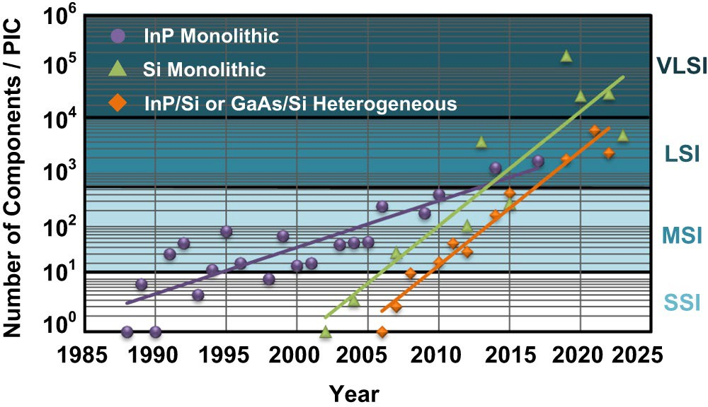

Figure 35: PIC technologies have seen rapid growth in integrating large numbers of components on a single chip. PIC chips are becoming more complex, and similar to their electronic IC counterparts, they are beginning to meet the demands of mass markets in terms of their performance and cost [“Roadmapping the next generation of silicon photonics”, Nature Communications, January 2024].

As silicon PICs advance toward commercialisation focusing on scaling for the short MIR range (2200 nm to 2400 nm), this enables other novel applications like lab-on-chip sensors and free-space communications. The global MIR market, especially related to sources, is projected to grow from USD 1.1B in 2023 to USD 2.9By 2033. Concurrently, improved efficiency light emitting diodes (LEDs) and detectors drive the adoption of LED-based nondispersive infrared systems for gas detection. Innovations in quantum cascade lasers (QCLs) enhanced precision and cost-effectiveness for emissions monitoring and real-time process control. The nondispersive infrared market is increasingly driven by a focus on environmental monitoring and greenhouse gas reduction, leading to a rising demand for sensors that detect gases like CO2, carbon monoxide, and volatile organic compounds (VOCs). Valued at $625.4 million in 2023, the nondispersive infrared market is expected to expand from USD 667.8M in 2024 to
USD1.1B by 2032.
PIXEurope will create quality-controlled Design Kits for platforms of wavelength from 350 nm through to 5000 nm using the same design flows, fully integrating test, assembly and packaging. In view of the impactful application areas enabled by MIR and VIS technology platforms and the related markets, the proposed Pilot Line is well positioned to generate significant revenues. Assuming a share of a few percent, the PIXEurope’s related business value across the whole chain, ranging from design to fabrication,
integration in a product and use in applications, is expected to reach 1B€.
Develop scalable and cost-effective manufacturing processes for PICs, ensuring compatibility with current industrial standards and promoting widespread adoption
Capacity building to enable large-volume PIC production is at the heart of PIXEurope’s Pilot Line. The White Paper on Integrated Photonics by EPoSS and Photonics21 (EPoSS, Photonics21, 2023) identified cost-efficient services for prototyping as one of the priorities for strengthening Europe’s position in the worldwide market of Integrated Photonics. Although there are EU-based PIC foundries with volume capability, these are not accessible to Europe’s SMEs, and a Pilot Line is needed to bridge to the required manufacturing readiness level.
PIXEurope will build industry-grade research capacity across the full value chain to pilot production processes and provide the blueprints for Europe’s advanced PIC factories. The cost saving of wafer production scales with capacity and with yield. To this end, PIXEurope leverages the upfront
investment into advanced equipment to increase the PIC integration levels, de-risks the transfer

to larger wafer sizes, and matures hybrid integration processes for novel materials. The design methods are developed to enable designers to maximise production efficiency and yield.

The following table shows the SoA wafer sizes vs. Pilot Line wafer sizes to be achieved at the end of the PL development phase (for details on Pilot Line phases, please refer to the first part of Annex 1, Section 3.2, “Implementation,” of the proposal).

Table 12: State of Art (SoA) wafer sizes vs. PIXEurope Pilot Line wafer sizes

Platform SoA wafer size (mm) Pilot Line wafer size (mm)
InP 100 150
SiN 150 200/300
Thin SOI 200 300
Thick SOI 150 200
SiC Not available 150
MIR PICs 100 150/200
UV VIS PICs Not available 150/200
The migration to 150 mm for compound semiconductors is driven by the emergence of killer applications in sensing and communications, the increasing availability of high-quality substrates, and the leveraging of equipment developed for the microelectronics industry. Si processes will focus on 200 and 300 mm to facilitate larger area circuits, enable transfer to industrial production and exploit industry foundry investments. In both cases, using state-of-the-art tools and larger wafer areas enables improvements in the performance and yield through improved fabrication tolerances and a route to cost-downs as production volumes increase for a given process. As an example, the transition from 75 to 100 mm epitaxy at TU/e lead to layer thickness control from 5% to 1.5%. The compositional control and dimensional control from the transition to 150 mm will enable unprecedented control over wavelength accuracy and circuit uniformity. The increased wafer area is also augmented by wafer batch increases, providing a route to
aggressive per-chip cost reductions for a volume process. The MPW methodology ensures that the production cost benefits from volume scaling can be available regardless of the production run size.
Foster the integration of PICs with electronic integrated circuits, enhancing the functionality and efficiency of combined systems for applications in computing, telecommunications, and beyond.
PIXEurope primarily focuses on PIC and PIC-PIC integration. An example of the latter is the transfer printing of III-V components onto SiN waveguide platform and glass PIC interposer for coupling Si PICs and optical fiber connectors. However, the integration of PICs with EICs represents a necessary condition for the successful deployment of photonic technology systems: there is no photonics without electronics. The main challenges remain the low-cost energy-efficient integration of photonics with the electronic circuitry used for driving and controlling the photonic IC and processing its information and packaging, which is acknowledged as one of the main roadblocks to photonic integration within ICs. During the Pilot Line development phase, activities on PIC-EIC integration include:
- In WP4-HE, we will develop designs that combine PICs and EICs. More specifically, the Si-based PDK will be extended to include the newly developed scaled Cu microbumps module and with design rules for known-good die (KGD) testing.
- In WP5-HE, the incorporation of scaled Cu microbumps will allow high-speed RF EICs to be flip- chip bonded onto Si-based PICs with ultra-low parasitics (capacitance <20fF) and ultra-low RF loss (0.1-1dB) at frequencies out to 140GHz and beyond. When combined with the high-speed GeSi electro-absorption modulators and photodetectors, or wideband InP phase modulators, high-efficiency electro-optical transmitters and receivers at up to 400Gbps PAM-4 per lane could be achieved.
- In WP7-HE, electro-optical interposers will be developed for co-packaging of PIC and EIC chips. This automated wafer-level process will be highly scalable, enabling multi-project runs and scaling to large volumes beyond what is currently possible. Additionally, PIC chips will be designed for wafer-level packaging and die-to-wafer-scale EIC-PIC flip-chip assembly processes will be developed for reliable and high-yield assembly with the scaled Cu micro bumps.
- In WP8-HE, KGD testing methods will be developed for highly parallel transceiver PICs with high channel count (16-32) at 300 mm wafer-scale. This will involve widely parallel optical and electrical testing to verify the PIC functionality before bonding the (expensive) EIC dies.
- In WP9-HE, functional hybrid EIC-PIC demonstrators will be developed, targeting optical engines operating at 400Gbps PAM-4 lane rates for datacom transceivers and a co-packaged optical interconnect module for computation.
We have a large number of end-users who expressed interest in PIXEurope and can highly benefit from advanced in PIC-EIC integration. For example, Intel, Corning and Nokia develop products for optical interconnects and transceivers (Telecom market). These applications are also covered by the demonstrators, reinforcing the commitment of the proposed Pilot Line to develop technologies and

platforms for significant markets. The PIC-related Telecom market is valued at about US 2.4 B$ with an expected CAGR of >40% over the next years by 2027.

PIXEurope will work closely with Pilot Lines CPL-3 and CPL-4 for EIC integration. With the former, more focused on heterogeneous electronic integration, links will be established to extend their technologies to PIC-EIC. With the latter more focused on wide-bandgap power electronics, we will investigate the synergies of using SiC as both a photonic and electronic platform and the enablement of co-designed,
hybrid circuits.
PIXEurope will develop and demonstrate novel, high-throughput processes and make designs combining PICs and EICs available through standardised PDKs and create synergies with CPL-3 and CPL-4 to build European capability for upscaled PIC-EIC integration.
Innovate in the fields of photonic testing and packaging to improve the reliability, scalability, and performance of PICs.
Rapid progress in making photonic ICs has outpaced the developments in test, assembly, and packaging (TAP) for integrated photonics. The TAP processes are essential for turning PICs into functional devices and products that can be manufactured in volumes with the desired yields. However, currently, the TAP processes can require considerable manual labour and operator interventions, and account for up to 75% of the cost of a PIC-based product.
Packaging is recognised to be a significant cost contributor to PIC manufacturing. This is due to the slow package-level processes commonly used to assemble PIC chips in packages that require optical and electrical connections and thermo-mechanical components to manage heat and ensure stable mechanical performance. These cost constraints and limited throughput capabilities result in a packaging bottleneck that blocks users from commercialising full system solutions. Additionally, PIC chips are becoming more complex, with increased optical and electrical connections, particularly for emerging applications such as AI. A more disruptive approach is required to address these considerable cost, design and manufacturing challenges. PIXEurope will develop a novel electro-optical interposer consistent with state-of-the- art EIC chiplet packaging technologies. This wafer-level approach will enable standardised packaging processes using standardised packaging equipment such as automated flipchip bonding tools. This approach will also enable the co-packaging of photonic and electronic chips on a common electro-optical interposer. This will reduce unit packaging times from minutes to seconds through standardised, automated process steps. PIXEurope targets reducing process time to 120s for packages made through wafer-level processes. This will mean a 4-5 times reduction in process times, moving from current standard packages to 300 mm wafers and over 10 times for larger panel-level processes. Operational innovations will enable the parallel procurement of codesigned substrates, chipsets, test interfaces and package materials.

There will also be a significant increase in the number of optical and electrical connections achievable using this technology, enabling emerging mass-market applications to be manufactured in volume. PIC chips will also be designed for wafer-level packaging, including design features such as surface coupling and copper pillars for eutectic flip chip bonding. The wafer-level approach is inherently more reliable as materials such as epoxies that bond optical fibres to the PIC waveguides will be eliminated. Automation of the packaging process also ensures increased repeatability and improved yield. It is planned to develop demonstrators that will showcase 100 optical and 1000 electrical connections, which can scale to even higher numbers of connections. These wafer-level processes will be made available to users through multi-project runs and will be ready for scaling to volume production. The current package-level approach is suitable for low-to-medium volume process capabilities (e.g. 100 to 1,000 units), while the required volumes are projected to reach over 100,000 units. PIXEurope will showcase a capacity to process with a capability of up to 150 units (wafer-level) and 625 package units (panel level) per run. External industry partners will be engaged to transfer processes to scale-up.

A major challenge for industrial assembly has been the dependence on custom packaging solutions, leading to expensive non-standard packages at costs an order of magnitude higher than the actual PIC chip cost (https://www.fibre-systems.com/feature/problem-packaging). PIXEurope will prepare standardised design rules in the form of Assembly Design Kits (ADKs) and make them available to users
on an Open Access basis.
PIXEurope will advance packaging technology to transition from package-level to wafer-level processes, aligning to innovations in the electronics IC sector. Improved capability will bring 4-5 times reduction in process times, increase yield, and prepare processes to be taken up for large-volume production (100,000 units) to respond to the demand of emerging mass-markets.
The TAP processes can account for up to 75% of the cost of a PIC-based product and the test on its own is reaching nearly 30%. This high contribution is mainly attributed to the complexity of test processes, lack of standard tools and solutions, and ultimately, time needed to test a component, i.e. time-to-test. Test processes need to be strategically deployed at every stage of the product creation chain, which is critical for high-yielding production at scale. For integrated photonics to become an integral part of the
semiconductor supply chain, reliability related failure mechanisms must be identified and remedied early

in the production process in adherence to the industry standards and qualification criteria. The PIC technologies are based on diverse material systems, which further increases the complexity and the need for PIC-specific characterisation, test, and reliability methods to better utilise massive, in-process metrology for root cause analysis and failure mode effects analysis. The time-to-test has to be reduced dramatically by up to two orders of magnitude. This can be achieved by highly parallel and automated tests deployed early in the production flows, at the front-end. The Wafer-Level-Test (WLT), Wafer-Level Reliability (WLR), and wafers-scale high-resolution inspection systems developed in PIXEurope will be essential for highly yielding pilot production and inevitable for scale-up to high volume manufacturing. It is planned to deploy WLT, WLR, and inspection systems capable of processing tens or even hundreds of wafers per day, with supporting substrate diameters up to 300 mm. Test methods and solutions allow for the assessment of photonic components with time-to-test in the order of a few seconds or sub-seconds will be developed. Moreover, Design-for-Test (DfT) methodologies, along with openly accessible, standardized, mature, and production-grade Test Design Kits (TDK), will be made available in Open Access mode. The DfT will dramatically reduce the number of errors before production commences and ultimately shorten the design-in windows for new products. Practical implementation of
the DfT, along with the TDKs, will be showcased in PIXEurope demonstrators.
PIXEurope will develop Wafer-Level-Test (WLT), Wafer-Level Reliability (WLR), and wafers-scale high- resolution inspection systems, with the capacity of processing tens to hundreds wafers/day, enabling time- to-test a component in the order of seconds. Design-for-Test methodologies will be made available in a
form of TDK in Open Access mode.
According to the Yole Group, TAP has also become a strategic priority for governments and industry leaders given geopolitical tensions, supply chain disruptions, and the race for technological supremacy. The TAP supply chain is undergoing a significant transformation: OSATs are expanding their testing capabilities. Foundries, substrate suppliers, Electronics Manufacturing Service providers and Original Design Manufacturing providers are all making inroads into packaging and assembly, blurring traditional boundaries. PIXEurope will secure European technological sovereignty in this area and attain a share of the Advanced Packaging market, which has gained a value of $37.8 billion in the year 2023 and is expected to surpass $69.5 billion by 2029, showcasing a CAGR of 11% during the period from 2023 to 2029. [https://www.yolegroup.com/press-release/advanced-packaging-industry-geopolitics-is-moving-
the-pieces-on-the-chessboard/].
Enable rapid prototyping through standardised Multi-Project Wafer runs and specialised one-to- one services, allowing for timely validation and iteration of PIC designs.
PIXEurope will launch rapid prototyping in the Development phase (grant period) of the project to facilitate timely validation of Design Kits. Validation methods will be automated to ensure interoperability of Design Kits before release. The design methods will be configured to identify and address design flaws before tape-out. At the end of the operational period and during the sustainability phase (after the grant period), PIXEurope Pilot Line will offer MPWs enable the creation of state-of-the-art scientific breakthroughs within the European photonics community. This will have a significant impact on European SMEs, which will benefit in various ways:
:
- Prototyping for end-users: PIXEurope’s services allow European SMEs, start-ups and RTOs to develop and demonstrate their technology at the prototype level and enable informed decisions prior to transfer to external manufacturing sites.
- Fabless Innovation Acceleration: Supporting the development of novel photonic devices and systems by allowing researchers and engineers to outsource the production and experimental assessment, enabling them to focus on new circuit ideas. PIXEurope will offer these beneficiaries the unique possibility of accelerated design through accurate design tools covering the full flow from wafer to module.
- Reduced Time-to-Market: The introduction of hybrid integration platforms that build upon the monolithic platforms enables rapid prototyping that can significantly reduce the time to market for new photonic products by speeding up the design validation process, giving companies a competitive edge.
- Customisation and Flexibility: The breadth of platforms that can be combined using the same Design Kit standards and design flows allow for the customisation of PICs for specific applications, which are increasingly important in fields like telecommunications, sensing, and quantum technologies, where bespoke solutions are often required.

The capacity of the proposed Pilot Line will increase significantly with the new equipment operating at the end of the development phase and throughout the operational phase. Figure 36 below summarises the standardised MPW services provided by PIXEurope. This includes 23 Monolithic Wafer and 10 Hybrid Integration MPW runs, 6 Packaging, 40 Test and 20 Reliability service runs. Additionally, PIXEurope will offer specialised services such as material and structural characterisation of PICs, deposition of ultra- thin films, micro-nano structuring of waveguides and surfaces. All of these advanced services will largely use the newly installed equipment.

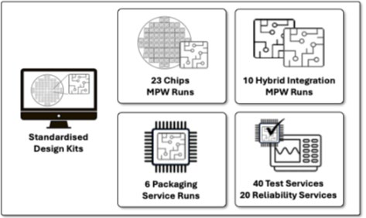

Figure 36: Summary of PIXEurope’s standardised MPW runs, packaging, test and reliability services. All services will be compatible with PIXEurope’s standardised Design Kits, enabling users to easily design PICs from chips through to packaging and test.
Develop demonstrators to validate the achievement of the advanced PIC technologies and to quantify their performance.
PIXEurope dedicates WP9-HE entirely to validating PIC-developed technologies. The proposed 8 demonstrators have been selected to cover all relevant technology platforms developed in the Pilot Line, from design (WP4-HE) to monolithic and hybrid fabrication (WP5-HE and 6-HE, respectively), packaging (WP7-HE) and testing (WP8-HE). We note that besides demonstrators that put together different technology components, the proposal also presented KPIs for each component separately and for the demonstrators themselves (Annex 1, Section 1 “Excellence”). All KPIs are quantitative data that also help assess integration platforms’ performance. In the table below, we list the 8 demonstrators and indicate the main technology platforms that we validate and the partners involved.
Table 13: Demonstrators to validate PIXEurope's technology platforms. For a detailed description, especially KPIs, please refer to the Annex 1, Section “Excellence”, of the proposal, where quantitative data for the different technology components and demonstrators can be found
 | # | Name | Application | Wavelength | Leader | Technology platform
 | 1 | Optical Space Switch | Communications, Quantum | C Band | ICFO | SiN
 |  |  |  |  |  | TFLN (on SiN)
 | 2 | Ultra High-Speed Coherent Transmitter | Communications | C Band | IMEC | SOI, III-V, TFLN
 |  |  |  |  |  | EIC
 | 3 | Next-Generation SFP for PON Optical Transceivers | Communications | C Band | IMDEA | III-V
 |  |  |  |  |  | SOI
 |  |  |  |  |  | EIC (amplifier)
 | 4 | Visible Light Engine for Displays | AR/VR | Visible | TNI | SiN
 |  |  |  |  |  | Red Laser
 |  |  |  |  |  | Blue, Green
 | 5 | MIR Photonic Sensing Blocks | Sensing | MIR | WUT | SiN
 |  |  |  |  |  | SiC
 |  |  |  |  |  | Ge-on-Si
 |  |  |  |  |  | 2D Materials

 |  |  |  |  |  | TFLN
 |  |  |  |  |  | QCL
 |  |  |  |  |  | Detectors
 |  |  |  |  |  | Design
 | 6 | LiDAR Transmitter for Multi-Modal Sensing | LiDAR | C, O, 2um | TU/e | InP
 | 7 | Programmable Photonic Processor | AI,  Communications | C, O, VIS | UPV | SiN (vis, O, C)
 |  |  |  |  |  | InP SOA Coupons (O, C)
 |  |  |  |  |  | RGB Coupons (VIS)
 | 8 | Co-Packaged Optics & Electronics for AI | AI, CPO | C, O | IMEC | SOI (300 mm)
 |  |  |  |  |  | Polymer Chiplets
 |  |  |  |  |  | EIC
In addition to platform and interoperability validation, the proposed demonstrators provide the blueprint for workflows for future services. They will be used to fine-tune the operational flows to present end-users with the technologies and services that will be offered by the Pilot Line. We note that demonstrators target prominent applications. They are thus particularly important to vertical integrator end-users, for example, as a starting point in creating new prototyping activities for their products.

Demonstrators are proof points to stimulate market engagement with the PIXEurope Pilot Line beyond the 5-years grant period. Through the services of the Pilot Line, the end-users will be able to accelerate the increase in TRL to address almost all growing application areas for PICs, from communication to sensing, interconnect in data centres, processors for AI, quantum and information displays for AR, VR and HUD.

Figure 38 clearly quantifies the market potential related to them.
Demonstration success stories will be shared through scientific and non-scientific articles, project website, leading conferences, social media and other relevant communication channels, using the PIXEurope branding. This will raise awareness of PIXEurope foundry and service capabilities, in this way attract end- users in different application areas.
Supporting National and European initiatives to build and expand expertise in advanced semiconductor technologies and manufacturing.
PIXEurope consortium partners have received significant support and backing from their national governments. All participating countries see the investment in PIXEurope as a critical part of their strategies to develop greater expertise and awareness in advanced semiconductor technologies, particularly in advanced semiconductor manufacturing and the creation of skilled jobs. They also see photonics as a key and enabling technology which has great synergy with microelectronics.
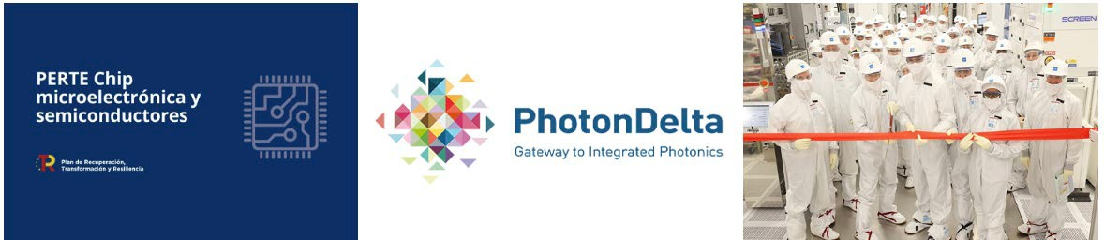

Figure 37: PIXEurope consortium partners have received significant support and backing from their national governments. Examples include Spain (PERTE Chips Act will invest EUR 12bn in semiconductor technologies), the Netherlands (PhotonDelta Growth Fund has invested EUR 1.1bn in PIC technologies) and Ireland (supporting major investments in semiconductor manufacturing industries, including Intels new Fab34 costing 17bn Euros).

The development of advanced services by PIXEurope, such as multiple MPW chip and hybrid integration services, as well as packaging and testing services, will positively impact on the creation of new startup companies and bolster existing companies’ technology portfolios at a national level. This further supports

the creation of new high-skill jobs. PIXEurope’s focus on training in advanced PIC manufacturing processes and technologies will also educate the workforce needed for these jobs. It will ensure new employees receive highly specialised and dedicated training (online and hands-on training) and can be rapidly deployed to support companies in growing their business. PIXEurope will support the ongoing training needs of these companies, ensuring companies are flexible and responsive to evolving market demands.

B. The wider impacts, in the longer term

PIC technologies are set to revolutionise multiple sectors. In telecommunications, PICs will enhance transceivers and interconnects, driving more efficient data transmission, especially for AI. In the automotive industry, applications such as LiDAR and gyroscopes will benefit from PICs, advancing vehicle automation, driver, passenger and pedestrian safety. Meanwhile, quantum cybersecurity and quantitative trading will leverage PICs to enhance security and processing power in the finance sector, paving the way for more robust financial systems. According to Mordor Intelligence, the PIC Market size is estimated at USD 15.11B in 2024 and is expected to reach USD 38.35B by 2029, growing at a CAGR of 20.7% during the forecast period (2024-2029). [https://www.mordorintelligence.com/industry-reports/hybrid- photonic-integrated-circuit-market].

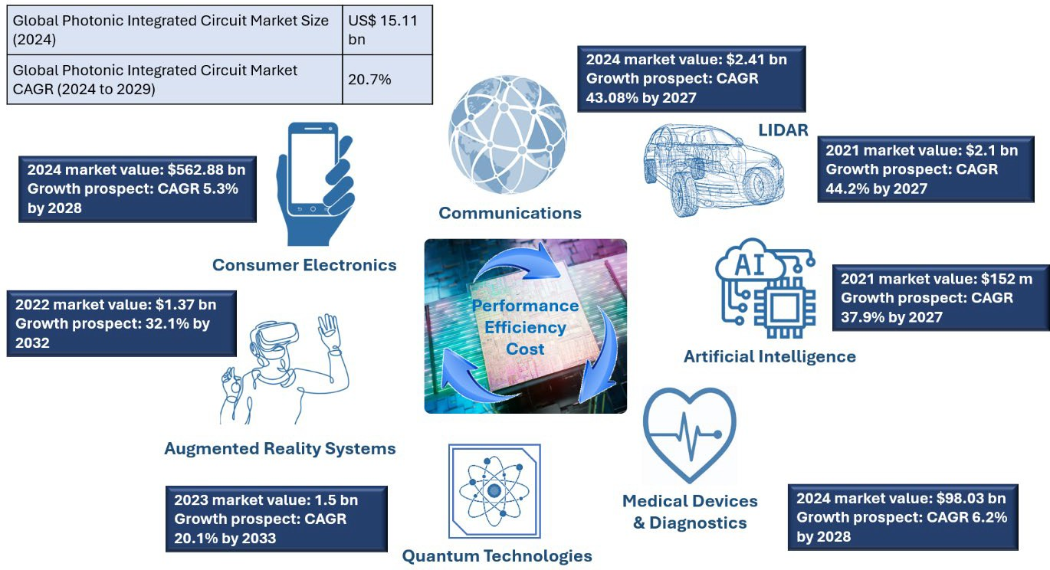

Figure 38: PIC-enabled markets: Communications (transceiver, interconnects), Automotive (LiDAR, gyroscope), Augmented Reality Systems (Sources and waveguiding), Artificial Intelligence (Interconnects and Processors), Consumer Electronics, Medical Devices & Diagnostics, and Quantum Technologies. [Mordor Intelligence, Global Photonics Market, OPTICA, Future Market Insights, Precedence Research, World of Photonics.com]

Europe still has a leading role, particularly in R&D in photonics: the number of publications from 2017-21 was more than twice that of the US. However, other competing economies have already implemented investment plans that will help them commercially exploit the significant opportunities that photonics will provide to their economies and improve their position in the market.

Specifically, China has a proactive approach to implementing industrial development plans and funding, with its government steadily increasing its annual spending in photonics, complemented by regional investments, often a multiple of central government funding. This massive investment effort will reach EUR 39B in 2024. A study published in July 2024 by Europe’s photonics technology platform, Photonics21, shows tremendous growth in China’s photonics industry, with a global market share increasing from 10% to more than 30% over the past two decades – dwarfing both the US and Europe each with 15% respective shares. The new study shows that despite China’s GDP growth gearing down from a rapid 7% to a steadier 4% over the next few years, photonics production in China is still expected to reach €315bn in 2025. [https://www.photonics21.org/2024/experts-urge-eu-to-increase-investment-in- photonics-or-risk-falling-behind-china].

Other countries, which are seeking to keep high-value manufacturing jobs onshore, are also investing. In the US, photonics has been classified as a strategic key enabling technology and has identified critical photonics-driven fields crucial to US competitiveness and national security. One example from the US is

the AIMs initiative, which provides more than USD 1B of public-private partnership funding in different phases for developing US-based integrated photonics manufacturing capabilities.

As a result of these global investments in photonic integration, Europe’s place as a market leader is not guaranteed and requires immediate actions and active support. We note several shortcomings for the European PIC industry, including:
- Reliance on foundry processes outside Europe;
- Low (about 15%) market share;
- Low investment levels, currently less than 20% of the investment in the US;
- Business acquisitions by non-EU entities.

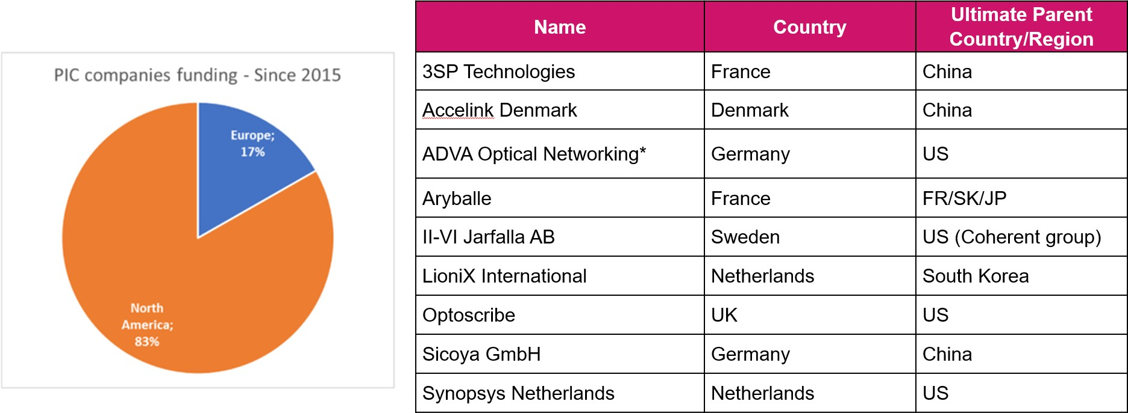

Figure 39: Examples of shortcomings of the European PIC ecosystem: the investment of European companies is low (left), and several non-EU entities have acquired European companies in recent years (right).

European companies have a strong technology position and the potential to succeed in PIC-related businesses (Table 14). A long-awaited public investment and policy action like PIXEurope will allow Europe to capitalise on its knowledge and transfer technology to realise its full market potential. The main challenge is transforming promising research and early-stage inventions into innovative solutions.
Table 14: List of European companies showing potential in the PIC value chain.
 | Company | Country | Potential
 | Sivers Semiconductor | UK, SE | Key supplier of III-V components to the global silicon photonics community
 | Smart Photonics | NL | First advanced pure play PIC foundry
 | Xfab | FR, DE | Volume silicon fab licensing photonic platforms
 | Ligentec | FR, CH | Produces photonic integrated circuits
 | III-V Labs | FR | Advanced III-V electronics and photonics
 | Phix | NL | Offer process development and manufacturing in scalable volumes for photonics and MEMS
 | Argotech | CZ | one stop service provider for design, assembly and packaging in semiconductor photonics and microelectronics
 | Lumentum | UK | Volume supplier of III-V components to communications and sensing markets
 | Coherent | DE, SE | Volume supplier PIC components to communications and sensing markets

Dissemination and communication of the project and its results
If relevant, describe the communication and dissemination activities, activities (target groups, main messages, tools, and channels ) which are planned in order to promote the activities/results and maximise the impact. The aim is to

inform and reach out to society and show the activities performed, and the use and the benefits the project will have for citizens
Clarify how you will reach the target groups, relevant stakeholders, policymakers and the general public and explain the choice of the dissemination channels.
Describe how the visibility of EU funding will be ensured.
In case your proposal is selected for funding, you will have to provide a more detailed plan for these activities (dissemination and communication plan), within 6 months after grant signature. This plan will have to be periodically updated; in line with the project progress.
Dissemination
Several high-quality measures to exploit and disseminate PIXEurope’s results and to communicate the planned activities to different stakeholder groups have been identified.
ICFO will lead dissemination and communication activities to ensure a comprehensive, well-structured and personalized approach towards stakeholders. A broad cross-section of stakeholders will be targeted to share the project results with the European science community, supporting the commercialisation of the system and facilitating policymaking. To prevent any infringement of exploitation efforts, strict rules of dissemination review and approval will be applied in line with EC/Chips JU rules. Peer-reviewed publications and research data will be handled in an open-access regime (see Annex 1, Section 1.2.8.)
The PIXEurope dissemination plan provides the guidelines for focused actions to deliver key messages to relevant stakeholder groups, which are listed below.
Table 15: Summary of PIXEurope stakeholder groups and associated dissemination activities
 | Stakeholder Group | Dissemination Measures
 | Experienced Industrial Users | A key dissemination activity targeting this group is training and workshops on the PIXEurope technology standards. Another activity for these users will involve on-site training at the Pilot Line facilities. This will include Open House events and dedicated user site visits to partner facilities.
 | Potential Industrial Users | A key dissemination activity is to encourage and educate this group in workshops, where demonstrators will be used as case studies, and partners participating on technology demonstration will provide testimonials as to the benefit of PICs and access to the Pilot Line. This group would also be trained on packaging standards, so they can become more aware of manufacturing protocols within the Pilot Line.
 | Third Party Industrial Users | This stakeholder group are not directly involved in the manufacturing of photonic technology products but would greatly benefit from their use. Dissemination activities will be non-technical and will focus on promoting the benefits of PIC technologies, and on highlighting the availability of sustainable Pilot manufacturing. A key dissemination activity for this group will involve the use of application demonstrators to highlight the benefits of PIC technologies. This will be achieved through presentations at tradeshows and exhibitions (e.g., Photonics West, Laser World of Photonics, ECOC, Medica, Electronica, ISSCC - International Solid-State Circuits Conference and EPIC technology meetings). This will encourage this stakeholder group to request that their suppliers (Experienced and Potential Industrial Users) develop PIC-based  solutions for their future products.
 | Research and Scientific Community | The research community can be divided into two groups; photonic experts and non-experts, with different dissemination measures required for both. The key method for engagement with these groups will be through technical conferences such as ECOC, OFC and Photonics West. Non-photonics conferences will also be targeted to encourage new entrants to evaluate the potential of PIC technologies for their business.
 | Other Pilot Lines and PIC Initiatives | It is critically important that PIXEurope forms strong partnerships with the other Pilot Lines, European Digital Innovation Hubs, PhotonHub Europe, and Chips JU Competence Centres and Design Platform. A key dissemination activity will be an annual Pilot Line workshop, where invitees from other Pilot Line consortia meet to present their capabilities, review synergies between Pilot Lines, and follow new opportunities for collaboration and best-practices sharing.
 | Standards and | To promote its packaging standards, PIXEurope will target key standards

 | Regulatory Bodies |  | bodies, (e.g., IEC - International Electrotechnical Commission and IEEE Standards Association) with technical presentations outlining the benefits of adopting standards for PIC packaging. Open standards will also be supported where appropriate.
 | Policy Makers & Funding Agencies |  | A key dissemination measure for this important group will be the dissemination of top-line KPIs and metrics. This includes KPIs on user numbers, revenue generation, and job-growth opportunities. Key policy makers include the European Commission, Chips JU, Photonics21, and national agencies. Interaction with governing bodies will be encouraged (e.g. participation in policy dialogues, fora, surveys). KPIs will be presented and disseminated at high-profile events, such as Photonics21 annual meetings and HE promotional events.
 | Media & General Public |  | The key method for dissemination to media and the general public will be through social media, including a project website, LinkedIn, X (formerly Twitter), and press releases. Additional activities will include “open-day” site tours for students to increase engagement in STEM, which will be primarily managed by the individual research organisations, who have significant experience managing outreach activities.
Communication
PIXEurope will move from one-way communication to two-way communication to effectively inform our target audiences and stakeholders - Public, Researchers, Industry, End-users - beyond the partners’ networks about the project itself and the results. Regular interaction and user-centred dissemination and communication materials (e.g., workshops for professionals, regular exchange meetings with industry partners, training workshops for scientists, inclusive design, interactive online campaigns). The main message and overarching vision to convey:

PIXEurope will develop a European Photonic Pilot Line to provide all European citizens with the socioeconomic benefits of advanced photonics technologies. Therefore, the PIXEurope consortium brings together scientific and technology expertise from across Europe to validate photonic technologies for upscaled production and ensure the security of supply for European citizens.

The message will be conveyed through the following channels:
- The PIXEurope project webpage will offer user-friendly and up-to-date access to the project’s progress achievements and crucial facts and figures. All public materials, such as presentations, leaflets, posters, journal publications, press releases, and public deliverables, will be accessible for download. Information about the state-of-the-art of the project’s related fields and how the project will address its main challenges will be found there. Visual and straightforward content will encourage visitor interaction, e.g. through videos, a news and updates section, FAQ or newsletter subscription.
- Social media channels (LinkedIn, X (Twitter), YouTube) will be used to reach a broader audience with engaging content and transmit the project's main message. They will also allow for a simplified and creative way of communicating the need, project concept, and results.
- The communication kit will introduce the project's visual identity and a set of materials (e.g., post templates, slide deck, leaflet, roll-up, brochure, press release text).
- Press releases will be circulated to international and national media contact lists.
- The partners will actively organise and attend events for targeted engagement and education of relevant stakeholders, demonstrating the project outcomes and gaining crucial feedback. Additional communication/community-building tools and techniques will be considered (e.g. videos, interviews, blog posts, newsletters, or quizzes).

All activities will be monitored through defined KPIs and, if needed, adapted and refined to maximize their impact.

Table 16: Summary of PIXEUROPE Communication Activities
 | Objectives | Targets |  | Tools & KPI´s | Engagement / feedback
 | Increase awareness of  the PIC  technology | Public Researche rs Industry End-users |  | > 3000 website visits per year | - Collect public opinion on the problem and its seriousness
 | Increase awareness of  the PIC  technology |  |  | 1000 social media followers | - Collect public opinion on the problem and its seriousness
 | Increase awareness of  the PIC  technology |  |  | 2000 copies of printed material  distributed | - Collect public opinion on the problem and its seriousness

 |  |  | 1 press release/year published by 5 media outlets | - Make industry aware of the business opportunity  - Inform end-users that their problem is being resolved
 |  |  | 3 videos viewed 1000 times each
 | Receive feedback on the project approach | Researche rs Industry End-users | Annual meeting with the External Advisory Board composed of relevant stakeholders | - See end-user attitude towards the solution  - Obtain market feedback  - See available options to help reach the project goals
 | Set stage for market acceptance of project results | Public Industry End-users | 1 press release/year published in targeted 5 media outlets | - See end-user opinion on integration into workflows  - Align expectations of key stakeholders  - Demonstrate business value
 | Set stage for market acceptance of project results | Public Industry End-users | 4 workshops with industry and end-users
 | Set stage for market acceptance of project results | Public Industry End-users | 10 presentations/year at photonics symposia
 | Set stage for market acceptance of project results | Public Industry End-users | Participation to the annual event “Researchers Night”
 | Demonstrate need for pan- European cooperation | Public Researche rs Industry End-users | > 3000 views of website per year | - Increase understanding of the need for pan-European research and innovation cooperations in the photonics domain
 | Demonstrate need for pan- European cooperation | Public Researche rs Industry End-users | Clustering with other Pilot Lines and CoCs; regular contact with Chips JU
 | New training courses on advanced PIC manufacturing and production technologies | Industrial Workforce Training | 28 online, 18 hands-on and specialised one-to-one training courses on advanced PIC manufacturing technologies delivered through PIXEurope training | - Address the current and emerging needs to European industry and training postgraduate, graduate and technical level employees  - Increase the knowledge of investors and  entrepreneurs (including non-photonic people) interested in investing in European photonic-based companies
 |  | Industrial Workforce Training | Targeting 1000 training course attendees per year
Implementation planning
- Initial awareness phase (M0-24): A detailed project communication, dissemination and exploitation plan will be defined to specify measures and procedures to be followed. This includes the establishment of a reference document for the publically shared strategy, key messages, brand identity and mission of the project. This messaging aligned to the strategy will be shared via the website, through the identification of communication and dissemination opportunities, creation of basic tools incl. visual identity (i.e., logo, templates for documents and presentations), consolidation of a stakeholder network on a local, regional, national, and European level to optimise targeted communication and dissemination.

- Targeted dissemination phase (M25-42): The consortium will enrich the website, publish the new achievements, issue the first press release and attend selected events. Preliminary project results will be presented to the target audiences through scientific publications, conferences and workshops. Impact assessment will be done at this stage to monitor audience engagement and reevaluate the strategy and fine tune the messaging.

- Presentation of results (M43-60): This represents the period before the end of the project when the Pilot Line reaches its most significant outputs. This phase will focus on informing the target audiences (industry, policymakers, and public) about exploitation opportunities and sharing results. A professional communications company will be considered for maximising impact.

Work package WP2-HE (Training, Dissemination, Exploitation & Collaboration) is dedicated to implementing the dissemination plan. Table 16 indicates the key dissemination and outreach activities to ensure all stakeholders are reached. PIXEurope will leverage the expertise of consortium members who were/are involved in ePIXfab, PhotonHub, JePPIX and PIXAPP, who already have significant experience
in providing training workshops to Photonics suppliers, manufacturers, vertical integrators and designers.
#§COM-DIS-VIS-CDV§#

Competitiveness and benefits for society

Competitiveness and benefits for the society
Describe the extent to which the project will strengthen competitiveness and bring important benefits for society
Industrial and societal impact
The proposed Pilot Line will have a profound impact on the European industry, especially SMEs, by providing services to accelerate the Technology Readiness Level (TRL) through the licensing of technologies to enable its widespread uptake. This will start during the pilot line's development phase and will be strengthened during the subsequent operational phase.

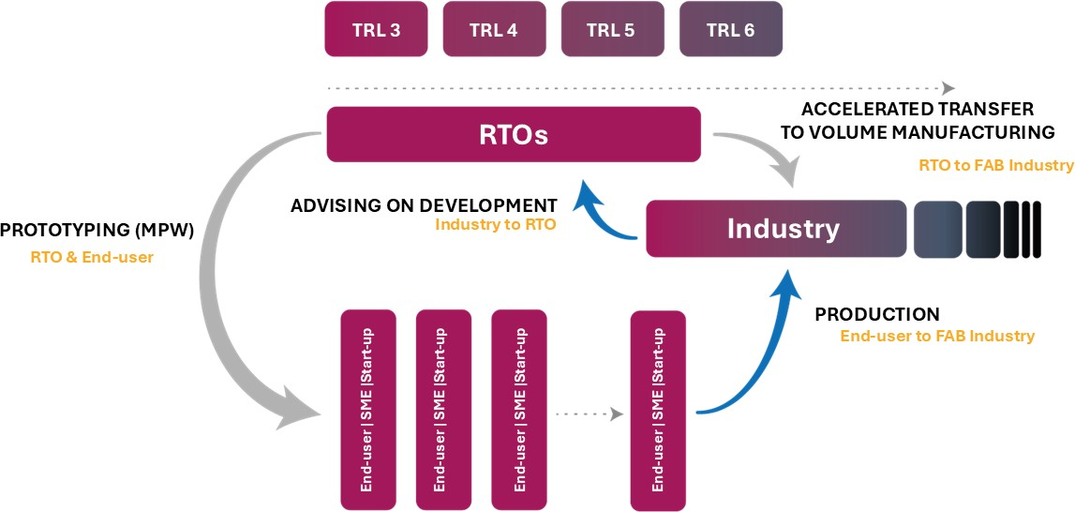

Figure 40: PIXEurope Pilot Line will create an industry ecosystem for European RTOs, SMEs, start-ups, sin-offs and large industries, all benefiting through a virtuous cycle.

End users, such as SMEs, start-ups, large corporates and RTOs, will benefit from the Pilot Line’s activities and infrastructures in several ways:
- SMEs and start-ups will be able to access the PL to increase the TRL of their product through prototyping without incurring high costs and service delays;
- Manufacturing industry and RTOs outside of the consortium will have the possibility – subject to eligibility - to license technologies and co-develop new technologies using the operational infrastructure. Processes will be designed to ensure seamless transfer to series and volume production;
- RTOs within and outside the consortium will use the Pilot Line facilities to develop new designs which can be transferred to the existing industry or their spin-offs;
- Large companies and consortia of SMEs will be able to undertake more disruptive innovations at reduced risk and capital expenditure through open innovation program line- based research;
- All PIXEurope partners will generate new know-how and thus enrich their portfolio of mature processes, PDKs, ADKs, TDKs, services and technologies offered on the market);
- The Pilot Line will build capacity and develop knowledge to be exploited and leveraged by the European photonic ecosystem, including both RTOs and industrial technology providers, the majority of which are SMEs (design houses, pure-play foundries, testing and packaging houses, equipment and material suppliers, …).

The innovation capacity of the industry ecosystem is currently impeded by long design cycles that lead to missed market opportunities. PIXEurope accelerates the design process by:
- Account management: single point of contact to interface with the designer and the specialist team of service suppliers for design, fab, testing and packaging. New entrant designers will
receive extensive support, mentoring and training from the Pilot Line.

- Codesign built-in: interoperable processes and established workflows within the PIXEurope Pilot Line will ensure that each component and integration level is compliant, derisking the module build for each design cycle.
- Optimised manufacturing flows: using the demonstrator work-flows, the pilot line will generate the know-how for optimal workflow for a given set of requirements. The optimal flow is selected a priori. Therefore, PIXEurope will offer a comprehensive pilot line service covering design, fabrication, hybrid integration, testing and packaging, and shipping. The interoperable production chain based on standardised PDK, ADK and TDK, combined with Gateway’s assistance in selecting the platform and integration techniques, will significantly reduce the total PIC production time with the first full-service and pre-scheduled open access service from chip to module.
- Accelerated time-in-fab: Not a KPI for the project or a goal for RTOs, but an anticipated outcome: The increased use of standard processes by a wider developer eco-system will motivate the licensing of standard processes that are scaled up within the wider industry. The application of standard Semicon methods to optimise the line and line yields leads to predictable and efficient services.

Time-efficient production will benefit European vertical integrators, and especially SMEs, by optimizing time to market. This will help them stay ahead of competitors and increase their market shares. European supply chains will benefit from the scale-up in business and improved performance gains that go with higher frequency processes.
During the relatively short period (less than 2 months) over which the ChipsJU CPL-5 call has been opened, PIXEurope has already received more than 65 expressions of interest by SMEs, start-ups and large companies, ranging from designers to suppliers, manufactures, including package and test houses and large range of vertical integrators. All of them have provided a letter of support that also identifies specific topics for collaboration, joint development projects, prototyping and service needs. With such a large number of potential end-users and previous track of record by several partners in previous Pilot Lines (e.g. JePPIX, PIXAPP, PIX4LIFE), the probability of direct impact is high. The signed Letters of Support and the company information
can be found as an Appendix 1.
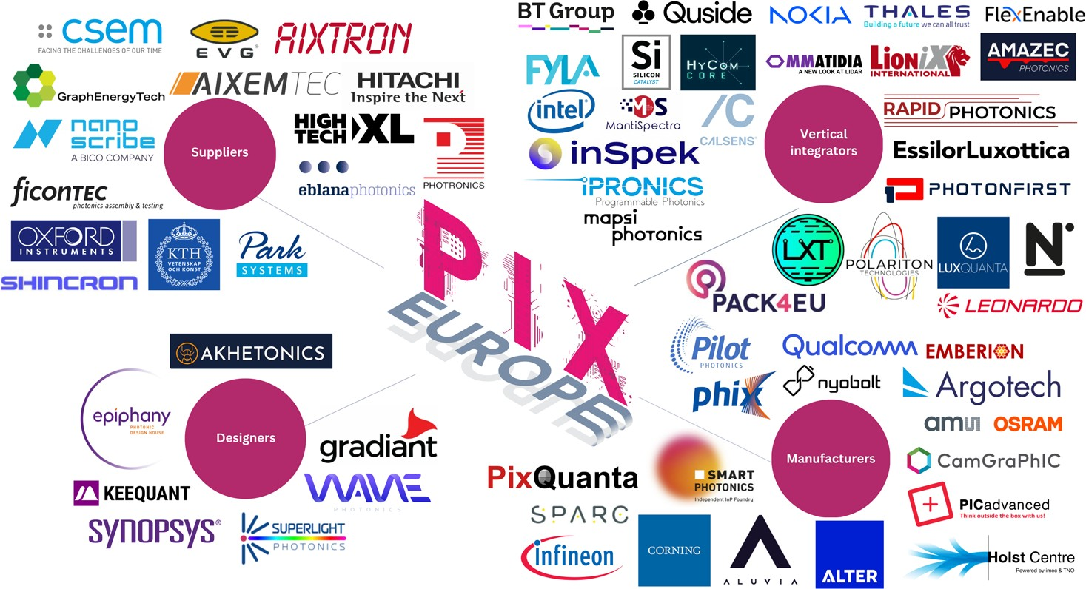

Figure 41: Overview of PIXEurope European PIC ecosystem, divided by Suppliers, Designers, Manufacturers and Vertical Integrators.

All factors described above characterise the proposed Pilot Line and will translate into a market impact for the European industry. The PIC market is projected to experience substantial growth, reaching an estimated value over EUR 30B by 2030, with a robust CAGR of 20.47%. Within this thriving global market, thanks to PIXEurope, its end users (SMEs, start-ups and corporates whose core technologies include PICs) are expected to capture at least 10% share, translating to EUR 3B by the same year. The end- users will achieve this by increasing the TRL (from 6 to 8). This will increase the deployment in market sectors, such as Telecom, Finance, Space and Automotive, where large European businesses are strong, and well positioned to exploit the products from the Pilot Line’s end-users. The business associated with this market is estimated to be in the order of EUR 10B.

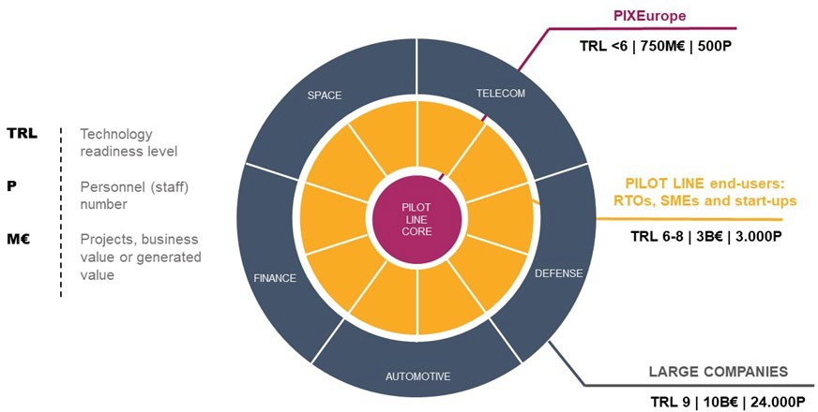
Figure 42: PIXEurope Pilot Line and its impact on the surrounding ecosystem. The advanced PIC technologies and platforms developed by the project will allow end-users such as SMEs and start-ups to increase the technology readiness level (TRL) of their product and access the market of large companies. At the same time, the number of trained personnel (P), including scientists and engineers, as well as capacity and generated business (M€), will increase significantly.

This strategic positioning within the photonics and PIC areas, as illustrated in the provided diagram of Figure 42, highlights the central role of PIXEurope’s Pilot Line in the collaborative efforts within the technological and industry ecosystems for driving innovation (TRL increase), economic growth (business value), and employment. Alongside the increase of TRL and the growth of the business we expect to generate jobs. The chips JU grant will allow us to employ more than 220 new people who, added to existing staff, will make the Pilot Line mobilise 500 people. They will include design, fabrication and processing, packaging, test (scientists, engineers and technicians), equipment operation and maintenance experts, facilities management, project management and administration, legal and contract management personnel. According to previous experience in smaller Pilot Line, the number of people mobilised by the end-users (mainly SMEs) will be at least 6 times larger, that is 3000. We note that, in the rapidly evolving field of photonics, the transition from TRL8 to TRL9 is a critical step, requiring substantial resources and effort. The International Society for Optics and Photonics (SPIE) estimates that for every one job in photonics at TRL 8, seven to eight additional jobs are necessary to bring the innovation to the market as a fully developed product (TRL9). Therefore, the number of mobilised work-force people increases to more than 20,000 for large companies addressing the creation of PIC-enabled products in applications market.
In addition, the PIC industry is transforming, offering new opportunities in new markets, such as AI, which is also growing fast. In this context, PIXEurope is a timely infrastructure that lays the essential foundation for innovation and application development, supporting Europe’s SMEs and OEMs to build a robust supply chain and gain a significant market share.
Strategic and ecosystem impact
The semiconductor industry has faced substantial challenges since the US initiated a trade war in 2019, further exacerbated by potential conflicts between China and Taiwan. The geopolitical tension, aggravated by the COVID-19 pandemic, has emphasised the importance of technology sovereignty. Nevertheless, the US and Europe have relied on overseas foundries, predominantly in Asia, as the heightened demand requires substantial production capacity. According to the Yole Group, critical suppliers collectively shape the global semiconductor supply chain, including Taiwan, South Korea, Japan, Singapore, and Malaysia. However, this supply chain's intricate, interdependent nature has proven vulnerable to disruptions. PIXEurope will respond to these disruptions, aiming to enhance domestic production capabilities and reduce dependency on foreign suppliers, thus mitigating risks and enhancing resilience.
PIXEurope contributes to achieving open strategic autonomy in digital technologies and in future emerging technologies by strengthening European capacities in low-power consumption and ultra-secure photonics components for a wide range of applications.
The PIC market has experienced steady growth, and advanced PICs will enlarge their application even further into emerging areas such as AI and quantum technologies. Due to their extensive capabilities and use, and in light of the predicted growth of the application-specific markets, PICs represent a critical emerging enabling technology which requires early investment to gain European technological sovereignty and to achieve the goals set by the European Chips Act to strengthen Europe´s research

and technology leadership towards smaller and faster chips. PIXEurope will act in line with the EU’s plan to reach Open Strategic Autonomy by 2040 by
- Supporting mastery of the component development within an EU-based supply chain,
- Generating knowledge on the integration approaches and thus widening the possibilities of deployment of the PICs in applications areas vital for healthcare, LiDAR, advanced sensing, as well as green and digital transitions
- Bolstering the European supply chain to avoid external and/or one-sided dependencies, raise demand preparedness and thus
- Provide easy access to European industry and technology.
PIXEurope comes in a period of geopolitical changes which affect the nature of competition and bring the need for Europe´s sovereignty to the forefront. PIXEurope key production processes and supply chain are based in the EU. The consortium has been built around research and technology organisations rooted in national and regional innovation systems. The technologies developed and validated within PIXEurope will be transferred to industrial component producers and integrators active in relevant markets and end-users in the key application areas. Together, these stakeholders form a strong and cohesive European value chain.
In the following Table 17, we summarise the proposed Pilot Line's contributions to the European Chip Act’s priorities.
Table 17: Contributions of PIXEurope to the priorities of the European Chip Act.
 | EU Chip Act priority | PIXEurope contribution through WP3 and technologies  WP4-9-HE
 | Strengthen Europe’s research and technology leadership towards smaller and faster chips. | - A wide range of monolithic and hybrid PIC technologies enabling uses across the entire set of applications, from communication to sensing, artificial intelligence and quantum  - Miniaturization of PIC made by using the latest advances in design and micro-nano-fabrication, highly performing materials and their combination  - Designs of PICs for achieving faster direct modulation of the light source or external to it and greater information capacity by multiplexing with multiple degrees of freedom
 | Put in place a framework to increase production capacity to 20% of the global market by 2030. | - Design cycle acceleration, enabling faster convergence on design intent, manufacture tolerant design and design for test  - Fast prototyping with reduced turnaround from design to chip fabrication and packaging  - Raising the TRL level of open access PIC development services  - Establishment of Gateway and Open access to provide a long-term catalyst for innovative new technologies  - Freedom to operate: Mechanisms to manage IP associated with building blocks in the PDKs, ADKs and TDKs  - Scaling to pre-commercial runs enabled by the Pilot Line’s equipment
 | Build and reinforce capacity to innovate in the design, manufacturing and packaging of advanced chips. | - Novel and complete set of monolithic PIC platforms, their hybrid combination and addition of functional materials to implement innovative designs  - Development of new PIC processes using state-of-the art deposition and micro-nano-fabrication equipment  - Advanced packaging techniques such as CPO available to Europe’s SMEs for reaching new functionalities and capabilities with PICs  - Accurate PDK, ADK and TDK design tools showing process variability to the user in the design tools with a priori definition of the design space  - Precision prototyping and manufacturing, systematically reducing the  variability of building block specifications enabling users to identity design sweet-spots which are resilient to manufacturing tolerances
 | Develop an in-depth understanding of the global semiconductor supply chain. | - Engaging new entrant businesses which have so far not leveraged the potential of PIC technology by lowering the entrance threshold, providing mentoring for new-entrant external users from the wider Semicon community  - Interoperable services with common design and test infrastructure and second-sourced foundry services and test houses  - Quality assurance through unified operational management across the tool chain, enabling cost effective software and test tooling  - Active outreach to new photonic and non-photonic markets

 | Address the skills shortage, attract new talent and support the emergence of a skilled workforce. | - External training of personnel using online, hands-on and specialised training courses for all PIXEurope technologies  - 28 online and 18 hands-on training courses delivered through PIXEurope training  - Specialised training visits  - Develop and assess PIXEurope training courses and materials with 1000 course participants  - Internal training of skilled personnel to meet demand of Pilot Line for each of the PIC phases, from design to chip fabrication, packaging and testing  - Enable competence centres and other Pilot Lines for provide  comprehensive training that includes PIC and other semiconductor technologies

  - Environmental sustainability and contribution to European Green Deal goals

Environmental sustainability and contribution to European Green Deal goals
Describe the extent to which the project will contribute to environmental sustainability and in particular to European Green Deal goals
This might not be applicable to all topics — for details refer to the Call document.
PICs serve as a key enabling technology essential for achieving priorities set by European Commission. Two primary priorities include Digital Transformation, where technologies like sensors, cameras, lasers, and communications systems are crucial, and the Green Deal, where photonic integration plays a significant and ever-growing role in materials and energy resource reduction for digital technologies.
For example, optical links at the package and board levels have the potential to be more energy-efficient than current solutions, particularly in scenarios requiring extremely high frequencies and data rates, such as in data centres. The expected impact of the ICT industry on global energy consumption and global warming is significant. In 2008, it accounted for ~2% of all greenhouse emissions, ~3.7% in 2020 and is predicted to reach ~14% by 2040, so improved energy performance is essential for technology sustainability. This is one of many areas where cutting-edge, clean technological innovation enabled by integrated photonics has significant potential.
According to SPECTARIS's “Green Photonics” study, photonics will reduce up to 3B tonnes of CO2 by 2030 [White Paper on Integrated Photonics, EPoSS and Photonics21]. This reduction will be achieved not only through decreased energy consumption in data centres enabled by PICs but also through minimised fertilizer usage supporting the ‘From Farm to Fork’ strategy, more efficient resource use in manufacturing, and by enabling innovative production, testing, and gas detection processes. For example, methane is a potent greenhouse gas responsible for approximately 30% of global warming. During COP-26, an international coalition of 105 countries committed to reducing methane emissions by 30% over the next decade, recognising this as one of the most effective strategies for curbing near-term global warming. A key approach to achieving this goal is minimising natural gas leaks from fossil fuel production infrastructure, where developing and deploying new PIC- based low-cost technologies for rapid leak detection will be essential. As such, PICs are vital catalysts for promoting global sustainability. [https://www.spectaris.de/fileadmin/Content/Verband/Themenspecial/Study_GreenPhotonics_2020_eng
.pdf.]
PIC-enabled products will support a clean and circular economy, but one must consider the environmental impacts linked to the manufacturing of PICs, including the material and energy inputs into the manufacturing supply chain, the fabrication processes, product use and the end-of-life disposal, so-called life cycle analysis (LCA). For example, forever chemicals such as poly-fluorinated alkyl substances (PFAS), are extensively used in the fabrication of semiconductor devices. These are a class of over 4,700 industrial compounds (e.g. CF4, SF6, typically used to etch silicon) that are highly persistent, with certain types taking over 1,000 years to degrade. These substances pose significant health risks and, in their gaseous form, contribute substantially to global warming. PIXEurope will seek to partner with sustainable semiconductor manufacturing initiatives and programmes (e.g. FUTUR-IC) to promote sustainability goals, innovate in the area, and adopt the latest developments from elsewhere.
#§IMP-ACT-IA§#

#@WRK-PLA-WP@#

WORK PLAN, WORK PACKAGES, ACTIVITIES, RESOURCES AND TIMING

Work plan

Work plan
Provide a brief description of the overall structure of the work plan (list of work packages or graphical presentation (Pert chart or similar)).
The PIXEurope workplan is divided into 11 Work Packages, all of which are presented in Annex 1. In view of the ambitious goal of developing a unified, interoperable PIC technology supply chain covering two generations of components targeting premium performance, we prepared a well-orchestrated work plan allowing for iterative development through interactions between technical WPs (WP4-HE, WP5-HE, WP6-HE, WP7-HE, WP8-HE), while procuring and commissioning (WP3-HE) novel tools and employing them in the development tasks (all tools are planned to be installed by M38).
Technical work packages focused on development of Monolithic PIC platform fabrication (WP5-HE), Hybrid PIC integration (WP6-HE), Packaging (WP7-HE) and Test and Reliability (WP8-HE) will continuously interact with Design integration (WP4-HE). Work package WP9-HE validates the technology for TRL6 and workflows for the whole supply chain and demonstrates the technology offer for a wide range of application areas. The present DEP proposal focuses merely on WP3, which will run in parallel with the remaining WPs, and focus on establishing framework and processes for external users’ Open Access.
The cross-cutting work package WP2-HE and WP2 focus on planning for sustainability and external training activities with the goal of preparing Pilot Line offering and establishing its brand in the European PIC technology ecosystem. Project management and Coordination (WP1) is a cross-cutting activity ensuring lean decision-making and quality assurance through reporting and risk management. To take stock of the progress of the project and make decisions on the next steps, annual project reviews are planned (M1, M26, M38, M50 and final review in M60).

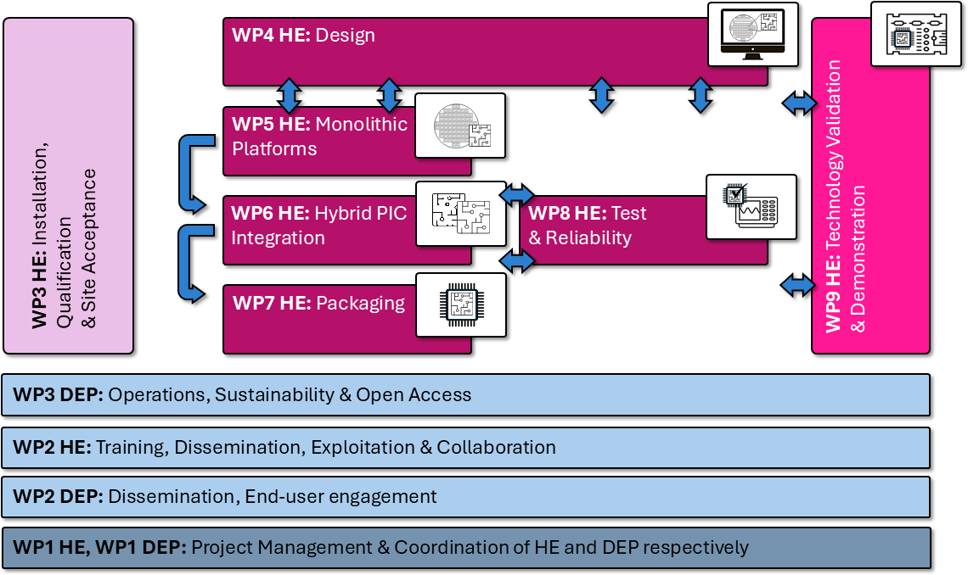

Figure 43: PIXEurope PERT chart showing Pilot Line workplan and the cross-cutting WP3: Operations, Sustainability & Open Access

Work packages, activities, resources and timing

Staff effort (n/a for Lump Sum Grants)

WP | Title | RP | Totals | ICFO | TNI | TU/e | UPV | VTT | IMEC | CSIC | TNO | UTWENTE | UGENT | UVIGO | IT | WUT | SAL | WUT | IMDEA
1 | Project management & Coordination | WP1 Total | 114.1 | 50.0 | 10.0 | 10.0 | 10.0 | 1.0 | 2.0 | 9.0 | 2.0 | 2.0 | 0.1 | 8.0 | 6.0 | 1.0 | 1.0 | 1.0 | 1.0
1 |  | Planned RP1 | 20.9 | 10.0 | 2.0 | 2.0 | 1.0 | 0.2 | 0.4 | 2.0 | 0.0 | 0.5 | 0.0 | 1.0 | 1.0 | 0.2 | 0.2 | 0.2 | 0.2
1 |  | Planned RP2 | 21.1 | 10.0 | 2.0 | 2.0 | 2.2 | 0.2 | 0.4 | 1.0 | 0.0 | 0.5 | 0.0 | 1.0 | 1.0 | 0.2 | 0.2 | 0.2 | 0.2
1 |  | Planned RP3 | 23.1 | 10.0 | 2.0 | 2.0 | 2.2 | 0.2 | 0.4 | 2.0 | 0.0 | 0.5 | 0.0 | 2.0 | 1.0 | 0.2 | 0.2 | 0.2 | 0.2
1 |  | Planned RP4 | 23.9 | 10.0 | 2.0 | 2.0 | 2.2 | 0.2 | 0.4 | 2.0 | 1.0 | 0.3 | 0.0 | 2.0 | 1.0 | 0.2 | 0.2 | 0.2 | 0.2
1 |  | Planned RP5 | 25.1 | 10.0 | 2.0 | 2.0 | 2.4 | 0.2 | 0.4 | 2.0 | 1.0 | 0.3 | 0.0 | 2.0 | 2.0 | 0.2 | 0.2 | 0.2 | 0.2
2 | Dissemination, End- user engagement | WP2 Total | 117.1 | 50.0 | 10.0 | 10.0 | 10.0 | 1.0 | 2.0 | 10.0 | 3.0 | 3.0 | 0.1 | 8.0 | 6.0 | 1.0 | 1.0 | 1.0 | 1.0
2 |  | Planned RP1 | 19.7 | 10.0 | 2.0 | 2.0 | 1.0 | 0.2 | 0.4 | 1.0 | 0.0 | 0.3 | 0.0 | 1.0 | 1.0 | 0.2 | 0.2 | 0.2 | 0.2
2 |  | Planned RP2 | 22.4 | 10.0 | 2.0 | 2.0 | 2.2 | 0.2 | 0.4 | 2.0 | 0.0 | 0.8 | 0.0 | 1.0 | 1.0 | 0.2 | 0.2 | 0.2 | 0.2
2 |  | Planned RP3 | 24.6 | 10.0 | 2.0 | 2.0 | 2.2 | 0.2 | 0.4 | 2.0 | 1.0 | 1.0 | 0.0 | 2.0 | 1.0 | 0.2 | 0.2 | 0.2 | 0.2
2 |  | Planned RP4 | 24.4 | 10.0 | 2.0 | 2.0 | 2.2 | 0.2 | 0.4 | 2.0 | 1.0 | 0.8 | 0.0 | 2.0 | 1.0 | 0.2 | 0.2 | 0.2 | 0.2
2 |  | Planned RP5 | 26.0 | 10.0 | 2.0 | 2.0 | 2.4 | 0.2 | 0.4 | 3.0 | 1.0 | 0.3 | 0.0 | 2.0 | 2.0 | 0.2 | 0.2 | 0.2 | 0.2
3 | Operations,  Sustainability, Open Access | WP3 Total | 802.2 | 140.0 | 100.0 | 82.0 | 124.0 | 18.0 | 26.0 | 88.0 | 31.9 | 33.0 | 0.8 | 62.0 | 42.0 | 18.0 | 20.5 | 6.0 | 10.0
3 |  | Planned RP1 | 94.4 | 20.0 | 12.0 | 14.0 | 4.0 | 3.0 | 5.2 | 4.0 | 0.0 | 6.0 | 0.2 | 6.0 | 12.0 | 1.0 | 4.5 | 0.5 | 2.0
3 |  | Planned RP2 | 144.8 | 30.0 | 15.0 | 17.0 | 24.0 | 3.5 | 5.2 | 12.0 | 0.0 | 7.0 | 0.2 | 12.0 | 10.0 | 2.0 | 4.0 | 1.0 | 2.0
3 |  | Planned RP3 | 175.4 | 30.0 | 20.0 | 17.0 | 24.0 | 3.5 | 5.2 | 24.0 | 0.0 | 7.0 | 0.2 | 24.0 | 8.0 | 5.0 | 4.0 | 1.5 | 2.0
3 |  | Planned RP4 | 195.4 | 30.0 | 27.0 | 17.0 | 36.0 | 3.5 | 5.2 | 24.0 | 15.0 | 7.0 | 0.2 | 12.0 | 6.0 | 5.0 | 4.0 | 1.5 | 2.0
3 |  | Planned RP5 | 192.2 | 30.0 | 26.0 | 17.0 | 36.0 | 4.5 | 5.2 | 24.0 | 16.9 | 6.0 | 0.2 | 8.0 | 6.0 | 5.0 | 4.0 | 1.5 | 2.0

In-kind contributions provided by third parties

No. partner name | Category | Cost (€) | Justification
Institució Catalana de Recerca i Estudis Avançats (ICREA) | Seconded personnel | 108,670 | Justification: ICREA will provide salary of Prof. Valerio Pruneri free of charge to ICFO as a third party giving in-kind contribution of the action (Article 9.2 Grant Agreement). The cost will be declared by ICFO under the conditions set out in Article 6 and will be included in Annex 2 as part of the costs of ICFO.

Subcontracting (n/a for prefixed Lump Sum Grants)

Subcontracting
Give details on subcontracted project tasks (if any) and explain the reasons why (as opposed to direct implementation by the Beneficiaries/Affiliated Entities).
Subcontracting — Subcontracting means the implementation of ‘action tasks’, i.e. specific tasks which are part of the EU grant and are described in Annex 1 of the Grant Agreement.
Note: Subcontracting concerns the outsourcing of a part of the project to a party outside the consortium. It is not simply about purchasing goods or services. We normally expect that the participants have sufficient operational capacity to implement the project activities themselves. Subcontracting should therefore be exceptional.
Include only subcontracts that comply with the rules (i.e. best value for money and no conflict of interest; no subcontracting of coordinator tasks).
Work Package No | Subcontract No (continuous numbering linked to WP) | Subcontract Name (subcontracted action tasks) | Description (including task number and BEN/AE to which it is linked) | Estimated Costs  (EUR) | Justification  (Why is subcontracting necessary?) | Best-Value-for-Money (How do you intend to ensure it?)
WP3 | S1.1 | Expert consultancy on establishment of the Open  Access single entry point | T10.3 Open Access; BEN 1: ICFO | 100,000 | ICFO has experience in managing operations and services to external users related to nano-fabrication, characterization and testing. However, the Open Access and Gateway of the Pliot Line requires management of a much larger operation involving also other RTOs. ICFO will thus seek for a  subcontractor with such experience to assist their | The subcontracting will be assigned through a public call for tender. ICFO has internal procedure which complies with national rules for public tenders, whereas the selection criteria will be based on the capacity of the subcontractor, their experience and track record in activities related  to task 10.3. In particular the subcontractor should

 |  |  |  |  |  | staff in T10.3, especially in the management flows of the single-entry point. | ideally have such experience related to multi-partner infrastructure for offering services to end-users.
Other issues:  If subcontracting for the entire project goes beyond 30% of the total eligible costs, give specific reasons. |  |  |  | N/A

Purchases and equipment

Purchase costs (travel and subsistence, equipment and other goods works and services)
Details for major cost items (needed if costs declared under ‘purchase costs’ are higher than 15% of the claimed personnel costs).
Start with the most expensive cost items, down to the 15% threshold.
Participant 1: | ICFO
Cost item name | Category | WP(s) | Explanations | Costs  (EUR)
ICFO1 | [Other goods and services] | WP3 | Costs related to organization of internal training, SME engagement activities & tech clustering activities; Analysis and optimization of the technological situation; Cost modelling advisors; integrated management system for PL equipment | 201,895
 | Remaining purchase costs |  |  | 300,605

 | (<15% pers. costs)
Total |  |  |  | 502,500
Participant 4: | UPV
Cost item name | Category | WP(s) | Explanations | Costs  (EUR)
UPV1 | [Other goods and services] | WP3 | Materials for the different activities (mainly clustering and training) | 316,000
UPV2 | [Travel and Subsistence] | WP3 | Trips 2000 EUR/trip x8 / year | 4,400
 | Remaining purchase costs (<15% pers. costs) |  |  | 75,600
Total |  |  |  | 396,000
Participant 12: | UVIGO
Cost item name | Category | WP(s) | Explanations | Costs  (EUR)
UVIGO1 | [Other goods and services] | WP3 | Materials/consumables for demos and hands-on training (95249.95 €) | 71,250
 | Remaining purchase costs (<15% pers. costs) | WP3 |  | 34,750

Total |  |  |  | 106,000
Participant 8: | TNO
Cost item name | Category | WP(s) | Explanations | Costs  (EUR)
TNO1 | [Other goods and services] | WP3 | Support operationalization: 'Support services for the operational phase of the Pilot Line. TNO will hire specialized engineers trained for the equipment that will be installed and needed for the operation of the Pilot Line. TNO is an R&D organization and thus does not employ on a permanent basis these operators. | 2,954,339
 | Remaining purchase costs (<15% pers. costs) |  |  | 64,661
Total |  |  |  | 3,019,000
Participant 14: | WUT
Cost item name | Category | WP(s) | Explanations | Costs  (EUR)
WUT1 | [Other goods and services] | WP3 | Materials | 50,000
WUT2 | [Travel and Subsistence] | WP3 | Cost of travel to training and collaborations | 18,026

 | Remaining purchase costs (<15% pers. costs) |  |  | 17,214
Total |  |  |  | 85,240
Total purchase costs > 15% (all participants) |  |  |  | 1,178,176.80
Remaining purchase costs < 15% (all participants) |  |  |  | 3,088,313.20
Total purchase costs (all participants) |  |  |  | 4,266.490.00

Other cost categories

Participant 5: | VTT
Cost category | Explanations | Costs  (EUR)
Financial support to third parties | N/A | N/A
Internally invoiced goods and services | Research infrastructure and technology platform costs are attributed and declared according to VTT’s usual cost accounting practices which are compliant with DEP rules article 6.2.D. The specific unit costs are based on the infrastructure’s actual costs of goods and services recorded in our accounts and provided for the project during the project duration. Estimated number of units 3160, estimated average unit cost 18 €. | 56,880

Other cost categories (financial support to third parties, internally invoiced goods and services, etc)
Complete the table below for each participant that would like to declare costs under other costs categories (e.g. financial support and internally invoiced goods and services), irrespective of the percentage of personnel costs.
Participant 7: | CSIC
Cost category | Explanations | Costs  (EUR)
Financial support to third parties | N/A | N/A
Internally invoiced goods and services | Samples for training and prototyping | 140,731,12

Participant 9: | UTWENTE
Cost category | Explanations | Costs  (EUR)
Financial support to third parties | N/A | N/A
Internally invoiced goods and services | Nanolab Cleanroom access training (80 Euro/hour) | 150,000

Participant 16: | CEA-LETI
Cost category | Explanations | Costs

 |  | (EUR)
Financial support to third parties | N/A | N/A
Internally invoiced goods and services | R&D Environment costs : The PIXEurope project will use the Optics and Photonics environment that brings together shared designs, characterization tools, packaging and assembly equipments and the Silicon clean room environment of CEA/LETI | 28,863

Timetable

Timetable (projects of more than 2 years)
ACTIVITY | YEAR 1 |  |  |  | YEAR 2 |  |  |  | YEAR 3 |  |  |  | YEAR 4 |  |  |  | YEAR 5 |  |  |  | YEAR 6
ACTIVITY | Q 1 | Q 2 | Q 3 | Q 4 | Q 1 | Q 2 | Q 3 | Q 4 | Q 1 | Q 2 | Q 3 | Q 4 | Q 1 | Q 2 | Q 3 | Q 4 | Q 1 | Q 2 | Q 3 | Q 4 | Q 1 | Q 2 | Q 3 | Q 4
WP1 Project Management & Coordination
T1.1 Strategic Decision making (General Assembly coordination)
T1.2 Project management, Quality assurance and Risk management
T2.2 Data Management Plan
WP2 Dissemination, End-user engagement
T2.1 Dissemination,
Communication and Networking activities
T2.2 End-user Engagement Strategy
WP3 Operations, Sustainability & Open Access
Task 3.1 - Operations, Sustainability & Open Access
Task 3.2 - Cost Models, Sustainability and Life Cycle Analysis
Task 3.3 - Open Access
#§WRK-PLA-WP§#

#@ETH-ICS-EI@#

OTHER

Ethics

Ethics
If the Call document contains a section on ethics, the ethics issues and measures you intend to take to solve/avoid them must be described in Part A.
See Application Form Part A.
#§ETH-ICS-EI§# #@SEC-URI-SU@#

Security

Security
The security issues and the measures you intend to take to solve/avoid them must be described in Part A.
Note: Beneficiaries must ensure that their projects are not subject to national/third country security requirements that could affect the implementation or put into question the award of the grant (e.g. technology restrictions, national security classification, etc).
See Application Form Part A.
#§SEC-URI-SU§# #@DEC-LAR-DL@#

DECLARATIONS

Double funding
Information concerning other EU grants  Please note that there is a strict prohibition of double funding from the EU budget (except under EU Synergies actions). | YES/NO
We confirm that to our best knowledge none of the projects under the action plan as a whole or in parts have benefitted from any other EU grant (including EU funding managed by authorities in EU Member States or other funding bodies, e.g. EU Regional Funds, EU Agricultural Funds, etc). If NO, explain and provide details. | YES
We confirm that to our best knowledge none of the projects under the action plan as a whole or in parts are (nor will be) submitted for any other EU grant (including EU funding managed by authorities in EU Member States or other funding bodies, e.g. EU Regional Funds, EU Agricultural Funds, etc). If NO, explain and provide details. | YES

Financial support to third parties (if applicable)
If in your project the maximum amount per third party will be more than the threshold amount set in the Call document, justify and explain why the higher amount is necessary in order to fulfil your project’s objectives.
Not applicable for the current proposal.
#§DEC-LAR-DL§#

LIST OF ANNEXES

ANNEXES

Standard
Detailed budget table/Calculator (annex 1 to Part B) — mandatory for certain Lump Sum Grants (see Portal Reference Documents)
CVs (annex 2 to Part B) — not applicable
Annual activity reports (annex 3 to Part B) — not applicable
List of previous projects (annex 4 to Part B) — mandatory, if required in the Call document

Special
Other annexes (annex 5 to Part B) — mandatory, if required in the Call document

LIST OF PREVIOUS PROJECTS

List of previous projects
Please provide a list of your previous projects for the last 4 years.
Participant | Project Reference No and Title, Funding programme | Period (start and end date) | Role (COO, BEN, AE, OTHER) | Amount  (EUR) | Website (if any)
TU/e, TNI | Indium-Phosphide Pilot Line for up-scaled, low- barrier, self-sustained, PIC ecosystem (Horizon 2020) | 1 January  2019 - 31  December 2023 | TU/e COO; TNI BEN | 17 281  093,71 | https://www.jeppix  .eu/
TNI, TU/e, | Photonic Integrated | 1 January | TNI | 15 690 | https://pixapp.eu/
IMEC, VTT, CEA-LETI, | Circuits Assembly and  Packaging Pilot Line (Horizon 2020) | 2017 – 30  September 2021 | COO;  TU/e, IMEC, | 921,43
 |  |  | VTT,
 |  |  | CEA-
 |  |  | LETI
 |  |  | BEN
TNI, TU/e, | One-Stop-Shop Open | 1 January | TNI, | 19 818 | https://www.photo
WUT, VTT | Access to Photonics  Innovation Support for | 2021 – 30  April 2025 | TU/e,  WUT, | 937,25 | nhub.eu/
 | a Digital Europe |  | VTT BEN
 | (Horizon 2020)
TU/e, POLIMI, UCAM, UPV | Photonic Integrated Circuits Accessible to Everyone  (Horizon 2020) | 1 January  2016 – 30  June 2019 | TU/e COO; POLIMI, UCAM BEN | 1 051  895,00 | http://www.pics4al l.jeppix.eu/
VTT, TNI | Photonics Solutions at Pilot Scale for Accelerated Medical Device Development | 1 January  2020 – 30  September 2024 | VTT COO; TNI BEN | 17 381  960,99 | https://medphab.e u/
 | (Horizon 2020)

An Exhaustive list of projects can be found within Annex 1, Section 1.2.8 Complementarity with national and international activities.

