Period covered by the report: M01-M06 (from 01/06/2025 to 30/11/2025)
Periodic report: 1st

Periodic Technical Report
Continuous Reporting (PART B)
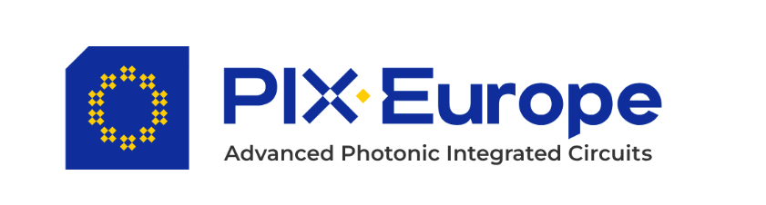



Project number: 101213744
Project acronym: PIXEurope - DEP
Project title: Advanced Photonic Integrated Circuits Pilot Line for Europe
Contents
1. Explanation of the work carried out by the beneficiaries and Overview of the progress 2
1.1. Objectives for this period (M01-M06) 3
1.2. Explanation of the work carried out per WP 3
1.2.1. Work Package WP2 – Dissemination, End-user engagement 3
1.2.2. Work package WP3 – Operations, Sustainability & Open Access 3
1.3. Impact 4
2. Update of the plan for exploitation and dissemination of results 5
3. Update of the data management plan 6
4. Deviations from Annex 1 and Annex 2 7

Explanation of the work carried out by the beneficiaries and Overview of the progress
This period corresponds to the initial steps of the project (Phase 1, M1 to M12) of the PIXEurope project. During this period we have fulfilled all the planned actions ensuring the successful development of the project PIXEUrope. The partners involved in this 1st PIXEurope reporting period are listed below together with their short name, which we will use through all this document:
Partners Name | Short Name
FUNDACIO INSTITUT DE CIENCIES FOTONIQUES | ICFO
UNIVERSITY COLLEGE CORK - NATIONAL  UNIVERSITY OF IRELAND, CORK | TNI
TECHNISCHE UNIVERSITEIT EINDHOVEN | TU/e
UNIVERSITAT POLITECNICA DE VALENCIA | UPV
TEKNOLOGIAN TUTKIMUSKESKUS VTT OY | VTT
INTERUNIVERSITAIR MICRO-ELECTRONICA  CENTRUM | IMEC
AGENCIA ESTATAL CONSEJO SUPERIOR DE  INVESTIGACIONES CIENTIFICAS | CSIC
NEDERLANDSE ORGANISATIE VOOR TOEGEPAST  NATUURWETENSCHAPPELIJK ONDERZOEK TNO | TNO
UNIVERSITEIT TWENTE | UTWENTE
UNIVERSITEIT GENT | UGent
UNIVERSIDAD DE VIGO | UVIGO
INSTITUTO DE TELECOMUNICACOES | IT
POLITECHNIKA WARSZAWSKA | WUT
SILICON AUSTRIA LABS GMBH | SAL
COMMISSARIAT A L ENERGIE ATOMIQUE ET AUX  ENERGIES ALTERNATIVES | CEA-LETI
FUNDACION IMDEA NETWORKS | IMDEA

Objectives for this period (M01-M06)

Explanation of the work carried out per WP

Work Package WP2 – Dissemination, End-user engagement

Objectives for the period

Progress towards objectives

Task 2.1: Dissemination, Communication and Networking Activities (ICFO, all) (M1, M60)

Task 2.2: End-user engagement Strategy (ICFO, all) (M11-M60)
Not applicable to this period

Significant results & Conclusions for WP1
- Xxx

Overview of achieved deliverables and milestones
Deliverable number | Deliverable name | Lead partner | Due date as per Annex 1 | Submission date | Comments

Work package WP3 – Operations, Sustainability & Open Access

Objectives for the period

Progress towards objectives

Task 3.1: Pilot Line Operations and Interoperability (ICFO, all DEP partners) (M1-M60)

Task 3.2: Cost Models, Sustainability and Life Cycle Analysis (TNI, all DEP partners) (M12-M50)
Not applicable to this period

Task 3.3: Open Access (TU/e, ICFO, TNI) (M1-M60)

Significant results & Conclusions for WP1
- Xxx

Overview of achieved deliverables and milestones
Deliverable number | Deliverable name | Lead partner | Due date as per Annex 1 | Submission date | Comments

Impact

Update of the plan for exploitation and dissemination of results
N/a

Update of the data management plan
N/a

Deviations from Annex 1 and Annex 2

