



MINUTES

Meeting | (Name of the Meeting)
Date & Time | 28/10/2025 10:00 am
Participants | Valerio Pruneri (VP)  Luis Trigo (LT)  Joaquin Faneca (JF)  Peter O'Brien (PO)  Sylwester Latkosxki (SL)  Wouter Rensen (WR)  Kevin Williams (KW)  Marina Santana (MS)  Sabine Runge (SR)  Joana Ibáñez (JI)  Ana Aguarod (AA)  Pascual Muñoz (PM)  Timo Aalto (TA)  Carlos Domínguez (CD)

Agenda
- Progress WPs​
- Open Access Form: Presentation ​
- Biannual technical report due Dec 2025: Preparation and templates ​

Meeting notes
WORK PACKAGE 1 (VP)
- VP welcomes attendees and informs about the first in-person Management & Coordination Team meeting (November 20th during SEMICON Europa, Munich). Work Package (WP) leaders from institutions with members in the MCT are reminded that they’re welcome and encouraged to visit ICFO as often as possible, suggestion to do so every three months.
- Members are informed of regular conversations with between VP and Chips JU Project Officer which happen every 2 to 3 weeks.
- Call for Tender for management support finalising. Currently in the final steps of signature.
- Partners are reminded to sign Joined Procurement Agreement (JPA) as soon as possible
WORK PACKAGE 2 (SG)
- SG shares slides on updates on Coms
  - Creation of “Partner Information Forms” which will feed the PIXEurope website and other materials in the future. Organisation and Individual forms will be sent shortly.
  - Summary of past and upcoming presentations: ICFO CLP Day (VP, 14 October, Barcelona), PIC Summit Europe (VP, 4 November, Eindhoven), Nordic Chip Summit (VP, 10 November, Espoo)
  - Public slide deck will be available soon
  - Website is still a work in progress.
  - Creation of promotion materials for exhibition booths (upcoming SEMICON Europa and EFECS 2025) Reminder to send photos and videos to create digital material.
  - Creation of Communication Guidelines in line with Horizon Europe and Chips JU requirements.
  - Creation of Events Calendar in Sharepoint. More information to follow soon.
- Members request to create a Sharepoint folder to share large video files Accepted
- Members request to access public slides these will be shared in Sharepoint within one week
Work Package 3 HE (CD)
- CD shares slides on WP3 DEP
  - Wouter Rensen from TNO appointed as WP3 DEP co-leader
  - Recruiting for an Equipment and Installation Acceptance Manager (1-2 months expected). In the meantime, Pau Güel acting as interim.
  - Reminder to sign JPA agreement with Chips JU for partners who have not done so yet (around 50% 15/10/2025). Lack of signatures is causing a 6-month delay to the WP 3 timeline. The impact is still under evaluation by the WP3 leader (CSIC) and PIXEurope coordinator (ICFO).
  - Change of date for WP3 DEP monthly meetings to first Thursday of each month
  - Presentation of PL Equipment Database Proposal, to be interconnected with PIXEurope database. First draft sent to all partners and currently receiving feedback.
*WP 3 HE and WP 4 presentations are postponed until later*
Work Package 5 (TA, JF)
- TA and JF explain the new meeting structure for WP 5: smaller meetings organised by task will be used for in-depth discussion while only task leaders will present in monthly meetings.
- TA highlights the need to start working on deliverable D5.1 (Schedule for MPW runs).
- VP brings WP 5 attention to the new project by ST Microelectronics, consisting on 3 mm Si photonics line, highlights the importance to connect with them early and offers to provide connections.
  - TA or JF will take action to contact ST Microelectronics
- TA requests to eliminate the lobby for Teams monthly meetings to ease access
  - AG already received this request and should be fixed now
- JF informs that upon conversations with Tyndall it has been decided that WP 7 testing kits will be fabricated in WP 5. Partners were informed and agreed to this.
- JF raises a question on whether PIXEurope’s Open Access offer will include background technology developed before the start of the project
  - VP reiterates the commitment to develop and supply technologies by all partners, and notes the difficulty to differentiate between background and PIXEurope technology. WP leaders are encouraged to discuss this point with the related partners.
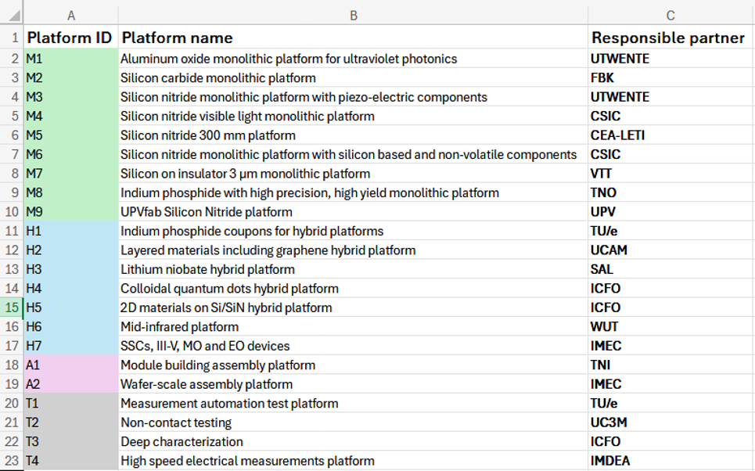
  - KW notes that this point was already discussed during the proposal writing. This is a list of the platforms that are recognised in the October meeting slides of WP4.

  - VP, KW, TA and JF agree to have an additional discussion on this topic.
  - Clarification from KW: Partners unsure about whether a platform should be within the PIXEurope Open Access Portfolio should join WP3 Open Access Sessions – contact Ana Aguarod to receive a meeting invite.

Work Package 3 DEP (KW)
- Currently looking at documentation needed for Open Access, such as NDAs, etc. Expected by end of the year ensuring compliance with Hosting Agreement, led by ICFO. Holding direct discussions with PO on this topic.
- Three types of Open Acess have been discussed:
    - Type 1: Lab-to-fab, where Chips Ju or national authorities leverage the pilot line with public calls.
    - Type 2: Services, such as consultancy, training, use of equipment or prototyping, where end-users will access through cash compensation. This model is beneficial to the pilot leading to incorporating end-user technology to the pilot line.
    - Type 3: Collaborative R&D projects that go beyond classical uses. This is the novel approach of PIXEurope that involves in-kind contribution (not necessarily cash) by end-user. The underlying objective is that the end-user contributes to the technology offering of the Pilot.
  - The services will be based on previous experience, e.g. JePPIX and PIXAPP, while Lab to Fab are public calls that do not carry state-aids issues.
Work Package 4 (KW)
- Slides are shared showing three main activities
  - 1) Internal frame program starts now, consisting in interactive webinars which will be recorded to form a repository of video content.
  - 2) Layouts from partners asked to specify their building blocks and document appropriately. Hoping to finalise PAK creating by the end of the year, and PDK by June.
  - 3) Ongoing consultation with partners to complete roadmap: what do they expect PDK to do in 5 years? This will serve to create a credible workplan aligned with partners’ needs and focus.
- WP 4 will create an Expert Group on standards, however there’s not enough knowledge yet to start this activity which will be postponed until next year.
- TU/e is currently involved in a proposal on design. Question is raised on knowledge of activities specific to photonic design enablement which could be integrated in PIXEurope.
- PM requests further insight in design enablement teams.
  - KW: The Design Enablement Teams topic will be introduced at the November edition of the WP4 meetings with time for Q&A
Work Package 6 (PM)
- Two meetings held so far; they collected information on current research activities
- Next action is to define remaining task leaders (8 out of 10 identified)
- Start time for WP activities is December, so still waiting for teams to be appointed
- VP asks if WP 6 has encountered any potential issues with Open Access offer, as discussed in WP 5. PM confirms there have not been any issues yet.
Work Package 7 (PO)
- Regular monthly meetings and individual meetings with ICFO ongoing
- PO shares a slide wit summary of equipment trials and tendering:
  - Electrical packaging – tools identified and talking to company for valuation
  - Optical packaging – might overlap with ICFO equipment. In conversations with several companies
  - Metrology – identified what they want to buy
- Lots of outreach done and more to come.
  - VP remarks the importance to let partners know which equipment is available for sharing
- PO highlights the importance to negotiate good customer support when purchasing working manufacturing equipment. This can be challenging since we’re not big partners.
Work Package 8 (SL)
- Regular monthly meetings ongoing
- WP 8 includes a broad range of TRL levels, but partners are aligned and working well
- Procurement team talking to CD from WP 3 to purchase equipment. Ongoing conversations with suppliers.
- Capabilities stablished to ensure stability of the Pilot Line.
- Working across geography is seen as a risk but leveraged with plenty of experience by WP leader, so not a concern
Work Package 9 (LT)
- WP 9 not started yet but ran a couple of meetings
- It’s been decided to focus on one demonstrator per meeting. Next meeting will start with demonstrator 1.
  - VP suggests to have a back up plan and validate two demonstrators at the same time
Other issues
- AA reminds SC of the upcoming technical report, due December 2025. A template will be circulated soon.

Action Items

Item | Responsible | Due Time
Circulate Template for Technical Report | Ana Aguarod | By 07/11/2025
Share public slide deck on Sharepoint | Sabine Grunge | Done
Share video content for digital materials for stands with SG | All | ASAP
Sign JPA with Chips JU | Partners who have not done so yet | ASAP
Create Events Calendar | Marina Santana | ASAP
Follow up discussion on technologies included in PIXEurope | Valerio Pruneri, Kevin Williams, Timo Alto, Joaquín Faneca | ASAP

