PIXEurope
Advanced Photonic Integrated Circuits Pilot Line for Europe
Starting date of the project: 01.01.2025
Duration: 42 months

= Deliverable D1.2 =
Project management handbook

Due date of deliverable: 28/02/2025
Actual submission date: 24/02/2025

WP and Lead Beneficiary: WP1, ICFO
Version: V1.1

Dissemination level
PU | Public
PP | Restricted to other programme participants (including the Commission Services)
RE | Restricted to a group specified by the consortium (including the Commission Services)
CO | Confidential, only for members of the consortium (including the Commission Services) | X

PIXEurope project has received fundings from the Smart Networks and Services Joint Undertaking (SNS JU) under the Horizon Europe research and innovation programme under Grant Agreement NO 101192681

AUTHOR
Author | Institution | Contact (e-mail, phone)

DOCUMENT CONTROL
Document version | Date | Change

VALIDATION PROCESS
Reviewers |  | Validation date

DOCUMENT DATA
Keywords | WP1, Management, Coordination
Point of Contact | Name: Valerio Pruneri  Partner: ICFO  Address: Mediterranean Technology Park, Avinguda Carl Friedrich Gauss, 3, 08860 Castelldefels, Barcelona, Spain  Phone: +34 935 53 40 02  E-mail:
Delivery date

DISTRIBUTION LIST
Date | Issue | Recipients

Executive Summary

Proper project management is a keystone to a successful project progress and leads to the fulfilment of its goals. A challenging project like PIXEurope requires an effective, efficient and well-defined management scheme. It has to ensure a flawless flow of research and knowledge between the various Work Packages. It has to provide mechanisms to make decisions that will affect the project’s outcome as well as administrative, technical and scientific co-ordination of the project.
This document describes the project management and quality assurance scheme which will be followed over the course of the project in order to smoothly achieve PIXEurope’s objectives. The setting will be reflected and could be modified in the future if another approach would seem more efficient.

Table of Contents

Contents
1. Content of deliverable 5
2. Consortium organizational structure and roles in the project 5
2.1. Project Coordinator (PC) 6
2.2. Project Manager (PM) 6
2.3. Work Package Leaders (WPLs) and Project Steering Committee (PSC) 6
2.4. Task Leaders (TL) 7
2.5. Dissemination Manager (DM) 7
2.6. Innovation Manager (IM) 8
2.7. General Assembly (GA) 8
2.8. External Advisory Board (EAB) 8
3. Internal management procedures 9
3.1. Communication 9
3.2. Decision making 9
3.3. Progress monitoring and reporting 10
3.4. Publication procedure 12
3.5. Project meetings 12
4. Conclusions 13
5. Degree of progress 13
6. Dissemination level 13
7. Annexes 14
7.1 Annex I: PIXEurope meeting minutes template 14
7.2 Annex II: PIXEurope deliverable template 14
7.3 Annex III: PIXEurope technical reporting template 14
7.4 Annex IV: PIXEurope presentation template 14
7.5 Annex VI: PIXEurope 6G Gantt chart 14

- Content of deliverable
The deliverable D1.2 Project Management Handbook is part of T1.3: Project management, Quality assurance and Risk management. The content of this document is based on and in line with the project management and implementation setting described in the Annex I of the project’s Grant Agreement (Description of the Action, DoA) and the project’s Consortium Agreement (CA).
The purpose of this document is to describe the proposed project management, procedures and quality assurance scheme which will be followed over the course of the project in order to smoothly and successfully achieve PIXEurope’s objectives. It will ensure a flawless flow of research and knowledge between various Work Packages (WPs) and provide mechanisms to take decisions that will affect the project’s outcome as well as administrative, technical and scientific coordination of the project. Moreover, the defined structure will ensure the effective dissemination of the tasks achieved during the project and will help to select the most appropriate exploitation routes for the generated know-how.

- Consortium organizational structure and roles in the project
The consortium organization is described below and depicted in Figure 1 Project Management Structure

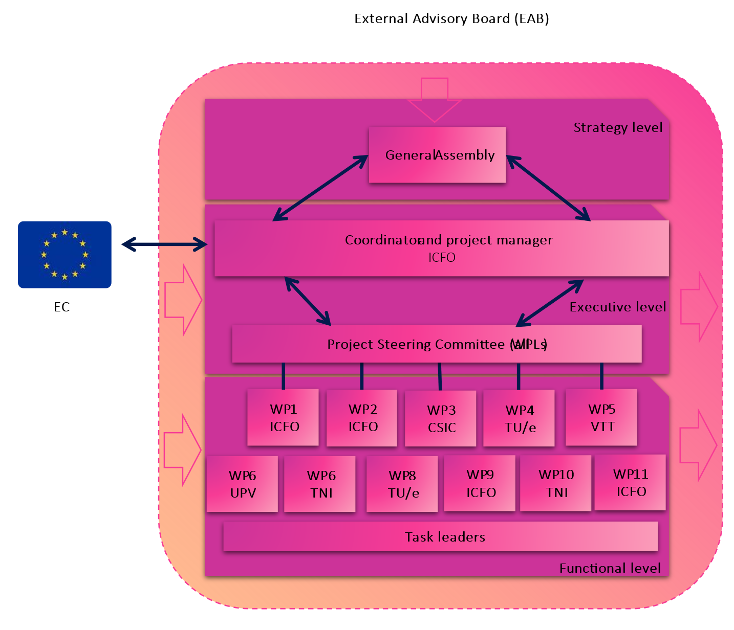
Figure 1 Project Management Structure
The organizational structure and the rights and duties of the operational bodies responsible for the decision-making in PIXEurope are explained and described in Section 6 of the CA, entitled Governance Structure. The External Advisory Board (EAB) will be established for delivering the strategic advice needed during the project periods.

  - Project Coordinator (PC)
On behalf of ICFO, Dr. Valerio Pruneri will act as PIXEurope Project Coordinator, responsible for the overall coordination of activities and technical monitoring of activities. He will be assisted in the management tasks by the Project Manager, the Work Package Leaders (and their deputies) and the General Assembly (GA), which will be empowered to make high-level decisions on every aspect of the project.
He follows the project throughout its whole lifecycle, on a day-to-day basis. He gathers the necessary information for efficient communication both with CHIPS JU (activity, financial and final reports, audits, etc.) and within the consortium (consortium meetings, schedules, reports, progress reports, etc.) from WPLs. The PC will be the sole interface between CHIPS JU and the consortium, and the contact point for communication with other projects in the Horizon Europe and Digital Europe programmes. He is also responsible for distribution of the financial support amongst the partners paid by CHIPS JU.
Should any major problem arise, the PC has the possibility to call for a meeting/teleconference of the Project Steering Committee (PSC) or for an extraordinary meeting of the GA.

  - Project Manager (PM)
Valerio Pruneri (ICFO) will have the role of Project Manager (PM) and will support the PC and WPLs in their administrative, financial, dissemination and communication roles. He will take care of project amendments, monitoring and timing of technical deliverables and milestones, timely and quality reporting, and checking the partners’ budget follow-up (e.g. preparing and checking cost statements, distribution of funding, etc.). The PM is responsible for the proper information flow between the PGA and PC on one side and WPLs and partners on the other. Furthermore, the PM coordinates the project meetings

  - Work Package Leaders (WPLs) and Project Steering Committee (PSC)
The structure of the work plan is divided into 9 Work Packages (WPs) and for each there is a Work Package Leader (WPL) nominated. WPLs are responsible for controlling the progress of the scheduled work within the WP in terms of technical achievement, planned deliverables and expenses and for informing the PGA and other WPLs about project progress. Other tasks of the WPLs are:
- To collect the information (e.g. technical, programmatic) needed to prepare periodic progress reports and to transmit them to the PM for information and monitoring; and to the PC for processing the information and inputs provided
- To transmit information from the PC to the partners involved in the WP
- To manage topic-oriented meetings, and to report to the PC on all matters related to the topic (e.g. planning, costs, etc.)
- To allow a fluid upstream and downstream exchange of information, regular contact is maintained between the PC, PM and WPL.
All WPLs form the Project Steering Committee (PSC), which acts as a managerial decision-making body for the project and is responsible for supporting the PC. In the event of technological changes that cannot be addressed directly by a WPL, the PSC will investigate and advise appropriate actions. Furthermore, the WPL(s) will implement any recommended actions and will make decisions in those cases where it is not necessary to refer to the GA. A consensus will be aimed to be reached wherever possible. If consensus cannot be reached, decisions will be taken after a simple majority vote. The PSC meets at least two times per year to perform the internal assessment of the project and to assure the conformity and the quality of all project deliverables. Monthly teleconferences of all PSC members are scheduled for the project duration. Other partner teleconferences (e.g. on WP level) and other (Ad-hoc) partner meetings are encouraged.

Table 1: list of X-TREME 6G Work Package leaders and members of the Project Steering Committee
WP | WP name | WP leader
1 | Project management and Coordiantion | ICFO
2 | Training, Dissemination, Exploitation and Collaboration | ICFO
3 | Installation, Qualification & Site Acceptance | CSIC
4 | Design | TU/e
5 | Monolithic PIC Platforms | VTT
6 | Hybrid PIC integration | UPV
7 | Packaging | TNI
8 | Test & Reliability | TU/e
9 | Technology Validation and Demonstration | ICFO

  - Task Leaders (TL)
The work to be implemented in each WP is divided into tasks. Every task is being managed by a Task Leader, who is responsible for carrying out the work planned in the task. Task Leaders communicate with their respective WPL on a regular basis. They provide inputs to enable project progress reports to be drafted. The list of all tasks is part of the DoA.

  - Dissemination Manager (DM)
As several dissemination activities are planned to be undertaken during the project lifetime, the role of Dissemination Manager (WP11 Leader, Valerio Pruneri, ICFO) has been established.
The aim is to assure that the results of the project will be disseminated to the European research and industrial community. In PIXEurope dissemination will target all important stakeholders in the field of microelectronics and telecommunications.
Specific communication activities will address the general public, scientific community, technicians, experts, media, policy makers, industries, end-users, etc. The Dissemination Manager will be responsible for the setup of the procedures to allow all dissemination activities to be quality assured including both the content and layout. In particular, he will check that:
- All messages to be transmitted outside of the consortium are suitable for the people addressed and are relevant for the industry (when applicable) and
- Scientific papers and publications contain sufficient reference to the project.

He will be in regular contact with all project partners and coordinate all the dissemination activities and will keep records of them. In collaboration with the exploitation manager, he will make sure that no project publication is jeopardising the potential protection of generated intellectual property (e.g. patent, product design) and further industrial application.

  - Innovation Manager (IM)
Valerio Pruneri (ICFO) will take on the role of the Innovation Manager (IM) which has been set up in order to monitor and advise IPR management and support exploitation
Combining strong technical expertise with a substantial understanding of market needs is one of the core competencies of the beneficiary ICFO, which will be responsible for the overall IPR management. ICFO will be supported by the respective IPR and Business Development managers of PIXEurope participants. The Exploitation and Innovation manager from ICFO will periodically provide a review of the relevant IPR developments (i.e. recently published patent application, granted patents) and will be responsible for advising the consortium about the continuation of research activities, e.g. in case of changes of prior art and IP protection.

  - General Assembly (GA)
The General Assembly (GA) is a decision-making consortium body at the strategic level, which is established at the beginning of the project. Minutes of these meetings will be prepared and submitted to the EC as deliverables under WP1. The GA consists of key senior representatives from each partner organisation. It acts and makes decisions in line with what is stated in the CA and DoA.

The tasks of the GA are as follows:
- Responsibility for project strategy and its exploitation
- Monitoring of project progress, its achievements, and costs
- Supervision of technical developments
- Coordination of dissemination actions and exploitation activities
- Making agreements on contract changes/amendments if required (e.g. budgets, resources, plans, etc.)
- Solving problems with a potential impact on project strategies, resources, and objectives, defining the necessary contingency plans
- Keeping track of medium- and long-term objectives.

The GA meets at least once a year and is chaired by the PC, who is assisted by the PM. The minutes of the GA serve as deliverables in WP1 to be submitted to CHIPS JU.
  - External Advisory Board (EAB)
The support of the External Advisory board will ensure high visibility to the project and wide participation of stakeholder groups. The EAB will provide inputs to the project and will receive periodic updates about the results. The existence of the EAB will increase the pan-European concept of this project and will provide desirable feedback from other closely related European and national activities in the materials characterisation and modelling database. The EAB will thus provide synergy with European R&D and industrial activities.
The EAB modus operandi is as follows:
- Strategic advice in technology processes, IPR environment and dissemination activities during the project
- EAB members will sign a Non-Disclosure Agreement (NDA) before the first EAB meeting as they are neither legally bound by any contract between participants (Consortium Agreement), nor by the Grant Agreement.
- Periodic meetings (at least once in two years) with all consortium partners
- No financial reimbursement to EAB members is foreseen but covering full travel and accommodation costs for physical meetings is foreseen.
- Access to the newest information from PIXEurope and related topics will be provided.

The name of EAB members cannot be disclosed at the moment, as we are still engaged in a negotiation phase. This document will be updated as soon as their names will be known.

The EAB should meet at least once a year with the General Assembly. EAB minutes are to be submitted to the Commission as a deliverable. Partners agree on acting openly towards the EAB members, since they will be bound by the NDA. They can participate in any of the regular Consortium meetings.
- Internal management procedures
The following procedures will ensure smooth implementation of the project and timely awareness and reaction to potential problems.
  - Communication
To make communication easier within the main consortium bodies, the following mailing lists have been set up:
- all@pixeurope.eu – All project participants
- finance@pixeurope.eu financial contacts
- psc@pixeurope.eu - WP leaders + substitutes + Project Coordinator + Project Manager
- ga@pixeurope.eu – primary contacts of each project partner.
- WP1-11@pixeurope.eu – one mailing list per work package
Additional mailing lists can be created following project needs. Mailing lists will be regularly updated following project needs.

In order to easily share files and documents related to the project, a common share point on teams will be used.
  - Decision making
It can be expected that most decisions will be taken by consensus of all the partners. It is the role of the Project Coordinator to identify and possibly resolve potential conflicts in a proactive manner in collaboration with the WPLs. All cases will be discussed among the conflicting parties in good faith. However, in case of a serious conflict, when the Project Coordinator is unable to mediate between the conflicting parties, each partner can ask the GA in writing to organise a conflict resolution meeting. The GA will organise such an extraordinary meeting within 10 calendar days following the receipt of the written request and attempts for arbitration will be performed in increasing order of authority from the level of the WPLs to the GA level. Within the meeting, agreement will be sought by dialogue and mutual concession. In case of a failure to find an agreement, the GA will make the final decision. The voting rules are described in section 6 of the CA.

  - Progress monitoring and reporting
    - Project deliverables
Progress made in reaching the deliverables in each WP will be regularly assessed by integrating all inputs from the WPLs and PC. The progress of the project will be assessed at two levels with the help of general indicators, which are the objectives, milestones, deliverables, and the appropriate use of budget, respectively.
All deliverables generated by the persons in charge will be checked and controlled in this sequence: WPL > PM > PC> Submission to SNS JU > SNS JU Project Officer (or reviewer) as also shown in Figure 2.
Figure 2 Procedure for quality assurance of deliverables
TASK LEADER (TL)
- completes the DRAFT Deliverable (based on the Deliverable Template)
- sends the DRAFT to WPL
WORK PACKAGE LEADER (WPL)
- checks the DRAFT
- if necessary, sends back to TL for revisions
- sends the DRAFT to PM
PROJECT MANAGER (PM)
- checks the DRAFT
- if necessary, sends back to TL for revision (WPL in copy)
- sends the DRAFT to COORD
COORDINATOR (COORD)
- checks the DRAFT
- if necessary, sends back to TL for revision (WPL and PM in copy)
- FINAL Deliverable is submitted to EC
3 WEEKS
2 WEEKS
1 WEEK
TO DEADLINE

The first draft of the report is to be ready approximately seven weeks before the submission date. Complete adherence with deadlines will be required in order to submit deliverables on time. A deliverables template is available for partners on share point.
Moreover, the PSC will conduct the internal quality assessment of milestones and deliverables that are based on the quantified objectives detailed in the DoA and within the WP description. It is foreseen that the 6 months periodicity for the PSC meeting will facilitate internal assessment of the project and ensure conformity and quality of all project deliverables with requirements. The WPL are responsible for monitoring progress in their own WP, to identify risks and to rapidly inform the PSC if any changes with regard to the DoA occur.

    - Internal reports
The internal reporting will consist of financial reporting, person-months reporting and technical reporting. The financial and person-months reporting template will be drafted in the coming weeks; the internal technical reporting template is available on the project’s share point. The following scheme is set:
Financial, Person-months reporting:
- Every 6 months, periodic activity report to CHIPS JU, official reporting towards the CHIPS JU in M18, M36 and M42.
- Any changes or problems should be immediately communicated to the PC and PM.
- Partners will be reminded about the reporting deadline 1 month in advance.

The aim of the six-monthly periodic activity report is to give an overview of the main activities and results obtained during the previous period of the project by individual partners in order to monitor project development over the preceding 6 months and prepare a summary activity report on project progress per WP. To enable this, internal templates will be provided to partners.
Reporting towards the EC is scheduled in M18, M36 and M42. The Periodic Reports (M18, M36) have to be submitted within 60 days from the end of the reporting period. These will include requests for payment and must be drawn up using the forms and templates provided in the electronic exchange system. They must be submitted electronically via the Participant Portal.

The periodic report consists of the following parts:
- Technical event report:
  - Explanation of work carried out including a publishable summary
  - Overview of progress
  - Deliverables check (according to the timetable in the list of Deliverables).
- Financial event report:
  - Explanation of the use of resources
  - Financial statement from each beneficiary and third party
  - Periodic summary financial statement.

If a partner does not provide the data, the PC will submit the statement without it, which means zero claimable costs for the partner concerned.

The Final report which is to be submitted electronically via the Participant Portal consists of:
- Periodic report
- Final publishable summary report
- Plan for the use and dissemination of results to spread awareness
- Report covering the wider societal implications of the project.

Project risks will be constantly assessed and evaluated during the whole project duration. The methodology to be followed for risk contingency consists of four steps:
- Risk identification: areas of potential risk will be identified and classified
- Risk evaluation: the probability of events will be determined, and the consequences associated with their occurrence will be examined
- Risk response: methods will be produced to reduce or control the risk
- Risk control and report: lessons learnt will be documented.

All risk management issues will be documented in the Periodic Reports.

  - Publication procedure
A fair and transparent procedure for the submission of an abstract, paper or other external publication will be implemented, in line both with the GA and the CA. The framework is defined in the CA Article 8.4 Dissemination and is in line with Article 17 of the GA.
Prior notice of any planned publication should be given to other consortium members at least 45 calendar days before the publication. Any objection to the planned publication shall be made in accordance with the GA in writing to the PC and to the consortium member proposing the dissemination within 30 calendar days after receipt of the notice. If no objection is made within the time limit, the publication is permitted (see also Figure 3).
The following information should always be mentioned in the publication: “PIXEurope project has received fundings from the Chips Joint Undertaking (CHIPS JU) under the Horizon Europe research and innovation programme under Grant Agreement NO 101192681”.

INTENTION OF PUBLICATION
Copy to be sent to COORD and PART
To be sent at the earliest time
45 DAYS PRIOR TO PUBLICATION
30 DAYS AFTER ITS RECEIVE
PUBLICATION
NO OBJECTIONS WITHIN 30 DAYS
OBJECTIONS TO PUBLICATION
Legitimate interests in relation to confidentiality, foreground and background will suffer harm => request for modification
Objections send to author and COORD
To seek in good faith to agree a solution
INFO ON PUBLICATION
To be sent to COORD and PM
Figure 3 Information and timeline of intention of publication

  - Project meetings
As already mentioned above in the respective chapters dedicated to consortium bodies, the GA should meet at least once a year, whilst the PSC should meet bi-annually in presence and monthly in a teleconference format. Moreover, WPLs will communicate regularly via dedicated teleconferences for the duration of the respective work package. Other partner teleconferences and exclusive partner workshop meetings are encouraged. If needed, an ad-hoc meeting can be scheduled in order to discuss any relevant issue. To save time and resources, operational meetings could also be held by teleconferencing systems, arranged according to availability.
The PM will inform participants at least 2 months in advance about the agenda and location of any physical meeting.
In case of an online meeting, the participants will be informed at least 4 weeks in advance.
Table 1 shows the PIXEurope management meetings and communication.

Table 1 PIXeurope management meetings and communication
Management level |  | GA | EAB | PSC
Periodicity | Responsibility | Coord. | Coord. | Coord.
Annually |  | X | X
Bi-annually |  |  |  | X
Monthly |  |  |  | telco
- Conclusions
The proposed project management, procedures and quality assurance setting will be followed throughout the course of PIXEurope in order to smoothly and successfully achieve the project objectives. The Consortium organisational structure, bodies and roles in the project are set and internal procedures drafted. The scheme will be followed throughout the project and if needed it could be modified if another approach is deemed to be more efficient. PIXEurope’s Consortium believes that the proposed processes will enable the project to achieve its objectives.
- Degree of progress
The deliverable is 100% fulfilled.
- Dissemination level
The Deliverable D1.2 is confidential, available only for members of the Consortium, including the Commission Services.

- Annexes
In the sections below, the report templates are shown (7.1 to 7.5) as well as the project gantt chart (7.5).

  - Annex I: PIXEurope meeting minutes template

  - Annex II: PIXEurope deliverable template

  - Annex III: PIXEurope technical reporting template

  - Annex IV: PIXEurope presentation template

  - Annex VI: PIXEurope 6G Gantt chart

