D1.8 Intermediate progress report M7




Project number: 101213727
Project acronym: PIXEurope - HE
Project title: Advanced Photonic Integrated Circuits Pilot Line for Europe
Contents
1. Explanation of the work carried out by the beneficiaries and Overview of the progress 3
1.1. Objectives for the period (M01-M06) 4
1.2. Explanation of the work carried out per WP 7
1.2.1. Work Package WP1 – Project Management & Coordination 7
1.2.2. Work Package WP2 – Training, Dissemination, Exploitation & Collaboration 10
1.2.3. Work package WP3 – Installation, Qualification & Site Acceptance 26
1.2.4. Work Package WP4 - Design 29
1.2.5. Work package WP5 – Monolithic PIC Platforms 35
1.1.1. Work package WP6 – Hybrid PIC integration 38
1.1.2. Work package WP7 – Packaging 41
1.1.3. Work package WP8 – Test & Reliability 45
1.1.1. Work package WP9 – Technology Validation & Demonstration 51
1.2. Impact 52
2. Update of the plan for exploitation and dissemination of results 53
3. Update of the data management plan 54
4. Deviations from Annex 1 and Annex 2 55

- Project acronym: PIXEUROPE
- Project title: PILOT LINE CPL-5 Advanced Photonic Integrated Circuits
- Grant Agreement: 101213727
- Deliverable: HE D1.8 Intermediate progress report M7
- Lead beneficiary: ICFO
- Delivery date: XX/XX/2025
- Authors: Valerio Pruneri, Marina Santana, Ana Aguarod
- Organization: ICFO
- Dissemination level: Sensitive
- Project website: https://pixeurope.eu/

Explanation of the work carried out by the beneficiaries and Overview of the progress
This period corresponds to Phase 1steps Phase 1 (M01 to M06) of the PIXEurope Pilot Line (PL). During this period, we have fulfilled all the planned actions ensuring the successful development of the initiative. The partners involved in this first PIXEurope reporting period are listed below, together with their short name, which will be used throughout this report:
Partners Name | Short Name
FUNDACIO INSTITUT DE CIENCIES FOTONIQUES | ICFO
UNIVERSITY COLLEGE CORK - NATIONAL  UNIVERSITY OF IRELAND, CORK | TNI
TECHNISCHE UNIVERSITEIT EINDHOVEN | TU/e
UNIVERSITAT POLITECNICA DE VALENCIA | UPV
TEKNOLOGIAN TUTKIMUSKESKUS VTT OY | VTT
INTERUNIVERSITAIR MICRO-ELECTRONICA  CENTRUM | IMEC
AGENCIA ESTATAL CONSEJO SUPERIOR DE  INVESTIGACIONES CIENTIFICAS | CSIC
NEDERLANDSE ORGANISATIE VOOR TOEGEPAST  NATUURWETENSCHAPPELIJK ONDERZOEK TNO | TNO
UNIVERSITEIT TWENTE | UTWENTE
UNIVERSITEIT GENT | UGent
UNIVERSIDAD DE VIGO | UVIGO
INSTITUTO DE TELECOMUNICACOES | IT
POLITECHNIKA WARSZAWSKA | WUT
SI AUSTRIA LABS GMBH | SAL
POLITECNICO DI MILANO | POLIMI
COMMISSARIAT A L ENERGIE ATOMIQUE ET AUX  ENERGIES ALTERNATIVES | CEA-LETI
FONDAZIONE BRUNO KESSLER | FBK
THE CHANCELLOR MASTERS AND  SCHOLARS OF THE UNIVERSITY OF  CAMBRIDGE | UCAM
UNIVERSITY OF SOUTHAMPTON | USOTON
FUNDACION IMDEA NETWORKS | IMDEA

Objectives for the period (M01-M06)
The main objective of PIXEurope is to create the world’s first fully integrated Open Access PL for Photonic Integrated Circuits (PICs), bringing together Europe’s leading research organisations across all advanced PIC technology domains. This collaboration will build a uniquely unified and standardised PIC ecosystem, positioning Europe as a global leader and ensuring technological sovereignty and competitive advantage in this critical field. Strategic investments in cutting-edge equipment will provide essential European infrastructure to drive breakthrough PIC innovations.
The specific objectives of each WP pertaining to phase one (M01-M06) are below in bold.
WP1: Project Management & Coordination
- To effectively and efficiently coordinate PL activities and monitor progress with the aim to ensure timely and successful achievement of PL objectives
- To ensure adequate financial and administrative management
- To provide a reliable interface to the European Commission (EC) services
WP2: Training, Dissemination, Exploitation & Collaboration
- Develop online and hands-on training courses to focus on PIC manufacturing (design, fabrication, packaging, testing and reliability).
- Training courses to focus on PIXEurope’s standardised technologies, including Process Design Kits (PDKs), Assembly Design Kits (ADKs) and Test Design Kits (TDKs)
- Collaborate with European Competence Centres to develop and deliver training courses
- Increase public awareness of the activities of the Pilot Line;
- Management of the collective impact of the consortium throughout the duration of PIXEurope by (1) evaluating the market potential and determination of product opportunities, (2) identifying and managing individual and collective opportunities of PL results exploitation
- Monitor new IPR creation inside and outside of the consortium
- Investigate and evaluate the market potential and determine new product opportunities
- Develop strategy considering future customer needs, competitors, market barriers and technology roadmap
- Ensure PIXEurope becomes fully integrated and involved into the European semiconductor ecosystem
- Develop synergistic partnerships with other Chip Pilot Lines (CPL1-4) and future Pilot Lines, including the Quantum Pilots and other flagship European initiatives such as PhotonHub Europe and Europractice, as well as major national initiatives and IPSEI programs in integrated photonics
- Collaborate with all partners to deliver joint workshops and training courses and work on common design and manufacturing process standards
- Engage with national agencies to encourage national funding support for users to leverage Pilot Line services
WP3: Installation, Qualification & Site Acceptance
- Installation: Ensure proper setup, compliance, and initial functionality
- Qualification: Validate design, installation, and operational aspects against specifications
- Site Acceptance: Confirm overall system performance, provide training, and obtain stakeholder approval

WP4: Design
- Creation of new, standardised, interoperable Design Kits and building block descriptions
- Automation of data flows, data integrity checking using a Digital Platform for design cycle management
- Creation of advanced methods for analysis and predictive design to detect common errors before tape-out
- Design flow optimizations through validation and real-time status monitoring for multi-platform design
- Scalable design frameworks connecting seamlessly to the Design Platform for upscaled design capacity
WP5: Monolithic PIC Platforms
- Develop scalable and cost-effective manufacturing processes for PICs with improved capacity
- Develop and enhance PIC technologies with new functionalities in the Near-infrared (NIR)
- Extend the operational wavelength of PICs into the visible and mid-infrared spectrum by enhancing existing technologies and developing new ones specifically designed for these wavelength ranges
- Develop scalable and cost-effective manufacturing processes for PICs with improved capacity
- Pave the way to large-volume manufacturing via commercial foundry partners, primarily in Europe
- Collect data from the PIC fabrication processes to support Design Kit development in WP4
WP6: Hybrid PIC integration
- Provide platforms with functions beyond the capabilities of the individual monolithic PIC technologies, by creating hybrid PIC platforms through advanced fabrication techniques and novel material systems, including:
  - Modular hybrid III-V on SiN, using micro-transfer printing (MTP) and laser-induced forward transfer (LIFT) for lasing or semiconductor optical amplification (SOA).
  - MTP of GaN and III-V coupons on SiN, for red-green-blue (RGB) light emission and infrared lasing, respectively.
  - MTP of III-V components, bismuth iron garnets (BIG) and thin-film lithium niobate (TFLN) / barium titanate (BTO) on thin Si for lasing/SOA, magneto-optic (MO) and electro-optic (EO) components, respectively.
  - MTP of III-V and TFLN on thick Si, for lasing/SOA and EO modulation/switching, respectively.
  - Novel material systems on Si, SiN, and Ge-on-Si functionalised with two-dimensional layered materials (2D LMs), colloidal quantum dots (CQDs), ultrathin metal films (UTMFs) and phase change materials (PCMs). These embrace multiple functions, including light emission, electro-optic modulation and programmable switching.
- Develop micro-nano structuring, lithography, etching and dicing processes of hybrid PIC substrates
WP7: Packaging
- Multiphysics simulation and design model for package-level and wafer-level packages, accounting for optical, electrical, thermo-mechanical domains
- Prepare materials for package and wafer-level packaging processes (linked with WP3)
- Fabrication of specialised process tooling such as chip pickup tools and process requirements such as specialised machine vision imaging and process thermal requirements.
- Enhance and optimise existing package-level processes
- Demonstration of wafer-level packaging process on 100 mm diameter platform, suitable for scaling to larger diameter wafer (e.g. 300 mm) and panels (e.g. 510 mm)
- Develop fully packaged modules to validate packaging processes
- Collect packaging design rules from the previous tasks (T7.1 - T7.5)
- Develop ADKs for package-level and wafer-level processes (linked with WP8)
WP8: Test & Reliability
- Develop measurement capabilities for materials and structure for determining layers, interface, structure, and morphology of PICs.
- Establish functional test processes at the building block level. Leverage the material characterisation, and test for identification of reliability issues and analysis of failure modes.
- Develop and establish capabilities for in- production Wafer Level Test at the Front-End and Wafer Level Reliability at the back-end-of-line (BEOL) at the pilot line level, supporting wafers up to 300 mm with the potential of scaling to high volume manufacturing (HVM). Enable early in-production failure modes identification.
- Develop and optimize test and reliability processes, and methods for the Back-End. Establish test and reliability capabilities scalable from units to batches for verification and validation of assembly, and packaging processes, from subassemblies to modules.
- Develop, and implement new, direct and indirect electronic-photonic characterization and test methods, and solutions, supporting highly parallel electronic-photonics probing. Migrated advanced characterisation methods into test processes in Font-End and Back end supporting pilot and HVM production.
- Establish high throughput, wafer scale inspection capabilities for in-production process validation, and qualification for core and hybrid technologies. Utilise machine-learning methods for process efficiency optimisation, and maximizing the throughputs. Develop solutions for rapid and accurate topography mapping, and contactless probing for optical, radiofrequency (RF), millimetre wave (mmW) and terahertz (THz) signals. Employ machine learning (ML) models for accelerated data classification and analysis.
- Develop test and reliability methods for qualification of processes, and PICs. Engage in standardization initiatives, and technology roadmaps for accelerated adoption of integrated photonics by semiconductor microelectronics supply chains, and application-specific markets.
- Develop, define, and implement TDKs following open standards, capturing the test and reliability process developed, and data obtained in this work package. Implement and demonstrate these in electronic design automatization (EDA) environments, as Design-for Test and Desing-for-Reliability methodologies.

Explanation of the work carried out per WP

Work Package WP1 – Project Management & Coordination

Progress towards objectives

T1.1: Strategic decision making (General Assembly coordination) (ICFO, all) M1-M60
The first General Assembly took place during the kick-off meeting, held on 9 and 10 June 2025. During these sessions, the PL’s WPs were presented to all partners.
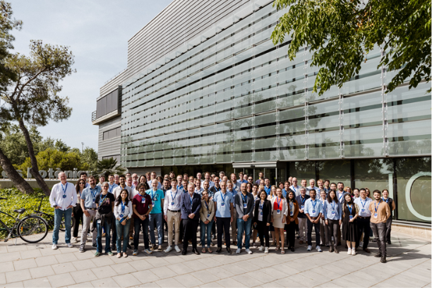
Picture 1 Kick-off Meeting at ICFO - June 9, 2025
The Pilot Line General Assembly (GA) is the decision-making body and it is constituted by all partners. The current version of the Consortium Agreement provides that at least one in-person meeting must be held each year. The next GA is scheduled for 20 May 2026.

T1.2: External Advisory Board coordination (ICFO, all) M13-M60
Not applicable to this period

T1.3: Project management, Quality assurance and Risk management (ICFO, all) M1-M60
The main governance structures were established during the first 6 months to ensure effective and efficient implementation of PL’s procedures.
- PL Steering Committee (SC): Supervisory body, responsible for the technical execution and strategic decision-making of the PL, reporting to and accountable to the GA. It is constituted by all WP Leaders, both from the DEP and HE. The SC assists the coordinator to manage quality assurance. To do this, SC meetings are held monthly online since September 2025, while in-person meetings will take place twice a year. The first of these will take place on 18–19 February 2026 at ICFO.
- PL Management & Coordination Team (MCT): Responsible for the daily management and coordination activities of the PL and execution of tasks to implement the guidelines and decisions of the SC and GA. It is also responsible for liaising with the Chips JU and External Advisory Board (EAB). MCT meetings are held monthly online since December 2025 and in-person at least once a year. The first face-to-face meeting was held on 20 November 2025 in Munich with the (PO).
The MCT is composed by:
- PL Director
- PL Project Manager (x2)
- PL Financial & Procurement Manager
- PL Installation & Acceptance Manager
- PL Dissemination & Communication Manager
- PL Exploitation & Innovation Manager
- PL Training Manager
- PL Interoperability Manager
- PL Open Access Manager
- PL Data and Gateway Manager (under discussion whether needed)
Besides governance body meetings, and to ensure proper operation and development of the PL, each of the WP leaders coordinates online monthly meetings.
Minutes of both governance bodies and WP meetings are recorded and shared with the whole consortium on SharePoint.
Other actions executed by the management team at ICFO include the preparation and submission of an amendment to the initial Description of Action (DoA) to replace UC3M partner with IMDEA, which assumed all of its tasks and responsibilities. This amendment was approved by the EC on 13 October 2025.
Furthermore, we developed initial key performance indicators (KPIs) for the innovation activities, which will be revised every 6 months:
As a first approach, PIXEurope will monitor three different KPI categories:
- Technology- and process-specific KPIs: as listed in the HE-GA for every technical Work Package, each measuring the evolution of distinct figures of merit and “transfer readiness” overall.
- User-journey KPIs: derived from the Pilot Line utilization experience by external users and collaborators, and overall, a measure of “market uptake potential”.
- Innovation & Exploitation KPIs: measuring the innovation capacity and techno-economic viability of key exploitable outputs.
By drawing correlations between these sets of KPI, tentative exploitation path(s) can be defined for specific use case(s), allowing the informed decision of an optimal market pathway.

PIC technology- and process-specific KPIs (WP4-WP9) |  | User-journey KPIs  (WP3) |  | Innovation & Exploitation KPIs (WP3)
- Design:  Interoperability, automation, … |  | - External gateway requests  - Active & completed collaborations/services  - R&D Projects  - Consultancy  - Equipment use  - Prototyping  - Percentage of SMEs / start-ups  - Equipment utilization rate  - Time-to-prototype  - Prototype chips fabricated  - Revenue from external users  - Cross-pilot collaborations |  | - New results/innovations piloted  - Result ownership cleared  - Innovation type (product, process, design…)  - Innovation degree (minor, differentiating, disruptive)  - TRL evolution  - Patents filed/granted  - Yield/reliability  - Cost-per-function  - Supply chain robustness  - Standard(s) compliance  - Design kit chain maturity (until release)  - Intellectual Property (IP) packetization  - Market (Time to market, segment, demand…)  - Process scale-up industry partners
- Monolithic fabrication: Wavelength range, Wafer up-scaling, …
- Hybrid integration: Integrability, Functionality, …
- Packaging:
Wafer compatibility, Interposer density, …
- Test & reliability:
Dynamic range, Design-for-test adoption, …
- Demonstrators:
Full functionality, Standardization, …
Figure 1: Technical, user-journey and Innovation and Exploitation KPIs.
During the upcoming months, these KPIs will start being populated, aiming to use entry-gateway logs and other internal processes to automate data gathering. To benchmark ambition, baselines will be established based on state-of-the-art performance metrics (technical KPIs) and available Chips JU/ECS historical data/objectives (user-journey, innovation KPIs). As the Pilot Line evolves and end user needs are integrated, these KPIs will be re-defined or complemented by new ones as needed. Any exploitation path will safeguard the institutional policies of contributing PL partners.
Finally, during these first 6 months, ICFO coordination team carried out the pre-financing of the corresponding amount from Horizon Europe to all the partners in the Consortium.

T1.4: Data Management Plan (ICFO, all) M1-M60
ICFO will submit the preliminary Data Management Plan (DMP) as Deliverable D. 1.5. This document will be updated in M24 and M48 (Deliverables D1.5 and D1.6). The DMP covers the description, storage and management of data generated by the PL, for all three programs: JP, HE and DEP.

Significant results & Conclusions for WP1
- The PIXEurope initiative successfully started with the kick-off meeting in June 2025, ensuring a shared understanding of objectives and WPs across the consortium.
- All key governance and management bodies were established within the first six months, enabling effective coordination and decision-making.
- Regular monthly meetings were implemented at both management and WP levels, supporting smooth execution of PL activities.
- The MCT has become fully operational, covering all critical technical, financial, and strategic roles.
- An amendment to the DoA was approved by the EC, allowing the seamless replacement of a consortium partner.
- Pre-financing from Horizon Europe was successfully distributed to all partners, allowing activities to proceed as planned.

Work Package WP2 – Training, Dissemination, Exploitation & Collaboration

Objectives for the period
WP2 plays a foundational role in the early phase one of the PL, setting up the essential structures that will support training, dissemination, exploitation, and collaboration throughout its full duration. During the first 6 months, WP2 focused primarily on establishing a strong communication and dissemination framework and initiating strategic collaborations across the European photonics and semiconductor ecosystem.
A central objective in this initial phase was the formulation of the PL’s communication and dissemination strategy. This includes initiating the creation of key communication tools - such as the website, visual identity, and promotional materials - which are being progressively developed to ensure coherent messaging and strong visibility across the broader photonics and semiconductor community. Alongside these tools, WP2 is shaping a targeted outreach framework and beginning to consolidate a network of stakeholders at local, national, and European levels, enabling effective engagement with diverse audiences from the outset.
n parallel, WP2 launches its collaboration activities by establishing early links with major European initiatives and pilot lines. These first interactions aim to position PIXEurope within the wider semiconductor and photonics landscape, identifying areas of shared interest and preparing future joint actions with CPL1–4, the European Design Platform, Competence Centres (CCs), and initiatives such as PhotonHub Europe, Europractice, JePPIX, and ePIXfab. These initial steps lay the groundwork for future cooperation in training, community development, and the harmonisation of design and manufacturing practices.
Through these efforts, WP2 ensures that the PL begins its journey with a coherent communication framework and a growing network of strategic partnerships, both of which are crucial to the successful dissemination of results and PIXEurope’s integration into the European ecosystem.
The remaining WP2 tasks - external training activities (T2.1), IPR management (T2.3), and exploitation strategy and innovation roadmap development (T2.4) - will begin later in the PL timeline. These activities are scheduled to start from Month 11 onward (Month 24 for external training), and their implementation will build on the communication, networking and ecosystem‑building activities initiated during the first six months.

Progress towards objectives
T2.1: External Training Activities (TNI, all) M24-M60)
Not applicable for this period. We are also analysing whether the reporting of them should go in WP2 of DEP.

T2.2: Dissemination, Communication and Networking Activities (ICFO, all) M1-M60
The communication, dissemination, exploitation, and collaboration activities for PIXEurope are coordinated by ICFO, acting in its role as coordinator. WP2 supports the strategic visibility and impact of PIXEurope’s activities by showcasing the research, development, and industrial advancements achieved across the consortium, and by strengthening PIXEurope’s integration within the broader European photonics and semiconductor ecosystem. Its mission is to ensure that the work of all partners is effectively communicated to relevant stakeholders - industry, academia, policymakers, end‑users, and the general public - while enabling long‑term exploitation and collaboration opportunities.
WP2 works to maximise the PL’s impact by:
- Developing and implementing a structured communication and dissemination strategy, aligned with the goals of the PIXEurope initiative and tailored to diverse audiences across Europe.
- Ensuring clear and effective internal communication within the consortium, supporting information flow and alignment across partners.
- Initiating and carrying out external communication, dissemination, and networking activities to raise awareness of the PL, highlight key achievements, and safeguard visibility across relevant communities.
- Establishing and nurturing collaborations with key European initiatives, including PLs, CCs, and major photonics and semiconductor platforms.
- Laying the groundwork for long-term exploitation activities, including future engagement with national and European stakeholders.
This report provides an overview of the communication, dissemination, and collaboration activities initiated and implemented during phase one of the PIXEurope initiative.
Executed Actions by month 6:
Internal Communications
During the first months of the PIXEurope project, WP2 has focused on establishing effective internal communication channels to support coordination across the consortium and ensure alignment during the initial implementation phase. Details on regular meetings have been provided above under WP1.
To support these interactions, ICFO has consolidated internal communication tools and processes. Throughout October 2025, partners were invited to complete a structured partner information form, to provide input for communication materials and PIXEurope’s website. This process has contributed to the creation of consistent partner profiles and a coherent representation of the consortium’s capabilities. In parallel, the team has been developing PIXEurope communication guidelines, which outline standards for internal and external communication, visual identity usage, and consistency across communication channels. These guidelines will serve as a reference for all partners as outreach activities intensify.
Additional internal communication actions initiated during this period include:
- Launch of PIXEurope’s corporate identity development process
- Creation of a Branding Handbook
- Creation of internal templates to support coherent communication across partners
- Set‑up of a Sharepoint repository for document storage and coordination
These measures ensure that PIXEurope enters its operational phase with a strong internal communication framework.
External Communcation Activities
During the first months of PIXEurope, the consortium carried out an initial set of external communication activities aimed at building early visibility for the PL, engaging key communities across Europe, and positioning PIXEurope within the wider photonics and semiconductor ecosystem. As this period precedes the generation of technical results, all actions fall under communication, focusing on awareness‑raising, stakeholder engagement, and showcasing partner expertise relevant to the forthcoming PL capabilities.
While the core reporting window covers Months 1 to 6 (June–November 2025), this summary also includes a small number of strategic events that took place shortly before June or in early December, as these were highly relevant to the PL’s early outreach and positioning within the European photonics and semiconductor ecosystem.
The activities presented below span participation in major conferences and workshops, invited talks and keynote presentations, presence at exhibitions and booths, and extensive communication through online channels. Together, these actions have ensured that PIXEurope is recognised from the outset as a key initiative under the Chips JU framework and have laid the foundation for future dissemination and exploitation efforts.
The following sections provide a quantified and structured overview of all external communication activities undertaken between June 2026 and beginning of December 2025, including:
- Participation in events and conferences: 25
- Presentations & panel discussions: 16
- Booth and exhibition presences: 8
- Social media posts: 30
- Press releases & news articles: 14
- Web pages referring to PIXEurope: 8

Total events participated: 25x
- DATE Conference (31 March - 2 April 2025) - CEA-Leti
- International Day of Light 2025: IMB-CNM’s role in new photonics initiatives (23 May 2025) - CSIC
- Joensuu Photonics Center event: Photonics Pilot Lines - Current Developments and Opportunities (27 May 2025) - VTT
- LID World Summit 2025 (CEA Leti) (17-19 June 2025) - CEA-Leti
- SEMI Conference (CEA Leti) (June 2025) - CEA-Leti
- Optoel Converence (Terrassa) (1-4 July 2025) - UPV
- Future of Chips event 2025 (Eindhoven, 30 September2025) – TU/e
- From science to industry: Deep Tech meeting and visit to IMB CNM ICTS (2 October 2025) - CSIC
- Global Photonics Economic Forum 2025 (Málaga) (7-8 October 2025) - UPV
- POEMS Strategic Dialogue on Semiconductors in Portugal (14 October 2025) - IT
- NPL IOP UK Joint Symposium on Quantum Technologies (14-15 October 2025) - USOTON
- Launch Event of FC3 - Flanders Chips Competence Center (Mechelen) (20 October 2025) - TU/e
- Launch Event of ChipNL Competence Centre (Nijmegen) (29 October 2025) - TU/e
- Invitation to exclusive event PIC Industry Executive Forum (3 November 2025) - ICFO
- PIC Summit Europe (4-5 November 2025) - TU/e / ICFO / UPV
- IMAPS Italy - Photonic Packaging (Milan) (4-5 November 2025) - POLIMI
- Nordic Chip Summit 2025 (10 November 2025) - VTT / ICFO
- PREIN Annual Research Symposium (11 November 2025) - VTT
- SEMICON Europe (München) (8–21 November 2025) - ICFO / CSIC / TU/e / TNI / UPV
- Thematic Workshop “Semiconductor Materials, Microelectronics and Emerging Technologies – Trends and Applications 2025” (18 November 2025) - IT
- PMDI 2025: A New Hub for Sustainable Optoelectronics and Photonics Research, University of Bozen, Italy (Workshop 24 Nov 2025) - FBK
- UVigo Qophi Lab Projects & Strategy presentation (20 November 2025) UVIGO
- EFECS 2025 (3–4 December 2025) - ICFO / TU/e
- CHIPNATION national congress of Spain’s semiconductor industry Gran Canaria) (3–5 December 2025) - ICFO / CSIC / UPV
- Big Science Industry Forum Spain 2025 (Madrid) (3–4 December 2025) - UPV

Total presentations & panel discussions at events: 16x
- DATE Conference
31 March – 2 April 2025
CEA-Leti slide on EU Pilot Lines incl. PIXEurope
- Webinar: International Day of Light 2025: IMB-CNM’s role in new photonics initiatives
23 May 2025
PIXEurope introduction as part of photonics initiatives - CSIC
- Nano Optoelectronics Workshop (iNOW, Wrocław)
21–31 July 2025
“Mid IR photonic integrated circuits – challenges and perspectives” - WUT
- Optica Sensing Congress (Long Beach, USA)
20–24 July 2025
“Recent progress in photonic integrated circuits for mid IR spectral range” - WUT
- Infrared & Terahertz Quantum Workshop (Saint Malo)
1–5 September 2025
“Mid IR photonic integrated circuits for sensing and free space communication: state of the art and perspectives” - WUT
- 6th International Workshop on Opportunities and Challenges in Mid Infrared Laser Based Gas Sensing (Würzburg)
9–11 September 2025
• “MIRPIC – mid IR photonic integrated circuits for gas sensing applications” - WUT
• “Development of the MIRPIC Process Design Kit” - WUT
- Keynote presentation - NPL IOP UK Joint Symposium on Quantum Technologies
14–15 October 2025 – USOTON
- Poster presentation representing PIXEurope at launch of the Casimir Institute 30 September 2025 — TU/e
- Invited talk: “PIXEurope by Valerio Pruneri” - PIC Industry Executive Forum
3 November 2025 - ICFO
- Keynote: “PIXEurope – From Pilot Line to Factory” - PIC Summit Europe
4 November 2025 - ICFO
- Presentation about PIXEurope at Nordic Chip Summit 2025
10 November 2025 - ICFO
- Presentation about PIXEurope and other Chips JU pilot lines
10 November 2025 – VTT
- Presentation about PIXEurope at SEMICON Europe
18 November 2025 — TU/e
- Representing PIXEurope at Chips JU Pilot Line Panel Discussion at SEMICON Europe, München (Germany), 20 November 25 - ICFO
- PMDI 2025 Workshop: A New Hub for Sustainable Optoelectronics and Photonics Research, University of Bozen, Italy
24 November 2025 – FBK
- PIXEurope presentation - CHIPNATION (Gran Canaria)
3–5 December 2025 - ICFO

Total PIXEurope booth presences: 8x
- Optoel - UPV Booth incl. information about PIXEurope (Terrassa, 1–4 Jul 2025) - UPV
- Global Photonics Economic Forum - PIXSpain Competence Center Booth incl. information about PIXEurope (Málaga, 7–8 Oct 2025) - UPV
- FC3 – Flanders Chips Competence Center Launch Event - PIXEurope Booth (Mechelen, 20 Oct 2025) - TU/e
- ChipNL Competence Centre Launch Event - PIXEurope Booth (Nijmegen, 29 Oct 2025) - TU/e
- PIC Summit Europe – PIXEurope Booth and UPV Booth incl. information about PIXEurope (Eindhoven, 3–6 Nov 2025) - TU/e/ICFO/UPV
- SEMICON Europe - Joint Chips JU booth displaying the 5 Pilot Lines and other Chips JU initiatives (München, 8–21 Nov 2025) - ICFO/TUE/TNI/UPV
- EFECS 2025 - PIXEurope booth at Chips for Europe Initiative zone (3–4 Dec 2025) - ICFO/TUE
- Big Science Industry Forum Spain - PIXSpain Competence Center + PIXEurope Booth (Madrid, 3–4 Dec 2025) - UPV

Total social media posts reported: 30
- Feb 2025 – WUT LinkedIn account
Announcement on WUT's involvment in PIXEurope
<https://www.linkedin.com/feed/update/urn:li:activity:7287825684628955136/>
- Apr 2025 - CEA Leti LinkedIn account
<https://www.linkedin.com/posts/sebastien-dauve-leti_semiconductors-euchipsact-techpolicy-activity-7308524201559093248-mC8h/>
- May 2025 - CSIC LinkedIn account
International Day of Light 2025: IMB CNM’s role in new photonics initiatives
<https://www.linkedin.com/posts/imb-cnm-csic_internationaldayoflight-imbcnmtalks-photonics-activity-7329086972650586113-0QQ1>
- Jun 2025 - SAL LinkedIn account
SAL communication on PIXEurope Launch
<https://www.linkedin.com/posts/Si-austria-labs_pics-tfln-aln-activity-7338119953310457856-UoO_>
- Jun 2025 - ICFO LinkedIn account
ICFO Communication of Launch of PIXEurope (as Coordinator)
<https://www.linkedin.com/posts/icfo_pixeurope-activity-7359139053855748096-YM2J/>
- Jun 2025 - UVIGO LinkedIn account
UVigo Qophi Lab Participation at PIXEurope Technical Kick Off meeting
<https://www.linkedin.com/feed/update/urn:li:activity:7338586821385150464>
- Jul 2025 - UPV LinkedIn account
Optoel (Terrassa)
<https://www.linkedin.com/posts/giuseppe-libero-bufi_last-week-i-had-the-chance-to-attend-my-activity-7348409446181548032-_ly->
- Sep 2025 - ICFO LinkedIn account
Strategic Initiative PICS@ICFO incl. PIXEurope job offers
<https://www.linkedin.com/posts/icfo_photonics-pixeurope-activity-7370003034497499136-vear/>
- Oct 2025 - ICFO LinkedIn account - Ecosystem / general update
ICFO CLP Day
<https://www.linkedin.com/posts/icfo_icfo-clp-day-2025-activity-7384962959153901568-pmv6/>
- Oct 2025 - IT LinkedIn account
POEMS Strategic Dialogue on Semiconductors in Portugal
<https://www.linkedin.com/posts/poems-portuguese-competence-centre-in-semiconductors_poems-strategicdialogue-semiconductors-activity-7359588753423716352-piRT/>
- Oct 2025 - PIXEurope LinkedIn account
PIXEurope Booth at Launch Event of FC3 (Mechelen)
<https://www.linkedin.com/feed/update/urn:li:activity:7394003055362347009>
- Oct 2025 - PIXEurope LinkedIn account
PIXEurope Booth at Launch Event of ChipNL (Nijmegen)
<https://www.linkedin.com/feed/update/urn:li:activity:7394003055362347009>
- Oct 2025 - UPV LinkedIn account
Global Photonics Economic Forum 2025
<https://www.linkedin.com/feed/update/urn:li:activity:7387086485168148480>
- Oct 2025 - TNO LinkedIn account - Press release
6″ InP Pilot Line - press release push
<https://www.linkedin.com/posts/tno_tno-thisisourtime-workingattno-activity-7383768955657805824-kqAp>
- Nov 2025 - PIXEurope LinkedIn account
Invited talk: “PIXEurope by Valerio Pruneri” - PIC Industry Executive Forum
<https://www.linkedin.com/feed/update/urn:li:activity:7391878557049798656>
- Nov 2025 - PIXEurope LinkedIn account
“PIXEurope – From Pilotline to Factory” - PIC Summit Europe
<https://www.linkedin.com/feed/update/urn:li:activity:7391878557049798656>
- Nov 2025 - PIXEurope LinkedIn account
PIXEurope Booth - PIC Summit Europe
<https://www.linkedin.com/feed/update/urn:li:activity:7391878557049798656>
- Nov 2025 - IT LinkedIn account
Thematic Workshop “Semiconductor Materials, Microelectronics and Emerging Technologies 2025”
<https://www.linkedin.com/posts/agenda-microeletr%C3%B3nica_microeletraejnica-inovaria-tecnologiasemergentes-activity-7393361744250703872-mJ8m>
- Nov 2025 - UVIGO LinkedIn account
UVigo Qophi Lab – Projects & Strategy presentation
<https://www.linkedin.com/feed/update/urn:li:activity:7397945354744135680/>
- Nov 2025 - CEA Leti LinkedIn account
SEMICON Europe (Munich)
<https://www.linkedin.com/posts/sebastien-dauve-leti_france2030-activity-7397222920911052800-MBYN
- Nov 2025 - VTT LinkedIn account
Central Europe week recap (shared)
<https://www.linkedin.com/posts/piia-konstari-1b4b4b30_exciting-and-busy-central-europe-week-behind-activity-7397277501737172994-OgsU>
- Nov 2025 - ICFO LinkedIn account
Strategic Initiative PICS@ICFO incl. PIXEurope job offers
<https://www.linkedin.com/posts/icfo_photonics-pixeurope-activity-7398647032648839168-hvs3/>
- Nov 2025 - UPV LinkedIn account
SEMICON Europa
<https://www.linkedin.com/posts/upvfab-micro-fabrication-pilot-line_semiconeuropa50-semieurope-semiconeuropa-activity-7396524128033222658-pDxi>
- Nov 2025 - UPV LinkedIn account
PIC Summit Europe
<https://www.linkedin.com/posts/upvfab-micro-fabrication-pilot-line_upvfab-picsummiteurope-integratedphotonics-activity-7392132294502780929-drk2>
- Nov 2025 - VTT LinkedIn account
Combined event recap
<https://www.linkedin.com/posts/piia-konstari-1b4b4b30_exciting-and-busy-central-europe-week-behind-activity-7397277501737172994-OgsU>
- Nov 2025 - ICFO LinkedIn account
Joint Chips JU booth and PIXEurope presentations - SEMICON Europe (multi post)
<https://www.linkedin.com/feed/update/urn:li:activity:7396516383095685120>
<https://www.linkedin.com/feed/update/urn:li:activity:7397186815205666816>
<https://www.linkedin.com/feed/update/urn:li:activity:7397295150454149121>
<https://www.linkedin.com/feed/update/urn:li:activity:7397644054320193537>
- Nov 2025 - TNO LinkedIn account - Ecosystem / general update
Contract build - 6″ InP Pilot Line
<https://www.linkedin.com/posts/tno_tno-innovationhub-pilotline-activity-7391821687769485312-rVrM>
- Dec 2025 - PIXEurope LinkedIn account
PIXEurope at EFECS 2025 - Chips for Europe Initiative zone
<https://www.linkedin.com/feed/update/urn:li:activity:7401590232715898881>
<https://www.linkedin.com/feed/update/urn:li:activity:7402356430894252032
- Dec 2025 - PIXEurope LinkedIn account
PIXEurope presentation - CHIPNATION (Gran Canaria)
<https://www.linkedin.com/feed/update/urn:li:activity:7402356430894252032
- Dec 2025 - UPV LinkedIn account
Big Science Industry Forum Spain 2025 (Madrid)
<https://www.linkedin.com/posts/pixspain-competence-center_bsifs2025-bsif-pixspain-activity-7402307130109800449-ne4G>
Total Press Releases & News Articles: 14x
- Nov 2024 - ICFO
Chips JU selects PIXEurope consortium
<https://www.icfo.eu/news/2436/the-european-commission-and-chips-ju-select-the-pixeurope-consortium-to-lead-the-european-pilot-line-on-advanced-photonic-integrated-circuits-nbsp-/>
- Nov 2024 - IMEC
EC & Chips JU select PIXEurope consortium
<https://www.imec-int.com/en/press/european-commission-and-chips-ju-select-pixeurope-consortium-lead-european-pilot-line>
- Nov 2024 - UTwente (Holland High Tech)
Europe has opted for a pilot plant for photonic chips with a large share in the Netherlands
<https://hollandhightech.nl/en/news-calendar/news/archive/2024/europe-has-opted-for-a-pilot-plant-for-photonic-chips-with-a-large-share-in-the-netherlands>
- Nov 2024 - UPV
Noticia: El chip fotónico…
<https://www.upv.es/noticias-upv/noticia-14934-el-chip-fotoni-es.html>
- Dec 2024 - TU/e
PIXEurope consortium to lead EU pilot line on advanced PICs
<https://www.tue.nl/en/news-and-events/news-overview/05-12-2024-pixeurope-consortium-to-lead-the-european-pilot-line-on-advanced-photonic-integrated-circuits>
- Dec 2024 - UCAM (University of Cambridge)
Cambridge to trial cutting-edge semiconductor technologies for wider use in major European project
<https://www.cam.ac.uk/research/news/cambridge-to-trial-cutting-edge-semiconductor-technologies-for-wider-use-in-major-european-project>
- Dec 2024 - UVIGO (atlanTTIC)
Opening of an experimental plant for photonic chips
<https://vigotecnoloxico.uvigo.es/atlanttic-liderara-la-apertura-de-una-planta-experimental-de-chips-fotonicos/>
- Jun 2025 - ICFO
Start of PIXEurope; Technical Kick‑off held 9 June 2025
<https://www.icfo.eu/news/2546/start-of-pixeurope-a-400m-euro-initiative-that-aims-to-accelerate-photonic-chip-development-in-europe-/>
- Jun 2025 - VTT
VTT joins PIXEurope – Advanced European Photonics Pilot Line
<https://www.vttresearch.com/en/news-and-ideas/vtt-joins-pixeurope-advanced-european-photonics-pilot-line>
- Jun 2025 - TNI (Tyndall)
Minister Lawless celebrates Ireland’s role in European Chips Act Pilot Line
<https://www.tyndall.ie/news/minister-lawless-celebrates-irelands-role-in-european-chips-act-pilot-line/>
- Jun 2025 - TNO
Signals start of photonic chip pilot line (6″ InP)
<https://www.tno.nl/en/newsroom/2025/06/tno-signals-start-photonic-chip-pilot/>
- Jun 2025 - SAL (Si Austria Labs)
SAL joins €400M PIXEurope initiative (TFLN focus)
<https://www.Si-austria-labs.com/en/press-downloads/details/Si-austria-labs-joins-eur400m-pixeurope-initiative-to-boost-integrated-photonics-with-thin-film-lithium-niobate>
- Jun 2025 - UTwente (ChipTech Twente)
Start of PIXEurope (€400M initiative)
<https://chiptechtwente.com/en/start-of-pixeurope-a-400me-initiative-that-aims-to-accelerate-photonic-chip-development-in-europe/>
- Jul 2025 - CSIC (IMB‑CNM)
EC & Chips JU select PIXEurope consortium
<https://www.imb-cnm.csic.es/en/outreach/news/european-commission-and-chips-joint-undertaking-chips-ju-select-pixeurope-consortium>
Total web pages referring to PIXEurope: 8x
- TNO - Photonic Chip Pilot Line: InP chip fabrication at 6‑inch wafer scale
<https://www.tno.nl/en/technology-science/facilities/photonic-chip-pilot-line/>
- TNO - Careers: Join our Photonic Chip Pilot Line team in Eindhoven
<https://www.tno.nl/en/careers/photonic-chip-pilot-line/>
- IMDEA Networks - Project page: PIXEurope
<https://networks.imdea.org/es/proyectos/pixeurope/>
- IT (Instituto de Telecomunicações) - Project page: PIXEurope
<https://www.it.pt/Projects/Index/4931>
- UGent - Research portal entry: PIXEurope
<https://research.ugent.be/web/result/project/fdbb3ec0-cd9a-4811-ac07-155dbb2f535b/details/en>
- UTwente (MESA+) - Integrated Photonics (centre‑of‑expertise page referencing PIXEurope)
<https://www.utwente.nl/en/mesaplus/research/centres-of-expertise/integrated-photonics/>
- WUT - Projects in progress: PIXEurope
<https://cezamat.pw.edu.pl/projects/in-progress/pixeurope/>
WUT - WUT as a partner in the European PIXEurope project
<https://cezamat.pw.edu.pl/cezamat-wut-as-a-partner-in-the-european-pixeurope-project/>

PIXEurope Website
The PIXEurope website is currently active with a basic landing page providing essential information and serving as an initial point of contact: https://pixeurope.eu.
This marks the beginning of the initiative’s digital presence and visibility. Work is now focused on developing a comprehensive and fully functional website that will offer structured content, interactive features, and resources tailored to different audiences, including researchers, industry partners, and the general public. While the final layout may evolve as the Pilot Line progresses, further details on the currently foreseen website structure may be found in the Deliverable D2.6 Initial Communication Kit.
Once the full site is published, web analytics will be implemented to monitor traffic, user engagement, and overall impact, providing valuable insights for continuous optimisation and ensuring the platform meets the needs of its stakeholders.
Event collateral and audio-visual materials
The PL Dissemination and Communication Manager has developed a range of audio-visual materials to strengthen the visibility of the initiative and support its presence at major industry events. These materials were designed to promote PIXEurope through social media channels and facilitate dissemination to press and media outlets, while also enhancing the project’s representation at physical events. The team created a dedicated flyer and a roll-up banner for PIXEurope booths, ensuring a clear and professional visual identity aligned with the project’s branding.
For SEMICON Europe and EFECS 2025, a promotional video was produced for display on booth screens, featuring video footage from several partners to highlight the joint effort of the consortium within the PIXEurope initiative. This dynamic content aimed to attract visitors and communicate the collaborative nature of this PL in an engaging and accessible format. These efforts are expected to maximize outreach and foster stronger engagement with stakeholders across the semiconductor and electronics ecosystem.
Link to video: PIXEurope Intro Video HD FINAL.mp4
Link to materials: EVENT MATERIALS
Social Media
LinkedIn is currently the primary social media channel used by PIXEurope to communicate and disseminate updates: https://linkedin.com/company/pixeurope. Through this platform, we share news, milestones, and relevant information to engage stakeholders and increase visibility within the research and industry community.
In the following sections we include a report on the analytics of each of the LinkedIn channel:
Follower Metrics
The graph below illustrates the evolution of PIXEurope’s LinkedIn followers over the reporting period. Growth has been entirely organic, with a noticeable spike in early August followed by a steady increase, reaching a total of 1,091 followers by mid-December.
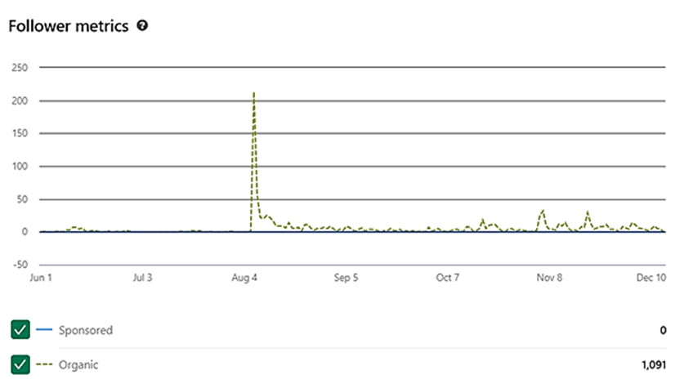
Figure 2: LinkedIn followers chart

Impressions and Highlights
The following graph provides an overview of post impressions and engagement highlights from June to December 2025. The data shows several peaks in visibility, particularly around major events, resulting in over 55,000 impressions and 1,392 reactions during this period.
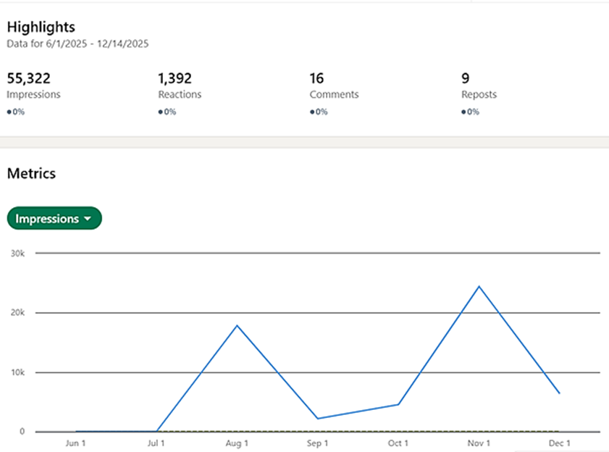
Figure 3: LinkedIn highlights and impressions graph
Benchmarking in LinkedIn
To assess PIXEurope’s performance within its ecosystem on LinkedIn, we have activated the benchmarking feature to compare engagement and growth against the other four Chips JU Pilot Lines. As of mid-December 2025, PIXEurope has surpassed 1,090 followers, positioning it second among the five initiatives. Despite having fewer posts overall (11 posts in the last 197 days), PIXEurope achieved an engagement rate of 19.2%, which is 26.3% higher than other PLs, indicating strong audience interaction relative to content volume.
This performance demonstrates that PIXEurope is one of the fastest growing and most engaging pages in its category, even with a lower posting frequency. The focus on high-quality, event-driven content and visual materials appears to resonate well with its target audience.
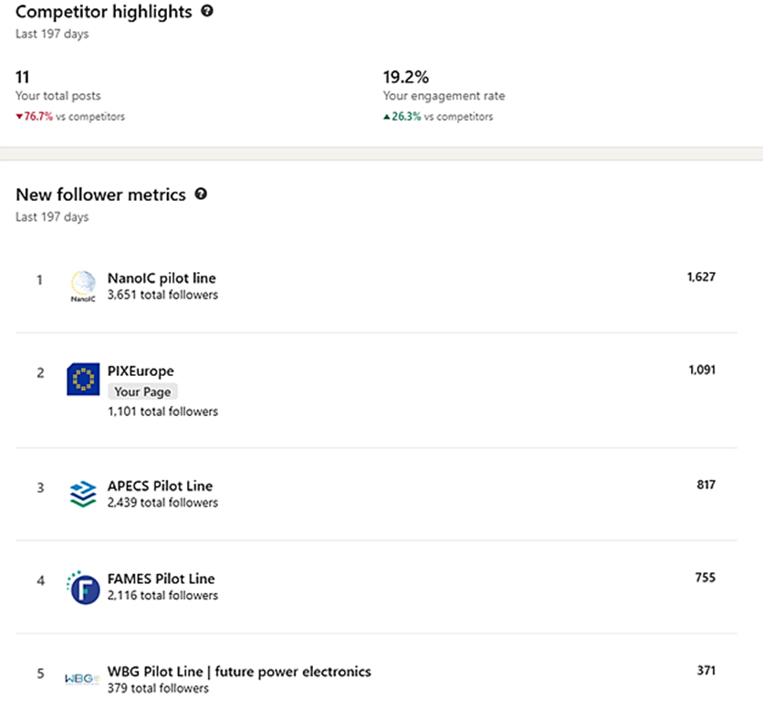
Figure 4: LinkedIn benchmarking overview
Visitor Demographics
The graph below shows the visitor demographics by industry for the PIXEurope LinkedIn page during the current reporting period. The largest share of visitors comes from research services (22.9%), followed by semiconductor manufacturing (16.1%), nanotechnology research (8.6%), and higher education (8.5%). Other notable sectors include appliances and electronics manufacturing (5%), business consulting (4.7%), and engineering services (4%), indicating strong engagement from both academic and industrial communities.
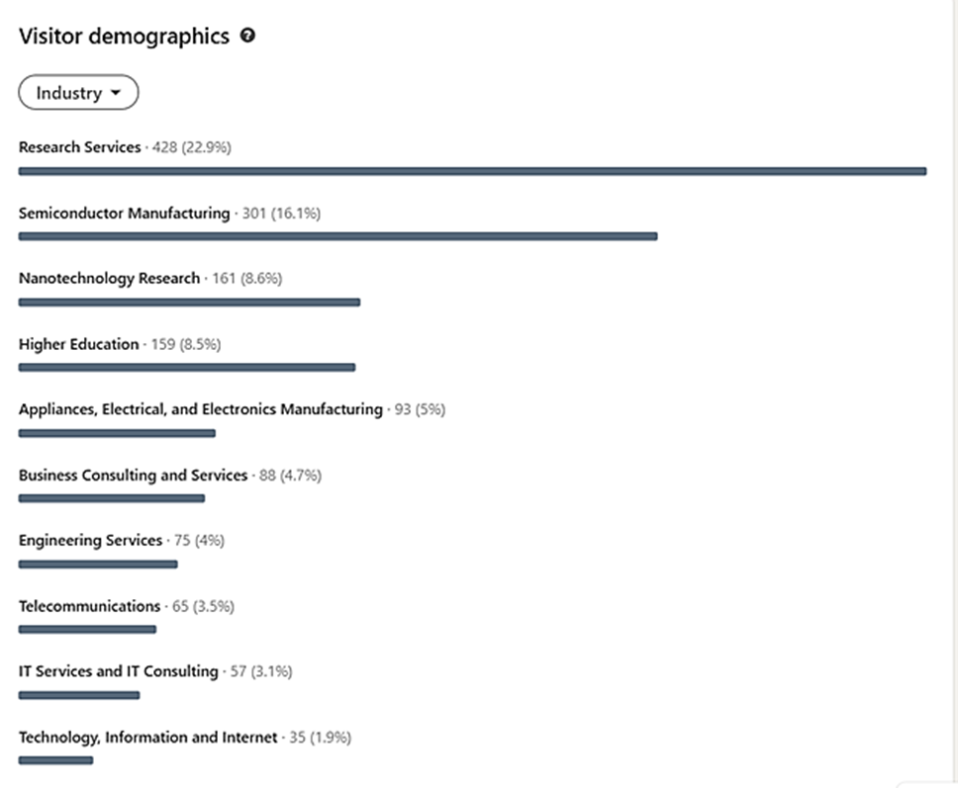
Figure 5: LinkedIn visitor demographics overview

Post Analytics Overview
The following graph presents detailed analytics for individual posts published under PIXEurope’s LinkedIn page during the reporting period, highlighting which updates generated the highest interaction, with some posts achieving engagement rates above 60%.
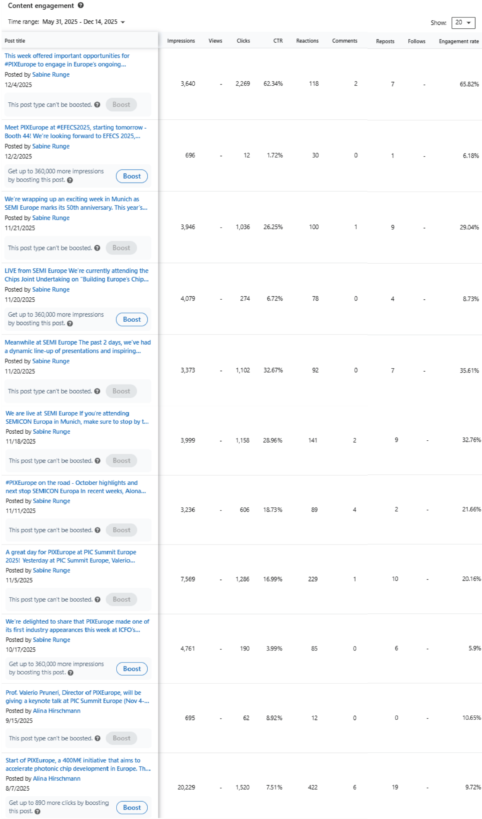
Figure 6: LinkedIn post analytics overview
Media Clipping Overview
During the reporting period, PIXEurope achieved significant visibility across European media channels. A total of 80 media clippings were recorded, including 56 online press articles and 24 printed items, reflecting growing interest in the initiative within both specialised and general media outlets. Coverage was monitored through professional media tracking services by ICFO, which provide only partial extracts for reporting purposes. The data presented here is therefore an indicative sample rather than a comprehensive list, intended to offer orientation on the overall media presence.
Most articles appeared in Spanish outlets, reflecting strong regional interest in the initiative and its role in advancing photonic chip development. Headlines frequently highlighted strategic investments in research infrastructure, technological sovereignty, and Europe’s ambition to lead in innovation.
International coverage complemented this regional focus, with mentions in technology and industry platforms such as Photonics Online, PR Newswire, Yahoo! Finance, and Benzinga, reporting on consortium developments and partner participation. Articles emphasised PIXEurope as a €400M initiative driving photonic chip innovation and strengthening European technological sovereignty.
This level of coverage demonstrates growing awareness of PIXEurope across both specialised and mainstream media, reinforcing its positioning as a strategic European initiative in advanced photonics.

T2.3: IPR management (ICFO, all) M11-M60
Not applicable to this period

T2.4: Exploitation Strategy and Innovation Roadmap (ICFO, all) M11-M60
Not applicable to this period

T2.5: Collaborations (ICFO, all) M1-M60
This task focuses on collaborations with three main agents: 1) Previously approved PLs (CPL1-4) and Design Platforms, such as EuroCDP 2) National Chip Competence Centres (CCCs) and 3) Large European Initiatives (PhotonHub, Europractice, JePPIX and ePIXfab).
- Pilot Lines:
  - FAMES à Several partners are involved in both PLs and have started initiatives to leverage synergies between them. Tyndall is exploring alignment between PIXEurope WP7 (packaging) and FAMES, focusing on advanced packaging approaches for RF components and smart PMICs, where packaging is a key enabler for high performance and low power consumption in future integrated circuits. In parallel, PIXEurope can benefit from ongoing work within FAMES at Tyndall on new interposer processing capabilities, such as high-density Sn-Ag bumping, which can be used to support advanced integration and heterogeneous assembly. Furthermore, WUT is exploring the creation of joint workshops that leverages synergies between both PLs.
  - APECS à Exploring collaborating opportunities. Potential joint activities are being identified, including interposer, PIC-EIC co-packaged optics and hybrid PIC integration. Several meetings have been held, including one between the two PL Directors. ICFO has also suggested Fraunhofer IZM to become associated partner of PIXEurope to facilitate joint R&D projects in line with the GA objectives and legal framework.

- Engagement with CCCs: Many PL partners are already involved in their national CCCs or have established engagement with them. Over the coming months, we will map CCCs with strong alignment to PICs and develop an engagement strategy through aCCCess. A key priority will be to clearly communicate to CCCs what PIXEurope requires from them and how they can advise their customers and end-users on accessing the PL.

- Large European Initiatives
  - JePPIX à The JePPIX Design Enablement Team, supported by PIXEurope, provides a cloud-based design infrastructure for photonic integration, linking designers and suppliers to PIXEurope. Through direct integration with the PIXEurope Digital Dashboard (WP4), it will enable a common design environment with access to tools, PDKs and IP, supporting faster and more seamless design-to-prototyping workflows.
  - PIXAPP à Strong potential for technology handover and coordinated training, aligning PIXAPP’s industry-facing programmes with PIXEurope processes to promote packaging-aware design from early stages. Further synergies can be achieved by aligning assembly design kits with PIXEurope PDKs, enabling more consistent design flows and reducing iteration cycles from fabrication to packaging and module integration, ultimately supporting efficient end-to-end workflows and industrial uptake.
  - PhotonHub, Europractice and ePIXfab à Initial discussions are exploring potential synergies with PIXEurope; In addition, PIXEurope will likely leverage partners’ participation in these Initiatives to define cost and IP models for Collaborative R&D Projects and Open Access Services.
Furthermore, PIXEurope has proposed to ChipsJU the possibility to work with end-users on Collaborative R&D projects. Collaborative R&D will be reserved to projects that align with the tasks already described in the Grant Agreement, and where the foreground technology has the potential to add value to the PL services. We are currently in conversations with Chips JU considering feasibility and legal compliance. Associated Partnership is also an existing framework to implement Collaborative R&D Projects, but it will be reserved for stable activities on core technologies.

Significant results & Conclusions for WP2
The communication and engagement activities carried out during this initial reporting period have significantly contributed to increasing PIXEurope’s visibility and interaction with potential stakeholders. Establishing awareness for a new initiative requires consistent content creation, active promotion across multiple channels, and continuous analysis of performance to refine strategies and identify new opportunities.
Based on the analytics and actions executed so far, the following conclusions have been drawn:
- PIXEurope has strengthened its presence on LinkedIn, which remains the primary social media channel for outreach during this reporting period. Since its launch in mid-2025, the account has grown to over 1,090 followers, supported by regular posts highlighting project milestones, event participation, and partner contributions. Engagement rates are notably high compared to similar initiatives, confirming the effectiveness of targeted, high-quality content.
- Digital communication has been reinforced through 30 social media posts, complemented by 14 press releases and news articles and 8 web pages referring to PIXEurope. These actions have helped position PIXEurope as a strategic European initiative within the semiconductor and photonics ecosystem.
- Event-driven communication has played a central role in visibility. During the reporting period, PIXEurope participated in 24 events and conferences, delivered 14 presentations and panel discussions, and maintained a strong presence at 8 booths and exhibitions. These activities were supported by dedicated promotional materials, including flyers, roll-up banners, and a booth video for SEMICON Europe and EFECS 2025.
- Media coverage has further amplified outreach, with 80 media clippings recorded - 56 online articles and 24 printed items - including mentions in leading Spanish outlets and international technology platforms. While the monitoring service provides only partial extracts, the sample indicates strong regional engagement and growing recognition at the European level.
- Although specific pathways towards collaboration with other PLs, CCCs and large European initiatives in PICs are still in development, early conversations indicate a strong desire in the PIC ecosystem to collaborate and work towards shared goals.
In parallel, the development of the PIXEurope website is progressing - while an active landing page is already live, work is ongoing to build a comprehensive site with structured content, interactive features, and analytics tools to monitor engagement. This website will serve as a central hub for information, resources, and stakeholder interaction to reinforce PIXEurope’s central gateway managed by ICFO.
Overall, the analysis confirms that PIXEurope is on a positive trajectory in terms of visibility and stakeholder engagement. Continued efforts will focus on expanding content diversity, leveraging event-driven communication, exploring new formats to maintain momentum and reach broader audience, as well as completing the website to provide a robust digital presence.

Overview of achieved deliverables and milestones
Deliverable number | Deliverable name | Lead partner | Due date as per Annex 1 | Submission date | Comments
D2.6 | Initial communication kit (website, factsheet, flyer, etc.) M6 | ICFO | 30 Nov 2025 | 07 Jan 2026
D2.7 | Dissemination and Communication planning & performance M6 | ICFO | 30 Nov 2025 | 07 Jan 2026
MS3 | Dissemination strategy outlined | ICFO | 30 Nov 2025 | 22 Dec 2025

Work package WP3 – Installation, Qualification & Site Acceptance

Objectives for the period
- Specification of equipment database format and content
- Tracking progress on equipment procurement and installation, ensuring alignment with the original planning

Progress towards objectives

Task 3.1: PL equipment installation protocol (CSIC, all Hosting Sites: ICFO, TNI, TU/e, UPV, VTT, IMEC, TNO, UTWENTE, UGENT, UVIGO, IT, SAL, CEA-LETI, IMDEA) M1-M12
Communication channels between the partners were established to streamline the flow of information on equipment procurement and installation progress. A main point of contact for each institution was identified, and monthly meetings involving all partners were organised.

To understand the progress on equipment installation, the signature status of the Joint Procurement Agreement (JPA) and National agreements from each institution was tracked, as procurement processes can only start upon signature of said agreement. As of 30 November ^{h}, 12 out of the 14 partners that will purchase equipment have signed the JPA. It should be noted that delays in the agreement signatures pose a risk to the original schedule of equipment procurement, installation and acceptance. At this stage, not all JPA’s have been signed, causing a potential delay for the organizations involved. The WP3 team is closely monitoring progress and will work on a risk mitigation plan if needed.

Regarding the progress on Deliverable 3.1 (Web for PL Equipment), a preliminary version of the Equipment Database was created and shared with all partners. The content of the Database is divided in three sections (administrative, technical and technological). The administrative section includes details on cost, origin of funding, ownership percentages, and expected dates for ordering and commissioning. The details of the technical and technological sections are still under discussion. It is foreseen that the technical section will contain the equipment technical details (i.e. installation certificates, procedures…), while the technological section will contain a summary of the essential technological capabilities that the PL Equipment enables. An operational section to monitor the status of equipment and/or technological capabilities from the partners was also considered and is currently under discussion in coordination with the interoperability WP (WP3 DEP) and the PL coordinator.

Progress on procurement and installation of tools was also monitored. The chart below showcases the current status of the equipment procurement, installation and acceptance as of 17th of December 2025.
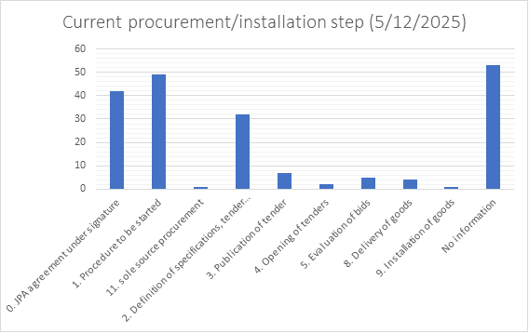
Figure 7: Status of equipment procurement, installation and acceptance

In addition, the expected ordering and commissioning dates of equipment were reviewed and updated, as needed.

The table below summarises the procurement status of each partner:

 | 0. JPA under signature | 1. Procedure to be started | 2. Definition of specs, tender docs & award conditions | 3. Publication of tender | 4. Opening of tenders | 5. Evaluation of bids | 6. Negotiations with tenderers | 7. Award of contract | 8. Delivery of goods | 9. Installation of goods | 10. Formal acceptance | 11. Sole source procurement | Missing data
ICFO | 24 | 9
UPV |  | 53
CSIC |  | 10 | 3
IMDEA |  |  |  |  |  |  |  |  |  |  |  |  | x
UVIGO |  |  |  |  |  |  |  |  |  |  |  |  | x
TNI | 12 | 6 | 6 |  |  | 3 |  | 1
TU/e | 6
TNO |  | 18 | 10 | 1 | 10 |  |  |  |  |  |  | 1
UTWENTE |  | 3
VTT |  | 2 | 2
IMEC |  |  |  |  |  |  |  |  |  |  |  |  | x
UGENT |  |  | 2 |  |  | 1
IT |  | 11
SAL |  |  | 5
Figure 8: Procurement status of each partner
Over the next six months, the main points of action include the completion of the equipment database (including but not limited to defining the documentation needed regarding installation and acceptance protocols and relevant technical characteristics), and the monitoring and support to the partners regarding equipment procurement, installation and acceptance processes.

Additionally, the remaining JPA’s will be completed, and the project partners will continue their tendering processes for the acquisition of equipment.

T3.2: PL equipment validation and qualification on-site (CSIC, all Hosting Sites: ICFO, TNI, TU/e, UPV, VTT, IMEC, TNO, UTWENTE, UGENT, UVIGO, IT, SAL, CEA-LETI, IMDEA) M12-M40
Not applicable to this period

T3.3: Equipment set-up and acceptance (CSIC, all Hosting Sites: ICFO, TNI, TU/e, UPV, VTT, IMEC, TNO, UTWENTE, UGENT, UVIGO, IT, SAL, CEA-LETI, IMDEA) M12-M40
Not applicable to this period

Significant results & Conclusions for WP3
- Equipment database created, under definition (Milestone 3.1)
- Equipment procurement & installation progress on schedule

Overview of achieved deliverables and milestones
Deliverable number | Deliverable name | Lead partner | Due date as per Annex 1 | Submission date | Comments

Work Package WP4 - Design

Objectives for the period
- WP4 focusses on design enablement in the first reporting periods. Design in the context of building block IP and circuit IP is expected to be developed in WP5 through WP9 and also through End User engagement.
- The first six months focus on 1) Creation of PDKs 2) Training to ensure the use of best practice and connectivity in due time with the wider design eco-system and 3) first roadmaps for design capability. The roadmaps will be important to align technological goals, partner resources, quality metrics and promotional materials.

Progress towards objectives

T4.1: Creation of new PDKs and building blocks (BBs) (TU/e, all) M1-M12
Responsibilities have been assigned to one named partner for the creation of more than twenty design kits (22). It is possible that more design kits are developed, depending on the implementation of the Collaborative R&D activities. For the purposes of PIXEurope activities in the first half year, we focus on the development of roadmaps and PDK creation.
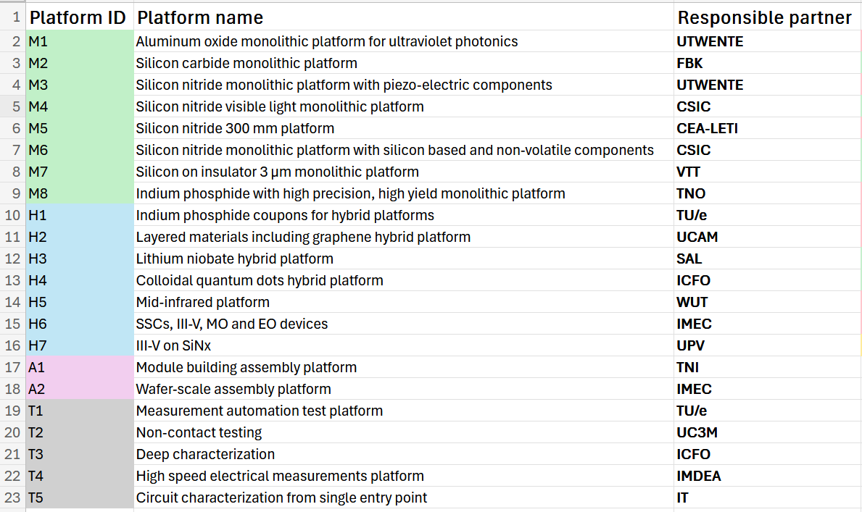
Table 1: The Design Kits to be developed in PIXEurope and the responsible partners
Distinctions are made for three types of contributors for the PL design capabilities
- Process owner – the partner site(s) at which production is performed (WP5, 6, 7, 8)
- Design kit owner – the partner (singular) responsible for data aggregation (WP4)
- IP developer – the parties responsible for data rights on designs (WP4, 9 and End Users)
It is possible for one Partner to offer all capabilities for a specific platform, but synergies are expected through multi-platform IP development and platforms that support multiple Design Kits. Roadmaps are developed at the end of 2025 to crystallise opportunities for synergy.
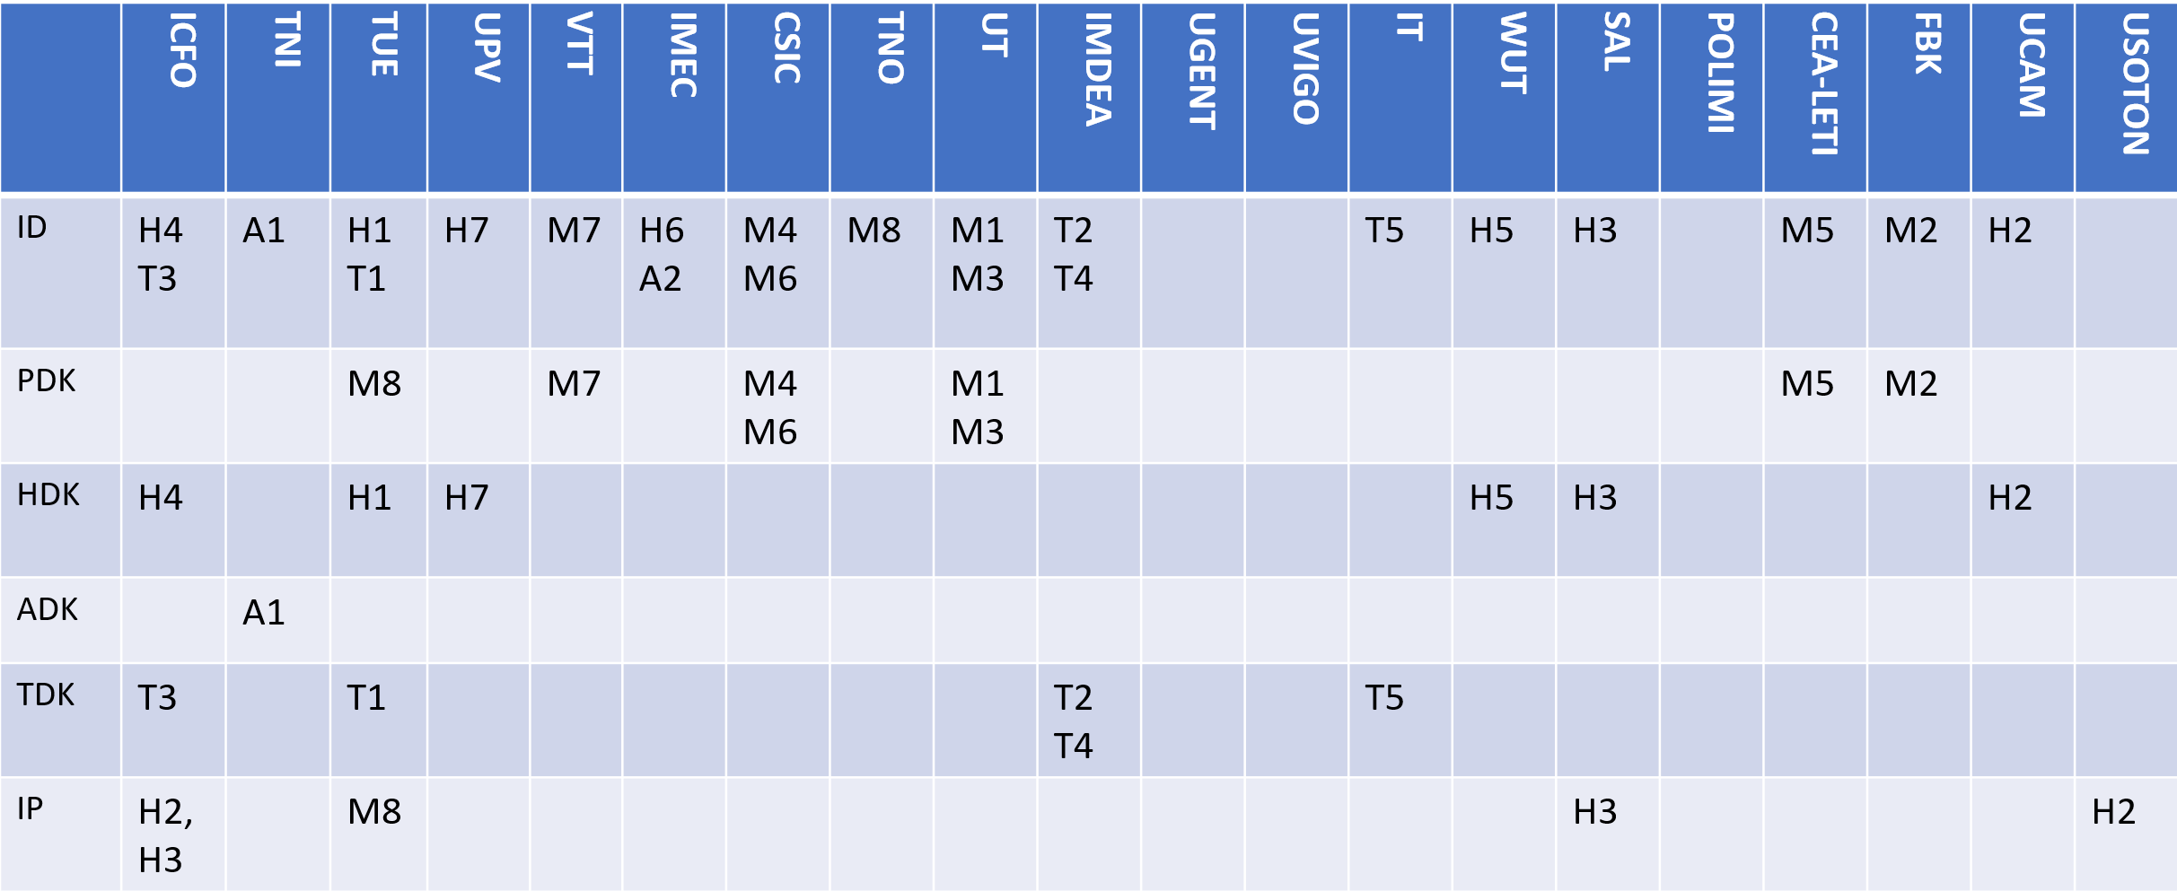
Table 2: The breakdown of responsibilities for process, hybrid, assembly and test design kits as established at M6. IP contributions are possible from all partners and will be formulised during roadmap review before M12.
The status of the consortium was benchmarked through an internal survey to show relatively low levels of design kit creation experience for half of the consortium partners. The consortium has the ambition to use a common design kit creation method, but non-uniform experience in the techniques to achieve this as shown in the figure below.
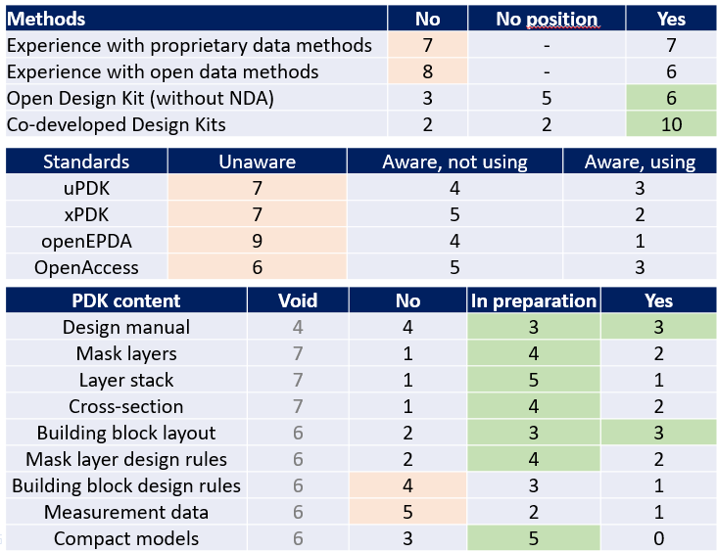
Table 3: Status of design kit creation capability in the consortium.
An internal training course titled Design Kit Creation has been co-created by WP lead and deputy TUE and USOTON to enable the upskilling of partners and the sharing of best practice. The first two modules were delivered in 2025 with high partner engagement. Three modules are to be offered in the first half of 2026. These have been complemented by a weekly helpdesk on practical methods for design kit creation. Open standards are being promoted in the training course.
A methodology has been agreed for achieving competitive design kits within five years. Year one focusses on the data flows and pipe-cleaning the delivery of data to the PDK server. The idea is that the same methods can be reused over and over again when improved data is available, and the methods can be improved so that human interventions (and associated errors) can be systematically removed. The goal is one simple methodology that connects all experimental platforms to the wider software eco-system via EuroCDP within five years.
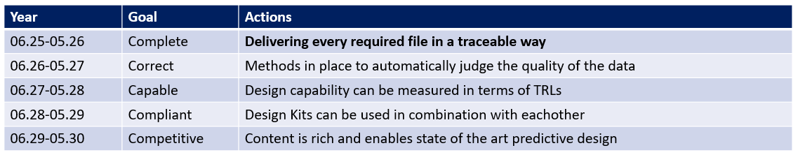
Table 4: Maturing design kits in WP4. The focus in year one is to achieve pipecleaned data flows.
Partner activity. CSIC started the definition, design and simulation of structures and components for SiN in the visible range, as well as Si-based modulators on SiN for NIR. ICFO created the first release version of the "Colloidal Quantum Dots Hybrid Platform" PDK and defined its development roadmap. At FBK, following the input of WP5, a draft of the roadmapped structures was drawn and min-max bounding boxes of the elementary structures were estimated to serve as an input for the first actual PDK implementation. TU/e has summarised information about all design kits that will be created in the project. We are coordinating the design kit release, starting with PDKs. The team is reviewing and updating the data file format for the PDKs. We have also started working out the content of the test and assembly design kits (ADKs). UPV has focused on defining the development roadmap, including the list of target building blocks and the desired PDK maturity level.
It has also worked on defining the internal infrastructure required for: the proper management of all data sources that will feed the PDK, establishing more efficient design workflows aimed at interoperability and collaboration, and enabling the automated orchestration of the PDK files to be subsequently delivered to the digital platform.

T4.2: Digital platform for automated Design Kit generation, release and verification (TU/e, all) M1-M24
The focus of the first period has been to align partner capabilities and converge to a unified methodology for propagating design capabilities to designers.
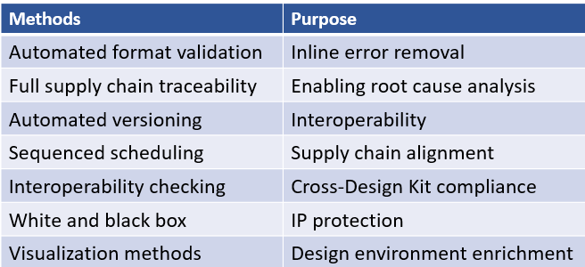
Table 5: Automated design kit generation methods and their purpose
The baseline content for design kits has been aligned upon. Layout is identified as the focus for the first six months. A standardised methodology using open EPDA is used. This is an openly published standard with no requirements for licensing. It does include a copy-left open license. While the WP does not exclude proprietary methods, the training materials will use open methods.
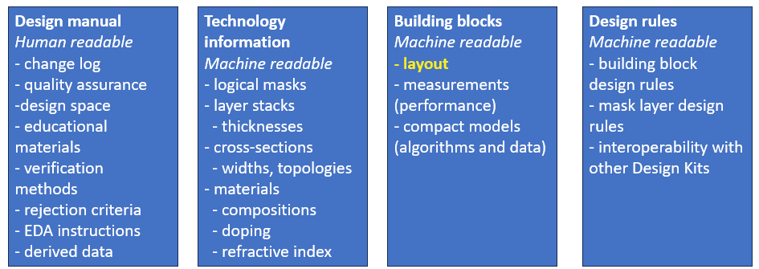
Figure 9: Contents for the design kits
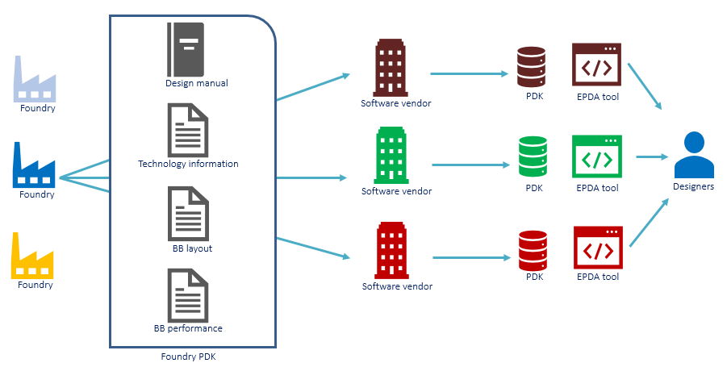
Figure 10: The methodology for propagating design kits from distributed PL infrastructure through to designers is standardised and streamlined.
The methodology proposed within PIXEurope has been accepted within JePPIX and the associated Design Enablement Team. The PDK server is already heavily used outside of the project for comparable workflows, and is designed to scale for multiple platforms, suppliers and customers. The platform is being configured for use to also support PIXEurope workflows. Partners have registered with accounts and begun the process of PDK content upload.
A decision was taken to delay the creation of ADKs and TDKs until 2026 pending standardisation activities in the project PhotonicLEAP.
Partner activity: CSIC has appointed people in WP4, followed the initial PDK tutorial material and joined the first training session. CSIC is in the process of recruiting a new staff member to take the lead on PDK development. ICFO established the platform on the JePPIX server by defining the platform description and successfully uploading release v.0.0.1 as part of the course participation activities from TU/e. FBK participated in the WP4 activities producing a roadmap for the development of a SiC photonic platform, getting training for the PDK development and inserting the PDK metadata on the JEPPIX platform. TU/e has onboarded all project partners to the PDK server. The team has prepared training modules of the PDK creation course, and executed one live session. We are running a weekly help desk regarding the PDK creation process. UPV created a test PDK in the digital platform that will be progressively improved.

T4.3: Design kit review and release (UPV - TU/e, CSIC, IMEC, UVIGO, VTT, ICFO, WUT, TNI) M13-M60
Not applicable to this period

T4.4: Design loop closure connecting functional evaluation to redesign – PDK improvement (TU/e - IMEC, ICFO, VTT, CSIC, WUT, POLIMI, IMDEA) M13-M60
Not applicable to this period

T4.5: Measurement-driven-model creation (UVIGO - IMEC, TU/e, IT, VTT, ICFO, CSIC, POLIMI, FBK, IMDEA) M25-M60
Not applicable to this period

T4.6: Design kit implementation and evaluation (ICFO - CSIC, IMEC, IT, UVIGO, VTT, WUT, SAL, IMDEA) M31- M60
Not applicable to this period

T4.7: Access through Chips JU Design platform (TU/e - IMEC, IT, VTT, ICFO, UVIGO, CEA-LETI) M31-M60
Not applicable to this period

Significant results & Conclusions for WP4
- Design enablement is at the heart of WP4. 23 design kits are defined with clear responsibilities and categorizations. Separation of roles for process owner, design kit owner and intellectual property owner with an initial assignment of roles per platform.
- Creation is at a relatively low level within the consortium at start of the PL, with a survey to clarify the initital status indicating a need for internal standardisation and upskilling. A methodology is elaborated whereby the focus is on efficient workflows from the start.
- Automated flows from the JePPIX PL are used as the baseline to ensure onward connectivity with the established commercial services and other ChipsJU initiatives. Partners already engage with the methods and are participating in an associated training titled Design Kit Creation.
- Partners are aligned on the ambition to deliver complete Design Kits within the first twelve months of the project. It is noted that the capabilities of Design Kits will be continuously improved, in a structured way and that first-year activity focusses on ensuring efficient and traceable data flows.

Overview of achieved deliverables and milestones
Deliverable number | Deliverable name | Lead partner | Due date as per Annex 1 | Submission date | Comments
D4.10 | Real-time work-in-progress monitoring | USOTON | M6 | January 2026 | Draft in review with WP4 partners until end 2025

Work package WP5 – Monolithic PIC Platforms

Objectives for the period
- Define the initial scope and identify the partners involved in the different monolithic technologies. Assign a specific contact point for each entity within every task.
- Schedule monthly meetings to provide updates on each monolithic platform. Organise dedicated preparatory meetings by each task leader to plan activities and consolidate updates for the monthly sessions.
- Advance the preparation of infrastructure and equipment required for monolithic PIC fabrication.
- Identify relationships and dependencies with other work packages (WP4, WP6, and WP7) to ensure alignment and collaboration.
- Define the work plan to align with the global scope and start technology development activities.

Progress towards objectives

Task 5.1 III-V components and PICs (TU/e, TNO) M1-M54
The overall goal of this task is to extend the functionality of InP PICs to other wavelengths (O-band and 2-um) and other integration platforms (hybrid integration with SiN). Work is in progress to complete the 100 mm III-V pilot line at Nanolab@TUe, as well as starting with new building block developments. On the processing level, advanced infrastructure is required for performance improvements. The procurement of new etching tools is under planning. Communication with different vendors is now complete and a tender is expected to be released by Q1 2026. Additionally, TNO currently works on the procurement of tools and the arrangements for the building of the new 150mm manufacturing facility at the High-Tech Campus Eindhoven.
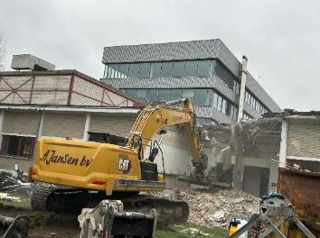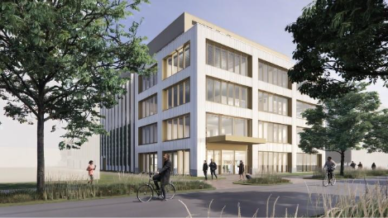
Figure 11: Demolition ongoing at construction site and artist's impression of new facility
Construction will be partially completed towards the end of 2026 and fully completed mid-2027. The first tenders for equipment have been published.
Additionally, recruitment for process engineers is ongoing.

Task 5.2 Thin SOI PICs (IMEC) M1-M54
The main objective of this task is to augment the 300 mm platform (iSiPP300) with a scaled Cu microbumps process module. With a view to achieve high shoreline densities as envisaged in e.g. co-packaged optics applications, pitches and diameters ranging down to 20-40 µm pitch are targeted. In this reporting period, shortloops have been defined and planned to enable the development of this process module on the 300 mm line.

Task 5.3 Thick SOI PICs (VTT) M1-M54
The wafer size conversion from 150 mm to 200 mm in the VTT clean room took place during this reporting period. VTT has started a test run to optimise and confirm the Thick-SOI waveguide process on 200 mm wafers. VTT has also designed a new process evaluation chip with critical waveguide and process structures. This evaluation chip will be included in all 200 mm wafer runs to monitor the process repeatability. Documentation of the process in-line control procedures has been started. VTT has started the planning of the layer transfer process development and related test runs. The procurement of the DUV lithography tools and epitaxy tool, which are all needed in the Thick SOI PICs development in PIXEurope, has been initiated and is going on in WP3.

Task 5.4 SiN PICs (CSIC - UTWENTE, UPV, CEA-LETI) M1-M54
Integration enhancements (CSIC, UPV): During this period, CSIC defined the design of experiments to explore and refine the SiN stoichiometry deposited using LPCVD, targeting footprint and/or loss reduction. The material deposition, together with the morphological and optical characterization will start in the following months. In parallel, and in collaboration with UPV, CSIC started the definition of the photonic components which will be designed and modelled using the material characteristics extracted from the SiN material study.
Functionality expansion (CSIC, CEA-LETI, UTWENTE): To advance towards the development of Si-based modulators, CSIC started the deposition of LPCVD amorphous Si on top of the intended device stack (SiO₂ and SiN). Different annealing conditions and implantation will be tested, alongside the electrical and optical characterization. CEA-LETI is focusing on the integration of Si active devices with thick and ultra-low loss SiN waveguides in 200 mm wafer size. In this regard, a trial run is on-going, and a new mask set has been designed to integrate Si pn junction modulators and Ge photodiode with 800 nm-thick SiN waveguides by direct bonding. CEA-LETI is also focused on integrating a turning mirror for vertical fiber coupling with SiN waveguides. The objective is to generate a vertical light beam for broadband coupling and high-density surface connections. The fabrication methods under consideration include grayscale lithography, imprint lithography, and direct 3D laser writing. Over the past months, CEA-LETI have designed a test circuit for the 200 mm SiN wafer fabrication platform. This circuit features edge-coupling-like optical ports designed for a 7.2 µm mode-field-diameter at a 1.31 µm wavelength, along with alignment marks necessary to fabricate the turning mirror using the various processes under evaluation.

Develop a fully integrated platform with high performance 800 nm thick SiN (CEA-LETI): CEA-LETI is working on achieving ultra-low loss waveguides in 300 mm wafer size. The process flow for thick and low loss SiN waveguides with 300 mm wafer size is under preparation. Two deposition methods are under consideration (PVD and LPCVD) and deposition tests should start in Q1-Q2 2026. The main challenge is high SiN stress management during fabrication.

Feature size reduction (CSIC, UTWENTE): This activity is not expected to start until the required equipment for advanced high-resolution lithography, including DUV and fast e-beam writing, is installed.
UTWENTE is planning to recruit a new staff member to take over the activities under WP5, Task 5.4. The anticipated start date for this position is Q1 2026.

Task 5.5 SiC PICs (FBK - POLIMI) M1-M54
During the reporting period, FBK and POLIMI have focused their efforts on the initial development aspects for the realization of the monolithic SiC PIC platform. Following an in-depth global market research, samples of SiC, SiC-on-Si, and SiC-on-insulator (SiCOI) wafers were acquired to initiate technology development. The quality of the SiC samples was characterised in terms of thickness and refractive index uniformity, material absorption, sheet resistance and defect density. The techniques for RIE etching of SiC were investigated with a particular focus on their implementation in existing laboratory equipment and the technical specifications required for any new equipment. Meanwhile, a significant effort was invested on simulation and design of SiC waveguides, with a primary focus on a 1.55 µm of working wavelength, for various geometries, including channel and rib waveguides for the SiCOI platform, and free-standing rib for the SiC-on-Si platform. The first test PICs layout was designed and has started their fabrication process. For the realisation of the suspended waveguides, we established contacts with suppliers for XeF2 etching services and equipment.

Task 5.6 Mid-IR components and PICs (2-10um) (WUT - UTWENTE, VTT, FBK, POLIMI, UPV, USOTON, UCAM) M1-M54
VTT has started to evaluate the applicability of the Thick SOI waveguides and PICs for mid-IR applications. In this reporting period the focus has been in simulations of the MIR range single-layer antireflection coatings. Simulations have been performed for different coating thicknesses in the wavelength range from 1.2 µm to 5 µm.

Task 5.7 UV-Visible range components and PICs (300-750 nm) (CSIC - UTWENTE, FBK) M1-M54
CSIC started the measurements and analysis of stoichiometric SiSiN in the visible range, including morphological (thickness, stress) and optical characteristics (refractive index). In parallel, the first list of components for visible (i.e. waveguides, bends, crosses, MMIs) was defined, which will be designed and modelled in the forthcoming months. The fabrication of components is not expected to start until the required equipment is installed (i.e. DUV scanner), as the minimum resolution of the existing equipment is larger than the required feature size for visible components.

T5.8: PIC technology scaling to manufacturing (VTT - UTWENTE, CEA-LETI, TNO, TU/e, USOTON) M30-M60
Not applicable to this period

Task 5.9 Chips Design Rules & PDKs for Open Access (TU/e - IMEC, VTT, CSIC, UTWENTE, UPV, CEA-LETI, WUT, FBK, POLIMI, USOTON, UCAM) M18-M60
Not applicable to this period

Significant results & Conclusions for WP5
- VTT successfully completed the conversion of its 3 µm SOI PIC processing line (Micronova, Espoo) from 150 to 200 mm wafer size
- Construction activities have started for the 150mm InP line at the High Tech Campus in Eindhoven
- Development of new platforms such as SiC has started.

Overview of achieved deliverables and milestones
Deliverable number | Deliverable name | Lead partner | Due date as per Annex 1 | Submission date | Comments

Work package WP6 – Hybrid PIC integration

Objectives for the period
- Kick-start the pre-organization of the individual tasks in the work package

Progress towards objectives

T6.1: Multi-band O/C/2 μm III-V onto SiN (UPV - CSIC, TU/e) M6-M60
Main global objective: development of a hybrid III-V/SiN platform with different gain bands co-existing in a single chip.
Brief description:
- Material interface specifications: UPV and TU/e will jointly define the interface specifications between the CSIC SiN platform and TU/e-designed III-V SOAs. Vertical evanescent coupling will be co-designed considering lithography, etching, and transfer, with numerical simulations using tools like GDSfactory and tidy3D.
- Device design, patterning and transfer: TU/e will design III-V devices (epitaxy, metallisation, patterning, coupon release), while UPV will work on SiN platform transfer. CSIC will provide 100 mm SiN wafers, and UPV will create dummy Si technologies to validate designs before applying them to functional III-V coupons.
- Technology transition to 150 mm wafers: UPV and CSIC will transition part of the technology to 150 mm wafers. Hybrid multi-band PICs will integrate UPV’s patented Si-pillar technology for thermal management, processed before SiN deposition. TU/e will receive ultra-flat SiN wafers with passive components for further InP+SiN hybrid integration experiments.
Points of action/objective for 2025Q4:
- Task kick-off to be appointed by UPV with TU/e &CSIC: 22nd Jan 2026 – 10:30-12:00 h CET.
- Identification of partner personnel involved with roles:
- UPV – P. Muñoz & D. Pastor (leads)
- UPV – G.L. Bufi, L.R. vd Zon, R. Alemany, M. Cascant (manufacturing)
- UPV – A. Dias, C. Cano (design/PDK)
- CSIC – Joaquín Faneca (lead), back-up: Carlos Domínguez, Pau Güell
- CSIC – Yohana López (fabrication)
- CSIC – Theo Rouanet (PDK)
- TU/e – Victor Calzadilla (lead)
- TU/e – Marco Rossi (manufacturing)
- TU/e – Marco Gagino (design/PDK)
- Outline of plan for 2026 (UPV intent / draft)
- SiN platform with Si pillar heat sinks – PoC 2026Q1, Alpha 2026Q3, Beta 2026Q4
- C-band coupons by external foundry – PoC 2026Q1, Alpha 2026Q4
- C-band III-V/SiN hybrid platform – PoC 2026Q2
- O-band coupons by external foundry – PoC 2026Q2
- O-band III-V/SiN hybrid platform – PoC 2026Q3

6.2: III-V O-band die onto SiN (UPV, CSIC) M18-M60
Not applicable to this period

T6.3: MTP of active materials on thin Si (IMEC - TNI, UGENT) M6-M60
- T6.3.1 electro-optic and magneto-optic bulk crystals (IMEC,UGent)
Process flow to obtain printable bulk crystal devices – focus: magneto-optics
- T6.3.2 MTP of spot size converters on IMEC SiPho (IMEC,UGent)
Installation of 3D printing tool for SSC definition on source wafer – also evaluate direct printing on target wafer
- T6.3.3 Micro-transfer printing of RGB laser diodes on IMEC SiPho (IMEC, UGent, TNI)
Platform and integration strategy for RGB laser integration – to be started
- T6.3.4 Maturing MTP of InP and LiNbO3 (IMEC,UGent)
Wafer-scale integration process development – 99% printing yield for LiNbO3 demo’d
- T6.3.5 Alpha fab runs (IMEC,UGent,TNI)
Continuously updating MTP PDK for O/C-band PICs, to be started for VIS

T6.4: Hybrid PIC integration on thick Si (VTT - IMEC, CEA-LETI, SAL, TU/e, CSIC, UPV) M6-M60
Global objective: Development of hybrid integration of other PICs and components on VTT’s 3 μm SOI PIC platform.
Critical and fundamental challenge: to realise highly efficient light coupling
- Between 3 μm SOI waveguides and waveguides in other PICs
- Further development of up-reflecting mirror (URM) process
- Develop GeSi based escalator process to replace a-Si escalators
- Develop high efficiency polymer writing based waveguide coupling solutions
- Develop low temperature flip-chip bonding process
- Develop micro transfer-printing (MTP) technology on thick SOI
Actions/objectives for 2025Q4:
- Thin film LiNiO₃ (TFLN) integration on thick SOI platform using waveguide escalator and flip-chip
- Preparing the epitaxial tool investment and tendering (in WP3)

T6.5 LIFT transfer of PICs on SiN (TNO - UPV, CSIC, TU/e) M6-M60
Global objective: Development of LIFT technology for assembly of InP active devices onto SiN platforms, to allow efficient wafer scale hybrid integration.
Activities for this task include:
- The co-design of the active InP coupons, by TU/e and TNO to meet the fabrication requirements for the LIFT process.
- Tailoring the LIFT process for InP coupons and the transfer stack, with attention to the optical beam shape that must match the often-elongated InP coupons.
- Defining and implementing alignment strategies. For photonic hybrid integration, the alignment tolerances are substantially tighter compared to conventional electronic hybrid integration.
Activities have started on the investigation of requirements for the InP-coupons. In parallel, work is done on a test setup for LIFT transfer.

T6.6: Novel materials and functional layers for hybrid PICs (ICFO - SAL, UPV, WUT) M6-M60
Main objective: investigate novel functional layers on Si, SiN, and Ge-on-Si platforms
Objectives/Activities for 2025Q4: (M6-M7)
- Definition of specific roles of partners involved in each hybrid platform
- Define the priority of the approaches to be investigated for each hybrid platform based on state of the art
- Define workflow, taking into account synergies between partners
Task kick-off meeting done. Partner roles revised and updated. Next actions: thematic meetings on the various PIC technologies.

T6.7: 2D LMs on monolithic PICs (UCAM, USOTON) M6-M60
Main global objective
1.Growth of graphene and related layered material (LM) over 8” wafers
2.Integration of LMs into PICs up to 8” scale and their characterization
Brief description:
1.Growth of high-quality, single-layer graphene and related layered materials on 200 mm wafers using an MOCVD system.
2.Preparation of PICs on 200 mm Si, SiN, and Ge-on-Si to build a layered-material (LM) hybrid integration platform (USOTON).
3.Transfer graphene onto PICs and cover it with materials like hBN or WSe₂ using wet or semi-dry transfer methods.
4.Characterization of graphene and based heterostructures using Raman, AFM, SEM after PIC integration.
5.Fabrication of graphene-based devices on PICs or on Si/SiNx test substrates, including Hall bars and TLM structures, to measure mobility and sheet resistance.
Objective for 2025Q4
T6.7 will start at month 6, UCAM will coordinate with USOTON and other partners regarding wafer substrates exchange.

T6.8 Post-process of single dies for copper pillar flip-chip assembly (CEA-LETI) M6-M60
Global objective: Development of a Cu pillar manufacturing flow at chip level to reach a level of maturity required on the platform (TRL6)
First action done:
- Design of test vehicle for standard and reduced pitch
- Startup of electrodeposition process bench for Cu and SnAg
Objective for 2025Q4/2026Q1: Single die process development and integration flow for standard pitch to be confirmed (RDL/Passivation/µbumps)
Participants | Contact | Function
MOURIER Thierry | thierry.mourier@cea.fr | Task leader Hybrid PIC Integration
GROLIER--LEE Stelliane | stelliane.grolier--lee@cea.fr | Single die processing process leader
SAHOUANE Yacoub | yacoub.sahouane@cea.fr | Packaging for photonic process integrationleader

T6.9 Photo-detector integration and control loop (POLIMI, FBK) M6-M60
Global objective: Develop photodetectors (PDs), non-invasive optical power monitoring techniques and control loops into programmable PICs for real-time monitoring, control, and reconfiguration.
Main Activities
- Si PIN PDs integrated into SiN PICs via evanescent coupling and backside thinning (FBK, CSIC).
- Development of SPAD detectors for 600–900 nm on SiNx platforms (FBK).
- Integrated (non-invasive) monitor PDs based on photo-resistive/photo thermal effects (POLIMI)
- Integration of Si-Ge detectors on SiC platform (POLIMI)
- Develop a control layer (electronics/software/algorithms) for automated calibration, configuration, and thermal stabilization (POLIMI) enabling tool for functional testing (Task T8.4)
- Contribution to optical/electrical I/O definition, integration with electronics, thermal management.
Activities for 2025Q4
- Present FBKs SPAD PIN diode to WP partners
- Discuss with partners WP5 VIS waveguides feasible architectures and integration schemes.
- Present integrated (non-invasive) monitor PDs for feedback and control. (POLIMI)

T6.10 Plasma dicing of hybrid PICs on Si (UPV - CSIC, IMEC, UGENT, VTT, ICFO) M24-M60
Not applicable to this period

Significant results & Conclusions for WP6
No significant results, tasks just started

Work package WP7 – Packaging

Objectives for the period
WP7 aims to establish the full packaging capability of the PIXEurope PL, covering both package-level and wafer-level integration. The key objectives are:
- Develop a multiphysics simulation and design framework that links optical, electrical, thermal and mechanical domains, supporting the design of advanced packaging solutions.
- Prepare and evaluate materials, processes and equipment required for both package-level and wafer-level packaging workflows.
- Develop and optimise package-level processes, including bonding approaches, micro-optics integration and prototype package structures.
- Develop and demonstrate wafer-level packaging processes based on electro-optical interposers, transfer printing and high-precision flip-chip assembly.
- Design and fabricate the interposers and PIC/EIC reference components needed to validate packaging processes and assess performance.
- Build fully packaged modules and prototypes that demonstrate the capability and reliability of the developed packaging flows.
- Collect and structure packaging design rules emerging from modelling and process development.
- Generate ADKs for both package-level and wafer-level processes, enabling standardised design entry and open access through the pilot line.
During the first six months, WP7 focuses on establishing the foundations needed for later technical development. The objectives for this period are to:
- Define the initial scope, coordination approach and expected modelling domains for simulation activities.
- Begin planning the package-level process development path, including early concepts, equipment needs and engagement with vendors.
- Advance the preparation of facilities and infrastructure for packaging and materials activities, including cleanroom planning and equipment down-selection.
- Align with partners on packaging approaches and interfaces between tasks to ensure a shared understanding of future workflows.
- Establish the preparatory work that will support the start of wafer-level and interposer development activities in the next project period.

Progress towards objectives

Task 7.1 Package Simulation & Design (IMDEA - TNI, ICFO, TU/e) M1-M54
Activity in Task 7.1 during the first six months has focused on identifying the available software design tools in the market, request of evaluation licenses, and purchase under other funding schemes of the initial licenses to test them. For PIC design, Ansys Lumerical software license has been evaluated, which add to already available Synopsys Optocompiler and Photon Design PICWave. For RF design, Ansys HFSS and Keysight ADS software licenses, which add to already available Synopsys Optocompiler and Photon Design PIC Wave.
In addition, IMDEA started the design of RF calibration structures, which allow testing the RF performance of the substrates. To take into account the material characteristics, we have used standard materials (Quartz) as well as companies that have metal additive manufacturing equipment and additive manufacturing of substrates. In Figure 12 we present the calibration kit (calkit) for Quartz, prepared to be printed using XTPL metal printing equipment. This calkit is intended to be used for measuring the propagation properties (attenuation and characteristic impedance) of the 50 Ω CPW transmission line. This test will be helpful to provide useful transmission line as well as allow us to measure the roughness of the printing to avoid probe damages. The planned approach is:
  - Manufacture a device whose geometrical features are as close as possible to those of the simulation models.
  - Measure the geometrical features of the fabricated samples and re-run our simulations with a model adapted to the features of the fabricated device.
  - Compare the new simulation results with our measurements from the fabricated samples. We expect some differences between the propagation properties of the manufactured and simulated devices.

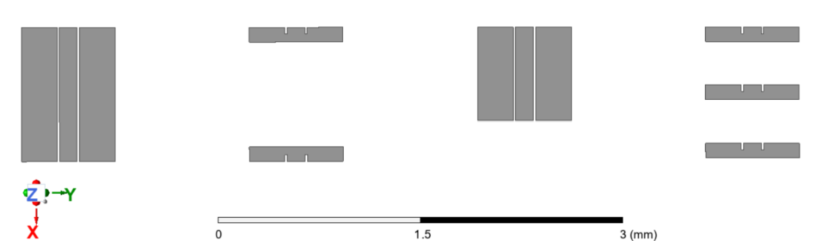
Figure 12: Design of 50 Ω RF calibration kit including through and short transmission line standards.

Task 7.2 Package-Level Processes (TNI - ICFO, UVIGO, IMDEA) M1-M54
Activity in Task 7.2 during the first six months has focused on planning and early coordination to prepare for the package-level process development that will take place later in the project. A key part of this period has been the definition of the equipment requirements at Tyndall. Work has involved reviewing potential packaging platforms, engaging with vendors and assessing capability across a range of tools to ensure compatibility with both package-level and wafer-level workflows. This has included consideration of bonding approaches, micro-optical assembly and the broader process flow that will be supported by the equipment procured under PIXEurope.
To support this planning, site visits and evaluations were carried out with equipment suppliers. This included a visit to SET in France to review flip-chip bonding platforms and better understand alignment capabilities relevant to future wafer-level and package-level activities.
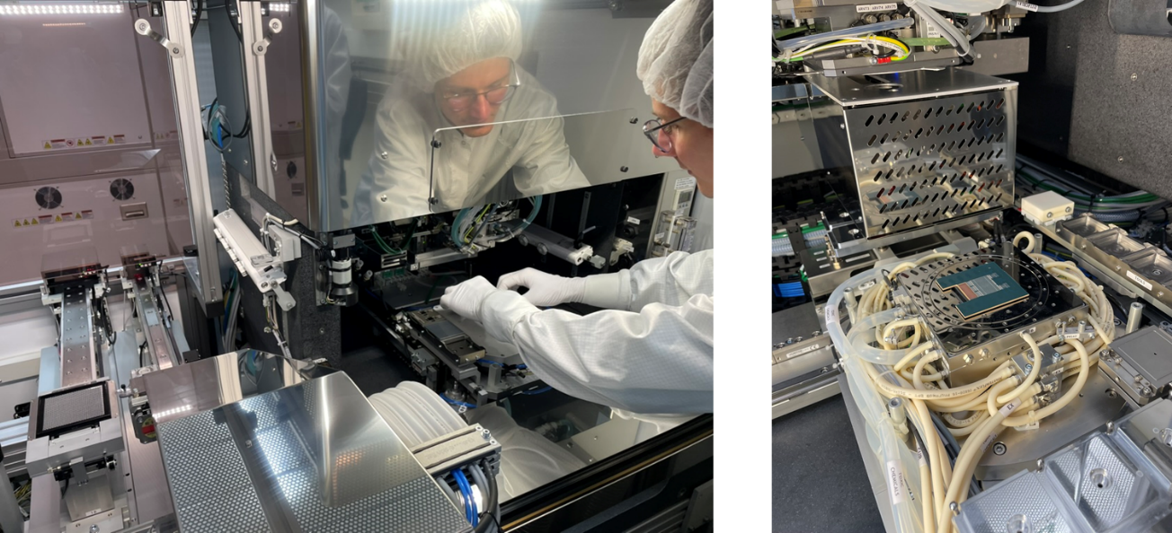
Figure 13: Visit to SET, France, to assess flip-chip bonding platforms and alignment capabilities.
In parallel, different hermetic sealing approaches have been explored, including seam-sealing tools suitable for sealing butterfly-style packages. These activities have helped shape the emerging equipment strategy and informed the early concepts for the processes that will be developed later in the project.
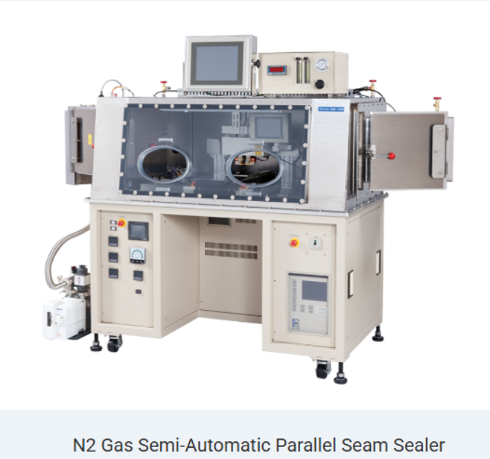
Figure 14: Investigation of hermetic sealing approaches, including seam-sealing tools for butterfly-style packages.
Early process flow concepts were also discussed and outlined during this period. These initial ideas will be refined once interposers and reference components from Task 7.4 become available. Coordination with partners formed an important part of the work, with meetings held with ICFO and UVigo to ensure alignment on packaging approaches, terminology and expected interfaces across the tasks in WP7. This has helped establish a shared understanding of the direction of the packaging activities as the work transitions from planning into development in the next reporting period.

Task 7.3 Wafer-level Processes (TNI - ICFO, IMEC, IMDEA) M6-M60
Not applicable to this period

Task 7.4 Electro-Optical Interposers & Reference Chips (TNI - ICFO, VTT, TU/e, IMDEA) M6-M50
Not applicable to this period

Task 7.5 Packaging Materials (UVIGO - TNI, ICFO) M1-M48
Activity during the first six months has focused on planning, facility preparation and early equipment down-selection, which aligns with the initial objectives for this period. The location for the UVigo facilities has been confirmed at Parque Tecnológico de Valladares, and the rental agreement with the building owner is in place. The facilities will be arranged over two floors, with the cleanroom located on the ground floor and offices and supporting laboratory space on the upper floor. Work on the cleanroom layout and building renovation plans has started, although the final configuration has been paused temporarily to ensure it aligns with the equipment that will be procured. This is particularly important for the 3D-printing technologies being considered, as they introduce specific infrastructure requirements.
Progress on equipment specification has advanced in parallel. UVigo expects to finalise the equipment list by early January 2026, allowing the cleanroom design to be completed shortly afterwards. A significant amount of effort has gone into evaluating 3D-printing technologies and suppliers, leading to a clear strategy for hybrid photonic packaging and rapid prototyping. Stealth-dicing capabilities have also been reviewed in detail, with several suppliers visited and tool demonstrations completed to ensure that the selected system meets technical needs. Work on flip-chip equipment has progressed as well, with multiple vendors assessed and one preferred supplier identified pending final quotation. Most major equipment categories have now been scoped and shortlisted, and the remaining work will focus on testing equipment and tools such as the coating system.

Task 7.6 Packaging Design Rules & ADKs for Open Access (TU/e - TNI, ICFO, UVIGO, IMDEA) M18-M60
Not applicable to this period

Significant results & Conclusions for WP7
- The scope, objectives and coordination framework for WP7 packaging activities have been defined, establishing a clear foundation for package-level and wafer-level integration within the PIXEurope PL.
- Initial progress in packaging simulation and design has been achieved through tool evaluation and early RF calibration structure design, supporting future multiphysics modelling and validation.
- A package-level process strategy has been outlined, supported by early equipment down-selection, vendor engagement and assessment of bonding and hermetic sealing approaches.
- Preparatory work on facilities, materials and partner alignment has advanced, positioning WP7 to move from planning into active process development in the next reporting period.

Overview of achieved deliverables and milestones
Deliverable number | Deliverable name | Lead partner | Due date as per Annex 1 | Submission date | Comments

Work package WP8 – Test & Reliability

Objectives for the period
The WP8 aims to establish world-class test and reliability capabilities in the PIXEurope PL. The capabilities will cover the full production flow of integrated photonics, enabling test, validation, characterisation, and qualification of front-end and back-end processes. The test process will be captured by the design kits and integrated into the design phase.

Progress towards objectives
During the initial period (M0-M6), WP8 partners focused on exchanging information on existing capabilities at their sites, alignment of research and development ambitions to be executed during PIXEurope. Partners with significant equipment investments initiated structured procurement processes. Partners engaged regularly to map all capabilities and ambitions towards a cohesive work plan and delivery of a comprehensive set of processes and capabilities for the reliability and testing of integrated photonics.
- Define the scope, coordination approach for the test, and reliability development.
- Initiate and advance the preparation of facilities and infrastructure for test and reliability, including cleanroom planning and equipment down-selection.
- Align partners to ensure a structured R&D agenda and comprehensive coverage of the capabilities established.
A series of monthly online meetings were scheduled by the WP8 lead and ICFO team. Cloud resources for executing the meeting and seamless exchange and access to the information were also established and provided by ICFO.
The WP partners have provided an overview of their current capabilities, interests, and planned contributions to the WP8. All information provided in the form of the presentations is shared via WP8 SharePoint hosted by ICFO.

T8.1: Material and structure characterization (ICFO - CSIC, TU/e, VTT, POLIMI, CEA-LETI, UCAM, IMDEA) M1- M60
Partner activity ICFO (task lead):
- General material characterisation (chemical analysis, multispectral maps, atomic distribution, etc.​
- Focus on interfaces characterisation for hybrid integration ​
- Morphology: wafer level PIC fabrication assessment (topography of surfaces, cross sections, volumes, sidewalls and line edge roughness, critical dimensions…). Characterisation of embedded structures.​
Partner activity VTT: In WP8, VTT is mainly planning to develop testing for its own 3 µm SOI PIC technology, which is targeted to support related services for PIXEurope’s end users. Planned activities at VTT are summarised below:​
- Material composition studies, especially for SiGe that is to be epitaxially grown with the new epi reactor bought in PIXEurope​
- Surface structure and roughness analysis to support the development of PIC fabrication in WP5 & WP6​
- Polymer structures are to be fabricated with an in-house two-photon polymerization tool​
- Design for Test and Design for Reliability (DfT, DfR) with link to WP4​
Partner activity CEA-LETI
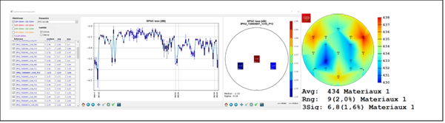
Figure 15: Starting point for data correlations: die-level, wafer-level, batch-level Data collection & visualization
Next steps : ​
- Common referential for first-level data correlation (on a limited number of data) ​
- Upgraded data server links, infrastructure, and configuration for large data set handling
Partner contributions CSIC: CSIC will prepare layers of SiN, a-Si, and other materials essential for developing photonic components. These thin films will be thoroughly analysed after each processing step to identify potential alterations in their electro-optical properties and the impact on propagation characteristics and functionality. Various samples, differing in stoichiometry and doping levels, will undergo structural and compositional analysis. Additionally, the crystallinity of amorphous Si, phase change materials, and others, as well as the photoluminescence dependence on material type, will be examined to ensure optimal performance.

T8.2: Wafer-Level Test and Reliability (UPV - CSIC, TU/e, ICFO, TNI, VTT, CEA-LETI, IMEC, UVIGO, USOTON, IT) M1-M56

Partner activity UPV (Task 8.2 lead): UPV will work on in-fab wafer-level testing (WLT) using advanced optical frequency domain interferometry (OFDI) for the qualification of process parameters. With activities such as:
- Automatic input/output optical coupling tools and alignment routines developed to perform WLT inside the cleanroom.​
- Full-field measurements (amplitude, phase, polarisation) with ability to identify events along chip/wafer paths; increased temporal/spatial resolution to resolve events on the PIC.​
- Investigate new integrated structures to reinforce OFDI capacities, developing advanced multi-test architectures for automated wafer-level testing.​
- In-line functional testing for monolithic and hybrid PIC technologies, via grating couplers, enabling inclusion at intermediate fabrication steps to monitor processes, detect issues early, reduce time and costs​
- Methods to assess the photonic performance are required, at the wafer-level, and are amenable for inclusion in intermediate steps of PIC fabrication
- Methods of homogenization for PICs​
- Expected progress: New integrated structures to reinforce OFDI capacities and advanced multi-test architectures for automated wafer-level testing
- UPV will collaborate with CSIC in the design and fabrication of the WLT test structures.
Partner activity TU/e (WP8 Lead): Has secured additional lab space for the capabilities to be established in PIXEurope. This lab space will be co-located with the front-end cleanroom, where the 6” InP line established in PIXEurope by TNO. The lab space will feature: a clean room class ISO 6, an electrostatic discharge protected area (EPA) with standardised ESD protection, ambient conditions control, and monitoring. The laboratory space will have a clean pass-through to the front-end 6” line for seamless material transfer, and in-line process development and optimisation. Independent of the front-end classroom entrance, it will enable autonomous operations and accessibility to the capabilities for material and activities outside of the 6” InP line.
TU/e, together with CSIC (WP2), has established internal procurement procedures in adherence to the PIXEurope procurement flow. This process will be used for the acquisition of the WLT, inspection, and reliability systems.
TU/e has hosted an experience exchange workshop on the development of a scalable test process for photonics. A team of experts from ICFO visited PITC automation laboratories, high-capacity optical transmission, and characterization laboratories at TU/e. Along with the presentation of development capabilities at TU/e, its delegates provided a relevant direct laboratory demonstration.
To strengthen and accelerate the development for the reliability of integrated photonics within PIXEurope, TU/e will collaborate internally with the electronic IC reliability laboratory.
Partner activity TNI: TNI outlined the main contributions to the WP8 as the following objectives:
- Ensure packaged photonic chips survive real-world operating conditions.
- Turn research packaging into repeatable, usable reliability tests
- Close the loop between design, packaging, and testing​
- Build the foundation for reliability as a PL service.
Main focus areas of the TNI team:​
- Develop reliability and qualification methods for complete photonic packages and co-packaged assemblies
- Understand how thermal, mechanical, and optical stresses affect performance and lifetime​
- Provide feedback to packaging (WP7) and demonstrator validation (WP9)​
Activities planned:​
- Environmental & mechanical testing – temperature/humidity cycling, vibration, shock, and thermal ageing
- Optical & electrical lifetime testing – monitor power, insertion loss, and contact stability over time​
- Accelerated ageing & failure analysis – identify degradation mechanisms and correlate with materials and design​
- Standard test protocols – define repeatable methods that can evolve into future PL reliability services​
- Data integration – share reliability datasets with TU/e for TDK development
- Strengthen European capability and confidence in photonic manufacturing
Partner activity ICFO:
- Wafer-level testing (WLT) of hybrid and functionalized structures - fabricated at ICFO as part of T6.6 -e.g. colloidal quantum dots (CQDs) and ultrathin metal films (UTMFs) to assess the quality of the hybridisation at the wafer level.
Partner activity VTT:
- Development of WLT concepts, hardware, and software. The main goal is to develop horizontal edge coupling with polymer periscopes and vertical coupling to up-reflecting total internal reflection mirrors with polymer lenses​
- Polymer structures are to be fabricated with an in-house two-photon polymerization tool​
- Testing of chips, modules, and packages developed in PIXEurope. Some of the testing will be done in WP5 & WP6​ (If needed, VTT can consider offering similar test services also within the PIXEurope consortium)
Partner activity CEA-LETI: The existing capabilities include 4 fully automated on-wafer 12’’ probers with:​
- Ambient temperature up to 90°C (2 prober equipped)​
- Surface coupling capability (face 2 face & fiber array)​
- Edge coupling capability (1 prober qualified in 2024)​
- O-band & C-band lasers sources & detectors​
Small signal analysis & BER measurements​
- Bandwidth measurement up to 67 -> 100 GHz​
- 1 VNA 67GHz, 1 VNA 110GHz​
- BER and eye diagram up to 64 Gbaud (NRZ/PAM4)​
- 1 Parber 32G, 1 Parber 64, (1 Parber 56G, old gen)​
Within the PIXEurope CEA-LETI will further expand these with 1 additional fully automated 12’’ prober featuring:​
- Automated wafer-loader​
- Cooling & heating capability ​
- Surface & Edge coupling capability​
- O-band & C-Band lasers sources & detectors​
Small signal analysis & BER measurements​
- BER and eye diagram up to 120 Gbaud (NRZ/PAM4)​
- Coherent communication tests: Real-time Sampling Oscilloscope (>120Gech/s >50GHz, specs to be confirmed)​
Partner activity IT: IT shall focus on developing test and measurement procedures based on OFDR to enable the characterisation of multiple devices from a single access point. Details are as follows:
- Hardware: designing low-loss and compact test/access points into the PICs (together with the foundries) and developing matching 3D-printed optical probes
- Software: super-resolution methods shall be explored to enhance the resolution of OFDR measurements. In addition, better device characterization shall be sought by considering numerical modeling information as well as the designed layout on top of the OFDR traces
- If possible, such techniques shall be used and demonstrated in the development of demonstrator 3 of WP9 ​
Partner activity CSIC: CSIC, in collaboration with UPV, will design and fabricate structures for wafer-level characterisation of photonic components. These structures, made from the same materials as the guiding elements, will feature geometries optimised for measuring critical parameters such as propagation losses, polarisation, splitting ratios, and others. By enabling testing between fabrication steps, these wafer-level structures will ensure the functionality and performance of the various components throughout the manufacturing process, allowing for the identification of any issues before proceeding to the next step.

T8.3: Package level test and reliability (TNI - TU/e, ICFO, CSIC, UPV, VTT) M24-M56
Not applicable to this period

T8.4: Test methods and protocols for HVM (UVIGO - TU/e, CSIC, UPV, TNI, POLIMI, CEA-LETI) M12-M48
Not applicable to this period

T8.5: Contactless and visual inspection (TU/e - IMDEA, UPV) M18-M56
Not applicable to this period

T8.6: Qualification methods and Standardization (TU/e - TNI, CEA-LETI, UPV, USOTON, IT) M24-60
Not applicable to this period

T8.7: Design for Test and Reliability (IT - TU/e, UPV, ICFO, TNI, VTT, UVIGO, CEA-LETI, POLIMI) M18-M60
Not applicable to this period

Significant results & Conclusions for WP8
- Complementary scope of partner activities has been elaborated and coordination approach for the test, and reliability development have been developed.
- Space has been allocated for the equipment to be purchased, and the equipment down-selection is underway.
- Aligned partners to ensure a structured R&D agenda and comprehensive coverage of the capabilities established.
- Target capabilities have been elaborated

Overview of achieved deliverables and milestones
Deliverable number | Deliverable name | Lead partner | Due date as per Annex 1 | Submission date | Comments

Work package WP9 – Technology Validation & Demonstration
Not applicable to this period

Impact

Update of the plan for exploitation and dissemination of results
N/a

Update of the data management plan
N/a

Deviations from Annex 1 and Annex 2

GA HE Annex 1 Part B Section 1.1.2

