D1.2 Intermediate progress report M7




Project number: 101213744
Project acronym: PIXEurope - DEP
Project title: Advanced Photonic Integrated Circuits Pilot Line for Europe
Contents
1. Explanation of the work carried out by the beneficiaries and Overview of the progress 3
1.1. Objectives for this period (M01-M06) 4
1.2. Explanation of the work carried out per WP 5
1.2.1. Work Package WP1 – Project Management & Coordination 5
1.2.1. Work Package WP2 – Dissemination, End-user engagement 8
1.2.2. Work package WP3 – Operations, Sustainability & Open Access 22
1.3. Impact 26
2. Update of the plan for exploitation and dissemination of results 27
3. Update of the data management plan 28
4. Deviations from Annex 1 and Annex 2 29

- Project acronym: PIXEUROPE
- Project title: PILOT LINE CPL-5 Advanced Photonic Integrated Circuits
- Grant Agreement: 101213744
- Deliverable: DEP D1.2 Intermediate progress report M7
- Lead beneficiary: ICFO
- Delivery date: XX/XX/2025
- Authors: Valerio Pruneri, Marina Santana, Ana Aguarod
- Organization: ICFO
- Dissemination level: Sensitive
- Project website: https://pixeurope.eu/

Explanation of the work carried out by the beneficiaries and Overview of the progress
This period corresponds to Phase 1steps Phase 1 (M01 to M06) of the PIXEurope Pilot Line (PL). During this period, we have fulfilled all the planned actions ensuring the successful development of the initiative. The partners involved in this first PIXEurope reporting period are listed below, together with their short name, which will be used throughout this report:
Partners Name | Short Name
FUNDACIO INSTITUT DE CIENCIES FOTONIQUES | ICFO
UNIVERSITY COLLEGE CORK - NATIONAL  UNIVERSITY OF IRELAND, CORK | TNI
TECHNISCHE UNIVERSITEIT EINDHOVEN | TU/e
UNIVERSITAT POLITECNICA DE VALENCIA | UPV
TEKNOLOGIAN TUTKIMUSKESKUS VTT OY | VTT
INTERUNIVERSITAIR MICRO-ELECTRONICA  CENTRUM | IMEC
AGENCIA ESTATAL CONSEJO SUPERIOR DE  INVESTIGACIONES CIENTIFICAS | CSIC
NEDERLANDSE ORGANISATIE VOOR TOEGEPAST  NATUURWETENSCHAPPELIJK ONDERZOEK TNO | TNO
UNIVERSITEIT TWENTE | UTWENTE
UNIVERSITEIT GENT | UGent
UNIVERSIDAD DE VIGO | UVIGO
INSTITUTO DE TELECOMUNICACOES | IT
POLITECHNIKA WARSZAWSKA | WUT
SILICON AUSTRIA LABS GMBH | SAL
COMMISSARIAT A L ENERGIE ATOMIQUE ET AUX  ENERGIES ALTERNATIVES | CEA-LETI
FUNDACION IMDEA NETWORKS | IMDEA

Objectives for this period (M01-M06)
The main objective of PIXEurope is to create the world’s first fully integrated Open Access PL for Photonic Integrated Circuits (PICs), bringing together Europe’s leading research organisations across all advanced PIC technology domains. This collaboration will build a uniquely unified and standardised PIC ecosystem, positioning Europe as a global leader and ensuring technological sovereignty and competitive advantage in this critical field. Strategic investments in cutting-edge equipment will provide essential European infrastructure to drive breakthrough PIC innovations.
The specific objectives of each WP pertaining to phase one (M01-M06) are below in bold.
WP1: Project Management & Coordination
- To effectively and efficiently coordinate project activities and monitor progress with aim to ensure timely and successful achievement of DEP project objectives;
- To ensure adequate financial and administrative management of DEP project;
- To provide a reliable interface to the EC services.
WP2: Dissemination, End-user engagement
- Increase public awareness of the service of the PL;
- Management of the collective impact of the consortium throughout the project by (1) evaluating the market potential and determination of product opportunities, (2) identifying and managing individual and collective opportunities of project results exploitation
- Monitor new IPR creation inside and outside of the consortium
- Investigate and evaluate the market potential and to determine new product and service opportunities
- Develop strategy considering future customers’ needs, competitors, market barriers, technology roadmap Increase public awareness of the activities of the PL
WP3: Operations, Sustainability & Open Access
- Establish the operational structures for PIXEurope's distributed PL
- Establish the PL Gateway as a single-entry point for all users
- Establish operational tools including CRM and operation-performance monitoring software
- Establish the workflows for the demonstrators and services
- Set up the procedures to monitor and report important operational metrics and Key Performance Indicators (KPIs)
- Develop internal training courses for PL staff, particularly new hires of the consortium
- Prepare standardised Multi-Project Wafer (MPW) services and make them available on an Open Access basis
- Preparation of Open Calls for PIXEurope’s MPW services
- Facilitate user access for specialised (one-to-one) services and make them available on an Open Access basis

Explanation of the work carried out per WP

1.2.1. Work Package WP1 – Project Management & Coordination

Progress towards objectives

T1.1: Strategic decision making (General Assembly coordination) (ICFO, all) M1-M60
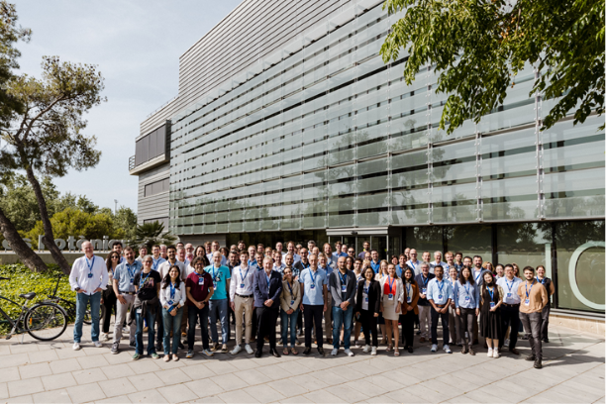
The first General Assembly took place during the kick-off meeting, held on 9 and 10 June 2025. During these sessions, the PL’s WPs were presented to all partners.
Picture 1: Kick-off Meeting at ICFO– June 9, 2025
The Pilot Line General Assembly (GA) is the decision-making body of the Hosting Consortium and it is constituted by all partners. The current version of the Consortium Agreement provides that at least one in-person meeting must be held each year. The next GA is scheduled for 20 May 2026.

T1.2: Project management, Quality assurance and Risk management (ICFO, all) M1-M60
The main governance structures were established during the first 6 months to ensure effective and efficient implementation of PL’s procedures.
- PL Steering Committee (SC): Supervisory body, responsible for the execution and strategic decision-making of the PL, reporting to and accountable to the GA. It is constituted by all WP Leaders, both from the DEP and HE. The SC assists the coordinator to manage quality assurance. To do this, SC meetings are held monthly online since September 2025, while in-person meetings will take place twice a year. The first of these will take place on 18–19 February 2026 at ICFO.
- PL Management & Coordination Team (MCT): Responsible for the daily management and coordination activities of the PL and execution of tasks to implement the guidelines and decisions of the SC and GA. It is also responsible for liaising with the Chips JU and External Advisory Board (EAB). MCT meetings are held monthly online since December 2025 and in-person at least once a year. The first face-to-face meeting was held on 20 November 2025 in Munich with the (PO).
The MCT is formed by:
- PL Director
- PL Project Manager x2
- PL Financial & Procurement Manager
- PL Installation & Acceptance Manager
- PL Dissemination & Communication Manager
- PL Exploitation & Innovation Manager
- PL Training Manager
- PL Interoperability Manager
- PL Open Access Manager
Besides governance body meetings, and to ensure proper operation and development of the PL, each of the WP leaders coordinates online monthly meetings.
Minutes of both governance bodies and WP meetings are recorded and shared with the whole consortium on SharePoint.
Other actions executed by the management team at ICFO include the preparation and submission of an amendment to the initial Description of Action (DoA) to replace UC3M partner with IMDEA, which assumed all of its tasks and responsibilities. This amendment was approved by the EC on 13 October 2025.
Furthermore, we developed initial key performance indicators (KPIs) for the innovation activities, which will be revised every 6 months:
As a first approach, PIXEurope will monitor three different KPI categories:
- Technology- and process-specific KPIs: as listed in the HE-GA¹ for every technical Work Package, each measuring the evolution of distinct figures of merit and “transfer readiness” overall.
- User-journey KPIs: derived from the Pilot Line utilization experience by external users and collaborators, and overall, a measure of “market uptake potential”.
- Innovation & Exploitation KPIs: measuring the innovation capacity and techno-economic viability of key exploitable outputs.
By drawing correlations between these sets of KPI, tentative exploitation path(s) can be defined for specific use case(s), allowing the informed decision of an optimal market pathway.
PIC technology- and process-specific KPIs (WP4-WP9) |  | User-journey KPIs  (WP3) |  | Innovation & Exploitation KPIs (WP3)
- Design:  Interoperability, automation, … |  | - External gateway requests  - Active & completed collaborations/services  - R&D Projects  - Consultancy  - Equipment use  - Prototyping  - Percentage of SMEs / start-ups  - Equipment utilization rate  - Time-to-prototype  - Prototype chips fabricated  - Revenue from external users  - Cross-pilot collaborations |  | - New results/innovations piloted  - Result ownership cleared  - Innovation type (product, process, design…)  - Innovation degree (minor, differentiating, disruptive)  - TRL evolution  - Patents filed/granted  - Yield/reliability  - Cost-per-function  - Supply chain robustness  - Standard(s) compliance  - Design kit chain maturity (until release)  - Intellectual Property (IP) packetization  - Market (Time to market, segment, demand…)  - Process scale-up industry partners
- Monolithic fabrication: Wavelength range, Wafer up-scaling, …
- Hybrid integration: Integrability, Functionality, …
- Packaging:
Wafer compatibility, Interposer density, …
- Test & reliability:
Dynamic range, Design-for-test adoption, …
- Demonstrators:
Full functionality, Standardization, …
Table 1: Technical, user-journey and Innovation and Exploitation KPIs.
During the upcoming months, these KPIs will start being populated, aiming to use entry-gateway logs and other internal processes to automate data gathering. To benchmark ambition, baselines will be established based on state-of-the-art performance metrics (technical KPIs) and available Chips JU/ECS historical data/objectives (user-journey, innovation KPIs). As the Pilot Line evolves and end user needs are integrated, these KPIs will be re-defined or complemented by new ones as needed. Any exploitation path will safeguard the institutional policies of contributing PL partners.
Finally, during these first 6 months, ICFO coordination team carried out the pre-financing of the corresponding amount from Horizon Europe to all the partners in the Consortium.

T1.3: Data Management Plan (ICFO, all) M1-M60
ICFO will submit the preliminary Data Management Plan (DMP) as a Deliverable D. 1.7. This document will be updated in M24 and M48 (Deliverables D1.8 and D1.9). The DMP covers the description, storage and management of data generated by the PL, for all three programs: JP, HE and DEP.

Significant results & Conclusions for WP1
- The PIXEurope initiative successfully started with the kick-off meeting in June 2025, ensuring a shared understanding of objectives and Work Packages across the consortium.
- All key governance and management bodies were established within the first six months, enabling effective coordination and decision-making.
- Regular monthly meetings were implemented at both management and WP levels, supporting smooth execution of PL activities.
- The MCT has become fully operational, covering all critical technical, financial, and strategic roles.
- An amendment to the DoA was approved by the EC, allowing the seamless replacement of a consortium partner.
- Pre-financing from Horizon Europe was successfully distributed to all partners, allowing activities to proceed as planned.

Work Package WP2 – Dissemination, End-user engagement

Objectives for the period
WP2 plays a foundational role in the early phase one of the PL, setting up the essential structures that will support training, dissemination, exploitation, and collaboration throughout its full duration. During the first 6 months, WP2 focused primarily on establishing a strong communication and dissemination framework and initiating strategic collaborations across the European photonics and semiconductor ecosystem.
A central objective in this initial phase was the formulation of the PL’s communication and dissemination strategy. This includes initiating the creation of key communication tools - such as the website, visual identity, and promotional materials - which are being progressively developed to ensure coherent messaging and strong visibility across the broader photonics and semiconductor community. Alongside these tools, WP2 is shaping a targeted outreach framework and beginning to consolidate a network of stakeholders at local, national, and European levels, enabling effective engagement with diverse audiences from the outset.
Through these efforts, WP2 ensures that the DEP tasks start their journey with a clear communication framework and growing visibility, both of which are crucial for successful dissemination and long-term impact. The second task under WP2, focused on end-user engagement and market analysis, will begin in Month 11 and will build upon the communication and awareness-raising activities initiated during this reporting period.

Progress towards objectives

Task 2.1: Dissemination, Communication and Networking Activities (ICFO, all) (M1, M60)
The communication, dissemination, exploitation, and collaboration activities for PIXEurope are coordinated by ICFO, acting in its role as coordinator. WP2 supports the strategic visibility and impact of PIXEurope’s activities by showcasing the research, development, and industrial advancements achieved across the consortium, and by strengthening PIXEurope’s integration within the broader European photonics and semiconductor ecosystem. Its mission is to ensure that the work of all partners is effectively communicated to relevant stakeholders - industry, academia, policymakers, end--users, and the general public - while enabling long -term exploitation and collaboration opportunities.
WP2 works to maximise the PL’s impact by:
- Developing and implementing a structured communication and dissemination strategy, aligned with the goals of the PIXEurope initiative and tailored to diverse audiences across Europe.
- Ensuring clear and effective internal communication within the consortium, supporting information flow and alignment across partners.
- Initiating and carrying out external communication, dissemination, and networking activities to raise awareness of the PL, highlight key achievements, and safeguard visibility across relevant communities.
- Establishing and nurturing collaborations with key European initiatives, including PLs, CCs, and major photonics and semiconductor platforms.
- Laying the groundwork for long-term exploitation activities, including future engagement with national and European stakeholders.
This report provides an overview of the communication, dissemination, and collaboration activities initiated and implemented during phase one of the PIXEurope initiative.

Executed Actions by month 6:

Internal Communications

During the first months of the PIXEurope project, WP2 has focused on establishing effective internal communication channels to support coordination across the consortium and ensure alignment during the initial implementation phase. Details on regular meetings have been provided above under WP1.

To support these interactions, ICFO has consolidated internal communication tools and processes. Throughout October 2025, partners were invited to complete a structured partner information form, to provide input for communication materials and PIXEurope’s website. This process has contributed to the creation of consistent partner profiles and a coherent representation of the consortium’s capabilities. In parallel, the team has been developing PIXEurope communication guidelines, which outline standards for internal and external communication, visual identity usage, and consistency across communication channels. These guidelines will serve as a reference for all partners as outreach activities intensify.
Additional internal communication actions initiated during this period include:
- Launch of PIXEurope’s corporate identity development process
- Creation of a Branding Handbook
- Creation of internal templates to support coherent communication across partners
- Set-up of a Sharepoint repository for document storage and coordination
These measures ensure that PIXEurope enters its operational phase with a strong internal communication framework.

External Communication Activities

During the first months of PIXEurope, the consortium carried out an initial set of external communication activities aimed at building early visibility for the PL, engaging key communities across Europe, and positioning PIXEurope within the wider photonics and semiconductor ecosystem. As this period precedes the generation of technical results, all actions fall under communication, focusing on awareness raising, stakeholder engagement, and showcasing partner expertise relevant to the forthcoming PL capabilities.
While the core reporting window covers Months 1 to 6 (June–November 2025), this summary also includes a small number of strategic events that took place shortly before June or in early December, as these were highly relevant to the PL’s early outreach and positioning within the European photonics and semiconductor ecosystem.
The activities presented below span participation in major conferences and workshops, invited talks and keynote presentations, presence at exhibitions and booths, and extensive communication through online channels. Together, these actions have ensured that PIXEurope is recognised from the outset as a key initiative under the Chips JU framework and have laid the foundation for future dissemination and exploitation efforts.
The following sections provide a quantified and structured overview of all external communication activities undertaken between June 2026 and beginning of December 2025, including:
- Participation in events and conferences: 22
- Presentations & panel discussions: 14
- Booth and exhibition presences: 8
- Social media posts: 30
- Press releases & news articles: 14
- Web pages referring to PIXEurope: 8

Total events participated: 22x
- DATE Conference (31 March – 2 April 2025) — CEA-Leti
- International Day of Light 2025: IMB-CNM’s role in new photonics initiatives (23 May 2025) — CSIC
- Joensuu Photonics Center event: Photonics Pilot Lines – Current Developments and Opportunities (27 May 2025) — VTT
- LID World Summit 2025 (CEA Leti) (17–19 June 2025) — CEA-Leti
- SEMI Conference (CEA Leti) (June 2025) — CEA-Leti
- Optoel Converence (Terrassa) (1–4 July 2025) — UPV
- Future of Chips event 2025 (Eindhoven, 30 September2025) – TU/e
- From science to industry: Deep Tech meeting and visit to IMB CNM ICTS (2 October 2025) — CSIC
- Global Photonics Economic Forum 2025 (Málaga) (7–8 October 2025) — UPV
- POEMS Strategic Dialogue on Semiconductors in Portugal (14 October 2025) — IT
- Launch Event of FC3 – Flanders Chips Competence Center (Mechelen) (20 October 2025) — TU/e
- Launch Event of ChipNL Competence Centre (Nijmegen) (29 October 2025) — TU/e
- Invitation to exclusive event PIC Industry Executive Forum (3 November 2025) — ICFO
- PIC Summit Europe (4–5 November 2025) — TU/e / ICFO / UPV
- Nordic Chip Summit 2025 (10 November 2025) — VTT / ICFO
- PREIN Annual Research Symposium (11 November 2025) — VTT
- SEMICON Europe (München) (8–21 November 2025) — ICFO / CSIC / TU/e / TNI / UPV
- Thematic Workshop “Semiconductor Materials, Microelectronics and Emerging Technologies – Trends and Applications 2025” (18 November 2025) — IT
- UVigo Qophi Lab Projects & Strategy presentation (20 November 2025) — UVIGO
- EFECS 2025 (3–4 December 2025) — ICFO / TU/e
- CHIPNATION national congress of Spain’s semiconductor industry Gran Canaria) (3–5 December 2025) — ICFO / CSIC / UPV
- Big Science Industry Forum Spain 2025 (Madrid) (3–4 December 2025) — UPV

Total presentations & panel discussions at events: 14x
- DATE Conference
31 March – 2 April 2025
CEA-Leti slide on EU Pilot Lines incl. PIXEurope
- Webinar: International Day of Light 2025: IMB-CNM’s role in new photonics initiatives
23 May 2025
PIXEurope introduction as part of photonics initiatives — CSIC
- Nano Optoelectronics Workshop (iNOW, Wrocław)
21–31 July 2025
“Mid IR photonic integrated circuits – challenges and perspectives” — WUT
- Optica Sensing Congress (Long Beach, USA)
20–24 July 2025
“Recent progress in photonic integrated circuits for mid IR spectral range” — WUT
- Infrared & Terahertz Quantum Workshop (Saint Malo)
1–5 September 2025
“Mid IR photonic integrated circuits for sensing and free space communication: state of the art and perspectives” — WUT
- 6th International Workshop on Opportunities and Challenges in Mid Infrared Laser Based Gas Sensing (Würzburg)
9–11 September 2025
• “MIRPIC – mid IR photonic integrated circuits for gas sensing applications” — WUT
• “Development of the MIRPIC Process Design Kit” — WUT
- Poster presentation representing PIXEurope at launch of the Casimir Institute
30 September 2025 — TU/e
- Invited talk: “PIXEurope by Valerio Pruneri” — PIC Industry Executive Forum
3 November 2025 — ICFO
- Keynote: “PIXEurope – From Pilot Line to Factory” — PIC Summit Europe
4 November 2025 — ICFO
- Presentation about PIXEurope at Nordic Chip Summit 2025
10 November 2025 — ICFO
- Presentation about PIXEurope and other Chips JU pilot lines
10 November 2025 — VTT
- Presentation about PIXEurope at SEMICON Europe
18 November 2025 — TU/e
- Representing PIXEurope at Chips JU Pilot Line Panel Discussion at SEMICON Europe, München (Germany), 20 November 25 - ICFO
- PIXEurope presentation — CHIPNATION (Gran Canaria)
3–5 December 2025 — ICFO

Total PIXEurope booth presences: 8x
- Optoel - UPV Booth incl. information about PIXEurope (Terrassa, 1–4 Jul 2025) - UPV
- Global Photonics Economic Forum - PIXSpain Competence Center Booth incl. information about PIXEurope (Málaga, 7–8 Oct 2025) - UPV
- FC3 – Flanders Chips Competence Center Launch Event - PIXEurope Booth (Mechelen, 20 Oct 2025) - TU/e
- ChipNL Competence Centre Launch Event - PIXEurope Booth (Nijmegen, 29 Oct 2025) - TU/e
- PIC Summit Europe – PIXEurope Booth and UPV Booth incl. information about PIXEurope (Eindhoven, 3–6 Nov 2025) - TU/e/ICFO/UPV
- SEMICON Europe - Joint Chips JU booth displaying the 5 Pilot Lines and other Chips JU initiatives (München, 8–21 Nov 2025) - ICFO/TUE/TNI/UPV
- EFECS 2025 - PIXEurope booth at Chips for Europe Initiative zone (3–4 Dec 2025) - ICFO/TUE
- Big Science Industry Forum Spain - PIXSpain Competence Center + PIXEurope Booth (Madrid, 3–4 Dec 2025) - UPV

Total social media posts reported: 30
- Feb 2025 – WUT LinkedIn account
Announcement on WUT's involvment in PIXEurope
<https://www.linkedin.com/feed/update/urn:li:activity:7287825684628955136/>
- Apr 2025 - CEA Leti LinkedIn account
<https://www.linkedin.com/posts/sebastien-dauve-leti_semiconductors-euchipsact-techpolicy-activity-7308524201559093248-mC8h/>
- May 2025 - CSIC LinkedIn account
International Day of Light 2025: IMB CNM’s role in new photonics initiatives
<https://www.linkedin.com/posts/imb-cnm-csic_internationaldayoflight-imbcnmtalks-photonics-activity-7329086972650586113-0QQ1>
- Jun 2025 - SAL LinkedIn account
SAL communication on PIXEurope Launch
<https://www.linkedin.com/posts/silicon-austria-labs_pics-tfln-aln-activity-7338119953310457856-UoO_>
- Jun 2025 - ICFO LinkedIn account
ICFO Communication of Launch of PIXEurope (as Coordinator)
<https://www.linkedin.com/posts/icfo_pixeurope-activity-7359139053855748096-YM2J/>
- Jun 2025 - UVIGO LinkedIn account
UVigo Qophi Lab Participation at PIXEurope Technical Kick Off meeting
<https://www.linkedin.com/feed/update/urn:li:activity:7338586821385150464>
- Jul 2025 - UPV LinkedIn account
Optoel (Terrassa)
<https://www.linkedin.com/posts/giuseppe-libero-bufi_last-week-i-had-the-chance-to-attend-my-activity-7348409446181548032-_ly->
- Sep 2025 - ICFO LinkedIn account
Strategic Initiative PICS@ICFO incl. PIXEurope job offers
<https://www.linkedin.com/posts/icfo_photonics-pixeurope-activity-7370003034497499136-vear/>
- Oct 2025 - ICFO LinkedIn account - Ecosystem / general update
ICFO CLP Day
<https://www.linkedin.com/posts/icfo_icfo-clp-day-2025-activity-7384962959153901568-pmv6/>
- Oct 2025 - IT LinkedIn account
POEMS Strategic Dialogue on Semiconductors in Portugal
<https://www.linkedin.com/posts/poems-portuguese-competence-centre-in-semiconductors_poems-strategicdialogue-semiconductors-activity-7359588753423716352-piRT/>
- Oct 2025 - PIXEurope LinkedIn account
PIXEurope Booth at Launch Event of FC3 (Mechelen)
<https://www.linkedin.com/feed/update/urn:li:activity:7394003055362347009>
- Oct 2025 - PIXEurope LinkedIn account
PIXEurope Booth at Launch Event of ChipNL (Nijmegen)
<https://www.linkedin.com/feed/update/urn:li:activity:7394003055362347009>
- Oct 2025 - UPV LinkedIn account
Global Photonics Economic Forum 2025
<https://www.linkedin.com/feed/update/urn:li:activity:7387086485168148480>
- Oct 2025 - TNO LinkedIn account - Press release
6″ InP Pilot Line - press release push
<https://www.linkedin.com/posts/tno_tno-thisisourtime-workingattno-activity-7383768955657805824-kqAp>
- Nov 2025 - PIXEurope LinkedIn account
Invited talk: “PIXEurope by Valerio Pruneri” - PIC Industry Executive Forum
<https://www.linkedin.com/feed/update/urn:li:activity:7391878557049798656>
- Nov 2025 - PIXEurope LinkedIn account
“PIXEurope – From Pilot line to Factory” - PIC Summit Europe
<https://www.linkedin.com/feed/update/urn:li:activity:7391878557049798656>
- Nov 2025 - PIXEurope LinkedIn account
PIXEurope Booth - PIC Summit Europe
<https://www.linkedin.com/feed/update/urn:li:activity:7391878557049798656>
- Nov 2025 - IT LinkedIn account
Thematic Workshop “Semiconductor Materials, Microelectronics and Emerging Technologies 2025”
<https://www.linkedin.com/posts/agenda-microeletr%C3%B3nica_microeletraejnica-inovaria-tecnologiasemergentes-activity-7393361744250703872-mJ8m>
- Nov 2025 - UVIGO LinkedIn account
UVigo Qophi Lab – Projects & Strategy presentation
<https://www.linkedin.com/feed/update/urn:li:activity:7397945354744135680/>
- Nov 2025 - CEA Leti LinkedIn account
SEMICON Europe (Munich)
<https://www.linkedin.com/posts/sebastien-dauve-leti_france2030-activity-7397222920911052800-MBYN>
- Nov 2025 - VTT LinkedIn account
Central Europe week recap (shared)
<https://www.linkedin.com/posts/piia-konstari-1b4b4b30_exciting-and-busy-central-europe-week-behind-activity-7397277501737172994-OgsU>
- Nov 2025 - ICFO LinkedIn account
Strategic Initiative PICS@ICFO incl. PIXEurope job offers
<https://www.linkedin.com/posts/icfo_photonics-pixeurope-activity-7398647032648839168-hvs3/>
- Nov 2025 - UPV LinkedIn account
SEMICON Europa
<https://www.linkedin.com/posts/upvfab-micro-fabrication-pilot-line_semiconeuropa50-semieurope-semiconeuropa-activity-7396524128033222658-pDxi>
- Nov 2025 - UPV LinkedIn account
PIC Summit Europe
<https://www.linkedin.com/posts/upvfab-micro-fabrication-pilot-line_upvfab-picsummiteurope-integratedphotonics-activity-7392132294502780929-drk2>
- Nov 2025 - VTT LinkedIn account
Combined event recap
<https://www.linkedin.com/posts/piia-konstari-1b4b4b30_exciting-and-busy-central-europe-week-behind-activity-7397277501737172994-OgsU>
- Nov 2025 - ICFO LinkedIn account
Joint Chips JU booth and PIXEurope presentations - SEMICON Europe (multi post)
<https://www.linkedin.com/feed/update/urn:li:activity:7396516383095685120>
<https://www.linkedin.com/feed/update/urn:li:activity:7397186815205666816>
<https://www.linkedin.com/feed/update/urn:li:activity:7397295150454149121>
<https://www.linkedin.com/feed/update/urn:li:activity:7397644054320193537>
- Nov 2025 - TNO LinkedIn account - Ecosystem / general update
Contract build - 6″ InP Pilot Line
<https://www.linkedin.com/posts/tno_tno-innovationhub-pilotline-activity-7391821687769485312-rVrM>
- Dec 2025 - PIXEurope LinkedIn account
PIXEurope at EFECS 2025 - Chips for Europe Initiative zone
<https://www.linkedin.com/feed/update/urn:li:activity:7401590232715898881>
<https://www.linkedin.com/feed/update/urn:li:activity:7402356430894252032
- Dec 2025 - PIXEurope LinkedIn account
PIXEurope presentation - CHIPNATION (Gran Canaria)
<https://www.linkedin.com/feed/update/urn:li:activity:7402356430894252032
- Dec 2025 - UPV LinkedIn account
Big Science Industry Forum Spain 2025 (Madrid)
<https://www.linkedin.com/posts/pixspain-competence-center_bsifs2025-bsif-pixspain-activity-7402307130109800449-ne4G>

Total Press Releases & News Articles: 13x

- Nov 2024 - ICFO
Chips JU selects PIXEurope consortium
<https://www.icfo.eu/news/2436/the-european-commission-and-chips-ju-select-the-pixeurope-consortium-to-lead-the-european-pilot-line-on-advanced-photonic-integrated-circuits-nbsp-/>
- Nov 2024 - IMEC
EC & Chips JU select PIXEurope consortium
<https://www.imec-int.com/en/press/european-commission-and-chips-ju-select-pixeurope-consortium-lead-european-pilot-line>
- Nov 2024 - UTwente (Holland High Tech)
Europe has opted for a pilot plant for photonic chips with a large share in the Netherlands
<https://hollandhightech.nl/en/news-calendar/news/archive/2024/europe-has-opted-for-a-pilot-plant-for-photonic-chips-with-a-large-share-in-the-netherlands>
- Nov 2024 - UPV
Noticia: El chip fotónico…
<https://www.upv.es/noticias-upv/noticia-14934-el-chip-fotoni-es.html>
- Dec 2024 - TU/e
PIXEurope consortium to lead EU pilot line on advanced PICs
<https://www.tue.nl/en/news-and-events/news-overview/05-12-2024-pixeurope-consortium-to-lead-the-european-pilot-line-on-advanced-photonic-integrated-circuits>
- Dec 2024 - UVIGO (atlanTTIC)
Opening of an experimental plant for photonic chips
<https://vigotecnoloxico.uvigo.es/atlanttic-liderara-la-apertura-de-una-planta-experimental-de-chips-fotonicos/>
- Jun 2025 - ICFO
Start of PIXEurope; Technical Kick-off held 9 June 2025
<https://www.icfo.eu/news/2546/start-of-pixeurope-a-400m-euro-initiative-that-aims-to-accelerate-photonic-chip-development-in-europe-/>
- Jun 2025 - VTT
VTT joins PIXEurope – Advanced European Photonics Pilot Line
<https://www.vttresearch.com/en/news-and-ideas/vtt-joins-pixeurope-advanced-european-photonics-pilot-line>
- Jun 2025 - TNI (Tyndall)
Minister Lawless celebrates Ireland’s role in European Chips Act Pilot Line
<https://www.tyndall.ie/news/minister-lawless-celebrates-irelands-role-in-european-chips-act-pilot-line/>
- Jun 2025 - TNO
Signals start of photonic chip pilot line (6″ InP)
<https://www.tno.nl/en/newsroom/2025/06/tno-signals-start-photonic-chip-pilot/>
- Jun 2025 - SAL (Silicon Austria Labs)
SAL joins €400M PIXEurope initiative (TFLN focus)
<https://www.silicon-austria-labs.com/en/press-downloads/details/silicon-austria-labs-joins-eur400m-pixeurope-initiative-to-boost-integrated-photonics-with-thin-film-lithium-niobate>
- Jun 2025 - UTwente (ChipTech Twente)
Start of PIXEurope (€400M initiative)
<https://chiptechtwente.com/en/start-of-pixeurope-a-400me-initiative-that-aims-to-accelerate-photonic-chip-development-in-europe/>
- Jul 2025 - CSIC (IMB-CNM)
EC & Chips JU select PIXEurope consortium
<https://www.imb-cnm.csic.es/en/outreach/news/european-commission-and-chips-joint-undertaking-chips-ju-select-pixeurope-consortium>

Total web pages referring to PIXEurope: 8x

- TNO - Photonic Chip Pilot Line: InP chip fabrication at 6-inch wafer scale
<https://www.tno.nl/en/technology-science/facilities/photonic-chip-pilot-line/>
- TNO - Careers: Join our Photonic Chip Pilot Line team in Eindhoven
<https://www.tno.nl/en/careers/photonic-chip-pilot-line/>
- IMDEA Networks - Project page: PIXEurope
<https://networks.imdea.org/es/proyectos/pixeurope/>
- IT (Instituto de Telecomunicações) - Project page: PIXEurope
<https://www.it.pt/Projects/Index/4931>
- UGent - Research portal entry: PIXEurope
<https://research.ugent.be/web/result/project/fdbb3ec0-cd9a-4811-ac07-155dbb2f535b/details/en>
- UTwente (MESA+) - Integrated Photonics (centre-of-expertise page referencing PIXEurope)
<https://www.utwente.nl/en/mesaplus/research/centres-of-expertise/integrated-photonics/>
- WUT - Projects in progress: PIXEurope
<https://cezamat.pw.edu.pl/projects/in-progress/pixeurope/>
- WUT - WUT as a partner in the European PIXEurope project
<https://cezamat.pw.edu.pl/cezamat-wut-as-a-partner-in-the-european-pixeurope-project/>

PIXEurope Website

The PIXEurope website is currently active with a basic landing page providing essential information and serving as an initial point of contact: https://pixeurope.eu.
This marks the beginning of the initiative’s digital presence and visibility. Work is now focused on developing a comprehensive and fully functional website that will offer structured content, interactive features, and resources tailored to different audiences, including researchers, industry partners, and the general public. While the final layout may evolve as the Pilot Line progresses, further details on the currently foreseen website structure may be found in the Deliverable D2.1 Dissemination and Communication planning & performance.
Once the full site is published, web analytics will be implemented to monitor traffic, user engagement, and overall impact, providing valuable insights for continuous optimisation and ensuring the platform meets the needs of its stakeholders.
Event collateral and audio-visual materials
The PL Dissemination and Communication Manager has developed a range of audio-visual materials to strengthen the visibility of the initiative and support its presence at major industry events. These materials were designed to promote PIXEurope through social media channels and facilitate dissemination to press and media outlets, while also enhancing the project’s representation at physical events. The team created a dedicated flyer and a roll-up banner for PIXEurope booths, ensuring a clear and professional visual identity aligned with the project’s branding.
For SEMICON Europe and EFECS 2025, a promotional video was produced for display on booth screens, featuring video footage from several partners to highlight the joint effort of the consortium within the PIXEurope initiative. This dynamic content aimed to attract visitors and communicate the collaborative nature of this PL in an engaging and accessible format. These efforts are expected to maximize outreach and foster stronger engagement with stakeholders across the semiconductor and electronics ecosystem.
Link to video: PIXEurope Intro Video HD FINAL.mp4
Link to materials: EVENT MATERIALS
Social Media
LinkedIn is currently the primary social media channel used by PIXEurope to communicate and disseminate updates about the initiative: https://linkedin.com/company/pixeurope. Through this platform, we share news, project milestones, and relevant information to engage stakeholders and increase visibility within the research and industry community.
In the following sections we include a report on the analytics of each of the LinkedIn channel:
Follower Metrics
The graph below illustrates the evolution of PIXEurope’s LinkedIn followers over the reporting period. Growth has been entirely organic, with a noticeable spike in early August followed by a steady increase, reaching a total of 1,091 followers by mid-December.
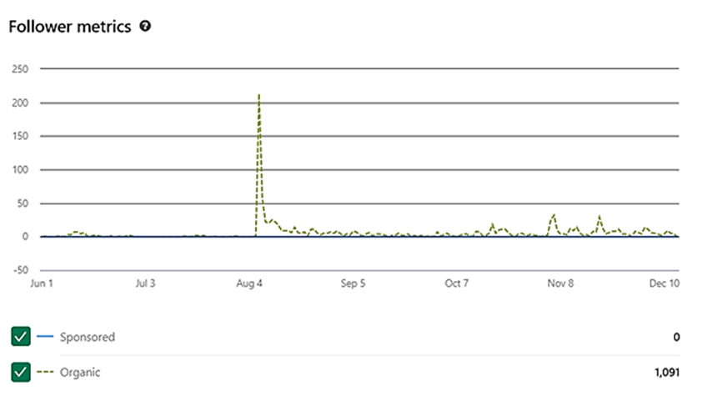
Figure 1: LinkedIn followers chart
Impressions and Highlights
The following graph provides an overview of post impressions and engagement highlights from June to December 2025. The data shows several peaks in visibility, particularly around major events, resulting in over 55,000 impressions and 1,392 reactions during this period.
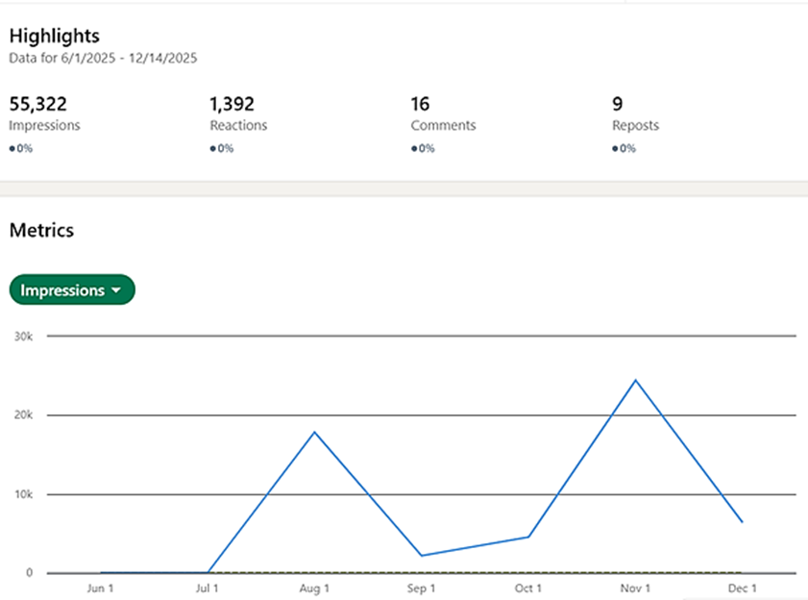
Figure 2: LinkedIn highlights and impressions graph
Benchmarking in LinkedIn
To assess PIXEurope’s performance within its ecosystem on LinkedIn, we have activated the benchmarking feature to compare engagement and growth against the other four Chips JU Pilot Lines. As of mid-December 2025, PIXEurope has surpassed 1,090 followers, positioning it second among the five initiatives. Despite having fewer posts overall (11 posts in the last 197 days), PIXEurope achieved an engagement rate of 19.2%, which is 26.3% higher than competitors, indicating strong audience interaction relative to content volume.
This performance demonstrates that PIXEurope is one of the fastest growing and most engaging pages in its category, even with a lower posting frequency. The focus on high-quality, event-driven content and visual materials appears to resonate well with its target audience.
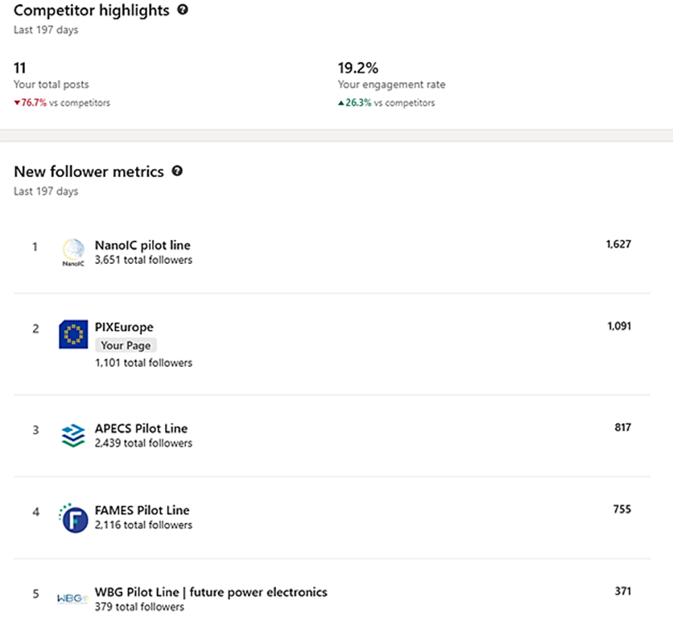
Figure 3: LinkedIn benchmarking overview
Visitor Demographics

The graph below shows the visitor demographics by industry for the PIXEurope LinkedIn page during the current reporting period. The largest share of visitors comes from research services (22.9%), followed by semiconductor manufacturing (16.1%), nanotechnology research (8.6%), and higher education (8.5%). Other notable sectors include appliances and electronics manufacturing (5%), business consulting (4.7%), and engineering services (4%), indicating strong engagement from both academic and industrial communities.

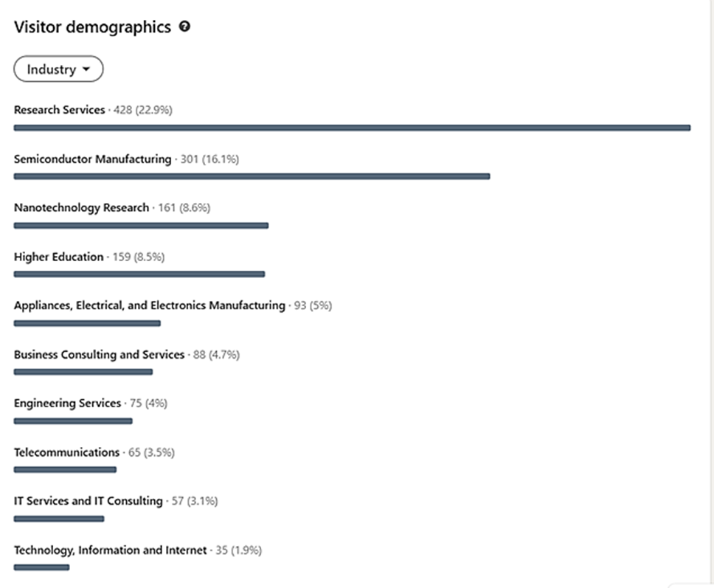
Figure 4: LinkedIn visitor demographics overview
Post Analytics Overview
The following graph presents detailed analytics for individual posts published under the PIXEurope LinkedIn during the reporting period, highlighting which updates generated the highest interaction, with some posts achieving engagement rates above 60%.
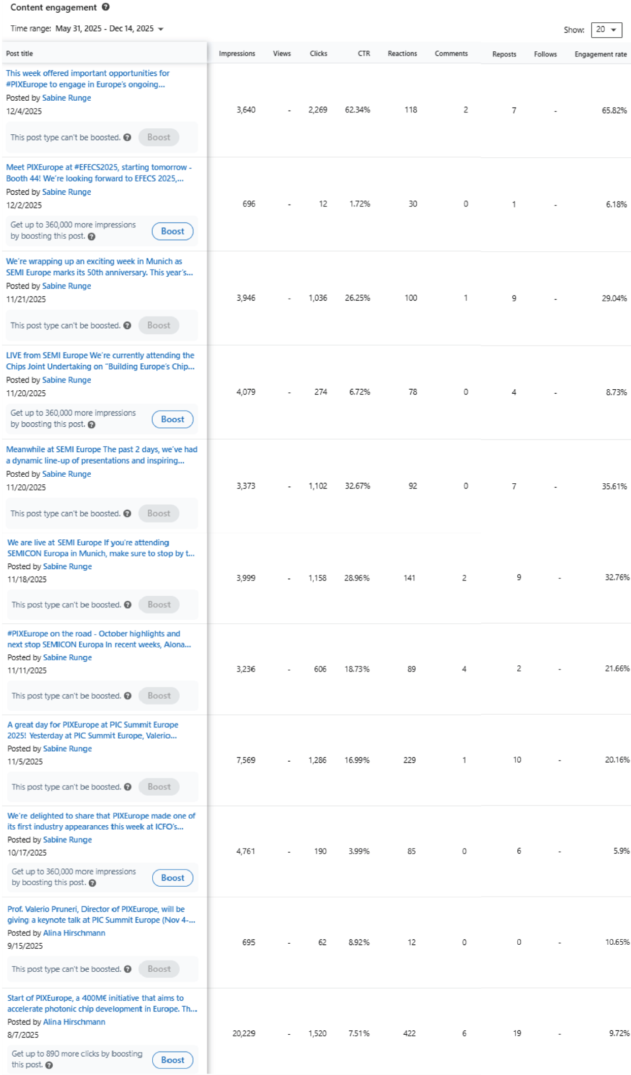
Figure 5: LinkedIn post analytics overview
Media Clipping Overview
During the reporting period, PIXEurope achieved significant visibility across European media channels. A total of 80 media clippings were recorded, including 56 online press articles and 24 printed items, reflecting growing interest in the initiative within both specialized and general media outlets. Coverage was monitored through professional media tracking services by ICFO, which provide only partial extracts for reporting purposes. The data presented here is therefore an indicative sample rather than a comprehensive list, intended to offer orientation on the overall media presence.
Most articles appeared in Spanish outlets, reflecting strong regional interest in the initiative and its role in advancing photonic chip development. Headlines frequently highlighted strategic investments in research infrastructure, technological sovereignty, and Europe’s ambition to lead in innovation.
International coverage complemented this regional focus, with mentions in technology and industry platforms such as Photonics Online, PR Newswire, Yahoo! Finance, and Benzinga, reporting on consortium developments and partner participation. Articles emphasized PIXEurope as a €400M initiative driving photonic chip innovation and strengthening European technological sovereignty.
This level of coverage demonstrates growing awareness of PIXEurope across both specialized and mainstream media, reinforcing its positioning as a strategic European project in advanced photonics.

Task 2.2: End-user engagement Strategy (ICFO, all) (M11-M60)
Not applicable to this period

Significant results & Conclusions for WP2
The communication activities carried out during this initial reporting period have significantly contributed to increasing PIXEurope’s visibility and interaction with potential stakeholders. Establishing awareness for a new initiative requires consistent content creation, active promotion across multiple channels, and continuous analysis of performance to refine strategies and identify new opportunities.
Based on the analytics and actions executed so far, the following conclusions have been drawn:
- PIXEurope has strengthened its presence on LinkedIn, which remains the primary social media channel for outreach during this reporting period. Since its launch in mid-2025, the account has grown to over 1,090 followers, supported by regular posts highlighting project milestones, event participation, and partner contributions. Engagement rates are notably high compared to similar initiatives, confirming the effectiveness of targeted, high-quality content.
- Digital communication has been reinforced through 30 social media posts, complemented by 14 press releases and news articles and 8 web pages referring to PIXEurope. These actions have helped position PIXEurope as a strategic European initiative within the semiconductor and photonics ecosystem.
- Event-driven communication has played a central role in visibility. During the reporting period, PIXEurope participated in 24 events and conferences, delivered 14 presentations and panel discussions, and maintained a strong presence at 8 booths and exhibitions. These activities were supported by dedicated promotional materials, including flyers, roll-up banners, and a booth video for SEMICON Europe and EFECS 2025.
- Media coverage has further amplified outreach, with 80 media clippings recorded - 56 online articles and 24 printed items - including mentions in leading Spanish outlets and international technology platforms. While the monitoring service provides only partial extracts, the sample indicates strong regional engagement and growing recognition at the European level.
- Although specific pathways towards collaboration with other PLs, CCCs and large European initiatives in PICs are still in development, early conversations indicate a strong desire in the PIC ecosystem to collaborate and work towards shared goals.
In parallel, the development of the PIXEurope website is progressing - while an active landing page is already live, work is ongoing to build a comprehensive site with structured content, interactive features, and analytics tools to monitor engagement. This website will serve as a central hub for information, resources, and stakeholder interaction to reinforce PIXEurope’s central gateway managed by ICFO.
Overall, the analysis confirms that PIXEurope is on a positive trajectory in terms of visibility and stakeholder engagement. Continued efforts will focus on expanding content diversity, leveraging event-driven communication, exploring new formats to maintain momentum and reach broader audience, as well as completing the website to provide a robust digital presence.

Overview of achieved deliverables and milestones
Deliverable number | Deliverable name | Lead partner | Due date as per Annex 1 | Submission date | Comments
D2.1 | Dissemination and Communication  planning and performance M6 | ICFO | 30 Nov 2025 | 07 Jan 2026
MS3 | Dissemination Strategy Outlined | ICFO | 30 Nov 2025 | 22 Dec 2025

Work package WP3 – Operations, Sustainability & Open Access

Objectives for the period
Operations
Operations focus on ensuring that connections between the different actions of PIXEurope PL - Joint Procurement (JP), PL development and setting up (Horizon Europe) and Open Access (DEP) - are fully functional. The main objectives are:
- Establishing the operational structures for PIXEurope's distributed PL
- Establishing the PL Gateway as a single-entry point for all users
Activity in this period has focused on:
- Establishing the management structures and their interrelations
- Defining the entry criteria for PL Associated Partners and End Users, that may engage in Collaborative R&D Projects and Open Access, respectively.
Interoperability
Interoperability aims to ensure that the PL functions as a connected system across all technical work packages. The main objectives are:
- Defining the key interfaces and handoffs between design, fabrication, hybrid integration, packaging and test so that activities align and information flows predictably.
- Developing a shared interoperability framework that captures how WPs interact, where dependencies exist and how these links will eventually be validated.
- Preparing for coordinated PL operation, including early planning for interface validation and future integration with Gateway and training activities.
Activity in this period has focused on setting the foundations for later interoperability work. The objectives for this period were:
- Establishing a common understanding of interoperability, clarifying its role within WP3 and how it supports coordination across the technical WPs.
- Outlining high-level WP-to-WP interactions and dependencies, identifying where key handoffs are expected to occur once technical work progresses.
- Preparing for structured coordination, including identifying WP contacts and considering how meetings and communication should be organised in the next period.
Open Access
Open Access aims to ensure that the PL can be approached and used by end-users in a clear and consistent way. The key objectives are:
- Defining the Open Access model, including access types and the basic structure of the user journey
- Setting up the operational and procedural foundations needed to support external access across partners
- Ensuring a consistent approach to responsibilities, documentation and communication across the PL
- Preparing the early outline of the user workflow through the Gateway, including required steps and information
These objectives provide the basis for a unified approach to Open Access that will be refined as technical and operational work progresses.
Activity in this period has focused on the early preparation required to establish the PL’s Open Access model, with the following objectives:
- Identifying the responsible contact points for Open Access across the partner institutions
- Collecting partner input on Open Access experience, needs and expectations through an initial survey
- Outlining the Open Access types that will be supported within PIXEurope
- Establishing regular WP3 meetings to coordinate the development of Open Access procedures and workflows
- Describing the required operational procedures, recognising these will evolve as technical work progresses
- Initiating expert discussions on legal processes, documentation and the structure of the end-user journey through the Gateway
- Updating the early Open Access framework based on partner feedback

Progress towards objectives

T 3.1: Pilot Line Operations and Interoperability (ICFO, all DEP partners) (M1-M60)
Activity in operations has focused on defining the different management structures, their responsibility and relations, which include those describe in WP1, T1.2 (see above), and the following:
- Pilot Line Open Access Team (OAT) supervises the eligibility of Associated Partners and End-Users and the work-plan for External Activities (Collaborative R&D Projects and Open Access Services). Members are a subset of the MCT and the Open Access Officers at each site of the 16 partners involved. Currently, meetings are part of the MCT monthly online meetings and in person gatherings.
- PL Gateway is central to coordinate the operation of the PL. This is being built in collaboration with the MCT, OAT and SC. The Gateway is the first entry point for the Associated Partners and End-Users of the PL. The Gateway Manager at ICFO will be coordinating the Open Access officers to make sure that the external activities (Collaborative R&D Projects and Open Access Services), once approved, are properly executed. The proper implementation of the data management related to external activities will also be critical.
Activity in interoperability during the first six months has centred on preparation and early planning. The priority has been to build a shared understanding of what interoperability means within WP3 and how it will link activities across the PL. Work so far has focused on clarifying purpose and scope, placing emphasis on coordination across design, fabrication, hybrid integration, packaging and test, and on framing interoperability as an activity that connects these areas through interfaces, handoffs and shared information rather than as a technical development task of its own.
Alongside this, a first high-level view of expected relationships between WPs has been outlined, giving an initial picture of where key interactions are likely to emerge once technical work accelerates. This has also involved early preparation for coordination activities, such as identifying contacts across WPs, shaping a suitable meeting structure and outlining how alignment with demonstrator work from ICFO will be maintained. These steps are aimed at setting up clear communication paths as activity scales up. Early thinking has also gone into how a future interoperability framework might be structured, limited for now to identifying the types of information that will eventually need to be captured, such as dependencies, WP inputs and outputs, and likely interface points.
There have also been initial discussions on future interface validation and how Integration Test Vehicles might later be used to check critical handoffs. These ideas remain at a conceptual stage. Overall, progress in this period has been preparatory, establishing shared terminology, identifying initial WP connections and shaping the foundations for a more structured approach. More detailed activity, including defining interfaces, drafting the framework and planning validation work, will follow as technical inputs from the WPs become available.
TRAINING
Empowering a new generation of European technologists and engineers with world-class expertise in PIC manufacturing is the goal of training in PIXEurope. We will achieve this by implementing a comprehensive training programme for both consortium members of the PL through an internal training programme, and for End Users through an external training programme. At M06, we are on track with the planning and implementation of the internal training programme and related initial actions which are vital to achieve our first milestone due in M22, PIXEurope training syllabus ready. Major accomplishments in the first six months have been:

Governance:
- Identified training contacts within all consortium members, who are establishing the PIXEurope training committee, 15 contacts have been nominated
Implementation:
- Issued a survey to assess partners’ training capacities and capabilities
- Coordinated the roll-out of 3-4 courses by M12, with the number of courses increasing every 6 months
One online training on Design Kit Creation has been created by TU/e, targeting consortium members in WP4, and is available since November 2025. In addition, one-on-one training sessions through visits to partner sites have already taken place to support learning about key PIXEurope manufacturing capabilities. To date, three such trainings have been recorded from ICFO going to TU/e.
Key activities planned for the next six months include but are not limited to: coordinating the implementation of the training infrastructure implementation via the PIXEurope website and Gateway and completing the initial draft of the training syllabus.

Task 3.2: Cost Models, Sustainability and Life Cycle Analysis (TNI, all DEP partners) (M12-M50)
Not applicable to this period

Task 3.3: Open Access (TU/e, ICFO, TNI) (M1-M60)
Activity in Open Access during the first six months has focused on initial preparation and information gathering to establish the foundations for how end-users will eventually engage with the PL. Work in this period has revolve around identifying the responsible personnel at each partner institution, gathering their experience and expectations through a structured survey. This early work has supported the development of a shared understanding of access types, responsibilities and operational considerations.
A significant part of the activity has involved mapping the administrative and procedural landscape across partners. Most partners have now identified key contact points for costing, contracting and multi-party industry projects, and Open Access officers have been assigned. In parallel, partner experience with Open Access models and user journeys has been collected, including detailed input from TNI and WUT, helping to build a clearer picture of existing practices that may inform the PIXEurope approach. Early engagement has also taken place with CCCs and other European PLs to gather external insights and align with broader best practices.

Significant results & Conclusions for WP3
- Core operational governance for the PIXEurope PL has been established, with management structures defined, key roles assigned and day-to-day coordination in place
- The PL Gateway has been established as the single-entry point for external users, with early alignment between operations and Open Access teams supporting future execution
- A shared foundation for interoperability has been created, clarifying WP interactions, interfaces and coordination mechanisms ahead of technical integration
- Open access responsible team's efforts concentrated on laying the groundwork for Open Access implementation as well as administrative and procedural mapping.

Overview of achieved deliverables and milestones
Deliverable number | Deliverable name | Lead partner | Due date as per Annex 1 | Submission date | Comments

Impact
PIXEurope is already having impact in the European ecosystem and worldwide through the different dissemination and communication activities described in the current deliverables, especially in WP2. Many companies and RTOs contacted and had initial discussion with PIXEurope’s partners. These range from designers to equipment suppliers, manufacturers and vertical integrators. Once the Collaborative R&D Projects and Open Access cost procedures, including cost and IP models, are in place, we foresee a strong engagement of external collaborators (including associated partners) and end-users.
In addition to Collaborative R&D Projects and Open Access, in the next period we will focus on evaluating the potential of the technologies and processes we will develop within PIXEurope. All these activities leading to industry and societal impacts will be fostered and potentiated by an increasing interaction with European companies and stakeholders.

Update of the plan for exploitation and dissemination of results
N/a

Update of the data management plan
N/a

Deviations from Annex 1 and Annex 2

