Towards Novel Quantum Applications of Ultrafast Physics (Towarultra)
1. Excellence
1.1 Long-term vision
TOWARULTRA aims to develop a new class of novel quantum light sources and light-matter states, and diagnostics for exploring a new frontier in physics and technology, enabling unprecedented access to ultrafast quantum electrodynamics phenomena.
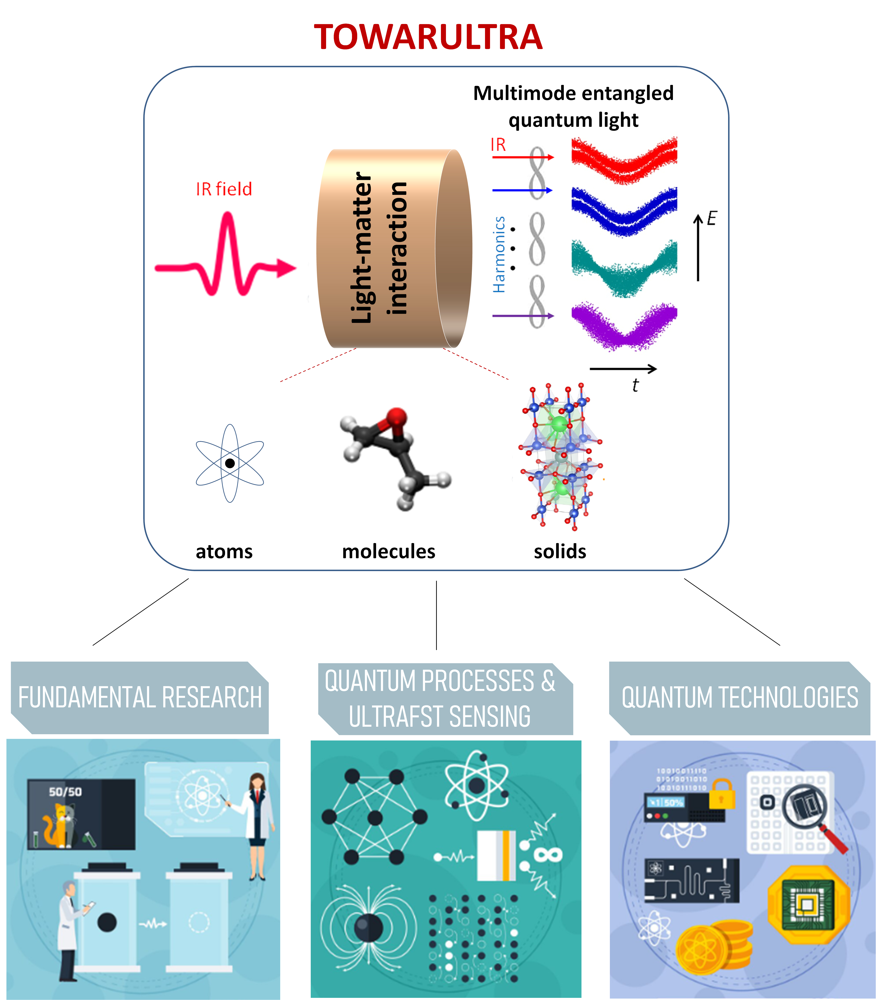
Fig. 1.1.1. An illustration of the TOWARULTRA project showing the core schemes (up panel) underlying investigations in fundamental science and technology (down panels).

Specifically, TOWARULTRA aims to develop massively entangled quantum states (MQS) of light and light-matter, with controllable quantum features, pulse durations in the attosecond (as)-femtosecond (fs) time scale, mean photon numbers >10^10 per pulse, multimode entanglement across $≈$20 frequency modes, and frequencies from the IR to XUV. This defines a new paradigm: such states have never been created before, and the possibilities of their application have not been explored. The ultrafast quantum electrodynamics of many-body systems is imprinted on them,
and can be read off with appropriate diagnostics/sensing. We aim to develop diagnostics for these quantum light sources with unprecedented temporal precision (on the as scale) and spectral broadness (from IR to XUV). All these features are far beyond the current state-of-the-art technology.

TOWARULTRA is directly related to a fast-expanding research area at the cutting edge of quantum optics, quantum technologies, and ultrafast science, driven by the pioneering work of its partners [LCP21,ABB22,TJP24] (for reviews see [BLM23,SRM23,STR26,LSR25]), and other groups in the field [BTB25,Moi24,TCS24,TBG23, LJP205,LHM24,LMw 25,GLM25,LHM25]. It explores a new frontier in physics and technology that arises from linking quantum optics and quantum information science with strong-field physics and ultrafast science (research fields that have produced major breakthroughs, from Nobel Prize-winning experiments [Mou19,Str19,Ago23, Kra23,Lhu23] to sigenificant interndisciplinary advances in both fundamental research and technology).
TOWARULTRA seeks totally novel exploitations of ultrafast physics at the fully quantized level. Our explorations will reach totally unknown regions of the area, having little in common with the “conventional” results achieved so far.[ABC19,Bra07,CBB25,Cor93,CPL17,CSS16,KSK92,KSK93,LBI94]). By leveraging ultrashort timescales—during which matter is effectively frozen and quantum decoherence from thermal effects becomes negligible—this approach aims to develop innovative methods in ultrafast quantum science and technology. It seeks to address long-standing questions in fundamental physics while unlocking significant potential for applications in quantum technologies and ultrafast science, particularly in natural systems (i.e., systems that are not isolated from their environment), beyond the reach of current technological capabilities. Some examples, among the others outlined in Sections 1.2,3, are: (I) development of methods for the generation and characterization of a novel class of high photon number, ultrafast, multimode entangled quantum light sources with controllable quantum features and frequencies spanning from the far-infrared (IR) to extreme-ultraviolet (XUV); (II) establishment of methodologies for performing ultrafast spectroscopy at the fully quantized level; and (III) formulate approaches to investigate ultrafast many-body quantum-correlated systems with unprecedented temporal precision, including the detection and control of topology. Addressing these, we will develop new tools and approaches that advance the exciting new paths provided by TOWARULTRA to fundamental science, quantum information, and technologies emerging from the connection of quantum optics and quantum information science with strong-field physics and ultrafast science (Fig.1.1.1).
Collectively, these research directions address long-standing challenges in both fundamental science and technological innovation, ranging from fundamental tests of quantum theory to quantum technologies and ultrafast science, including quantum light engineering, diagnostics, and sensing. All these extend far beyond the current state of the art and serve as the core pillars of a long-term vision to advance and sustain a rapidly emerging research field.
TOWARULTRA partners have produced major theoretical and experimental advances in recent years. For instance, we have shown: (I) that strong laser–matter interactions can produce high-photon-number, highly entangled non-classical light states such as optical Schrödinger “cat” and squeezed states—with tunable quantum properties across a broad spectral range from the far-infrared (IR) to the extreme-ultraviolet (XUV) [LCP21,TCS24]; (II) how quantum light propagates through nonlinear media [RKS26]; (III) how such states can be harnessed for advanced sensing applications [SML24]; (IV) how quantum correlations in many-body systems can be mapped onto the quantum features of the emitted light [ABB22,TZV25,ZTV25,BAD23,DAB24,Dab26] (V) how the robustness of high-Tc superconducting quantum states under intense optical fields enables the transfer of material entanglement to emitted radiation [ABB22,TZV25,ZTV25,BAD23,DAB24,Dab26] (see also contributions of L.B. Maden, and D.H. Ko and P.B. Corkum to [BAA26]); and (VI) how treating quantum harmonic light as a measurable observable makes it possible to characterize multimode entanglement in nonlinear optical responses [TCS24,THC24,LJP25,BTB25]; VII) how ultrafast high harmonic spectroscopy can be used to study strongly correlated many-body systems [SJA19]; and VIII) how ultrafast strong laser fields can be used to control the topological properties of 2D materials, relevant to valleytronics devices [JSS20,TJP24]. These and other advances are summarized in recent review articles [BLM23,SRM23,STR26,LSR25]. Clearly, this consortium has experience, expertise, and creative power to realize a convincing, radically new technology in the field of ultrafast science.
The scientific excellence of the TOWARULTRA field is supported by the strong publication record of the partners, including numerous articles in high-visibility, high-impact scientific journals, as well as recognitions by the Institute of Physics (IOP) and American Physical Society (APS) in Physical Review collection, which described the work as “The research that shaped atomic and molecular physics in 2025” and "Current Trends and Future Perspectives of Attoscience", respectively. Considering the above, we can claim that TOWARULTRA is grounded in a clearly defined and forward-looking research vision that aims to advance and explore new directions in basic research and technology, consolidating progress into a transformative field.

1.2 Towards-technology breakthrough
Fundamentals and challenges of current quantum technologies Quantum technologies rely on fully quantized light-matter interactions under conditions of negligible decoherence. Key developments include the engineering of I) quantum light sources (such as squeezed, Fock, optical Schrödinger "cat" states and entangled photon sources) [LCP21,SRM24,TSC24] which can provide reduced noise and the notable feature of quantum correlations; II) isolated quantum systems (such as ion traps, cold atoms etc.) exhibiting pronounced and detectable quantum features at long time scales (micro-millisecond range); and III) the development of diagnostics including quantum state characterization approaches (e.g. photon correlation measurements, quantum state tomography, etc.) [LRS25,SML24,SRC26] and entanglement certification protocols [Sta22,RPL26]. However, and despite the remarkable progress achieved so far, the existing technologies do not yet provide access to: (I) the development of sources capable of delivering high–photon-number, massively entangled quantum light states across a broad spectral range; (II) investigations of the quantum properties of non-isolated many-body systems; and (III) the development of diagnostics of highly quantum-correlated systems, including ultrafast sensing. These challenges can be addressed by combining quantum optics and ultrafast science technologies involving high-power ultrashort light pulses (>10^13 photons per pulse), defining a new frontier addressed by TOWARULTRA.
Breakthrough of the TOWARULTRA project Here, we discuss the scientific and technological breakthroughs stemming from the implementation of the TOWARULTRA project in the areas of (I) quantum light engineering, and (II) diagnostics and sensing.
I) Engineering a new class of novel quantum light sources: This involves the development of quantum light sources capable of delivering massively entangled ($≈$20 frequency modes) quantum light states with high mean photon numbers (up to 10^13 photons), spanning frequencies from the far-IR to the XUV spectral range. The approach builds on recent theoretical and experimental advances by the partners of the TOWARULTRA project [LCP21,ABB22,TJP24], which rely on the highly nonlinear process of harmonic generation induced by the interaction of intense femtosecond (fs) IR light fields with matter (up panel of Fig. 1.1.1). Using this process in atoms, molecules, and solids combined with conditioning schemes in non-depleted media [LCP21,RLP25], without conditioning schemes in depleted media [SRL22,SRM24], without conditioning schemes in quantum correlated non-depleted media [YKB25], RSM24a], and wave mixing schemes in the harmonic generation process [KBS25], it has been demonstrated that high–photon-number, massively entangled optical Schrödinger “cat” states and squeezed light states of fs duration can be generated, with controllable quantum features and frequencies spanning the far-IR to XUV range. Fig.1.2.1 shows an example of the produced optical “cat” states. We have also demonstrated that these quantum light states can serve as primary light sources for engineering quantum light in different spectral regions via frequency up-conversion processes [LTS25].
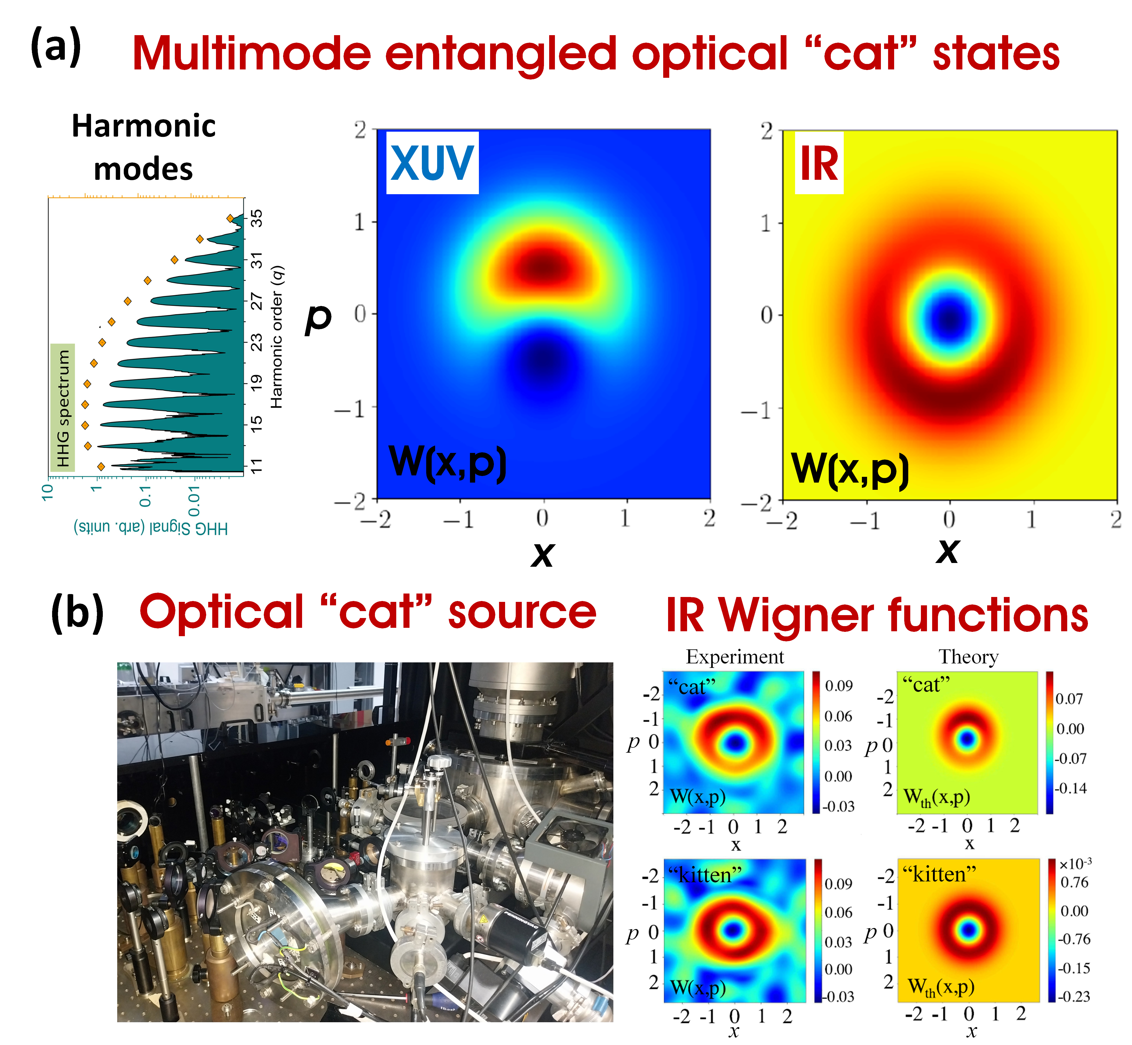
Fig. 1.2.1. (a) Theoretically calculated Wigner functions of the multimode entangled optical cat states from IR to XUV (harmonic modes) spectral range. Figures from Ref. [LCP21]. (b) Left panel: A photo of the IR optical “cat” state source. Right panel. Wigner functions of the measured and calculated IR optical “cat” and “kitten” states depicting the controllable quantum features. Figure from Ref. [LSR25].
Among the aforementioned schemes, a quantum light source delivering high–photon-number optical Schrödinger “cat” states with controllable quantum features in the infrared (800 nm) region has been experimentally demonstrated using conditioning schemes in non-depleted atomic media [LCP21,RLP25] (Fig. 1.2.1b).
This source has been employed in nonlinear optics [LRS25], where the emitted second harmonic (400 nm) exhibits optical “cat” state characteristics. Importantly, these states are robust against photon losses [SFL24], enabling metrological applications. While the fundamental principles of the other schemes have been established theoretically, experimental realization requires further investigation, with emphasis on laser-driven semiconductors for delivering massively entangled light states from IR to VUV [RSM24,NRF25].
II) Development of novel diagnostic and sensing approaches: This involves the development of methods for the quantum state characterization of a) high photon number light states, b) the development of ultrafast quantum metrology approaches for tracing the ultrafast quantum electrodynamics of many-body systems, and c) the development of protocols for multimode entanglement certification. Most of these developments build on recent theoretical and experimental advances by the partners of the TOWARULTRA project [see references mentioned above] and they are based on, the unique advantages provided by the high-photon-number quantum light sources described above, the use of nonlinear processes, and the bidirectional imprinting of quantum properties i.e. the system’s quantum features are encoded in the quantum state of light, and vice versa. Below we provide additional information concerning the developments a) to c):

a) Diagnostics for characterization of high photon number quantum light states: Standard characterization methods (quantum tomography, photon correlations [LRS25, RPL26, SRC26]) face challenges at high photon numbers. Leveraging our quantum light sources, we can now develop diagnostic tools for probing quantum features of such states. We have already demonstrated a scheme for characterizing high-photon-number optical “cat” states [LRS25] (Fig. 1.2.2).

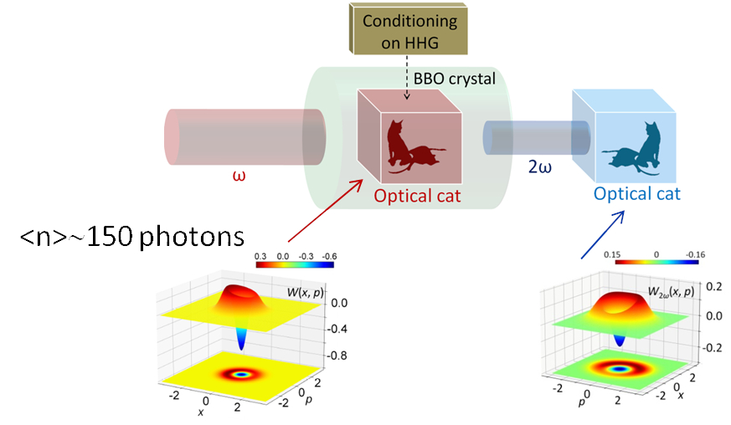
Fig. 1.2.2. A schematic showing the operation principle used in the experiment of Ref. [LRS25] for implementing intense IR optical “cat” states in non-linear optics. An intense IR optical “cat” state of frequency ω (created via conditioning on HHG, not shown here) was used to drive the second harmonic (2ω) generation process in an optical BBO crystal through a frequency up-conversion process. The 2ω also depicts the quantum features of an optical “cat” state. Down left panel: Wigner function of the ω field. Downright panel: Wigner function of the generated 2ω field. Figure from Refs [LRS25].

In TOWARULTRA, we will extend this to higher photon-number regimes via higher-order nonlinear processes. Recent studies have introduced a wave-mixing process (RABITT) [TMY25] revealing quantum properties of squeezed-light sources, which we will extend to more complex states. Beyond the demonstrated IR feasibility, TOWARULTRA will develop diagnostics in the VUV and XUV—technology that currently does not exist.

b) Diagnostics for ultrafast quantum metrology: This development build on our recent theoretical investigations conducted using interactions of ultrafast light pulses with atoms [...Misha...], molecules [RSM24a], and solids [RSM24,Misha]. These studies have shown that the ultrafast quantum electrodynamics of many-body quantum correlated systems (including state superpositions in atoms and molecules, topology and superconductivity in solids) are imprinted on the quantum state of the light field, as well as how quantum non-equilibrium, non-adiabatic many-body dynamics of matter can impart nontrivial photon statistics to its nonlinear optical response. Below we provide a few lines stressing the importance of these diagnostic approaches and some examples illustrating the operating principles.

All-optical imaging using nonlinear optics and ultrafast light generation is central to understanding matter far from equilibrium. Non-linear optical conversion offers some of the most versatile methods for probing ultrafast dynamics, from chemical bond breaking to charge density waves in correlated solids and light harvesting complexes.

Most ultrafast spectroscopies have focused on classical properties of the optical response: spectral intensity and phase. Using quantum light as a probe opens new opportunities where tuning the quantum state of incident light provides additional spectroscopic knobs [YKB25]. However, analysis of the photon statistics of the generated light has not yet entered the standard toolbox of ultrafast spectroscopy. Introducing quantum-state analysis of light generated by classically-driven quantum materials is the key breakthrough this project aims to achieve, offering a new window into the formation of correlated states in quantum matter.

Example #1: The potential of the ultrafast quantum optical spectroscopy is demonstrated by an illustrative example in Fig. 1.2.3 which shows the development of quantum correlations between 10 pseudospins placed inside a resonant cavity and driven by an external resonant classical field (Ω_{Rabi}/ω₀=0.01). The pseudospins interact with each other exclusively via (real or virtual) photon absorption and emission. The development of many-body correlations is illustrated by the parameter J, which would reach unity for a fully entangled state. The evolution of the Husimi representation of the generated light, shown in the insets, exhibits clear deviations from the minimum-uncertainty Glauber coherent state (round image at early times). Rapid growth of many-body correlations is accompanied by the emergence of the non-classical signatures in the generated light, represented by the emergence of the banana-like shape.

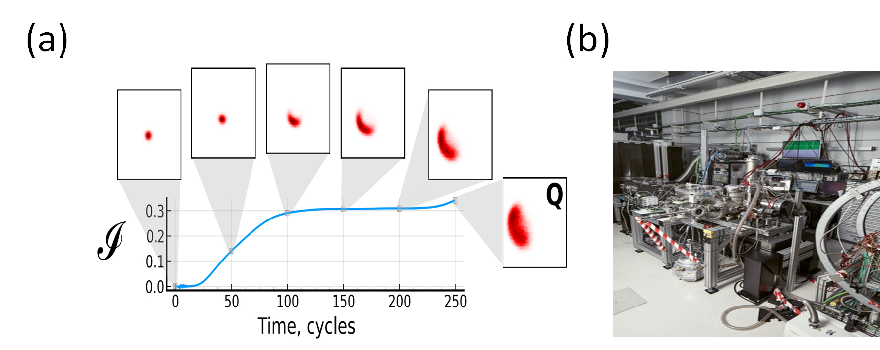
Fig. 1.2.3. (a) Time-resolved quantum-optical spectroscopy of many body correlations (see text for details). (b) ICFO Beamline (Biegert) for ultrafast quantum metrology in solids.

Example #2: An additional example [RSM24] depicting the applicability and the importance of this diagnostic approach towards ultrafast quantum electrodynamics of many-body systems is shown in Fig. 1.2.4, which shows how the ultrafast dephasing time of the harmonics generation process in laser-driven semiconductor solids affects the Wigner function of an IR optical “cat” state. An important role in the development of these diagnostics plays once again the unique features provided by our new class of quantum light states (including the robustness of the “cat” states against photon losses [SFL24]) and the diagnostics described above.

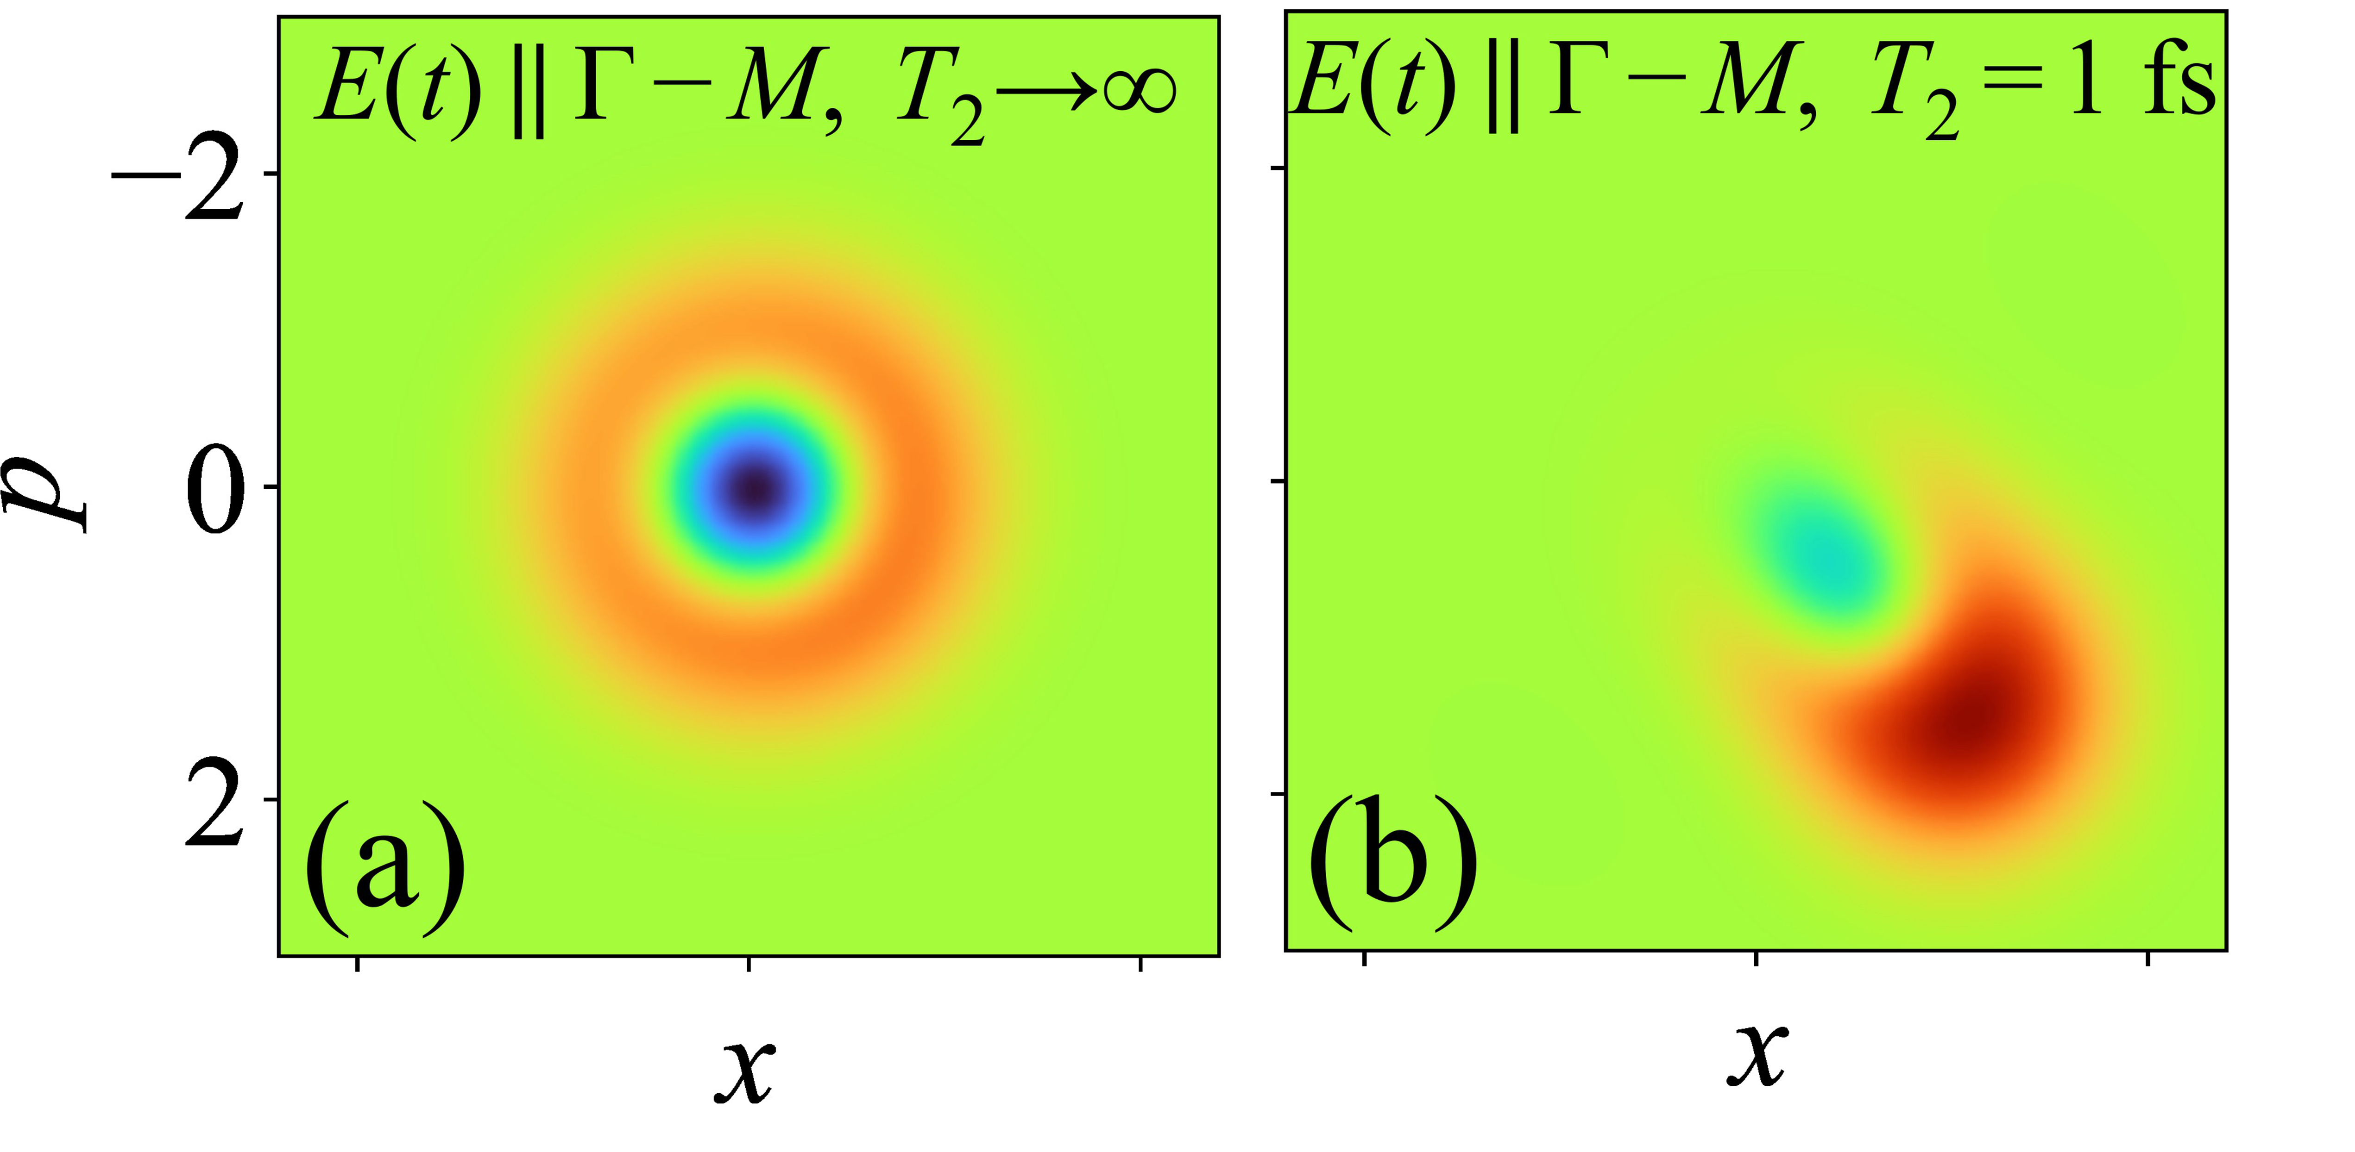
Fig. 1.2.4. Calculated Wigner function of the optical “cat” states produced in laser driven semiconductors for dephasing times (T2) (a) T2=infinity and (b) T2=1 fs. Figure from Ref. [RSM24].

c) Multimode entanglement certification protocols: In the cases with which we deal in the proposal, the generation of MQS in multimode cases corresponds to the generation of multimode squeezed states. These are particularly straightforward to characterize, classify, and quantify their entanglement. Multimode squeezed states are G$γ$aussian states, meaning that the quasi-probability distribution of quadratures of the components of the electric field is given by the multidimensional Gaussian function. All the necessary information to characterize its quantumness is included in the covariance matrix $γ$ , the matrix of bilinear correlations between the fluctuations of the components. The summary of “classical” results on bi-partite entanglement of the Gaussian states can be found, for instance, in the review [GKD01], and references therein:
- In the case where one party has one mode, and the other party N modes, positivity of the partial transpose provides the necessary and sufficient condition. This condition reduces to a simple algebraic inequality on the covariance matrix, $γ$. . It was originally discovered in [DGC00,Sim00].
- If the number of modes per party is bigger than 2, the bound entangled states become possible. The necessary and sufficient is the more complex, but still operational. It was derived in Ref. [GKL01].
- For 3 parties, and one mode per party, the exact criterion is still known and operational [GKD01].
- Criteria based on the covariance matrix can still be used for non-Gaussian states, where they are only necessary.
All the methods mentioned here apply to a stationary (time-independent) covariance matrix. In the context of attoscience, we will have to consider natural fast oscillations of harmonic components and the short durations of the signals. This requires the development of novel breakthrough technological approaches. Another pioneering approach that we want to pursue is based on mapping from continuous variables to qubits, or qudits, using novel rigorous mapping techniques [CPR26].
Table 1.2.1: TRL progression of the TOWARULTRA project
Current status
TRL1 | Basic principles: Observing and recoding the basic principles. | On the quantum light sources and light-matter states: The partners have demonstrated the basic principles concerning the generation of high photon numbers massively entangled quantum states of light and light-matter.  On the diagnostics and sensing: The parents have demonstrated the basic principles of a) the characterization of high photon number quantum light states in the IR spectral region, and b) the ultrafast quantum sensing.
TOWARULTRA project
TRL1  (2027-2028) | Basic principles: Observing and recoding the basic principles. | On the diagnostics and sensing: In TOWARULTRA we aim to develop methods for a) quantum light state characterization in the VUV-XUV spectral regions, and b) protocols for the multimode entanglement certification of light and light-matter.
TRL2  (2027-2029) | Formulation of a technological concept: Formulation of the technological concept and/or its applications. Research is now focused on specific practical applications. | On the quantum light sources: We aim to develop robust beamlines delivering ultrafast high photon numbers massively entangled quantum light states from far-IR to XUV and resources for creating MQS of light-matter. These will include the relevant quantum state diagnostics.  On the diagnostics and sensing: We aim to develop robust diagnostic and ultrafast sensing approaches that can be adapted to quantum light sources for tracing ultrafast quantum electrodynamics (including multimode entanglement) in atoms, molecules, and solids.
TRL3  (2029-2030) | Proof of Concept: Analytical and experimental confirmation of the critical functions of the technology through laboratory studies. | On the quantum light sources: We aim to confirm the reliable operation of the developed quantum light sources.  On the diagnostics and sensing: We aim to confirm the reliable operation of the developed diagnostic end sensing methods.
10 years vision after the end of TOWARULTRA project
TRL4-6 | Validation of the technology as prototype in the lab. and relevant environments and ready for larger-scale testing. | Our vision is the development of a complete and reliable beamline which includes a high photon number massively entangled quantum light sources and the relevant diagnostics for characterizing quantum states of light and light-matter, multimode entanglement and trace the ultrafast quantum electrodynamics in all states of matter.
TRL7-8 | Demonstration of the prototype in an operational environment and certification through testing and demonstrations. | Our vision is to develop a robust, commercially available system that can serve as a unique resource for advancing new technologies.
1.3 Objectives
Below, we describe 3 SMART objectives of the projects, first in a qualitative and descriptive way, and then in a more concrete way. For each objective, we propose novel, and ambitious science-to-technology breakthrough that goes beyond the current state of the art.
O1) Controlled ways of generating massive quantum states (MQS) of light and light-matter. The starting point consists of controlled methods for generating MQS of light and light-matter, involving three extremes: ultra-strong laser fields, ultra-fast time scales, and ultrabroad spectra from IR to XUV, with applications in quantum light sources, nonlinear optics, quantum metrology, and quantum communications. The science-to-technology breakthrough here will consist of the achievement of routine in the generation and exploitation of MQS.
The first preliminary observations and theory predictions suggest that the generation of MQS should be possible via conditioning/post-selection, non-linear effects beyond negligible depletion, and bright squeezed light. These methods require significant optimization to reach robust, on-demand MQS generation—a technically very challenging goal that calls for “exceptional ground-breaking R&I, novel concepts and approaches, new products, services, and organizational models.”
O2) Quantum sensing of light-induced topology in quantum materials. Today’s photonics technology allows one to shape the individual oscillations of the electric field. This opens an exciting opportunity at the interface between ultrafast photonics and two-dimensional (2D) materials: light-driven switching of both quantum properties and electronic responses in light-driven solids, faster than electronic dephasing times at room temperature. Our goals are to extend this control into the quantum optical domain by
- using tailored quantum light to induce and control topology in 2D materials, and
- detecting the quantum properties of light as a sensor of their topology.
In 2D TMDCs, valley minima with opposite Berry curvature enable valley-selective optics in monolayers. However, multilayer ‘’sandwiches’’ restore inversion symmetry, eliminating valley selection. Nontrivial topology further requires broken time-reversal symmetry, absent in non-magnetic multilayers. Our recent work [TJP24] overcame these challenges using a combination of two non-resonant, counterrotating, circularly polarized light pulses with controlled attosecond time delay between them, we have been able to break both inversion and time-reversal symmetries and induce valley-selective excitations in a multi-layer MoS2. However, material damage limited the light intensity we could apply, preventing us from triggering a light-induced topological phase transition.

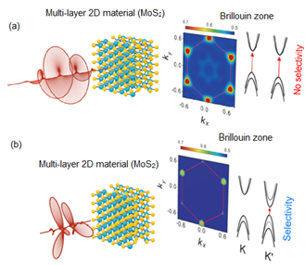 | Selective valley excitation in inversion-symmetric multilayer MoS2  The conventional approach developed for monolayers with broken inversion symmetry uses circularly polarized light tuned on resonance with the bandgap. The valley is selected by matching the light circularity to the Berry curvature, which is opposite in the two valleys. In multi-layer materials with restored inversion symmetry, this standard method no longer works (panel a). However, a field created by combining counter-rotating fundamental and second harmonic restores valley selectivity even in inversion-symmetric multi-layer materials (panel b). Valley selection is achieved by rotating the trefoil created by the two-color field relative to the hexagon of the lattice (adapted from [TJP24]).
Our goals are: First, to use quantum BSV light to generate topological phase transitions, exploiting the dramatically increased damage thresholds demonstrated in Ref. [RCB24]. We will generate the world’s first two-color quantum light made of counter-rotating BSV fundamental and second harmonic with attosecond precision. Second, to introduce quantum-optical detection of light-induced topology by measuring not only transmitted probe intensity but also quantum optical properties, showing that non-classical fluctuations emerge near the topological phase transition threshold. Next, we will use degenerate bi-photons to entangle excitons in K and K’ valleys of WS₂, extending our method [SIJ22,GMR26] to quantum information processing via entangling two pseudo-spins. Finally, we will analyze the possibility of frequency-upconverted bi-photon generation in TMDC (WS₂ or MoS₂) driven in 3-photon resonance by the bi-photon source. This will lead to two fundamental breakthroughs: (i) achieving quantum valley entanglement, a major challenge in valleytronics, and (ii) the first scheme for frequency up-conversion of polarization-entangled photons.
O3) Detection and characterization of strongly correlated materials with High Harmonics Generation (HHG) spectroscopy. This objective will transform HHG spectroscopy of strongly correlated materials from a scientific demonstration into a quantum-metrological diagnostic technology. Building on our demonstration [ALC22] of optical detection of quantum phases in YBCO, we will generalize from superconductors and charge-density waves [TYU25] to broader material classes. The key breakthrough is to move beyond identifying phases through nonlinear optical fingerprints, towards routine quantum-state-resolved readout using ultrafast-light-field tools. We will compare HHG driven by classical coherent light with HHG driven by bright squeezed vacuum light to determine how quantum fluctuations and entanglement are exchanged between the optical field, the correlated electronic system and the emitted harmonics. This introduces quantum metrology as a new layer in HHG spectroscopy. We will relate these studies to laser-induced phase transitions, with the prospect of steering correlated materials into regimes where they act as sources of non-classical radiation. Currently, HHG spectrometry of correlated materials remains largely unexplored, and a predictive description is still missing. TOWARULTRA will address this gap by combining ultrafast spectroscopy, quantum light sources, quantum metrology and theory to establish a transferable methodology for detecting hidden quantum order, characterizing non-equilibrium quantum phases, and quantifying light–matter entanglement.
Objectives will be beyond the state of art in terms of technological progress and applications. They will face serious technical challenges. Still, the aims will sacrifice the means, and we indeed expect to follow the old Latin saying per aspera ad astra.
The proposed objectives are concrete, plausible, and based on preliminary results. We propose a high-risk/high-gain approach, with each objective including concrete tasks detailing the methodology, concepts, models, alternative directions, gender dimension, and open science practices. Below we list the corresponding tasks; note that all tasks deal with “3xULTRA” regime - ultrastrong laser intensities, ultrashort time scales, and ultrabroad spectral range, from IR to soft XUV.
O1) Generation of massive quantum states (MQS) of light and light & matter, and development of diagnostics for future applications in quantum attosecond spectroscopy that utilizes photonic effects; Applications of MQS in ultrafast nonlinear optics; Applications of MQS for ultrafast quantum metrology and sensing.
O2) Two-color quantum-light control of valley and topological states in multilayer TMDCs; Quantum-optical sensing of light-induced topology through transmitted and harmonic radiation.
O3) Robust HHG fingerprints of correlated quantum phases using classical coherent light, generalizing from superconductors and charge-density-wave systems to broader material classes; Use bright squeezed vacuum light and quantum metrology to detect fluctuations, correlations, and possible light–matter entanglement, opening a route to superconductors as material-based non-classical light sources; HHG of CDW in TiSe2, including electron-phonon coupling.

TOWARULTRA is a high-risk project, but it opens the path to achieving high-gain objectives, such as new patents and licenses, and a significant increase in TRL.
The overall methodology, including the concepts, models, and assumptions, is very broad; thus, we can always seek alternative approaches to overcome obstacles and to realize the project’s objectives efficiently.
- One female PI leads for WP3 and WP4. WP7 is also led by a woman. The majority of the project’s personnel (both on the research team and on the working team) are female. For instance, M. Lewenstein group consists of 6/12 females. Applicants must provide information on how they intend to integrate the gender dimension into the project. The gender dimension refers to technical and scientific aspects of the project and not to the composition of the consortium and the persons that will work for the project.
- how appropriate open science practices are implemented as an integral part of the proposed methodology. Show how the choice of practices and their implementation are adapted to the nature of your work, in a way that will increase the chances of the project delivering on its objectives. Applicants must provide information on how they intend to integrate the gender dimension into the project. The gender dimension refers to technical and scientific aspects of the project and not to the composition of the consortium and the persons that will work for t he project.
- Research data management and management of other research outputs: how the data/ research outputs will be managed in line with the FAIR principles (Findable, Accessible, Interoperable, Reusable), addressing the following (the description should be specific to your project):
Open science practices TOWARULTRA starts at TRL 1 and addresses validation to TRL 3-4. Given the low starting TRL, a fully open-science approach is key. At more advanced TRL, exploitation plans will be considered in line with the consortium’s IP strategy (list de company). The approach will align with EU objectives on Open Science and Knowledge sharing. Key actions are described below:
Early and Open Access sharing: The decision to publish the data or to seek first IP protection will be discussed among the consortium members according to the protocols outlined in the Consortium Agreement. All scientific publications, including monographs and books, will be open to access at the time of publication and will comply with EU guidelines. Manuscripts will be deposited in trusted repositories, and pre-prints will be shared when journal policies allow. Authors will retain copyright and grant non-exclusive licenses to publishers. The experimental data needed to validate and reproduce the results from the scientific publications will be provided and properly archived in open-access data repositories (e. g. Zenodo INCLUDE),. When possible, open peer review will be preferred over traditional (‘blind’ or ‘closed’ peer review).
Citizen, civil society and end-user engagement:
Findings will be disseminated through social media, press releases, workshops, and webinars, and incorporated into existing outreach activities such as Science Open Days at ICFO.
Research data management (RDM)
Research data will be managed according to FAIR principles, with dedicated team members at each beneficiary and oversight by ICFO’s Data committee. A complete Data Management Plan (DMP) will be produced in Month 6 and updated throughout the project lifetime. An initial data identification is provided in Table 1.3 below:
Table 1.3 Data management
Type of data that Towarultra will generate/collect | ICFO | FORTH | MBI | COMPANY KILIAN
Experimental: data captured by lab equipment | Multimodal measurements of absorption, reflection and correlations like g(2) and higher. | PLEASE FILL | PLEASE FILL | PLEASE FILL
Simulation: data generated from numerical models | X
Dissemination Communication & Outreach material | Public deliverables, peer-reviewed journals, conference proceedings, social media content, infographics, videos, press releases, etc
Persistent identifiers to be used | Data and metadata will be stored according to the internal management procedures of all partners. Processed data included in publications will be made available through a DOI in trusted repositories. And all researchers will be identified with an ORCID code.
Accessibility of data/research outputs | IPR will be evaluated prior to publication and if a publication cannot be open access, thorough reasoning will be given.
Interoperability of data/research outputs | Data standards such as the recommended by the Library of Congress at https://www.loc.gov/preservation/resources/rfs/TOC.html,  that are open or under a liberal BSD-like license, will be used as a rule. When published, a set of keywords may be used to describe it and allow for interoperability.
Reusability of data | Use of data licenses that encourage their re-use. Those include, e.g., the creative commons licenses (CCO).
Preservation of data | One person per partner will be designated to manage the data. Provisions for data security will be put in place and also for long-term storage.

1.4 Interdisciplinarity
Interdisciplinarity is at the heart of TOWARULTRA. To achieve the expected breakthrough, the project must combine traditionally distant disciplines: a) Atomic, Molecular, and Optical Physics, including Ultrafast Laser Physics, Atto-science, Quantum Optics; b) Solid State and Condensed Matter Physics, including Optics of simple and complex materials, Atto-sciences of topological and correlated materials; c) Quantum Information Science, d) Machine Learning. A combination of disciplines has already led to new scientific collaborations, cf. with C. Faria (UCL), M. Hassan (UoA, Tuscon), O. Cohen/I.Kaminer (Techion), M. Nisoli/C. Rizzi (POLIMI), M. Maska (Politechnika Wroclawska), and many more.

2. Impact
2.1 Long-term impact
TOWARULTRA will establish scientific and technological foundations for a new generation of engineered quantum light states and diagnostic tools, enabling unprecedented access to ultrafast quantum electrodynamics phenomena. By moving beyond conventional light–matter interaction regimes and developing tailored ultrashort quantum states of light with non-classical and massive correlations, the project has the potential to redefine how electromagnetic interactions are probed, controlled, and ultimately exploited.
Scientific impact: The project will open new directions in ultrafast quantum science by bridging quantum optics, strong-field physics, and attosecond science, enabling exploration of previously inaccessible QED processes and positioning Europe at the forefront of next-generation quantum electrodynamics research.
Technological impact: The project lays the groundwork for new innovations in quantum photonics and sensing. The quantum light sources and diagnostics could evolve into enabling technologies for ultrahigh-precision measurements surpassing classical limits, with long-term applications in ultrafast spectroscopy, imaging, and next-generation metrology platforms.
Economic impact: The project seeds future deep-tech value chains in ultrafast quantum photonics, creating opportunities for commercialization through spin-offs and industry partnerships, aligned with Europe’s ambition to lead in quantum technologies.
Social impact: From a societal perspective, the long-term outcomes of TOWARULTRA may contribute to advances in medical diagnostics, environmental monitoring, and secure communication through improved measurement and control at the quantum level.
Impact on human capital: TOWARULTRA will train researchers at the interface of quantum optics, ultrafast science, and photonic engineering, creating a new generation of scientists and strengthening European research networks.
Impact on gender balance: The project will promote gender balance through equitable recruitment, transparent selection procedures, and targeted mentoring for female researchers. Efforts in this area are already supported by the presence of Olga Smirnova from MBI (co-PI in TOWARULTRA), as well as by the participation of the partner groups, where female representation averages around 25%. Strong emphasis will be placed on further increasing this representation, while the EU gender balance policy has already been adopted by all institutes within the consortium. Additionally, the gender dimension does not apply to the research content of this proposal. The proposed research is not influenced by sex or gender-related variables. Consequently, scientific methodology and expected outcomes are independent of gender considerations. In summary, the project’s long-term impact lies in establishing a new paradigm for generating and exploiting quantum light in extreme regimes, enabling transformative technologies for quantum science in Europe and beyond.

2.2 Innovation potential
à To what extent does the envisioned new technology have potential for generating disruptive innovations in the future and for creating new markets? How adequate are the proposed measures for protection of results and any other exploitation measures to facilitate future translation of research results into innovations? How suitable are the proposed measures for involving and empowering key actors that have the potential to take the lead in translating research into innovations in the future?

Describe:

- the envisioned new technology’s potential for generating disruptive innovations in the future and for creating new markets.
- the exploitation measures to facilitate future translation of research results into innovations.
  - Shortly describe the measures for a plausible path to commercialise the innovations.
  - Beneficiaries must use their best efforts to exploit their results or have them exploited by a third party, in priority those established in a Member State or an Associated country, including through transfer or licensing.
  - If exploitation is expected primarily in non-associated third countries, justify by explaining how that exploitation is still in the Union’s interest.
- your strategy for the management of intellectual property, foreseen protection measures, such as patents, design rights, copyright, trade secrets, etc. How adequate are they to support exploitation?
  - Clear description of necessary measures to allow future uptake, for instance through an adequate form of protection of the generated Intellectual Property (IP) and an assessment of relevant aspects related to regulation, certification, and standardisation is expected.
- the measures the consortium will implement for involving and empowering key actors (such as excellent early-career researchers or promising high-tech SMEs, including start-ups) that have the potential to take the lead in translating research into innovations.
2.3 Communication and Dissemination
The project will implement a coherent and integrated strategy for dissemination, exploitation, and communication, designed to maximize scientific impact, enable future acceptance of the results, and ensure broad visibility among relevant stakeholders (Figure X). The strategy balances open knowledge sharing with the protection of results that have potential for future valorization.
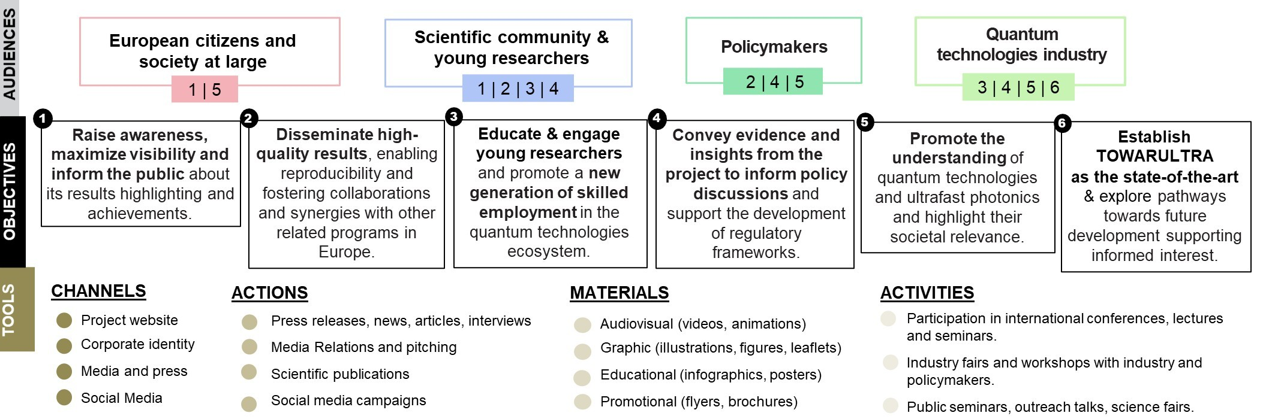
Dissemination: The consortium will publish in high-impact peer-reviewed journals and present at leading international conferences. Open science practices will be adopted, including open access publications and sharing of data and methods. KPIs (over 48 months): ≥16 peer-reviewed publications (≥50% open access; ~4 per year); ≥32 presentations in international conferences/workshops/schools (~8 per year); ≥4 invited/keynote talks; Organization of 1 international conference (M46) and 3 workshops (M18, M30, M46).
Exploitation: Exploitation will follow a planned approach identifying and protecting results with innovation potential. Clear ownership and access rights will be defined per the Consortium Agreement. Pathways including follow-up funding, industrial collaboration, and spin-off creation will be explored via a dynamic exploitation roadmap.
KPIs (over 48 months): ≥3 invention announcements (∼1 per year); ≥2 patent applications where justified (M24–M48); ≥3 industry engagement actions (e.g., workshops or targeted meetings at M24, M36, M48); annual exploitation roadmap updates (4 versions); ≥3 follow-up funding applications submitted (at least 1 by M36 and 2 by M48); 1 feasibility study for a spin-off company (M42–M48).
Communication: A communication plan will target European citizens, the scientific community, policymakers, and industry through a dedicated website, press releases, social media campaigns, videos, infographics, and public events.
KPIs (over 48 months): A project website (M4), with regular updates and technical maintenance beyond the end of the project; ≥20 posts in social media and ≥2 dedicated campaigns; ≥3 outreach events (science fairs, webinars, public talks ~1–2 per year); ≥4 educational engagement activities.

All KPIs will be regularly monitored at 6-month intervals to ensure progress and allow for adaptive improvements. This structure ensures that the project maximizes its scientific visibility, innovation potential, and societal outreach over its full 48-month duration.

à How suitable are the measures to maximise expected outcomes and impacts, including scientific publications, communication activities, for raising awareness about the project results’ potential to establish new markets and/or address global challenges?

Describe:

- the dissemination and communication measures that are planned, and the target group(s) addressed (e.g. scientific community, end users, financial actors, public at large) for raising awareness about the project’s outcomes.
  - Project results should include top-level scientific publications in Open Access.
  - Communication measures should promote the project throughout the full lifespan of the project. The aim is to inform and reach out to society and show the activities performed, and the use and the benefits the project will have for citizens. Activities must be strategically planned, with clear objectives, start at the outset and continue through the lifetime of the project. The description of the communication activities needs to state the main messages as well as the tools and channels that will be used to reach out to each of the chosen target groups.
  - All measures should be proportionate to the scale of the project, and should contain concrete actions to be implemented both during and after the end of the project, e.g. standardisation activities. Your plan should give due consideration to the possible follow-up of your project, once it is finished. In the justification, explain why each measure chosen is best suited to reach the target group addressed.
  - Describe possible feedback to policy measures generated by the project that will contribute to designing, monitoring, reviewing and rectifying (if necessary) existing policy and programmatic measures or shaping and supporting the implementation of new policy initiatives and decisions.
3. Quality and efficiency of the implementation
3.1 Work plan and allocation of resources The project is centered on 3 objectives: O1) Generating MQS of light and light-matter; O2) Quantum sensing of light-induced topology, O3) Strongly correlated materials with HHG spectroscopy. Each objective includes the 2 work packages: an initial and a final one. Each WP includes 2-3 concrete tasks, around which the work will be organized. These in turn determine deliverables, and define milestones, with the corresponding challenging, but doable timeline (see : 0- Gantt_draft.xlsx). Each task is related to its own risk and appropriate risk mitigation.

GANTT PERT!!!

à How appropriate and effective is the allocation of resources (comprising person-months and other cost items) to work packages and consortium members? I NEED TO KNOW HOW DO WE FINANCE PRESONEL?

Table 3.1a: List of work packages
Work package No | Work package Title | Lead Participant No | Lead Participant Short Name | Name & surname of Work package leader | Gender of Work package leader | Start Month | End month
WP1 | Generating MQS of light and light-matter and diagnostics I | 2 | FORTH | Paraskevas Tzallas | M | 1 | 12
WP2 | Generating MQS of light and light-matter and diagnostics II | 2 | FORTH | Paraskevas Tzallas | M | 12 | 36
WP3 | Quantum sensing of light-induced topology I | 3 | MBI | Olga Smirnova | F | 1 | 12
WP4 | Quantum sensing of light-induced topology II | 3 | MBI | Olga Smirnova | F | 12 | 48
WP5 | Strongly correlated materials with HHG spectroscopy I | 4 | ICFO | Jens Biegert | M | 1 | 12
WP6 | Strongly correlated materials with HHG spectroscopy II | 4 | ICFO | Jans Biegert | M | 24 | 48
WP7 | Project Management Communication, Dissemination and Exploitation | 1 | ICFO | Judith Salvador Herena | F | 1 | 48

Table 3.1b: Work package description
Work package number | WP1 (lead partners ICFO/FORTH)
Work package title | Generating MQS of light and light-matter and development of diagnostics I
Objectives: In this WP we aim to develop methods and diagnostics for the generation and characterization of MQS of light and light-matter for future applications in quantum attosecond spectroscopy that utilize photonic effects.
Description of work:
T1.1: Generation of MQS of light and light-matter: To generate MQS of light and light-matter, we will use harmonic generation processes that occur when intense fs IR light interacts with atoms (Argon, Xenon, Helium), simple molecules (H2+) and solids, including semiconductors (such as ZnO crystals), and high Tc superconductors YBCO [ABB22]. We will explore different approaches, including the use of conditioning schemes in non-depleted media, as well as setups without conditioning in both depleted and quantum-correlated non-depleted media. In addition, we will study wave-mixing processes that take place during harmonic generation. Regarding the generation of MQS of light, based on theoretical predictions from the partners of TOWARULTRA (see Section 1.2), we expect this approach to produce high mean photon number (>10^10 photons) massively entangled (about 40 frequency modes) quantum light states (such as optical “cat” states and squeezed states) with durations on the fs time scale. These states should have tunable quantum properties and cover a wide range of frequencies, from the IR to the XUV. We note that in the IR region, optical “cat” states have already been demonstrated experimentally in atoms using conditioning measurements. Building on this work, we will investigate how to better control their quantum properties and produce complex optical “cat”-type states by adjusting the conditioning process, following the theoretical predictions of Ref. [...JavierPRA25...]. For the generation of light-matter MQS, we will follow the theoretical predictions of Refs. [...JavierPRA-ATI; JavierPRA-H2...]. In particular, conditioning techniques will be applied to electrons produced through Above-Threshold Ionization (ATI), while excited H2+ molecules will be studied without the use of conditioning schemes. Additionally, for the generation of light–matter MQS, we will follow the theoretical predictions of Ref. [ABB22] in strongly quantum correlated high Tc superconductors, exploring both conditioning and non-conditioning approaches.
T1.2: Characterization of MQS of light and light-matter: Characterizing high-photon-number, massively entangled light states from IR to XUV is a central challenge. It requires (i) high-repetition-rate (>1 kHz), ultra-stable laser systems with high-dynamic-range multichannel DAQ, and (ii) precisely characterized detectors with quantum efficiency >0.6 and noise below shot-noise. Achieving spectrally flat efficiency across Vis-VUV-XUV remains challenging; ongoing discussions with industrial partners target detectors optimized for narrower spectral bands. For low photon numbers, g^(n) correlation measurements and homodyne/tomography will be used. For high photon number of light states, efforts will be placed mostly in the IR states (without excluding the XUV). Towards this goal approaches established by the partners of the TOWARULTRA will be implemented in the IR spectral range (see Section 1.2). These include non-linear interactions with 2nd and higher order of non-linearities and wave-mixing (IR+XUV) nonlinear processes. The diagnostics of light–matter MQS and their application to ultrafast sensing will rely on measuring the quantum properties of the emitted light (using n-order photon correlation functions (g^(n)), or quantum state tomography) after its interaction with matter (see Section 1.2). We will study how these quantum features depend on the properties of the underlying many-body system, such as decoherence and temperature (e.g., in high Tc superconductors), as well as on the time delay relative to the preparation of the system in a coherent superposition state. This will be implemented within a pump–probe scheme, enabling time-resolved access to the system’s dynamics. Regarding the Entanglement certification protocols, these will be aligned along the lines described in Section 1.2. The implementation of these protocols will rely on simultaneous measurements of the Wigner function for each mode. In addition, multimode photon-correlation measurements will be performed to detect potential violations of the Cauchy-Schwarz inequality.
Work distribution among the partners: The theory groups of M. Lewenstein (ICFO), M. Ivanov & O. Smirnova (MBI) will lead all the theoretical investigations of this WP. The experimental group of P. Tzallas (FORTH) will lead the experimental part of the work in concerning the interactions with gas phase media. The experimental group of J. Biegert (ICFO) will lead the experimental part of the work relevant to high Tc superconductors. The experimental groups of P. Tzallas (FORTH) and J. Biegert (ICFO) will lead the experimental part of the work related to interactions with semiconductors.
Deliverables
D1.1: Report on generation of MQS of light and light-matter (M12).
D1.2: Report on characterization of MQS of light and light-matter (M12).
Work package number | WP2 (lead partners ICFO/FORTH)
Work package title | Generating MQS of light and light-matter and development of diagnostics II
Objectives: In this WP we aim to justify the novelty of the MQS and diagnostics produced in WP1, by utilizing them in breakthrough investigations in nonlinear optics and ultrafast quantum metrology and sensing.
Description of work:
T2.1: Applications in ultrafast non-linear optics: Introducing quantum light into nonlinear optics is considered a breakthrough, as it opens the way to a wide range of investigations in ultrafast science and quantum technologies, including quantum light engineering. Here, we aim to demonstrate this capability by using the quantum light sources developed in WP1 as a primary source to engineer quantum light driven in deferent spectral regions. As described in Section 1.2, we have already demonstrated that quantum light states can serve as primary sources for engineering quantum light in different spectral regions via frequency up-conversion processes [LamprouPRL25]. Building on this demonstration for IR optical “cat” states via 2nd-harmonic generation in BBO [LamprouPRL25], we will extend to higher-order nonlinear processes generating quantum light in the UV (3rd harmonic), VUV (5th/7th), and XUV (high-order harmonics > 9th) by focusing intense IR “cat” states into Xenon gas. WP1 diagnostics will characterize the resulting states.
T2.2: Applications in ultrafast quantum metrology and sensing: A groundbreaking and straightforward application in ultrafast quantum metrology and sensing is to trace the ultrafast dephasing times in the high harmonic generation process in semiconductors. As shown in Section 1.2, we have already conducted theoretical investigations on this topic [JavierPRB], using conditional measurements on ZnO-driven harmonics where the dephasing time is encoded in the Wigner function of the IR field (Fig. 1.2.4). We aim to demonstrate this experimentally. Additionally, we will track ∼1 fs dynamics in coherently excited H2+ molecules via pump-probe Wigner function measurements, following predictions in Ref. [JavierPRA]. In a similar context, experiments will also be conducted using coherently excited atoms, guided by the theoretical frameworks developed in Refs. [MishaPRX, JavierPRA].
Work distribution among the partners: The theory groups of M. Lewenstein (ICFO), M. Ivanov & O. Smirnova (MBI) will lead all the theoretical investigations of this WP. The experimental group of P. Tzallas (FORTH) will lead the experimental part of the work concerning the T2.1 and the investigations using the H2+ molecule and resonant atoms in T2.1. The experimental groups of P. Tzallas (FORTH) and J. Biegert (ICFO) will lead the experimental part of the work related to the investigations of dephasing times in semiconductors in T2.2.
Deliverables
D2.1: Report on applications of quantum light into non-linear optics (M24).
D2.2: Report on applications in ultrafast quantum metrology and sensing (M36).

Work package number | WP3 (lead partner MBI)
Work package title | Quantum sensing of light-induced topology I
Objectives Development of methods, diagnostics, and control of the light-induced topological effects
Description of work:
T3.1: Two-color quantum-light control of valley and topological states in multilayer TMDCs: Generate and characterize counter-rotating fundamental and second-harmonic bright squeezed vacuum fields with attosecond-controlled delay, and apply them to multilayer MoS₂/WS₂ to induce valley-selective excitation and A light-induced topological phase transitions beyond the damage limits of classical driving.

MISHA OLGA DESCRIBE WITH DETAILS!!!

Work distribution among the partners: The theory groups M. Ivanov & O. Smirnova (MBI), and M. Lewenstein (ICFO) will lead the theoretical investigations of this task. The experimental groups of P. Tzallas (FORTH) and J. Biegert will lead the experimental part of the work concerning the interactions with solids and semiconductors.
Deliverables
D3.1: Two-color quantum-light control of valley and topological states (M12)

Work package number | WP4 (lead partner MBI)
Work package title | Quantum sensing of light-induced topology II
Objectives Development of methods, diagnostics, and control of the light-induced topological effects
Description of work:
T4.1: Quantum-optical sensing of light-induced topology through transmitted and harmonic radiation. Probe the driven TMDCs with classical and quantum optical fields, and detect not only transmitted intensity and HHG spectra, but also photon statistics, squeezing, noise, and higher-order correlations, using these quantum observables as sensitive signatures of emerging topology, valley correlations, and possible excitonic entanglement.
MISHA OLGA DESCRIBE WITH DETAILS!!!

Work distribution among the partners: The theory groups M. Ivanov & O. Smirnova (MBI), and M. Lewenstein (ICFO) will lead the theoretical investigations of this task. The experimental groups of P. Tzallas (FORTH) and J. Biegert will lead the experimental part of the work concerning the interactions with solids and semiconductors.
Deliverables
D4.1: Report on quantum-optical sensing of light-induced topology (M36)

Work package number | WP5 (lead partner ICFO)
Work package title | Strongly correlated materials with HHG spectroscopy I
Objectives Development of methods, diagnostics, and control in strongly correlated materials using HHG
Description of work:
T5.1: Robust HHG fingerprints of correlated quantum phases using classical coherent light. Detection and quantum-metrological characterization of strongly correlated materials with high-harmonic generation spectroscopy. HHG fingerprints of correlated quantum phases: We will establish reliable HHG fingerprints of selected strongly correlated materials, starting from systems where our consortium already has expertise: high-temperature superconductors, charge-density-wave materials, and correlated low-dimensional systems. The task will focus on experimentally accessible observables such as harmonic intensity, spectral shape, polarization dependence, temperature dependence, and pump-induced changes across known phase transitions.

JENS MACIEK

Establish robust HHG fingerprints of correlated quantum phases using classical coherent light, generalizing from superconductors and charge-density-wave systems to broader material classes; Use bright squeezed vacuum light and quantum metrology to detect fluctuations, correlations, and possible light–matter entanglement, opening a route to superconductors as material-based non-classical light sources; HHG of CDW in TiSe2, including electron-phonon coupling.

Work distribution among the partners: The theory groups M. Ivanov & O. Smirnova (MBI), and M. Lewenstein (ICFO) will lead the theoretical investigations of this task. The experimental groups of P. Tzallas (FORTH) and J. Biegert will lead the experimental part of the work concerning the interactions with solids and semiconductors.
Deliverables
D5.1: Report on HHG fingerprints of correlated quantum phases in broader material classes (M12)

Work package number | WP6 (lead partner ICFO)
Work package title | Strongly correlated materials with HHG spectroscopy II
Objectives Development of methods, diagnostics, and control in strongly correlated materials using HHG
Description of work:
T6.1: Use bright squeezed vacuum light and quantum metrology to detect fluctuations, correlations, and possible light–matter entanglement Bright squeezed vacuum light and quantum metrology: We will extend HHG spectroscopy from classical coherent driving fields to bright squeezed vacuum light in order to probe the quantum character of the strong-field interaction. By comparing the HHG response under coherent and BSV excitation, we will quantify how quantum fluctuations and correlations in the incoming light are modified, transferred, or amplified by the correlated electronic system. The task will focus on experimentally measurable quantum-metrological observables, including photon statistics, phase-sensitive noise, squeezing degradation or enhancement, and higher-order correlations in the emitted radiation.

JENS MACIEK

T6.2 HHG of CDW in TiSe2, including electron-phonon coupling. As the dominant driving mechanism behind CDW formation in TiSe2 remains unresolved, extension of the mean field model to include electron-phonon coupling will allow for the investigation of the phonon-specific signatures in the high harmonic generation process. With these differing order parameter arrangements resulting in the symmetry breaking, nematic ordering and possible chirality of the CDW domains will be studied. We generalize the mean field theory originally formulated in [TZV25,ZTV25], to include both phonon couplings and possible chiral ordering of the CDW phase. We will seek novel spectrocopical characterization and control of CDW states.

Work distribution among the partners: The theory groups M. Ivanov & O. Smirnova (MBI), and M. Lewenstein (ICFO) will lead the theoretical investigations of this task. The experimental groups of P. Tzallas (FORTH) and J. Biegert will lead the experimental part of the work concerning the interactions with solids and semiconductors.
Deliverables
D6.1: Report on fingerprints of correlated quantum phases using bright squeezed vacuum (M24)
D6.2: Report on HHG use for control of CDW (M36)

Work package number | WP7
Work package title | Project Management, Communication, Dissemination and Exploitation

Objectives
O7.1: To ensure the effective progress and management of the project by fostering clear communication
both internally (among partners) and externally (with the European Commission), while fulfilling all obligations towards the European Commission (EC) to support smooth project progression.
O7.2 To effectively communicate and exploit the project results and raise awareness about the project’s achievements and its impact on society. To ensure efficient coordination, and project management.

Task 7.1 Coordination: ICFO with the commitment and collaboration of all partners, will coordinate the implementation of all objectives by monitoring tasks, milestones, and progress across work packages, while compiling scientific reports. This task also includes efficient administrative, legal, and financial management, as well as good communication between partners and through the European Commission. (ICFO, all) M1-48
Task 7.2 Data Management: A Data Management Plan (DMP) will be delivered by Month 6 and regularly updated throughout the project, ensuring data follows FAIR principles and Open-Access requirements, but also planning for potential data business readiness. (ICFO, all) M1-48
Task 7.3 IP monitoring:
Task 7.4 Exploitation, incl. a Market research report:
Task 7.5 Communication and dissemination strategy: A thorough strategy will be developed and implemented to raise awareness about the project and make its impact visible to Europe and beyond, detailed in D6.3 (M6, updated in 48???), identifying target groups and specifying clear actions to reach them. A set of audio-visual materials (e.g. presentations, videos) explaining the technology and impact will be designed and distributed across all available channels. Partners will join industry fairs, international academic conferences or relevant events to further disseminate project outcomes and results. (ICFO, all) M1-48

Table 3.1c: List of Deliverables

Number | Deliverable name | Short description | Work package number | Short name of lead participant | Type | Dissemination level | Delivery date  (in months)
D1.1 | Generation of MQS of light and light-matter. | Development of methods for the generation and characterization of MQS of light and light-matter. | WP1 | FORTH | R | SEN | M12
D1.2 | Characterization of MQS of light and light-matter | Development of diagnostics for the characterization of MQS of light and light-matter. | WP1 | FORTH | R | SEN | M12
D2.1 | Applications of quantum light into non-linear optics. | Justification of the novelty of the MQS and diagnostics produced in WP1, by utilizing them in nonlinear optics. | WP2 | FORTH  ICFO | R | SEN | M24
D2.2 | Applications in ultrafast quantum metrology and sensing. | Justification of the novelty of the MQS and diagnostics produced in WP1, by utilizing them in ultrafast quantum metrology and sensing. | WP2 | FORTH  ICFO | R | SEN | M36
D3.1 | Two-color quantum-light control of valley and topological states (M12) | Development of theory and then experiment on control of valley polarization and topological effects including photonic effects | WP3 | MBI | R | SEN | M12
D4.1 | Report on quantum-optical sensing of light-induced topology | Report preparing publication on novel applicati0ns of MQS for quantum sensing and metrology | WP4 | MBI | R | SEN | M36
D5.1 | Report on HHG fingerprints of correlated quantum phases in broader material classes | Report preparing a paper on HHG fingerprints of correlated quantum phases in broader material classes | WP5 | ICFO | R | SEN | M12
D6.1 | Report on fingerprints of correlated quantum phases using bright squeezed vacuum | Report preparing a paper on fingerprints of correlated quantum phases using bright squeezed vacuum | WP6 | ICFO | R | SEN | M24
D6.2 | Report on HHG use for control of CDW | Report preparing a paper on HHG use for control of CDW (M36) | WP6 | ICFO | R | SEN | M36
D7.1 | Project handbook | Project management handbook | WP1 | ICFO | R | PU | M3
D7.2 | Plan for dissemination and exploitation including communication activities | Continuous plan for dissemination, exploitation including communication activities | WP1 | ICFO | R | SEN | M6, M48
D7.3 | DMP | Data Management Plans | WP1 | ICFO | DMP | SEN | M6, M30, M48

Table 3.1d: List of milestones
Milestone number | Milestone name | Related work package(s) | Due date (in month) | Means of verification
MS1 | Project website | WP7 | 3 | Available project website for the project
MS2 | Development of the optical arrangement, laser system and electronics | WP1, WP2 | 12 | Report
MS3 | Progress on topology control with quantum light | WP3 ,WP4 | 24 | Report
MS4 | Progress in studies of fingerprints of strong correlations in vaarious systems | WP5, WP6 | 36 | Report

Table 3.1e: Critical risks for implementation
Description of risk (indicate level of (i) likelihood, and (ii) severity: Low/Medium/High) | Work package(s) involved | Proposed risk-mitigation measures
Unstable two-colour BSV fields (M) | WP2 | classical pre-alignment; active delay stabilization; phase feedback
Weak valley selectivity (L) | WP2 | lattice-field angle control; polarization optimization; monolayer/bilayer controls
Fast exciton dephasing (M) | WP2 | low temperature; hBN encapsulation; time-gated detection; quality samples
Technical noise masks quantum signals | WP2/WP3 | shot-noise calibration; balanced detection; background subtraction; reference arm
No clear entanglement witness | WP3 | higher-order correlations; squeezing transfer; covariance analysis; alternative non-classicality metrics
Sample damage / heating | WP3 | fluence mapping; cryogenic cooling; pulse shaping; low-duty cycle
Broadband (Vis-UV-XUV) photon detector’s spectral flatness/low quantum efficiency (H/M) | WP1 | Detectors optimized for narrower spectral bands in the Vis-VUV–XUV range
Shot to short energy instabilities of the IR laser sources (L) | WP1-6 | Tagging of the measurements at <0.1% of the mean of the IR laser energy fluctuations
>0.5 fs time delay instabilities of the interferometer used for quantum tomography (L) | WP1,2 | active delay stabilization; phase feedback
Theory method fails | All WPs | Choose an alternative method, apply approximations, simplify the underlying model
Table 3an .1f: Summary of staff effort

 | WP1 | WP2 | WP3 | WP4 | WP5 | WP6 | WP7 | Total Person-  Months per Participant
1/ICFO | 24+2 | 24+2 |  |  | 24+2 | 24+2 | 4 | 60
Participant 2
FORTH
Participant 3
MBI

Participant 4
Company

Total Person
Month

Table 3.1g: ‘Subcontracting costs’ items

Participant Number/Short Name
 | Cost (€) | Description of tasks and justification
Subcontracting

Table 3.1h: ‘Purchase costs’ items (major equipment costs)

Participant Number/Short Name: FORTH
 | Cost (€) | Justification
Equipment | 270.000 | kHz-MHz repetition rate harmonic generation laser driver (200000€): Ultra stable (< 0.5% rms 12h) high repletion rate (tuneable up to 1MHz) laser system, delivering <100 fs pulses at 1μm carrier wavelength and energy in the range of hundreds-μJ per pulse. The price includes optics for beam shaping and delivery. Such high rep. rate stable light sources are crucial for conducting high harmonic generation experiments and high-quality photon statistics measurements. Detectors/DAQ system (70000€): Balanced detector for IR, UV-VIS (Si), XUV (Al or Si). Balancing circuits timing electronics with CFD and analog logic. Parallel multi-channel DAQ. The system will be used for the quantum light state characterization.

3.2 Quality of the consortium
Capacity and role of each participant and consortium expertise:
TOWARULTRA aims to develop novel quantum light sources and diagnostics at the frontier of quantum optics, strong-field physics and ultrafast science. Each consortium member (ICFO, MBI, FORTH & n2-Photonics GmbH) brings distinct expertise. The consortium combines complementary partners covering all key disciplines, with strong track records evidenced by high-impact publications and competitive projects. Academic members provide scientific and methodological expertise, while the industry partner contributes capabilities in validation and prototyping. All partners have the infrastructure, facilities, and skilled personnel needed to implement their tasks. The coordinator (ICFO) brings extensive EU project experience, supported by clear governance and defined roles.

Quality of the partnership:
ICFO - The Institute of Photonic Sciences: ICFO is one of the world’s leading photonic sciences institutes, with a mission to conduct frontier research, train the next generation of scientists, and promote knowledge and technology transfer. It is internationally recognized for leadership in quantum technologies and ultrafast photonics. Founded in 2002, ICFO is a Severo Ochoa Center of Excellence and hosts ca. 550 researchers from 60 countries, providing a stimulating international environment with extensive networking and training opportunities.

The core members of ICFO in TOWARULTRA are: Prof. Maciej Lewenstein (PI) (Researcher unique identifier: https://scholar.google.com/citations?user=ObF-4tYAAAAJ&hl=en): M. Lewenstein earned an MSc from Warsaw University (1978) and a PhD from Universität Essen (1983). After positions at Harvard, CEA Saclay, JILA Boulder, the Centre for Theoretical Physics in Warsaw, and Leibniz University Hannover, he moved to ICFO in 2005 as an ICREA Research Professor. His interests include quantum optics, quantum information, attosecond science, and statistical physics. He published over 800 papers, cited nearly 85000 times (h-index 133), is a recipient of 3 ERC AdGs, and a Highly Cited Researcher 2014-2025.
Prof. Jens Biegert (PI) (Researcher unique identifier: https://scholar.google.com/ citations?user=QKtLfo8AAAAJ&hl=en): J. Biegert is an ICREA Professor of Attoscience and Ultrafast Optics at ICFO. He received his PhD from the Technische Universität München and pursued his habilitation at ETH Zürich. His research focuses on generation, control, and application of ultrashort laser pulses to probe matter on electronic and atomic timescales.
Since joining ICFO, Biegert has pioneered mid-infrared photonics and attosecond soft X-ray science. His research has enabled new approaches to imaging chemical reactions, tracking electron dynamics, and observing carrier motion in quantum systems.Biegert serves in leadership roles in the international photonics community, including coordinator of a European Commission FET consortium and Guest Professor at the Fritz Haber Institute. He served as Executive Director of Laserlab-Europe and on Optica's Board of Directors. He is a Fellow of Optica and APS. Recent distinctions include the C.E.K. Mees Medal, the Allen Prize, the Humboldt Bessel Prize, and an ERC AdG. He published ≈150 papers, cited ≈13000 times (h-index 62).
Additional members of ICFO in TOWARULTRA are:
Dr. Fernando Ardana-Lamas (Staff Researcher): Staff Researcher at ICFO with PhD from EPFL. Expert in attoscience and ultrafast optics, contributing to breakthroughs including 19.2-attosecond soft X-ray pulses (1900 citations). Ms. Zoé de Bigault de Granrut is a PhD student in the group, with an MSc from the University of Strasbourg, conducting research in ultrafast optics and attoscience. Ms Arti Gaharwar (PhD), Ms Lidija Petrovic (PhD), both working in the field directly relevant to TOWARULTRA. Additional staff of ICFO (including early-stage and experienced researchers, technicians, administration, management) will also support TOWARULTRA.
MBI-Max Born Institute for Nonlinear Optics and Short Pulse Spectroscopy: MBI conducts basic research in nonlinear optics and ultrafast dynamics of matter with laser light. It develops ultrashort laser sources across a wide spectral range, combined with nonlinear spectroscopy methods. MBI includes 3 experimental divisions and a Theory Department with 3 full professors, about 25 postdocs and PhD students. Over the past decade, the Theory Department has developed a unique set of tools for attosecond science and ultrafast spectroscopy, with suites of codes for microscopic and macroscopic nonlinear optical response. The department invests about 100K Euro annually to maintain its high-performance computing facility.

ççThe core members of MBI in TOWARULTRA are:
Prof. Misha Ivanov (PI) (Researcher unique identifier: https://scholar.google.com/citations?user=Ncu-IYYAAAAJ&hl=de): M. Ivanov graduated from Moscow State University (1987), defended PhD at the General Physics Institute (1989). After positions at the NRC Canada, Imperial College London (Attosecond Chair, 2008), he moved to the Max Born Institute in 2012, where he leads the Department of Theory and holds a Professorship at Humboldt University. He is a recipient of the Rutherford medal of the Royal Society of Canada and the Humboldt Bessel prize, and member of the Academia Europea. His h-index is 84, with over 41000 citations to his over 260 papers.
Prof. Olga Smirnova (PI) (Researcher unique identifier: https://scholar.google.com /citations?user=wsyVUeMAAAAJ&hl=en): O. Smirnova graduated from Moscow State University (1996, PhD 2000). After a Lise-Meitner Fellowship at Vienna University of Technology and a position at the NRC Canada, she moved to the Max Born Institute in 2009 to establish her Strong Field Theory group. Since 2016 she holds a full professorship at TU Berlin. Awards include the Karl-Scheel-Preis, Ahmed Zewail Award (2020), and Mildred Dresselhaus Prize (2022). Her research focuses on ultrafast electron dynamics, especially in chiral molecules, supported by an ERC advanced grant. H-index 59, over 13000 citations to over 150 papers.
Additional members of MBI in TOWARULTRA are: Dr. Serguei Patchkovskii (Researcher unique identifier: https://scholar.google.com/citations?user=ZfntG90AAAAJ&hl=en): Dr. S. Patchkovskii (PhD, Univ. Zürich, 1997) joined MBI in 2014 after positions at the Univ. of Calgary and NRC Canada. His research focuses on quantum-chemistry methods and computational techniques for intense-field light-matter interactions (h-index 66, over 15000 citations). Dr. Felipe Morales (Researcher unique identifier: https://scholar.google.com/ citations?user=FcxICxIAAAAJ&hl=en): His research interests are strong field and attosecond physics, numerical and parallelization schemes applied to light- matter interaction both at microscopic and macroscopic level. His h-index is 29, with over 3500K citations. Dr. Stefanos Carlström (Researcher unique identifier: https://scholar.google.com/citations?user=pmg1sp8AAAAJ&hl=en): Dr. S. Carlström (PhD, Lund University, 2017) is a researcher at MBI and visiting researcher at Tokyo University, working on light-matter interaction methods and spin-polarized photoelectrons (h-index 14, ≈800 citations). Mr Nikolai Klimkin (PhD) (Researcher unique identifier: https://scholar.google.com/citations?user=ZfntG90AAAAJ&hl=en): His research interests are in AMO physics, strong field, attosecond science, quantum optics and machine learning. His h-index is 4, with ≈300 citations.Additional staff of MBI (including early-stage and experienced researchers, technicians, administration, management) will also support TOWARULTRA.
FORTH-Foundation for Research and Technology - Hellas: FORTH is the largest research center in Greece with ten research institutes. IESL, directly related to TOWARULTRA, has pioneered quantum light and quantum technologies. FORTH has established the "Quantum Light and Technologies (Q-Light)" and the Center for Quantum Science and Technologies (FORTH-QuTech). The Q-Light and Attosecond Science and Technology activities, both led by P. Tzallas, focus on atto-science and quantum light engineering.
Core members of FORTH in TOWARULTRA are:
Dr. Paraskevas Tzallas (PI) (Researcher unique identifier https://scholar.google.gr/citations?user=QsFJe7AAAAAJ&hl=en): P. Tzallas earned his PhD in physics in 2002. He continue his PostDoc in Max Plank Institute for Quantum Optics (MPQ) in Garching, Germany. Currently, he is Research Director at the Institute of Electronic Structure and Laser (IESL) of the Foundation for Research and Technology – Hellas (FORTH), Greece, and head of the "Quantum Light and Technologies" and "Attosecond Science and Technology" activities at FORTH. He is also Coordinator of the Center of Quantum Science and Technologies of FORTH (FORTH-QuTech) and Scientific Advisor of secondary sources at Extreme Light Infrastructure-Attosecond Light Pulse Source (ELI-ALPS), Szeged, Hungary. His research focuses on strong laser-field physics, attosecond science, quantum optics, and pioneering work on non-classical light states including optical “cat” states. He published ≈100 papers (h-index 41, ≈5500 citations).
Additional members of FORTH team in TOWARULTRA are: Dr Nikolaos Tsatrafyllis (Researcher unique identifier: https://scholar.google.com/citations?user=jOYdQxoAAAAJ&hl=el): He earned his PhD in AMO physics for the Univ. of Crete & FORTH-IESL in 2018. Currently he is PostDoc researcher at the Q-Light activity of FORTH-IESL. He is experienced in quantum optics and technologies with novel contributions on the development of conditioning measurements and the generation of optical "cat" states. His h-index is 7, with ≈420 citations. Dr. Deeksha Kanti: She earned her PhD in AMO physics from the Univ. of Warsaw in 2025. Currently she is PostDoc researcher at the Q-Light activity of FORTH-IESL conducting her research in AMO physics and quantum optics. Mr Sannik Acharya: He PhD student conducting his research at the Q-Light activity of FORTH-IESL in a topic which is directly connected with TOWARULTRA. Mr Y. Lamprakis: He is technical scientist at FORTH-IESL and member of the Q-Light group and experienced in laser technology. Dr. Georgina Kaklamani: Dr. Kaklamani is a member of Central Administration of FORTH. In the proposed Pathfinder project, Dr. Kaklamani will serve as Core Management Team member from the FORTH side on management issues.
Additional staff of FORTH (including early-stage and experienced researchers, technicians, administration, management), specialized in AMO physics, laser technology and computer science will support TOWARULTRA.
n2-Photonics GmbH: KILIAN please write something here.....xxxx......n2-Photonics GmbH is a high-tech SME specializing in nonlinear pulse compression of ultrafast laser systems, generating few-cycle pulses with high peak power via gas-filled multipass-cells. Their modular platforms support applications such as HHG and attosecond science. Within TOWARULTRA, n2-Photonics contributes expertise in ultrafast laser engineering and system integration for the development of robust, scalable light sources.
References:
[ABB22] Alcala, J. et al. (2022). Proc. Nat. Acad. Sci., 119; [ABC19] A Rep. Prog. Phys. 86 094401 (2023); [Bra09] Brabec, T., ed. (2009) Strong Field Laser Physics, vol. 134 of Springer Series in Optical Sciences. Springer, New York, NY; [BTB25] Boroumand, N. et al. (2025). Quantum engineering of high harmonic generation. ArXiv:2505.22536 [quant-ph]; [CBB25] Carbajo, S. et al. (2025), arXiv:2512.05042; [Cor93] Corkum, P. B. (1993) Phys. Rev. Lett., 71, 1994–1997; [CPL17] Ciappina, M.F. et al. Rep. Prog. Phys. 80, 054401; [CPR26] Centrone, F., Paz, J.P., Roncaglia, A. (2026), arXiv:2603.15258; [CSS16] Calegari, F. et al. (2016) J. Phys. B: At. Mol. Opt. Phys., 49, 062001; [DAB24] Dziurawiec, M. et al. (2024), Phys, Rev. B, 110(1), 014209 [DAB26] Dziurawiec, M. et al. (2026), in Phys. Rev. B, arXiv:2404.14411; [DGC00] Duan, L.M. et al. (2000) Phys. Rev. Lett. 84 (12), 2722; [GKC01] Giedke, G. et. al. (2001), Phys. Rev. A 64, 052303; [GKD01] Giedke, G. et al. (2001), Fortschritte der Physik-Progress of Physics, 49, 972-980 (2001); [GKL01] Giedke, G., et al. (2001), Phys. Rev. Lett. 87, 167904; [GLM25] Gothelf, R., Lange, C. and Madsen, L. (2025), Preprint, ArXiv:2502.11803v1 [GNR20] Gorlach, et al. (2020), Nature Comm., 11, 4598; [JSS20] Jiménez-Galán, Á. et al. (2020), Nature Photon. 14, 728; [KSK92] Krause, J. L. et al. (1992), Phys. Rev. Lett., 68(24), 3535–3538; [KSK93] Kulander et al. (1993). In B. Piraux, A. L’Huillier and K. Rzazewski, eds., Super-Intense Laser Atom Physics, vol. 316 of NATO Advanced Studies Institute Series B: Physics. Plenum, New York, 95–110; [LBI94] Lewenstein, M. et al. (1994). Phys. Rev. A, 49(3), 2117; [LCP21] Lewenstein, M. et al. (2021). Nature Phys., 17(10), 1104; [LHM24] Lange, C. S., Hansen, T., and Madsen, L. B. (2024). Phys. Rev. A, 109(3), 033110; [LHM25] Lange, C. S., Hansen, T., and Madsen, L. B. (2025). Phys. Rev. Lett. 135, 043603; [LJP25] Lemieux, S. et al. (2025). Nature Photon., 19, 767; [Lhu24] L’Huillier, A. (2024). Rev. Mod. Phys., 96, 030503; [LM25] Lange, C. S. and Madsen, L. B. (2025). Phys. Rev. A, 111(1), 013113 [LRS25] Lamprou, T. (2025). Phys. Rev. Lett., 134(1), 013601; [LSR25] Lamprou, T. et al. . Topical Review J. Phys. B, J. Phys. B: At. Mol. Opt. Phys. 58 132001 (2025); [Mou19] Mourou, G. (2019). Rev. Mod. Phys., 91, 030501; [NRF25] Nayak, A. et al. (2025). Nature Comm. 16, 1428; [RCB24] Rasputnyi, A. et al. (2024). Nature Phys., 20, 1960; [RKS2026] Rivera-Dean, J. et al. (2026), to appear in Nature Comm., arXiv:2509.19608; [RLP2] Rivera-Dean, J. et al. (2025), Phys. Rev. A, 112, 01311; [RPL26] Rivera-Dean, J. et al. (2026), Rep. Prog. Phys. 89, 047901 (2026); [RSM24] Rivera-Dean, J. et al. (2024), Phys. Rev. B 109, 035203; [RSM24a] Rivera-Dean, J. et al. (2024) Phys. Rev. A 109, 033706 (2024); [Sim00] Simon, R. (2000), Physical Review Letters 84 (12), 2726 [SJA19] Silva, R.E.F. et al. (2019) Topological strong-field physics on sub-laser-cycle timescale, Nature Photon. 13, 849; [SML24] Stammer, P. et al. (2024) Quant. Sci. Tech., 9, 045047; [SRL22] Stammer, P. et al. (2022) High Photon Number Entangled States and Coherent State Superposition from the Extreme Ultraviolet to the Far Infrared. Phys. Rev. Lett., 128, 123603; [SRM23] Stammer, P. et al. Phys. Rev. X Quantum 4, 010201 [SRT26] Stammer, P. et al., submitted to Rev. Mod. Phys.; [Sta22] Stammer, P. (2022), Phys. Rev. A, 106(5), L050402; [Str19] Strickland, D. (2019), Rev. Mod. Phys., 91, 030502; [TBG23] Tzur, M.E. et al. Nature Photon., 17(6), 501–509; [TCS24] Theidel, D. et al. (2024) Phys. Rev. X Quantum, 5, 040319; [THC24] Theidel, D. et al. (2024), Phys. Rev. X Quantum, 5, 040319; [TJP24] Tyulnev, I. et al. (2024) Nature, 628, 746; [TMY25] Tzur, M,E. et al. (2025) arXiv:2511.18362; [TPL26] Tudoce, J. et al. (2026), submitted to EPJ D, arXiv:2505.11159 [TZV25] Tyulnev, I. et al. (2025), Commun. Materials, 6, 152; [YKB25] Yi, S. et al. (2025), Phys. Rev. X, 15(1), 011023; [YRP24] Yamada, R. et al. (2024), In: T. Noll, M. Montiel, F. Gómez, F., O.C. Hamido, J.L. Besada, J.O. Martins (Eds.) “Mathematics and Computation in Music. MCM 2024”, Lecture Notes in Computer Science, vol 14639. Springer, Cham; [ZTV25] Zhang, L. et al. (2025), Phys. Rev. B 112, 085147 (2025)

